Screen Spec: SC-01 Landing — Introduction
DBIZ3 Session 4 template — one file per screen. The Screen ID is kept from the DBIZ2 Screen List. The mockup image stays an image; everything around it is text. Each orange numbered badge on the mockup is the row with the same number in section 3 (Element inventory).
Field | Value
Screen ID | SC-01
Screen name | Landing — Introduction
Actor | Guest
Priority | Must
Belongs to module | docs/spec/spec-M1.md
Mockup image | img/SC-01.png
Status | Draft
Route: / · Screen list file: Onboarding, item #1 (Tier 1 — Must) · Design note from the screen list file: Convey the positioning "removing uncertainty", not "location lookup".

1. Purpose
Shown when: The user opens cinematch.vn for the first time — from search, from a link sent by VFDA, or from a film promotion event.
The user leaves this screen when: The user clicks Get started (to the segment router SC-02) or Quick content check (to SC-03).

2. Mockup
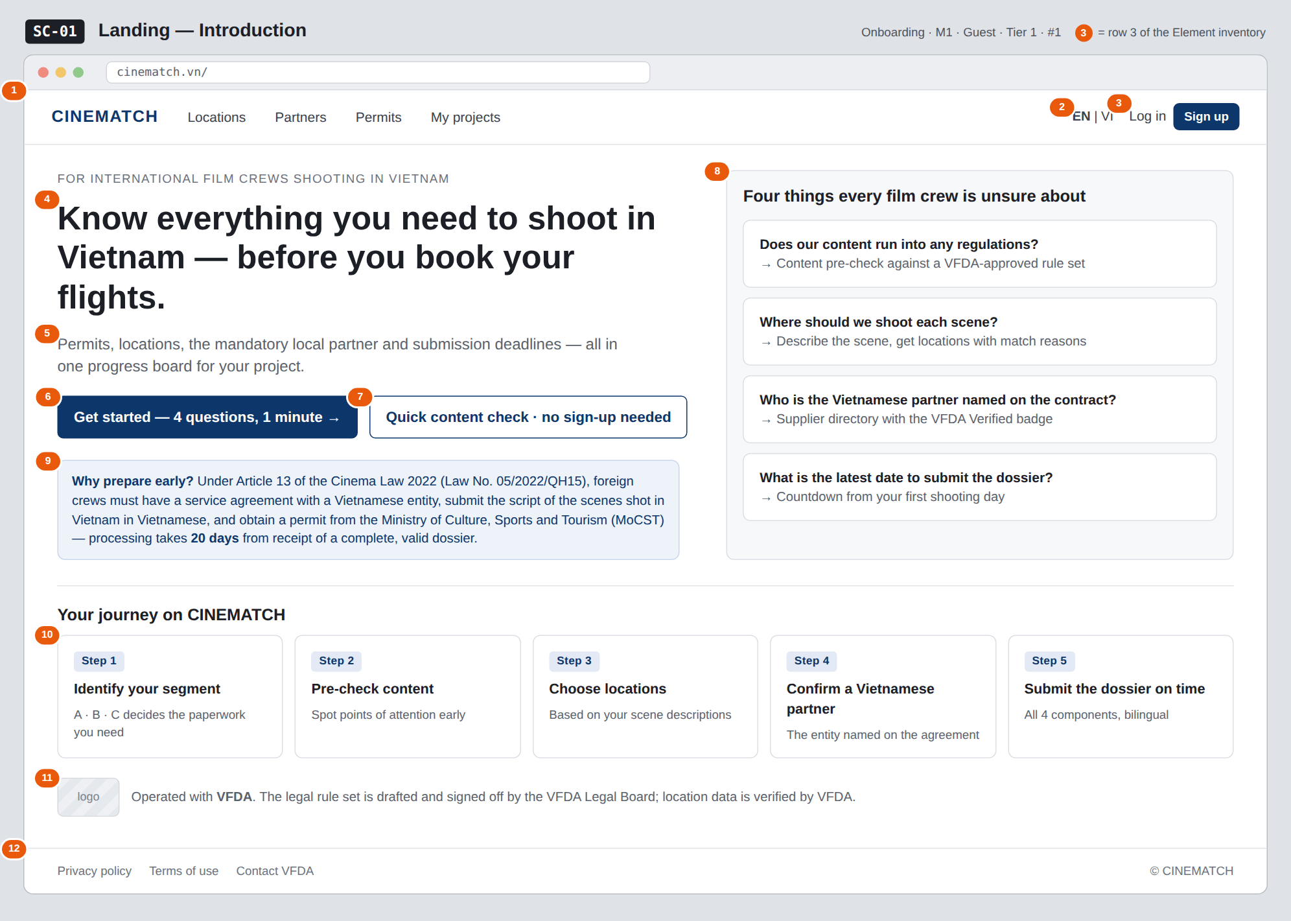
The image is the visual contract (layout, grouping, hierarchy); the tables below are the behavioural contract. All data in the mockup is sample data for one fictional project (The Last Ferry, Harbour Line Films); organisation names, people and phone numbers are examples, not real records.

3. Element inventory
# | Element | Type | Content / data source | Required | Validation
1 | Navigation bar | Header | static: CINEMATCH · Locations · Partners · Permits · My projects | — | —
2 | Language switch EN | VI | Toggle | static; value stored in the locale cookie | — | accepts only en / vi
3 | Log in / Sign up | Button | static; shown only when not logged in | — | —
4 | Positioning headline | Header | static, bilingual, from the display dictionary F-SYS-06 | Yes | —
5 | Lead sentence | Text | static, bilingual | Yes | —
6 | Get started — 4 questions, 1 minute button | Button | static | — | —
7 | Quick content check button | Button | static | — | —
8 | Four things every film crew is unsure about block | List | static: 4 questions → 4 modules (M2, M3, M4, M5) | Yes | exactly 4 items, each with one question and one entry point
9 | Article 13 legal basis strip | Text | static; wording approved by the VFDA Legal Board | Yes | must quote Article 13 of the Cinema Law 2022 and the 20-day deadline accurately
10 | 5-step journey | List | static | — | fixed order 1→5
11 | VFDA partnership line | Text + Image | static; VFDA logo (once permitted) | — | —
12 | Footer | List | static: Privacy policy · Terms · Contact VFDA | — | —

4. States
State | What the user sees | Trigger
Default | Positioning headline on the left, the four-uncertainties block on the right, Article 13 strip, 5-step journey, VFDA line, footer — exactly as in the mockup. | Page opens
Empty (no data) | Not applicable — all content is static and server-rendered; there is no list that can be empty. | —
Loading | Not applicable to the main content (static page). Only the button being clicked switches to a pending state during navigation. | Click a button
Error | If the VFDA logo fails to load: show the text VFDA instead of the image, no broken frame. Navigation errors use the system's generic error page. | Image error / network error
Success / confirmation | Not applicable — the page writes no data. Goes straight to SC-02 or SC-03. | —

5. Interactions and navigation
# | Element | User action | System response | Goes to screen
1 | Get started button | tap | Opens the segment router | SC-02
2 | Quick content check button | tap | Opens the pre-check form, no login required | SC-03
3 | Where should we shoot each scene? item | tap | Opens the scene description box | SC-15
4 | Who is the Vietnamese partner… item | tap | Opens the partner directory | SC-19
5 | What is the latest date… item | tap | No project yet → opens the router to create a project first | SC-02
6 | Log in / Sign up | tap | — | SC-04
7 | EN | VI | tap | Switches language, keeps scroll position | stays
8 | Footer | tap | — | SC-42 / SC-43

6. Screen-level rules
Rule ID | Rule | Source
SR-011 | The first message is removing uncertainty, not location lookup. The location search box does not appear on the landing page. | Screen list file — note #1
SR-012 | Each item in the Four things every film crew is unsure about block must lead to exactly one live module. Modules not yet built must not be promoted on the landing page. | No-empty-promises principle
SR-013 | The Article 13 strip only states the provision whose wording has been approved by the VFDA Legal Board; no further interpretation. | TL3 — division of responsibilities
SR-014 | Two primary buttons: one leads into the router (high commitment), one lets users try immediately without signing up (low commitment). | TL4 §3
SR-015 | The page is statically pre-rendered on the server (SSG) so search engines can read it; hreflang tags for both languages. | TL4 §7

7. Linked requirements
FR ID (from the module spec) | What this screen does for it
FR-001 · spec-M1.md (F-M1-01) | Entry to the segment router
FR-005 · spec-M2.md (F-M2-05) | Entry to the pre-check without login
FR-005 · spec-SYS.md (F-SYS-05) | VI/EN language switch
FR-006 · spec-SYS.md (F-SYS-06) | Bilingual content from the display dictionary

8. Responsive and accessibility notes
- Minimum supported width: 360px.
- Narrow screens: the Four things every film crew is unsure about block moves below the headline; the two buttons stack vertically at full width; the 5-step journey becomes a vertical list.
- Headline at least 28px on phones; text contrast ≥ 4.5:1.
- Both buttons are real <a> elements, reachable with Tab in reading order.

9. Open questions
# | Question | Blocking? | Status
1 | [NEEDS CLARIFICATION: does VFDA allow its logo and association name on the landing page, and what is the official wording] | Yes | Open
2 | [NEEDS CLARIFICATION: default language on a guest's first visit — follow the browser, or always EN since the main users are international crews] | No | Open

Completion checklist
- ☒ The mockup is a separate cropped image file, named with the Screen ID (img/SC-01.png).
- ☒ Every visible element in the mockup appears in the element inventory — machine-checked: badge numbers on the image = row numbers in section 3.
- ☒ Every input element has a validation rule or an explicit "—".
- ☒ All five states are filled in, or marked "Not applicable" with a reason.
- ☒ Every navigation target is a Screen ID that exists in docs/screen-list.md — machine-checked.
- ☒ Every element that displays data names the field it displays, matching docs/spec/spec-M1.md section 5.1.
- ☐ Checked by a person: (not signed — a Group C member compares the image with the tables and signs here)

DBIZ3 Session 4 · Group C · CINEMATCH. Built on the DBIZ2 Screen Design (Screen List and Screen Layout).

