Screen Spec: SC-02 Segment router + A/B/C result
DBIZ3 Session 4 template — one file per screen. The Screen ID is kept from the DBIZ2 Screen List. The mockup image stays an image; everything around it is text. Each orange numbered badge on the mockup is the row with the same number in section 3 (Element inventory).
Field | Value
Screen ID | SC-02
Screen name | Segment router + A/B/C result
Actor | Guest
Priority | Must
Belongs to module | docs/spec/spec-M1.md
Mockup image | img/SC-02.png
Status | Draft
Route: /start · Screen list file: Onboarding, item #3 (Tier 1 — Must) · Design note from the screen list file: 3–4 short questions; the result screen lets users confirm or change.

1. Purpose
Shown when: The user clicks Get started on SC-01, or has just verified a new account on SC-04.
The user leaves this screen when: The user confirms the segment (to project creation SC-10) or picks a different segment and confirms.

2. Mockup
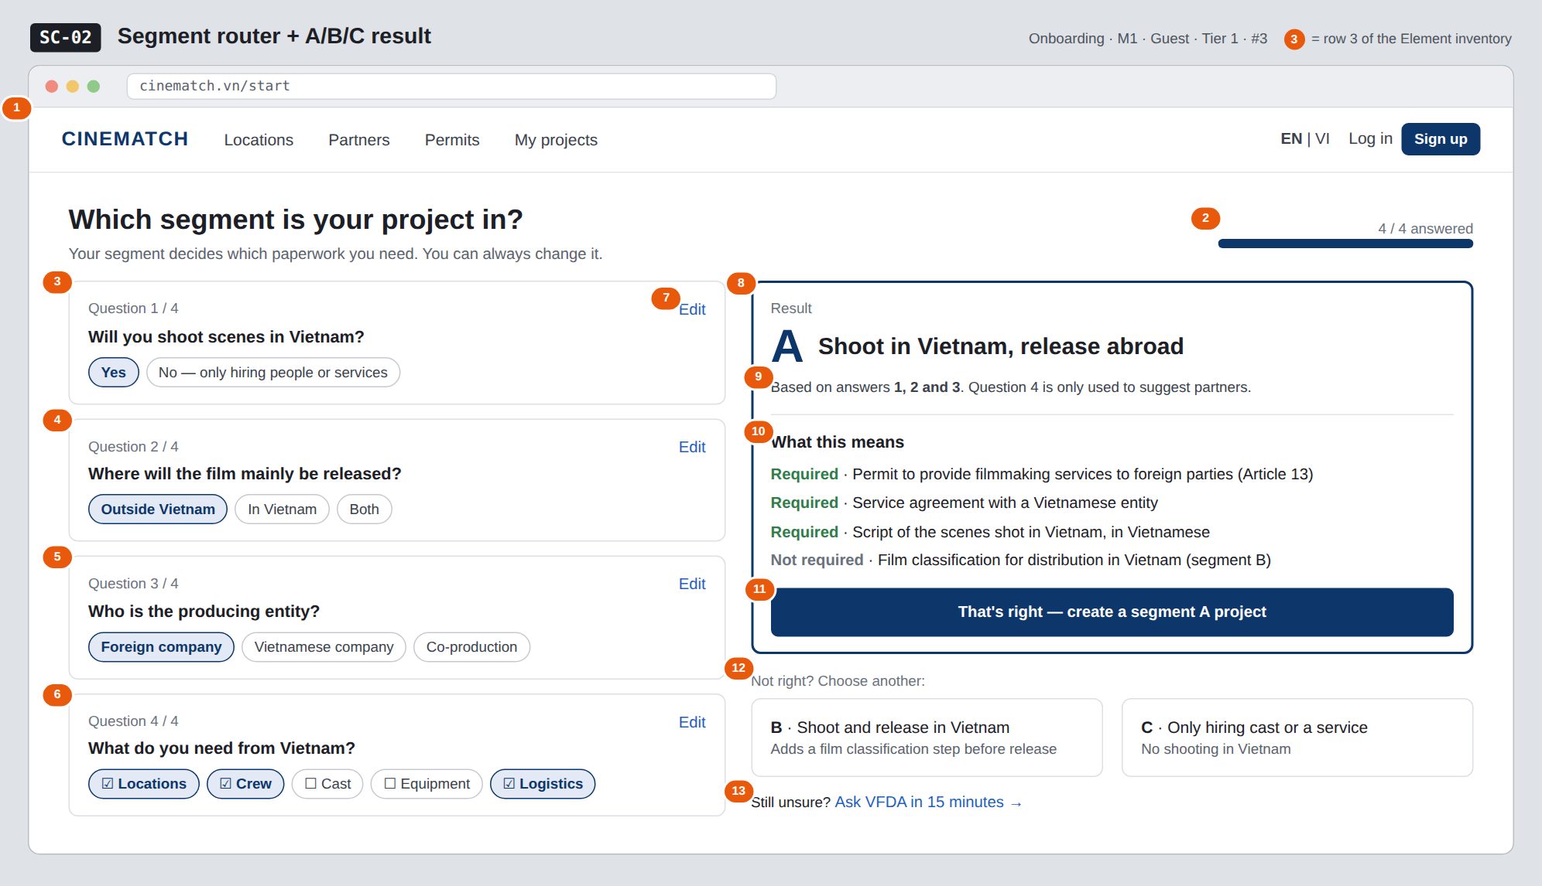
The image is the visual contract (layout, grouping, hierarchy); the tables below are the behavioural contract. All data in the mockup is sample data for one fictional project (The Last Ferry, Harbour Line Films); organisation names, people and phone numbers are examples, not real records.

3. Element inventory
# | Element | Type | Content / data source | Required | Validation
1 | Navigation bar | Header | static | — | —
2 | Progress indicator | Text + bar | number of questions answered / 4 | — | —
3 | Question 1 — Shooting in Vietnam? | Toggle (single choice) | segment_answers.q1_shoot_in_vn | Yes | Yes / No
4 | Question 2 — Release market | Toggle (single choice) | segment_answers.q2_release | Yes (if question 1 = Yes) | abroad / vietnam / both
5 | Question 3 — Producing entity | Toggle (single choice) | segment_answers.q3_producer | Yes (if question 1 = Yes) | foreign / vietnamese / coproduction
6 | Question 4 — Needs | Toggle (multiple choice) | segment_answers.q4_needs[] | No | subset of the 5 values
7 | Edit answer link | Button | static; on every question | — | —
8 | Segment result card | Container | computed from the decision table segment_rules (no language model) | Yes | exactly one of A / B / C
9 | Classification reason | Text | the answers that determined the result | Yes | must cite question numbers
10 | What this means block | List | segment_requirements for the segment | Yes | each line labelled Required / Not required
11 | That's right — create a segment A project button | Button | static | — | —
12 | The other two segment cards | Button | static | — | —
13 | Ask VFDA link | Button | static | — | —

4. States
State | What the user sees | Trigger
Default | First visit: only question 1 is shown; answering each question reveals the next; the result block appears once the required questions are answered. The mockup shows the completed 4/4 state. | Page opens
Empty (no data) | No questions answered: the right column shows a faded placeholder Your result will appear here after question 3. | First page visit
Loading | Not applicable to segment classification (computed instantly in the browser from the preloaded decision table). The create project button has a pending state when clicked. | —
Error | Contradictory answers that match no rule (e.g. not shooting in VN but needing Locations) → We couldn't classify this — choose directly or ask VFDA, showing all three A/B/C cards. | No rule matches
Success / confirmation | Confirming while logged in → SC-10 with the Create new project panel pre-filled with the segment. Not logged in → SC-04, selection kept in the session. | Segment confirmed

5. Interactions and navigation
# | Element | User action | System response | Goes to screen
1 | Option within a question | tap | Records the answer, reveals the next question, recalculates the result | stays
2 | Edit link | tap | Reopens that question; result recalculates immediately | stays
3 | That's right — create a segment A project button | tap | Saves projects.segment; if not logged in, keeps it in the session | SC-10 (or SC-04)
4 | Card B or C | tap | Switches the result to that segment, records segment_override = true | stays
5 | Ask VFDA | tap | Opens booking with topic Segment identification | SC-33

6. Screen-level rules
Rule ID | Rule | Source
SR-031 | At most 4 questions; question 4 does not affect the segment. | Screen list file — note #3
SR-032 | The segment is computed with a deterministic decision table (segment_rules), not a language model — the same answers always give the same result. | Explainability principle
SR-033 | The result always comes with the reason (which questions decided it) and a Required / Not required list. | No-black-box principle
SR-034 | Users can always change the segment; manual choices are recorded (segment_override) so VFDA can see where the router misclassifies. | TL4 §2
SR-035 | The Required / Not required list is read from the VFDA-approved segment_requirements table, not hard-coded. | TL5 §M1

7. Linked requirements
FR ID (from the module spec) | What this screen does for it
FR-001 · spec-M1.md (F-M1-01) | Segment selection screen
FR-002 · spec-M1.md (F-M1-02) | Record selection and configure the journey
FR-003 · spec-M1.md (F-M1-03) | Change segment

8. Responsive and accessibility notes
- Minimum supported width: 360px.
- Narrow screens: questions are shown one at a time (step by step); the result card takes the full screen when done.
- Options are real radio / checkbox groups, with a fieldset + legend per question.
- Segment letters A/B/C are always paired with their full name — users should never have to guess the meaning.

9. Open questions
# | Question | Blocking? | Status
1 | [NEEDS CLARIFICATION: decision table for the co-production case (question 3) — classify as A or B, and is a separate segment needed] | Yes | Open
2 | [NEEDS CLARIFICATION: does segment C really need no permit at all when a foreign crew only hires Vietnamese cast to shoot abroad] | Yes | Open

Completion checklist
- ☒ The mockup is a separate cropped image file, named with the Screen ID (img/SC-02.png).
- ☒ Every visible element in the mockup appears in the element inventory — machine-checked: badge numbers on the image = row numbers in section 3.
- ☒ Every input element has a validation rule or an explicit "—".
- ☒ All five states are filled in, or marked "Not applicable" with a reason.
- ☒ Every navigation target is a Screen ID that exists in docs/screen-list.md — machine-checked.
- ☒ Every element that displays data names the field it displays, matching docs/spec/spec-M1.md section 5.1.
- ☐ Checked by a person: (not signed — a Group C member compares the image with the tables and signs here)

DBIZ3 Session 4 · Group C · CINEMATCH. Built on the DBIZ2 Screen Design (Screen List and Screen Layout).

