Screen Spec: SC-03 Script content input (200-word pre-check)
DBIZ3 Session 4 template — one file per screen. The Screen ID is kept from the DBIZ2 Screen List. The mockup image stays an image; everything around it is text. Each orange numbered badge on the mockup is the row with the same number in section 3 (Element inventory).
Field | Value
Screen ID | SC-03
Screen name | Script content input (200-word pre-check)
Actor | Guest
Priority | Must
Belongs to module | docs/spec/spec-M2.md
Mockup image | img/SC-03.png
Status | Draft
Route: /pre-check · Screen list file: M2, item #6 (Tier 1 — Must) · Design note from the screen list file: Simple form, quick to fill in.
Notes against Screen List v2.0
- In the previous Screen List, SC-03 contained both the input and the results. Per the screen list file (#6 and #7), the results were split into a new screen SC-48 Content check results. SC-03 now covers input only.

1. Purpose
Shown when: A guest clicks Quick content check on SC-01, or clicks Edit summary and re-check on SC-48.
The user leaves this screen when: The user clicks Check content and gets the results on SC-48.

2. Mockup
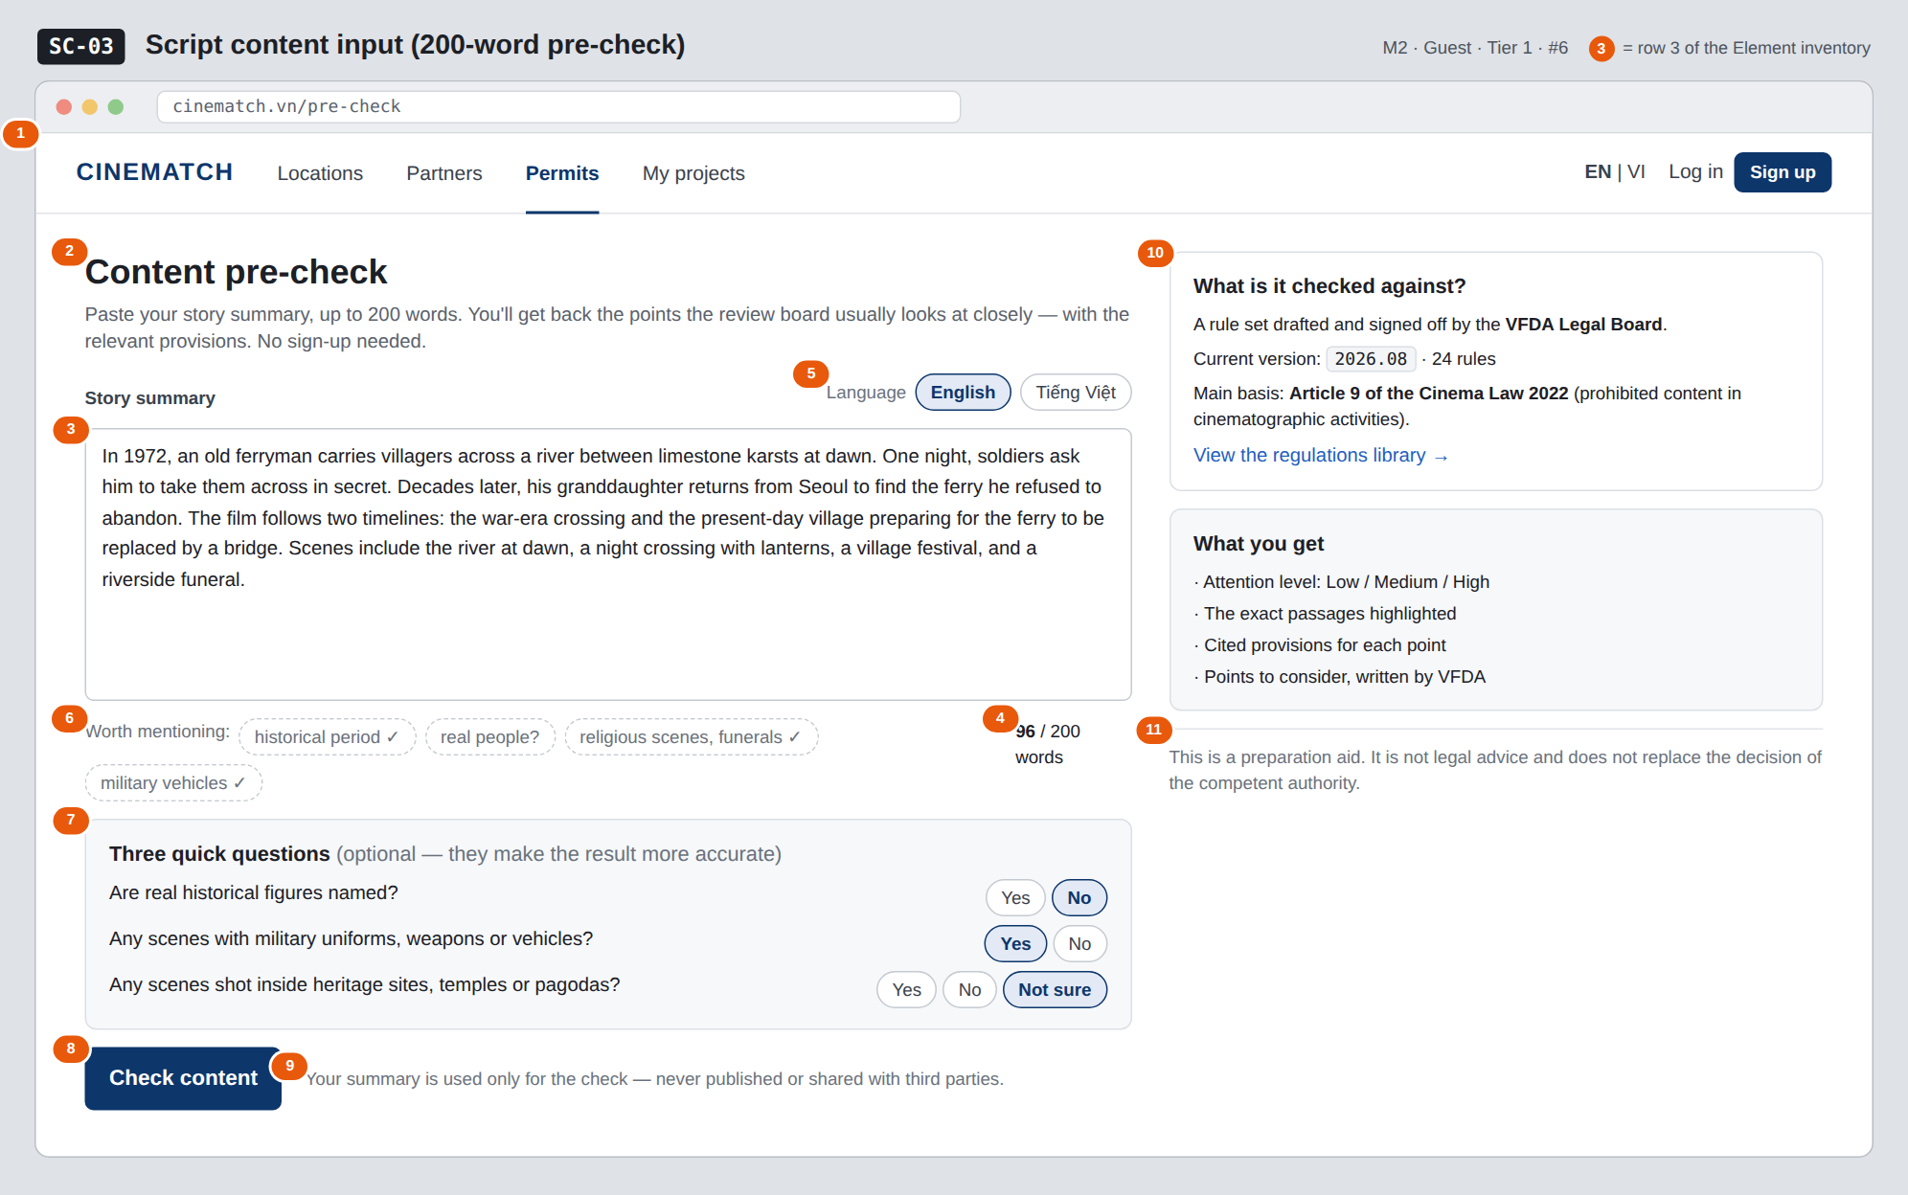
The image is the visual contract (layout, grouping, hierarchy); the tables below are the behavioural contract. All data in the mockup is sample data for one fictional project (The Last Ferry, Harbour Line Films); organisation names, people and phone numbers are examples, not real records.

3. Element inventory
# | Element | Type | Content / data source | Required | Validation
1 | Navigation bar | Header | static | — | —
2 | Title + description | Header + Text | static | — | —
3 | Story summary box | Input (textarea) | precheck_runs.summary_text | Yes | 20–200 words (word count); trim extra whitespace
4 | Word counter | Text | real-time count | — | red above 200, blocks submission
5 | Summary language selector | Toggle | precheck_runs.lang — en / vi | Yes | auto-detected from content, user can change
6 | Worth-mentioning hints | List (chip) | static; chips auto-tick ✓ when the topic is detected in the text | — | hints only, never block submission
7 | Three quick questions | Toggle (single choice ×3) | precheck_runs.flags — real_person, military, heritage_site | No | Yes / No / Not sure
8 | Check content button | Button | static | — | disabled below 20 or above 200 words
9 | Privacy line | Text | static | Yes | always shown next to the button
10 | What is it checked against? block | Text | ruleset_versions.current, count of approved rules | Yes | must show the rule set version
11 | Disclaimer line | Text | static | Yes | always shown

4. States
State | What the user sees | Trigger
Default | Empty summary box with placeholder text, counter at 0 / 200, check button disabled. The mockup shows a pasted 96-word summary. | Page opens
Empty (no data) | Empty box: placeholder e.g. A coastal village in the 1990s…; the basis block is still fully shown. | Page opens
Loading | Button changes to Checking… (about 10–20 seconds); input locked; a Cancel button is available. | Click check
Error | Red line under the button: We couldn't run the check right now. Your summary is still here — try again in a few minutes. Per-IP limit reached: You've used all of today's checks — create a free account to continue. | API error / timeout / rate limit
Success / confirmation | Goes to SC-48 with the results. | Check complete

5. Interactions and navigation
# | Element | User action | System response | Goes to screen
1 | Summary box | type | Counts words; ticks hint chips when topics are detected | stays
2 | Language chip | tap | Changes the analysis language | stays
3 | Quick question | tap | Records the flag | stays
4 | Check content button | tap | Calls F-M2-06, logs the run via F-M2-07 | SC-48
5 | View the regulations library | tap | — | SC-30

6. Screen-level rules
Rule ID | Rule | Source
SR-061 | No sign-up needed to use it. This is the platform's main conversion point. | TL4 §3
SR-062 | The 200-word limit is deliberate: enough to identify the topics, not enough for users to paste a whole script into a public tool. | Data minimisation principle
SR-063 | The three quick questions are optional; Not sure is a valid answer and is treated as no information. | No-guessing principle
SR-064 | Always show the rule set version that will be used — results must be traceable to the exact version. | TL5 §M2

7. Linked requirements
FR ID (from the module spec) | What this screen does for it
FR-005 · spec-M2.md (F-M2-05) | Summary input box
FR-006 · spec-M2.md (F-M2-06) | Submit for review
FR-007 · spec-M2.md (F-M2-07) | Log the pre-check run

8. Responsive and accessibility notes
- Minimum supported width: 360px.
- Narrow screens: the right column moves below the check button; the disclaimer line always sits right under the button.
- The summary box has a real <label>; the counter is announced via aria-live="polite".
- Hint chips don't convey information by colour alone — they carry a text ✓ mark.

9. Open questions
# | Question | Blocking? | Status
1 | [NEEDS CLARIFICATION: how long are guest summaries kept, and are they used to improve the rule set — privacy policy wording needed] | Yes | Open
2 | [NEEDS CLARIFICATION: daily pre-check limit per IP] | No | Open

Completion checklist
- ☒ The mockup is a separate cropped image file, named with the Screen ID (img/SC-03.png).
- ☒ Every visible element in the mockup appears in the element inventory — machine-checked: badge numbers on the image = row numbers in section 3.
- ☒ Every input element has a validation rule or an explicit "—".
- ☒ All five states are filled in, or marked "Not applicable" with a reason.
- ☒ Every navigation target is a Screen ID that exists in docs/screen-list.md — machine-checked.
- ☒ Every element that displays data names the field it displays, matching docs/spec/spec-M2.md section 5.1.
- ☐ Checked by a person: (not signed — a Group C member compares the image with the tables and signs here)

DBIZ3 Session 4 · Group C · CINEMATCH. Built on the DBIZ2 Screen Design (Screen List and Screen Layout).

