Screen Spec: SC-13 Project settings
DBIZ3 Session 4 template — one file per screen. The Screen ID is kept from the DBIZ2 Screen List. The mockup image stays an image; everything around it is text. Each orange numbered badge on the mockup is the row with the same number in section 3 (Element inventory).
Field | Value
Screen ID | SC-13
Screen name | Project settings
Actor | Member (edit permission; invitations by the owner only)
Priority | Must
Belongs to module | docs/spec/spec-M0.md
Mockup image | img/SC-13.png
Status | Draft
Route: /projects/[id]/settings · Screen list file: M0, item #27 (Added 30/09/2026 — Must) · Design note from the screen list file: Change segment, invite members.
Notes against Screen List v2.0
- Screen Spec added 30/09/2026. SC-13 was in Screen List v2.0 but had no mockup; it now reflects M0 BR-005 (archive, never delete) and M1 BR-004 (a segment change never deletes data).

1. Purpose
Shown when: A project member clicks Settings in the project sidebar on any project screen (for example SC-12 or SC-26).
The user leaves this screen when: The member goes back to another project screen through the sidebar (for example SC-12), redoes the segment questions on SC-02, or archives the project and lands on SC-10.

2. Mockup
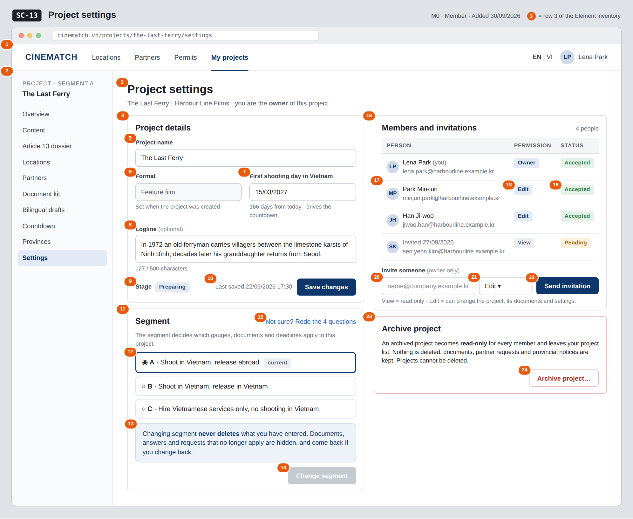
The image is the visual contract (layout, grouping, hierarchy); the tables below are the behavioural contract. All data in the mockup is sample data for one fictional project (The Last Ferry, Harbour Line Films); organisation names, people and phone numbers are examples, not real records.

3. Element inventory
# | Element | Type | Content / data source | Required | Validation
1 | Navigation bar | Header | static; My projects selected | — | —
2 | Project sidebar | List | static; Settings selected | — | —
3 | Title + project and the viewer's role | Header | project_name, the viewer's permission (owner / edit / view) | — | —
4 | Project details card | Container | static | — | read-only for members with view permission and for archived projects
5 | Project name | Input | project_name | Yes | 1–200 characters
6 | Format | Text (read-only) | format — Feature film / Documentary / Commercial / TV programme / Music video | — | not editable here: F-M0-02 does not list format as an input
7 | First shooting day in Vietnam | Input (date) | shoot_date; days remaining computed on screen for display only | No | must be after today
8 | Logline | Input (multi-line) | logline | No | max 500 characters; live counter
9 | Stage | Text | stage — draft / preparing / archived | — | changed to archived only through row 24
10 | Save changes button + last saved time | Button + Text | updated_at | — | disabled until a field changes; enabled only for edit permission
11 | Segment card | Container | static | — | —
12 | Segment choice A / B / C | Toggle (single choice) | current segment; selection becomes new_segment | Yes | enum A / B / C; the current value is pre-selected
13 | Nothing is deleted note | Text | static; reflects data_retained (always true) | — | —
14 | Change segment button | Button | static | — | disabled until a segment other than the current one is selected; opens a confirmation dialog
15 | Redo the 4 questions link | Link | static | — | —
16 | Members and invitations card | Container | project members of this project | — | —
17 | Member row | List | member name and invitee_email | — | only members of this project (Row Level Security)
18 | Permission | Text | permission — view / edit; the creator is shown as Owner | — | enum
19 | Invitation status | Text | invite_status — pending / accepted | — | enum
20 | Invitee email | Input (email) | invitee_email | Yes | valid email, max 254 characters; not already a member or pending invitee of this project
21 | Invitee permission | Toggle (dropdown) | permission — View / Edit | Yes | enum; default Edit
22 | Send invitation button | Button | static | — | shown to the owner only (F-M0-04); disabled until rows 20–21 are valid
23 | Archive project card | Container | static text explaining read-only archive | — | hidden when the project is already archived
24 | Archive project… button | Button | sets stage = archived after confirmation | — | edit permission only; confirmation dialog repeats that nothing is deleted

4. States
State | What the user sees | Trigger
Default | Details, segment and members for the project; the owner also sees the invite row. The mockup shows the owner's view. | Open /projects/[id]/settings
Empty (no data) | The owner is the only member: the members table shows one row and the line Only you are on this project — invite your line producer or co-producer. | No other members or invitations
Loading | Grey skeletons in the three cards; buttons disabled until the project has loaded. | Loading the project
Error | Invalid first shooting day: message under the field Must be after today. Save fails: red strip Couldn't save — your changes are kept. Email already invited: message under the email field. Segment change fails: the current segment stays selected and a red strip explains the change was not applied. | Validation / database write error
Success / confirmation | Save: green strip Project details saved. Invitation: new row with status Pending and strip Invitation sent to …. Segment change: strip Segment changed to B — 3 items no longer apply and are hidden, nothing was deleted. Archive: goes to SC-10 with strip The Last Ferry archived — find it under Archived. | Save / invite / change segment / archive succeeded

5. Interactions and navigation
# | Element | User action | System response | Goes to screen
1 | Project sidebar item | tap | Opens that project screen | SC-12
2 | Save changes button | tap | Updates the project details and updated_at; if another member saved in between, last write wins and a toast names who | stays
3 | Segment option | tap | Selects new_segment; enables Change segment | stays
4 | Change segment button | tap | Confirmation dialog listing what will be hidden (not deleted); on confirm sets the segment and returns the new journey_config | stays
5 | Redo the 4 questions link | tap | Opens the router with this project as context | SC-02
6 | Send invitation button | tap | Creates a member row with invite_status = pending and sends the invitation email | stays
7 | Archive project… button | tap | Confirmation dialog; on confirm sets stage = archived and closes the project for editing | SC-10

6. Screen-level rules
Rule ID | Rule | Source
SR-271 | Only members with edit permission can change details, segment or stage; members with view permission see this screen read-only. | M0 FR-002 (F-M0-02)
SR-272 | Only the owner can invite people, with view or edit permission. | M0 FR-004 (F-M0-04)
SR-273 | A segment change never deletes documents or answers: items that no longer apply are hidden, not removed, and reappear if the segment is changed back. | M1 BR-004
SR-274 | After a segment change the gauges and weights are read again from segment_requirements; this screen never computes scores. | M0 BR-001, M0 BR-004
SR-275 | Projects are archived, never deleted. An archived project (stage = archived) is read-only for its members, leaves the project list and keeps its documents, requests and notices. There is no Delete project action. | M0 BR-005

7. Linked requirements
FR ID (from the module spec) | What this screen does for it
FR-002 · spec-M0.md (F-M0-02) | Edit project details, including the first shooting day and the stage (archive)
FR-004 · spec-M0.md (F-M0-04) | Invite people by email with view or edit permission
FR-003 · spec-M1.md (F-M1-03) | Change the project's segment without deleting data

8. Responsive and accessibility notes
- Minimum supported width: 360px.
- Narrow screens: the project sidebar collapses into a menu button; the two columns stack (details, segment, members, archive).
- The members table becomes a list of cards (name, email, permission, status).
- The segment choice is a radio group with a visible label; the archive and segment confirmations are dialogs with a focus trap, closed with Esc.
- Permission and status labels always include text, not only colour.

9. Open questions
# | Question | Blocking? | Status
1 | [NEEDS CLARIFICATION: Can people outside the producer organisation (a lawyer, a freelance line producer) be invited to a project?] | No | Open
2 | [NEEDS CLARIFICATION: can the owner change a member's permission, remove a member or cancel a pending invitation? F-M0-04 only covers inviting] | No | Open
3 | [NEEDS CLARIFICATION: can an archived project be restored to preparing, and by whom?] | No | Open

Completion checklist
- ☒ The mockup is a separate cropped image file, named with the Screen ID (img/SC-13.png).
- ☒ Every visible element in the mockup appears in the element inventory — machine-checked: badge numbers on the image = row numbers in section 3.
- ☒ Every input element has a validation rule or an explicit "—".
- ☒ All five states are filled in, or marked "Not applicable" with a reason.
- ☒ Every navigation target is a Screen ID that exists in docs/screen-list.md — machine-checked.
- ☒ Every element that displays data names the field it displays, matching docs/spec/spec-M0.md section 5.1.
- ☐ Checked by a person: (not signed — a Group C member compares the image with the tables and signs here)

DBIZ3 Session 4 · Group C · CINEMATCH. Built on the DBIZ2 Screen Design (Screen List and Screen Layout).

