Screen Spec: SC-17 Location comparison (up to 4)
DBIZ3 Session 4 template — one file per screen. The Screen ID is kept from the DBIZ2 Screen List. The mockup image stays an image; everything around it is text. Each orange numbered badge on the mockup is the row with the same number in section 3 (Element inventory).
Field | Value
Screen ID | SC-17
Screen name | Location comparison (up to 4)
Actor | Guest / Member
Priority | Should
Belongs to module | docs/spec/spec-M3.md
Mockup image | img/SC-17.png
Status | Draft
Route: /locations/compare · Screen list file: Tier 2, item #18 (Tier 2 — Should) · Design note from the screen list file: Source M3·2.
Notes against Screen List v2.0
- Screen List v2.0 puts SC-17 at Must; the function list places it in Tier 2 — Should. This spec follows the function list.

1. Purpose
Shown when: User clicks View comparison on SC-14, or the Locations gauge on SC-12.
The user leaves this screen when: User sets a primary / backup location, downloads the PDF, or opens a location's details.

2. Mockup
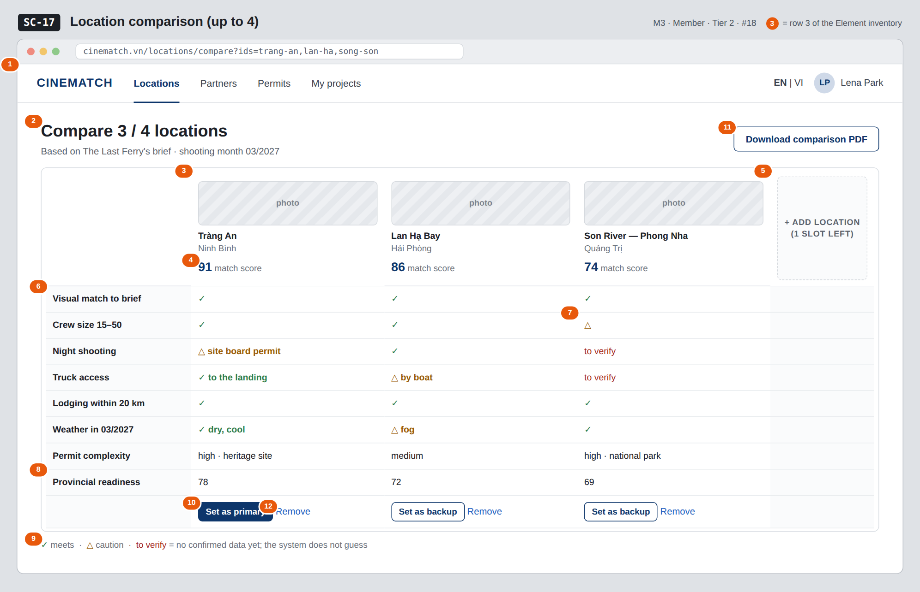
The image is the visual contract (layout, grouping, hierarchy); the tables below are the behavioural contract. All data in the mockup is sample data for one fictional project (The Last Ferry, Harbour Line Films); organisation names, people and phone numbers are examples, not real records.

3. Element inventory
# | Element | Type | Content / data source | Required | Validation
1 | Navigation bar | Header | static | — | —
2 | Compare n / 4 title + context | Header | number of columns; current query and shooting month | — | —
3 | Location column | List | locations.name, provinces.name, cover_image | — | 2–4 columns
4 | Match score | Text | F-M3-08 for the current query | — | —
5 | Add-location slot | Button | static | — | hidden when 4 columns are filled
6 | Criteria row | List | 8 fixed criteria | — | fixed order
7 | Value cell | Text | ✓ / △ / to verify + short note | Yes | never blank — missing data shows to verify
8 | Provincial readiness row | Text | v_province_readiness.score | — | same source as SC-18
9 | Symbol legend | Text | static | Yes | —
10 | Set as primary / Set as backup button | Button | writes project_shortlist.role = primary / backup | — | at most 1 primary location per scene; login required
11 | Download comparison PDF button | Button | generates PDF | — | login required
12 | Remove link | Link | removes from the basket | — | —

4. States
State | What the user sees | Trigger
Default | Table of 8 criteria × 2–4 columns, an empty 4th slot to add one, set buttons under each column. | Basket has ≥ 2 locations
Empty (no data) | Basket has 0–1 locations: You need at least two locations to compare + button back to SC-14. | Basket < 2
Loading | Grey skeleton in the shape of the table. | Loading
Error | Couldn't load comparison data. Your basket is still saved. + Try again. | Query error
Success / confirmation | Set → green strip Tràng An set as primary location and the Locations gauge goes up. | Writes F-M3-18

5. Interactions and navigation
# | Element | User action | System response | Goes to screen
1 | Location name at top of column | tap | — | SC-16
2 | + Add location slot | tap | Back to results to pick more | SC-14
3 | Set as primary / backup button | tap | Not logged in → SC-04; logged in → saved to the project | SC-12
4 | Download comparison PDF button | tap | Generate PDF | stays
5 | Remove | tap | Remove column | stays
6 | Provincial readiness row value | tap | — | SC-18

6. Screen-level rules
Rule ID | Rule | Source
SR-181 | At most 4 locations; the basket is kept for the session. | Function list — Tier 2 #18
SR-182 | Every cell is meets, caution, or to verify — never blank. To verify = no data yet; the system does not guess. | No-guessing principle
SR-183 | Weather is based on the project's shooting month, not the annual average. | TL5 §M3
SR-184 | Primary and backup are set separately — productions always need a plan B for outdoor locations. | Production practice
SR-185 | The table scrolls horizontally in its own frame; the criteria column is pinned. | Layout

7. Linked requirements
FR ID (from the module spec) | What this screen does for it
FR-016 · spec-M3.md (F-M3-16) | Select up to four locations
FR-017 · spec-M3.md (F-M3-17) | Comparison table by criteria
FR-018 · spec-M3.md (F-M3-18) | Add to shortlist

8. Responsive and accessibility notes
- Minimum supported width: 360px.
- Narrow screens: the table scrolls horizontally in its own frame, with the criteria column pinned on the left.
- ✓ / △ symbols always come with a text legend; the three states remain distinguishable in black-and-white print.
- The table uses <table> with <th scope>.

9. Open questions
# | Question | Blocking? | Status
1 | [NEEDS CLARIFICATION: data source for the Night shooting and Weather by month criteria — no matching field in locations yet] | Yes | Open

Completion checklist
- ☒ The mockup is a separate cropped image file, named with the Screen ID (img/SC-17.png).
- ☒ Every visible element in the mockup appears in the element inventory — machine-checked: badge numbers on the image = row numbers in section 3.
- ☒ Every input element has a validation rule or an explicit "—".
- ☒ All five states are filled in, or marked "Not applicable" with a reason.
- ☒ Every navigation target is a Screen ID that exists in docs/screen-list.md — machine-checked.
- ☒ Every element that displays data names the field it displays, matching docs/spec/spec-M3.md section 5.1.
- ☐ Checked by a person: (not signed — a Group C member compares the image with the tables and signs here)

DBIZ3 Session 4 · Group C · CINEMATCH. Built on the DBIZ2 Screen Design (Screen List and Screen Layout).

