Screen Spec: SC-29 20-day countdown
DBIZ3 Session 4 template — one file per screen. The Screen ID is kept from the DBIZ2 Screen List. The mockup image stays an image; everything around it is text. Each orange numbered badge on the mockup is the row with the same number in section 3 (Element inventory).
Field | Value
Screen ID | SC-29
Screen name | 20-day countdown
Actor | Member
Priority | Must
Belongs to module | docs/spec/spec-M5.md
Mockup image | img/SC-29.png
Status | Draft
Route: /projects/[id]/timeline · Screen list file: M5, item #17 (Tier 1 — Must) · Design note from the screen list file: Timeline counting back from the shoot, emphasising the submission deadline.

1. Purpose
Shown when: Member clicks the deadline strip on SC-12, Countdown in the sidebar, or the deadline link on SC-27.
The user leaves this screen when: Member changes the first shooting day / safety buffer, turns on reminders, or moves to the document kit.

2. Mockup
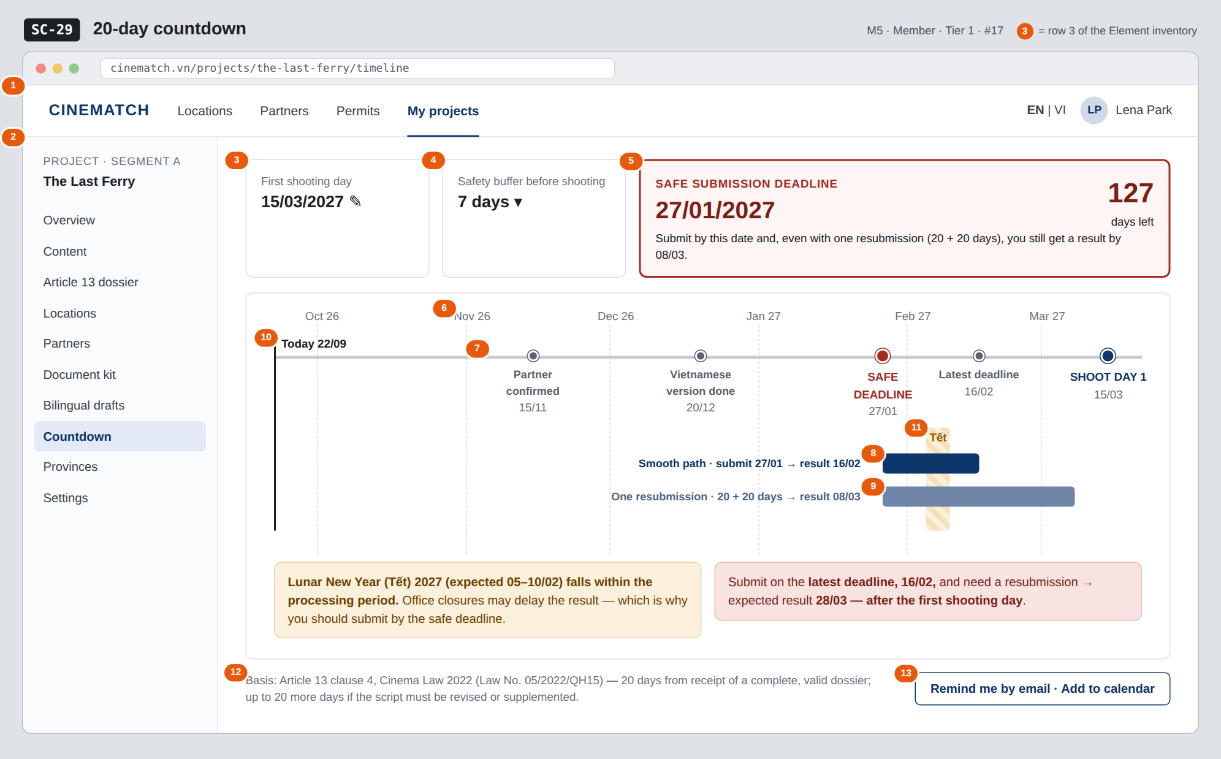
The image is the visual contract (layout, grouping, hierarchy); the tables below are the behavioural contract. All data in the mockup is sample data for one fictional project (The Last Ferry, Harbour Line Films); organisation names, people and phone numbers are examples, not real records.

3. Element inventory
# | Element | Type | Content / data source | Required | Validation
1 | Navigation bar | Header | static | — | —
2 | Project sidebar | List | static; Countdown selected | — | —
3 | First shooting day (editable) | Input (date) | projects.shooting_start_date | Yes | after today
4 | Safety buffer | Toggle (dropdown) | projects.buffer_days — 0 / 7 / 14 / 21 | Yes | default 7
5 | Safe submission deadline card | Text | F-M2-17: first shooting day − buffer − 20 − 20; days remaining | Yes | most prominent element on screen
6 | Timeline axis | Chart (timeline) | from today to after the first shooting day, monthly ticks | Yes | —
7 | Milestone | Chart marker | timeline_milestones — partner confirmed, Vietnamese version done, safe deadline, latest deadline, first shooting day | Yes | overdue milestones turn red
8 | Smooth-path bar | Chart bar | submission date → +20 days | Yes | —
9 | One-resubmission bar | Chart bar | submission date → +40 days | Yes | —
10 | Today line | Chart marker | current date | — | —
11 | Holiday band within processing period | Chart band + Text | public_holidays (Lunar New Year (Tết), 30/4–1/5, 2/9…) | No | only shown when it falls in the processing window; marked expected until the official calendar is out
12 | Article 13 cl.4 basis line | Text | static | Yes | —
13 | Remind me by email · Add to calendar button | Button | Resend + .ics file | — | —

4. States
State | What the user sees | Trigger
Default | Three top cards (first shooting day, buffer, safe submission deadline), timeline with milestones, two path bars, Tết band, two warnings. | First shooting day set
Empty (no data) | No first shooting day: the axis is replaced by Enter your first shooting day to calculate the deadline + date field. Segment C: Segment C projects don't need an Article 13 filming permit — no countdown. | No date / segment C
Loading | Not applicable — calculated instantly from the first shooting day; changing the date redraws the axis immediately. | —
Error | First shooting day too close (safe deadline has passed): card 5 changes to Safe submission deadline passed 12 days ago + red warning and a Book a VFDA consultation button. Bad news is never hidden. | Safe deadline < today
Success / confirmation | Reminders on → green strip We'll remind you 30, 14 and 3 days before 27/01/2027 and the .ics file downloads. | Reminders turned on

5. Interactions and navigation
# | Element | User action | System response | Goes to screen
1 | First shooting day | tap | Edit date; all milestones recalculated; deadline strip on SC-12 updated | stays
2 | Safety buffer | tap | Change buffer days; recalculate | stays
3 | A milestone | tap | Opens the related screen (partner confirmed → SC-25, Vietnamese version → SC-28) | SC-25 / SC-28
4 | Remind me by email button | tap | Creates email reminders, downloads .ics | stays

6. Screen-level rules
Rule ID | Rule | Source
SR-171 | Safe submission deadline = first shooting day − buffer − 20 − 20 days: room for one resubmission under Article 13 cl.4. This is the most emphasised figure. | Function list — note #17; Article 13 cl.4
SR-172 | Always show the consequence of submitting late (e.g. result after the first shooting day). Never soften bad news. | Honesty principle
SR-173 | The same calculation function is used by SC-12, SC-27 and this screen. | Consistency principle
SR-174 | Public holidays are read from the public_holidays table; dates without an official calendar are clearly marked expected. | No-guessing principle
SR-175 | Calculated in calendar days until the VFDA Legal Board confirms the method (see open questions). | Interim assumption

7. Linked requirements
FR ID (from the module spec) | What this screen does for it
FR-017 · spec-M2.md (F-M2-17) | Calculate the 20-day milestone and countdown milestones
FR-018 · spec-M2.md (F-M2-18) | Show both paths
FR-007 · spec-M5.md (F-M5-07) | Enter planned shooting date
FR-008 · spec-M5.md (F-M5-08) | Two-path timeline
FR-008 · spec-SYS.md (F-SYS-08) | Deadline reminder emails

8. Responsive and accessibility notes
- Minimum supported width: 360px.
- Narrow screens: the horizontal axis becomes a vertical list of milestones; the safe submission deadline card stays on top.
- The timeline has a table alternative (milestone – date – days remaining) for screen readers.
- The safe deadline stands out through font size and border, not red alone.

9. Open questions
# | Question | Blocking? | Status
1 | [NEEDS CLARIFICATION: are the "20 days" calendar days or working days — if working days, the safe deadline moves about 3 weeks earlier] | Yes | Open
2 | [NEEDS CLARIFICATION: official Lunar New Year (Tết) 2027 holiday dates — update once announced] | No | Open

Completion checklist
- ☒ The mockup is a separate cropped image file, named with the Screen ID (img/SC-29.png).
- ☒ Every visible element in the mockup appears in the element inventory — machine-checked: badge numbers on the image = row numbers in section 3.
- ☒ Every input element has a validation rule or an explicit "—".
- ☒ All five states are filled in, or marked "Not applicable" with a reason.
- ☒ Every navigation target is a Screen ID that exists in docs/screen-list.md — machine-checked.
- ☒ Every element that displays data names the field it displays, matching docs/spec/spec-M5.md section 5.1.
- ☐ Checked by a person: (not signed — a Group C member compares the image with the tables and signs here)

DBIZ3 Session 4 · Group C · CINEMATCH. Built on the DBIZ2 Screen Design (Screen List and Screen Layout).

