Screen Spec: SC-30 Requirements library
DBIZ3 Session 4 template — one file per screen. The Screen ID is kept from the DBIZ2 Screen List. The mockup image stays an image; everything around it is text. Each orange numbered badge on the mockup is the row with the same number in section 3 (Element inventory).
Field | Value
Screen ID | SC-30
Screen name | Requirements library
Actor | Guest
Priority | Should
Belongs to module | docs/spec/spec-M2.md
Mockup image | img/SC-30.png
Status | Draft
Route: /requirements · Screen list file: M2, item #28 (Added 30/09/2026 — Should) · Design note from the screen list file: Browse rules by topic.
Notes against Screen List v2.0
- Screen Spec added 30/09/2026. SC-30 was in Screen List v2.0 (Should) but had no mockup. SC-12 links to it as View the regulations library.

1. Purpose
Shown when: A visitor clicks Permits → Requirements library in the top navigation, View the regulations library on SC-12, or a citation link on SC-48.
The user leaves this screen when: The visitor opens one rule (SC-31) or starts a content pre-check (SC-03).

2. Mockup
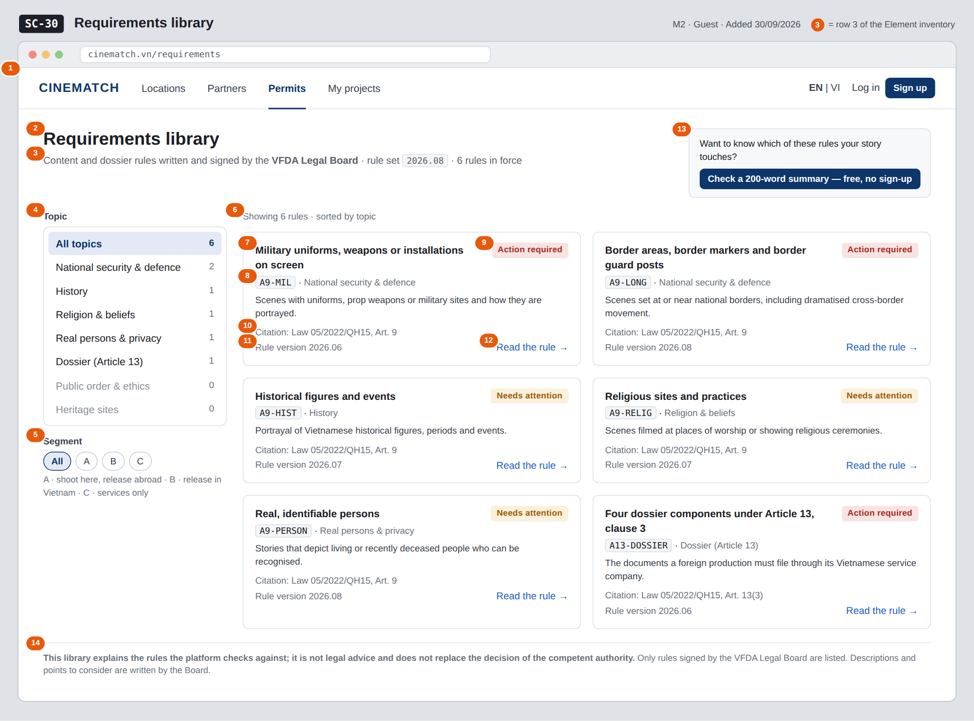
The image is the visual contract (layout, grouping, hierarchy); the tables below are the behavioural contract. All data in the mockup is sample data for one fictional project (The Last Ferry, Harbour Line Films); organisation names, people and phone numbers are examples, not real records.

3. Element inventory
# | Element | Type | Content / data source | Required | Validation
1 | Navigation bar | Header | static; Permits selected; guest view | — | —
2 | Title | Header | static | — | —
3 | Rule set line | Text | current rule_version and the number of rules in rules (approved rules only) | — | —
4 | Topic filter with counts | Toggle (single choice) | topic — security / history / religion / privacy / dossier / public_order / heritage, shown with readable labels; count of approved rules per topic | No | one of the 7 topic values or All topics; a topic with 0 rules stays visible, greyed, and shows the empty message when chosen
5 | Segment filter | Toggle (single choice) | segment — A / B / C | No | enum A / B / C or All
6 | Rule card list | List | rules (legal_rule_public[]) — approved, active rules only | — | draft and retired rules never listed
7 | Rule title | Text | title_en (or title_vi when the interface is in Vietnamese) | Yes | —
8 | Rule code and topic label | Text | rule_code, topic | Yes | —
9 | Severity label | Text | severity — notice → Needs attention, action → Action required | Yes | enum, 2 values
10 | Citation | Text | citation | Yes | never empty for a listed rule (M2 BR-002)
11 | Rule version | Text | rule_version in which this rule was last activated | Yes | —
12 | Read the rule link | Link | rule_slug | — | —
13 | Pre-check call to action | Button | static | — | —
14 | Disclaimer | Text | static | — | always shown

4. States
State | What the user sees | Trigger
Default | All approved rules as cards, sorted by topic; topic counts on the left. | Open /requirements
Empty (no data) | A topic or segment with no approved rule: No rules in force for this topic yet. The VFDA Legal Board adds rules as they are signed. and a link back to All topics. | Filter returns 0 rules
Loading | Grey skeletons sized like 4 rule cards; filters stay usable. | Loading the rules
Error | Couldn't load the requirements library — try again, with a Retry button; no stale or cached rules are shown as current. | Query failed
Success / confirmation | Not applicable — read-only screen; choosing a filter simply updates the list and the page URL. | —

5. Interactions and navigation
# | Element | User action | System response | Goes to screen
1 | Topic filter | tap | Filters the list by topic; the choice is kept in the page URL | stays
2 | Segment filter | tap | Filters the list by segment; the choice is kept in the page URL | stays
3 | Rule card / Read the rule | tap | Opens the rule page | SC-31
4 | Check a 200-word summary button | tap | Opens the content pre-check | SC-03

6. Screen-level rules
Rule ID | Rule | Source
SR-281 | Only approved rules in force are listed; drafts and retired rules are never public. | M2 FR-015 (F-M2-15)
SR-282 | Every listed rule shows its citation; a rule without a citation cannot be active and therefore cannot appear. | M2 BR-002
SR-283 | The words approved, accepted, legally compliant and safe are not used to describe a user's content on this screen. | M2 BR-003
SR-284 | Topics use the fixed topic list of the rule base (7 values) with readable labels, so the library and the admin rule base (SC-37) always group rules the same way. | M2 §5.1 FR-001, FR-002
SR-285 | The screen can be viewed without an account. | M2 US-5

7. Linked requirements
FR ID (from the module spec) | What this screen does for it
FR-015 · spec-M2.md (F-M2-15) | Public library of approved rules, filterable by topic and segment

8. Responsive and accessibility notes
- Minimum supported width: 360px.
- Narrow screens: the topic list becomes a horizontal chip row above the cards; cards stack in one column.
- Filters are real buttons with aria-pressed; the count is read with the label (e.g. History, 1 rule).
- Severity labels always include text, not only colour.

9. Open questions
# | Question | Blocking? | Status
1 | [NEEDS CLARIFICATION: F-M2-15 filters by segment, but a legal rule has no segment field (M2 §6). Who decides which rules apply to segments A, B and C, and where is it stored?] | No | Open
2 | [NEEDS CLARIFICATION: M2 §5.1 declares the public topic filter as VARCHAR(60) while the rule base uses the 7-value topic enum; confirm the library uses the same enum] | No | Open

Completion checklist
- ☒ The mockup is a separate cropped image file, named with the Screen ID (img/SC-30.png).
- ☒ Every visible element in the mockup appears in the element inventory — machine-checked: badge numbers on the image = row numbers in section 3.
- ☒ Every input element has a validation rule or an explicit "—".
- ☒ All five states are filled in, or marked "Not applicable" with a reason.
- ☒ Every navigation target is a Screen ID that exists in docs/screen-list.md — machine-checked.
- ☒ Every element that displays data names the field it displays, matching docs/spec/spec-M2.md section 5.1.
- ☐ Checked by a person: (not signed — a Group C member compares the image with the tables and signs here)

DBIZ3 Session 4 · Group C · CINEMATCH. Built on the DBIZ2 Screen Design (Screen List and Screen Layout).

