Screen Spec: SC-32 Provincial People's Committee notice
DBIZ3 Session 4 template — one file per screen. The Screen ID is kept from the DBIZ2 Screen List. The mockup image stays an image; everything around it is text. Each orange numbered badge on the mockup is the row with the same number in section 3 (Element inventory).
Field | Value
Screen ID | SC-32
Screen name | Provincial People's Committee notice
Actor | Member
Priority | Should
Belongs to module | docs/spec/spec-M7.md
Mockup image | img/SC-32.png
Status | Draft
Route: /projects/[id]/provinces · Screen list file: Tier 2, item #20 (Tier 2 — Should) · Design note from the screen list file: Source M7·1.
Notes against Screen List v2.0
- Screen List v2.0 puts SC-32 at Must; the function list places it in Tier 2 — Should. This spec follows the function list.

1. Purpose
Shown when: Member clicks I'm interested in this location on SC-16, Provinces in the sidebar, or a province replied notification.
The user leaves this screen when: Member adds a province, asks VFDA to send a notice, or opens the next step from a province's reply.

2. Mockup
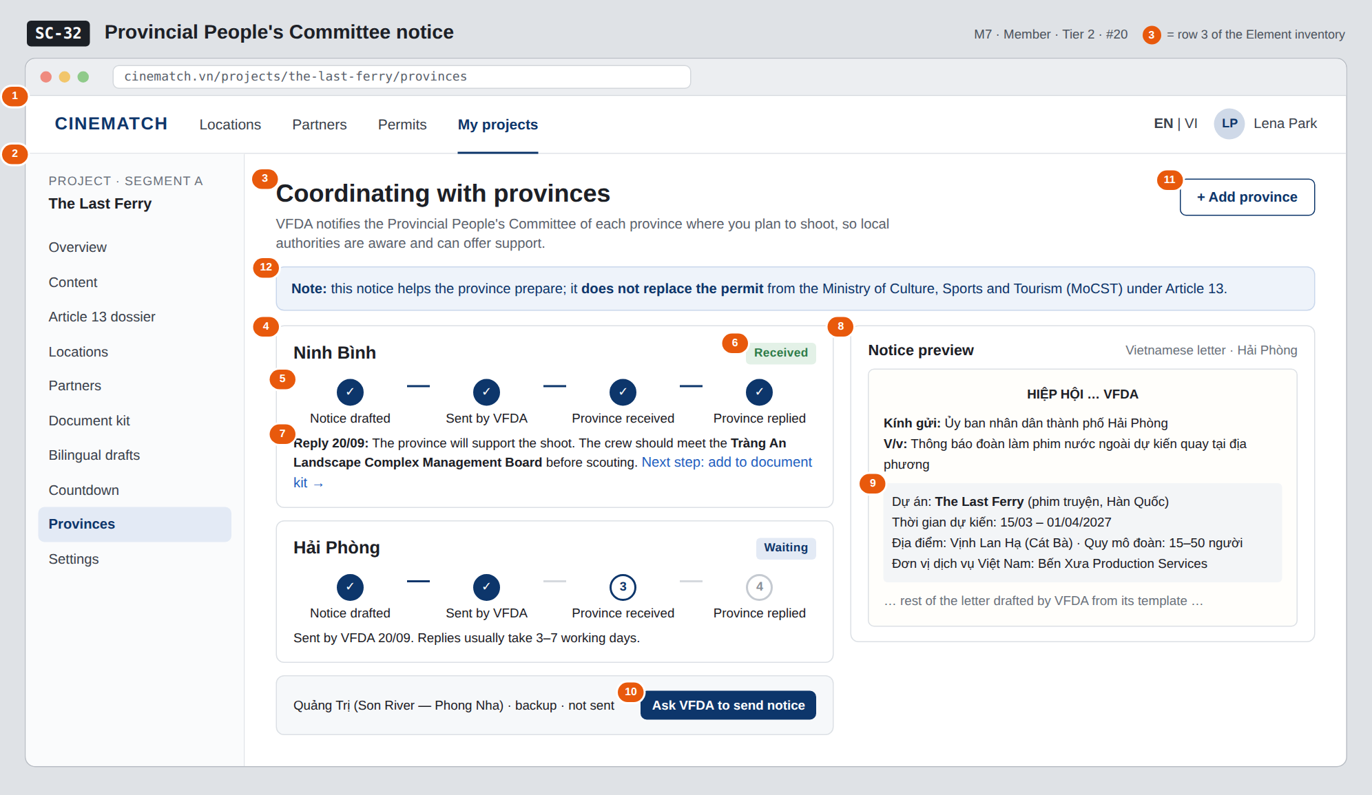
The image is the visual contract (layout, grouping, hierarchy); the tables below are the behavioural contract. All data in the mockup is sample data for one fictional project (The Last Ferry, Harbour Line Films); organisation names, people and phone numbers are examples, not real records.

3. Element inventory
# | Element | Type | Content / data source | Required | Validation
1 | Navigation bar | Header | static | — | —
2 | Project sidebar | List | static; Provinces selected | — | —
3 | Title + purpose | Header + Text | static | — | —
4 | Province card | Container | province_notices for the project | — | one card per province
5 | 4-step progress | Chart (stepper) | drafted_at, sent_at, received_at, responded_at | Yes | exactly 4 steps
6 | Reply status | Text | province_notices.response — Received / More info needed / Cannot support at this time / Waiting | Yes | enum; always has text
7 | Reply content + next step | Text | province_notices.response_note entered by VFDA from the province's official letter | — | —
8 | Notice letter preview | Container | notice_templates template drafted by VFDA | — | read-only for members
9 | Project details included in the notice | Text | projects.*, confirmed locations, confirmed partners | Yes | must include: project, dates, location, crew size, Vietnamese company
10 | Ask VFDA to send notice button | Button | creates province_notices with status requested | — | requires shooting dates and a location in the province
11 | + Add province button | Button | static | — | —
12 | Does not replace the permit note | Text | static | Yes | always shown

4. States
State | What the user sees | Trigger
Default | One card per province with 4-step progress and reply; letter preview on the right. | Project has at least one notice
Empty (no data) | No notices yet: No province has been notified yet. Click "I'm interested in this location" on a location, or Add province. + Add province button. | 0 notices
Loading | Grey skeleton for province cards. | Loading
Error | Required information missing (e.g. no shooting date): send button disabled with the reason A first shooting day is needed before notifying. Send error: Couldn't send the request to VFDA — try again. | Missing data / write error
Success / confirmation | Request sent → new province card at step 1 with VFDA will send the notice within 2 working days. Province replies → in-app notification and email. | Request created / reply received

5. Interactions and navigation
# | Element | User action | System response | Goes to screen
1 | + Add province button | tap | Choose from the 34 provinces and cities; suggestions from confirmed locations | stays
2 | Ask VFDA to send notice button | tap | Creates a request for VFDA (F-M7-02) | stays
3 | Next step: add to document kit | tap | — | SC-26
4 | Province card | tap | Switch the preview to that province | stays

6. Screen-level rules
Rule ID | Rule | Source
SR-201 | Notices are sent by VFDA, not directly by the production — VFDA is the point of contact with provinces. | TL3 — VFDA's role
SR-202 | Always show the note: the notice does not replace the permit from MoCST. | Honesty principle
SR-203 | The province's reply is one of three final statuses (Received / More info needed / Cannot support at this time — enum received, info_needed, cannot_support), entered by VFDA from the actual official letter. | F-M7-03
SR-204 | Response time is recorded and used for the provincial readiness index on SC-18. | F-M3-19
SR-205 | The preview uses real project data; if a required field is missing, sending is blocked. | Data integrity

7. Linked requirements
FR ID (from the module spec) | What this screen does for it
FR-001 · spec-M7.md (F-M7-01) | Mark interest in a location
FR-002 · spec-M7.md (F-M7-02) | Generate and send notice
FR-003 · spec-M7.md (F-M7-03) | Province replies with three statuses
FR-004 · spec-M7.md (F-M7-04) | Status tracking page

8. Responsive and accessibility notes
- Minimum supported width: 360px.
- Narrow screens: the preview collapses into a View notice button; the 4-step progress becomes a vertical list.
- Progress is an <ol> with aria-current="step".
- Reply status has text, not colour alone.

9. Open questions
# | Question | Blocking? | Status
1 | [NEEDS CLARIFICATION: does VFDA have the authority / established practice to send notices to Provincial People's Committees, and what is the official letter template] | Yes | Open
2 | [NEEDS CLARIFICATION: should the notice go to the Provincial People's Committee or the provincial Department of Culture] | Yes | Open

Completion checklist
- ☒ The mockup is a separate cropped image file, named with the Screen ID (img/SC-32.png).
- ☒ Every visible element in the mockup appears in the element inventory — machine-checked: badge numbers on the image = row numbers in section 3.
- ☒ Every input element has a validation rule or an explicit "—".
- ☒ All five states are filled in, or marked "Not applicable" with a reason.
- ☒ Every navigation target is a Screen ID that exists in docs/screen-list.md — machine-checked.
- ☒ Every element that displays data names the field it displays, matching docs/spec/spec-M7.md section 5.1.
- ☐ Checked by a person: (not signed — a Group C member compares the image with the tables and signs here)

DBIZ3 Session 4 · Group C · CINEMATCH. Built on the DBIZ2 Screen Design (Screen List and Screen Layout).

