Screen Spec: SC-35 Admin — Locations
DBIZ3 Session 4 template — one file per screen. The Screen ID is kept from the DBIZ2 Screen List. The mockup image stays an image; everything around it is text. Each orange numbered badge on the mockup is the row with the same number in section 3 (Element inventory).
Field | Value
Screen ID | SC-35
Screen name | Admin — Locations
Actor | VFDA Staff
Priority | Must
Belongs to module | docs/spec/spec-M3.md
Mockup image | img/SC-35.png
Status | Draft
Route: /admin/locations · Screen list file: M3, item #31 (Added 30/09/2026 — Must) · Design note from the screen list file: Add, edit, verify, publish.
Notes against Screen List v2.0
- Screen Spec added 30/09/2026. SC-35 is a Must screen that had no mockup (Screen List: Must screens still without a mockup). Location search (SC-14) has nothing to show without it.

1. Purpose
Shown when: VFDA staff sign in and choose Locations in the admin menu (from SC-34 or any admin screen).
The user leaves this screen when: Staff move to another admin screen through the menu (for example SC-34), open the public page of a published location (SC-16), or open the audit log (SC-41).

2. Mockup
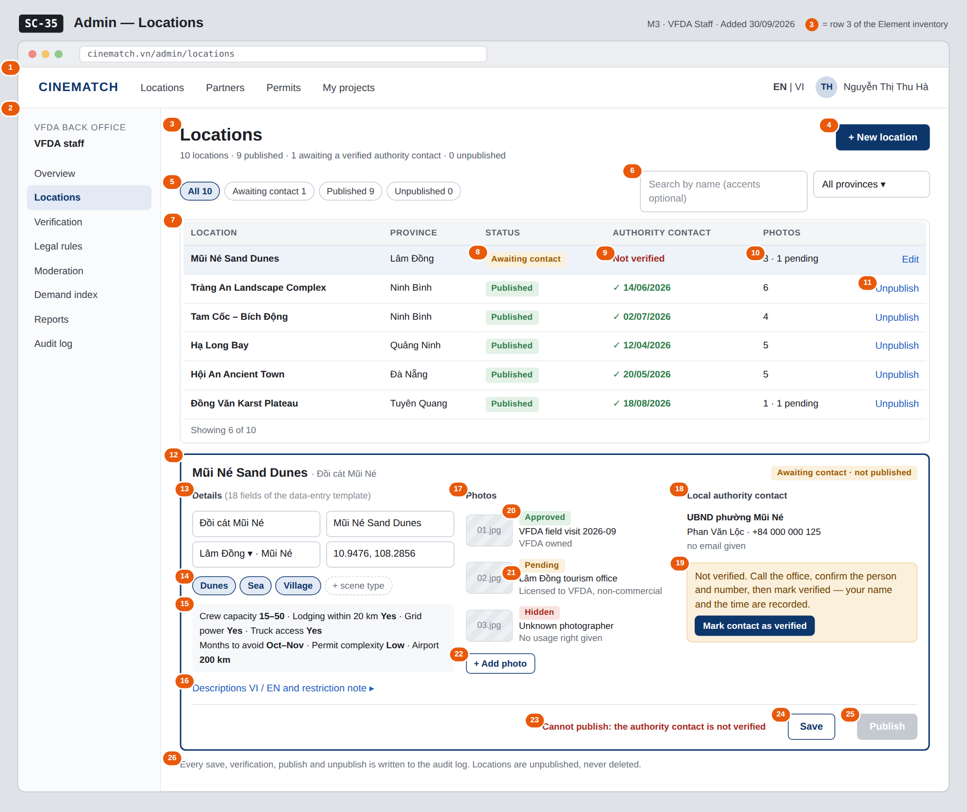
The image is the visual contract (layout, grouping, hierarchy); the tables below are the behavioural contract. All data in the mockup is sample data for one fictional project (The Last Ferry, Harbour Line Films); organisation names, people and phone numbers are examples, not real records.

3. Element inventory
# | Element | Type | Content / data source | Required | Validation
1 | Navigation bar | Header | static; signed in as VFDA staff | — | —
2 | Admin menu | List | static; Locations selected | — | items shown according to the user's role
3 | Title + counts by status | Header | counts of locations by intake_status | — | —
4 | + New location button | Button | static | — | opens an empty editor; a new location starts as awaiting_contact
5 | Status filter | Toggle (single choice) | intake_status — awaiting_contact / published / unpublished | No | enum or All
6 | Search and province filter | Input + Toggle (dropdown) | filter — name (with or without Vietnamese diacritics), province_id from the 34-province list | No | search max 200 characters
7 | Location table | List | locations (location_admin[]) including unpublished ones | — | visible to the vfda_staff role only (Row Level Security)
8 | Location status | Text | intake_status — Awaiting contact / Published / Unpublished | — | enum
9 | Authority contact verification | Text | contact_verified, verified_at | — | Not verified when contact_verified = false
10 | Photo count | Text | count of photos; number with image_status = pending | — | —
11 | Row action Edit / Unpublish / Publish | Link | published → Unpublish; awaiting_contact → Edit; unpublished → Publish again | — | Unpublish needs a confirmation dialog
12 | Location editor | Container | the selected location | — | —
13 | Names, province, district, coordinates | Input (several fields) | name_vi, name_en, province_id, district, lat, lng | Yes | names max 200 characters; province from the 34-province list; lat / lng inside Vietnam; district optional
14 | Scene types | Toggle (multiple choice) | scene_types — karst / river / village / rice_field / sea / floating_village / cave / jungle / old_town / market / rice_terrace / mountain / dunes / mangrove | Yes | at least 1; only enum values
15 | Logistics, season and permit complexity | Input (several fields) | crew_capacity, lodging_20km, grid_power, truck_access, months_to_avoid, permit_complexity, airport_km | Yes | crew_capacity u15 / 15_50 / o50; months 1–12; permit_complexity low / medium / high; months_to_avoid and airport_km optional
16 | Descriptions and restriction note | Input (multi-line) | desc_vi, desc_en, restriction_note | Yes | both descriptions required; restriction note optional
17 | Photos section | Container | location photos | — | —
18 | Local authority contact section | Input (several fields) | authority_name, contact_name, contact_phone, contact_email | Yes | office max 200, name max 120, phone max 20 characters; email optional, valid format
19 | Verification status + Mark contact as verified | Button | sets contact_verified = true, verified_by = current staff member, verified_at = now | — | confirmation dialog; any edit of the contact resets it to Not verified
20 | Photo status | Text | image_status — pending / approved / hidden | — | only approved photos are shown publicly
21 | Photo source and usage right | Text | image_source, usage_right | Yes | both required when a photo is added
22 | + Add photo button | Input (file) | image_file → image_url | — | jpg / png, max 10 MB; source and usage right asked before upload
23 | Publish blocked reason | Text | blocked_reason | — | shown whenever Publish is disabled
24 | Save button | Button | static | — | enabled when a field changed; required fields valid
25 | Publish button | Button | sets published / intake_status = published | — | disabled while contact_verified = false (database CHECK)
26 | Audit note | Text | static | — | always shown

4. States
State | What the user sees | Trigger
Default | Location table (all statuses) and the selected location in the editor below. The mockup shows a location awaiting a verified contact. | Open /admin/locations
Empty (no data) | No locations yet: No locations yet — add the first one with + New location. A filter with no match (e.g. Unpublished 0): No locations with this status. | 0 locations / filter returns 0
Loading | Grey skeleton rows in the table; photo uploads show a progress bar on their own row. | Loading / uploading
Error | Publish refused by the database: red strip with blocked_reason Authority contact not verified. Photo too large or wrong type: message at + Add photo stating the limit. Save fails: Couldn't save — your changes are kept. | CHECK constraint / file check / write error
Success / confirmation | Published: status Published, strip Mũi Né Sand Dunes is now visible in location search. Unpublished: status Unpublished, strip Removed from search — shortlists that include it now show No longer published. Verified: contact shows ✓ verified by Nguyễn Thị Thu Hà, 30/09/2026. | Publish / unpublish / verify succeeded

5. Interactions and navigation
# | Element | User action | System response | Goes to screen
1 | Admin menu item | tap | Opens that admin screen | SC-34
2 | Status filter / search / province | tap / type | Filters the table | stays
3 | Location row / Edit | tap | Loads the location into the editor | stays
4 | + New location button | tap | Empty editor; status awaiting_contact | stays
5 | Mark contact as verified | tap | Confirmation; records who verified and when; writes an audit record | stays
6 | + Add photo | tap | Asks for source and usage right, uploads, photo status pending | stays
7 | Save button | tap | Saves the location; writes an audit record | stays
8 | Publish button | tap | Publishes when the contact is verified; the database refuses otherwise; writes an audit record | stays
9 | Unpublish link | tap | Confirmation dialog; sets intake_status = unpublished; writes an audit record | stays
10 | Name of a published location | tap | Opens the public location page in a new tab | SC-16
11 | Audit note | tap | Opens the audit log filtered to locations (admin role) | SC-41

6. Screen-level rules
Rule ID | Rule | Source
SR-311 | A location cannot be published until its local authority contact is verified; enforced by a database CHECK constraint, and the reason is shown next to the disabled button. | M3 BR-004, M3 FR-005 (F-M3-05)
SR-312 | Locations are unpublished, never deleted (intake_status = unpublished); shortlists and provincial notices that refer to them keep them and show No longer published. There is no Delete action. | M3 BR-008
SR-313 | Every photo has a source and a usage right; photos are shown publicly only when their image_status is approved. | M3 FR-003 (F-M3-03)
SR-314 | The verification records who verified the contact and when; changing the contact clears the verification. | M3 FR-004 (F-M3-04)
SR-315 | Provinces use the 34 provincial-level units after the 2025 reorganisation. | M3 BR-006
SR-316 | Every save, verification, publish and unpublish writes one audit record in the same transaction. | M10 BR-005 (F-M10-08)

7. Linked requirements
FR ID (from the module spec) | What this screen does for it
FR-001 · spec-M3.md (F-M3-01) | List all locations including unpublished ones
FR-002 · spec-M3.md (F-M3-02) | Create and edit a location with the 18 template fields
FR-003 · spec-M3.md (F-M3-03) | Store photos with source, usage right and status
FR-004 · spec-M3.md (F-M3-04) | Record and verify the local authority contact
FR-005 · spec-M3.md (F-M3-05) | Publish blocked while the contact is not verified
FR-008 · spec-M10.md (F-M10-08) | Audit record for every admin action on a location

8. Responsive and accessibility notes
- Minimum supported width: 360px (admin work is expected on desktop; below 1024px the editor opens full screen over the table).
- The admin menu collapses into a menu button on narrow screens; the three editor sections stack.
- The disabled Publish button is linked to its reason with aria-describedby, so screen readers announce why.
- Status and photo labels always include text, not only colour; photos need a text alternative before publishing.

9. Open questions
# | Question | Blocking? | Status
1 | [NEEDS CLARIFICATION: Re-verification cycle for authority contacts (proposed 12 months).] | No | Open
2 | [NEEDS CLARIFICATION: who changes a photo's image_status from pending to approved when VFDA staff upload it themselves, and must a location have at least one approved photo before it can be published?] | No | Open

Completion checklist
- ☒ The mockup is a separate cropped image file, named with the Screen ID (img/SC-35.png).
- ☒ Every visible element in the mockup appears in the element inventory — machine-checked: badge numbers on the image = row numbers in section 3.
- ☒ Every input element has a validation rule or an explicit "—".
- ☒ All five states are filled in, or marked "Not applicable" with a reason.
- ☒ Every navigation target is a Screen ID that exists in docs/screen-list.md — machine-checked.
- ☒ Every element that displays data names the field it displays, matching docs/spec/spec-M3.md section 5.1.
- ☐ Checked by a person: (not signed — a Group C member compares the image with the tables and signs here)

DBIZ3 Session 4 · Group C · CINEMATCH. Built on the DBIZ2 Screen Design (Screen List and Screen Layout).

