Screen Spec: SC-39 Admin — Demand index
DBIZ3 Session 4 template — one file per screen. The Screen ID is kept from the DBIZ2 Screen List. The mockup image stays an image; everything around it is text. Each orange numbered badge on the mockup is the row with the same number in section 3 (Element inventory).
Field | Value
Screen ID | SC-39
Screen name | Admin — Demand index
Actor | VFDA Staff
Priority | Should
Belongs to module | docs/spec/spec-M10.md
Mockup image | img/SC-39.png
Status | Draft
Route: /admin/demand · Screen list file: M10, item #39 (Added 30/09/2026 — Should) · Design note from the screen list file: Six indicators and charts
Notes against Screen List v2.0
- New Screen Spec (30/09/2026). Written with the M10 Spec Document. Indicators 4 and 6 are shown as no data source yet until open question 1 of the M10 Spec Document is decided.

1. Purpose
Shown when: Staff click the Demand index summary on SC-34, the menu item, or Open in demand index on SC-40.
The user leaves this screen when: Staff click Prepare quarterly report (to SC-40) or leave through the admin menu.

2. Mockup
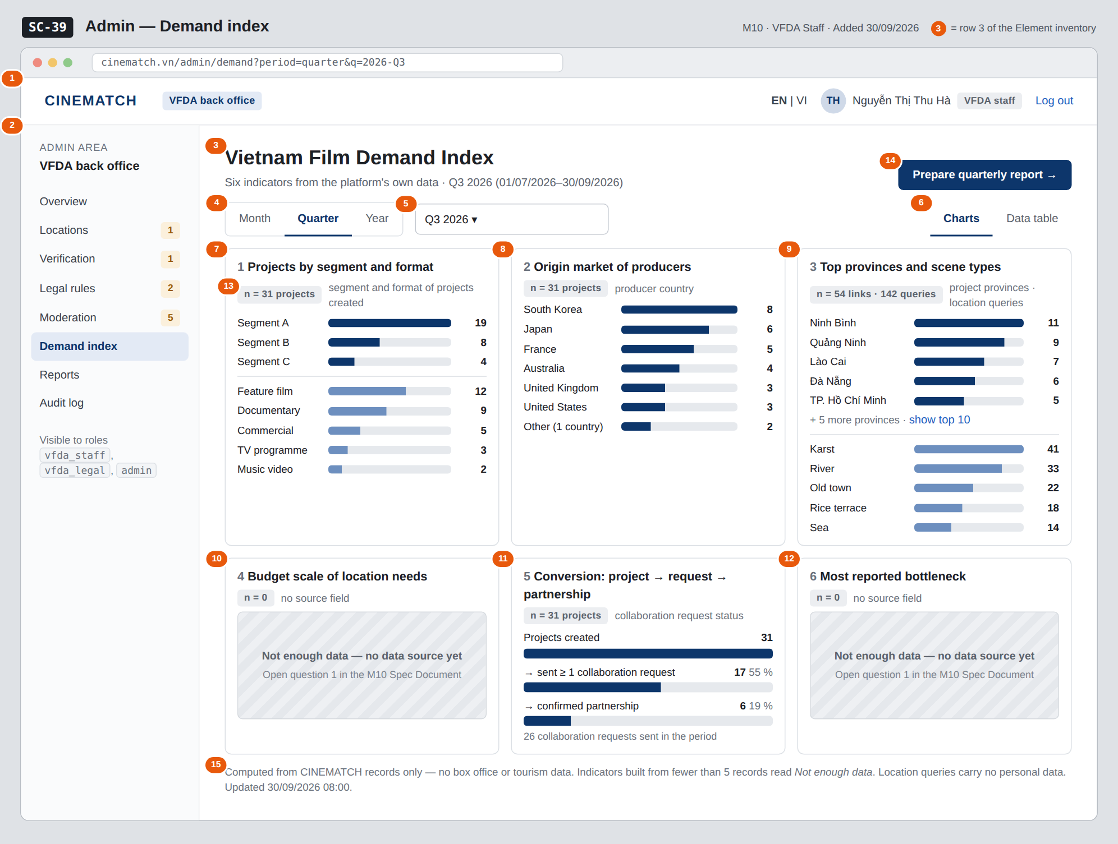
The image is the visual contract (layout, grouping, hierarchy); the tables below are the behavioural contract. All data in the mockup is sample data for one fictional project (The Last Ferry, Harbour Line Films); organisation names, people and phone numbers are examples, not real records.

3. Element inventory
# | Element | Type | Content / data source | Required | Validation
1 | Admin top bar | Header | static; signed-in user and role | — | —
2 | Admin menu | List | static; Demand index selected | — | —
3 | Title and period | Header | period_start, period_end of the selected period | Yes | —
4 | Period granularity | Toggle | period — Month / Quarter / Year | Yes | enum month, quarter, year
5 | Period picker | Toggle (dropdown) | period_start, period_end derived from the choice (e.g. Q3 2026 = 01/07/2026–30/09/2026) | Yes | period_start ≤ period_end; not after the current period
6 | Charts / Data table switch | Toggle | dashboard_view — same figures as charts or as a table (indicator, value, sample size, source) | — | —
7 | Indicator 1 — projects by segment and format | Chart | demand_index from projects.segment, projects.format created in the period | Yes | counts; Not enough data below 5 records
8 | Indicator 2 — origin market | Chart | demand_index from producer_organisation.country (ISO code shown as country name) | Yes | same rule
9 | Indicator 3 — top 10 provinces and scene types | Chart | demand_index from project_province.province_id (34-province list) and location_query.attributes.scene_types (readable labels) | Yes | same rule
10 | Indicator 4 — budget scale | Text | no source field yet | Yes | always Not enough data — no data source yet until a field exists
11 | Indicator 5 — conversion | Chart | demand_index from projects → collab_request sent → collab_request.status = confirmed | Yes | percentages only when the base has ≥ 5 records
12 | Indicator 6 — most reported bottleneck | Text | no source field yet | Yes | same as row 10
13 | Sample size label | Text | number of records each indicator was computed from | Yes | shown on every indicator (M10 BR-003)
14 | Prepare quarterly report button | Button | static | — | shown when the Quarter view is selected; disabled when the period has no data
15 | Data-source note | Text | static; time of the last aggregation | — | —

4. States
State | What the user sees | Trigger
Default | Q3 2026 selected, six indicator cards in charts view, each with its sample size; indicators 4 and 6 read Not enough data — no data source yet. | Screen opens (current quarter)
Empty (no data) | A period with no records: every indicator reads Not enough data, sample sizes read n = 0, and Prepare quarterly report is disabled with No figures for this period. | Period without data
Loading | Skeleton cards with the text Computing indicators for September 2026…; the period controls stay usable. | Period changed / screen opens
Error | The indicators could not be computed — try again. No partial figures are shown. | Aggregation query fails
Success / confirmation | Not applicable — the screen only reads; changing the period recomputes every indicator for that period (e.g. September 2026: indicators with fewer than 5 records switch to Not enough data). | —

5. Interactions and navigation
# | Element | User action | System response | Goes to screen
1 | Month / Quarter / Year | tap | Changes the granularity; the picker offers matching periods | stays
2 | Period picker | choose | Recomputes all six indicators for the chosen period | stays
3 | Charts / Data table | tap | Switches the view; figures stay the same | stays
4 | show top 10 link in indicator 3 | tap | Expands the list to ten provinces | stays
5 | Prepare quarterly report | tap | Opens the report for the selected quarter | SC-40
6 | Admin menu | tap an item | Opens that admin screen | SC-34 / SC-35 / SC-36 / SC-37 / SC-38 / SC-39 / SC-40 / SC-41

6. Screen-level rules
Rule ID | Rule | Source
SR-391 | Every indicator shows the number of records it was computed from; below 5 records it shows Not enough data instead of a value. | M10 BR-003
SR-392 | Indicators are built from the platform's own data only; no external source. | F-M10-03; Spec M10 §1 Out of scope
SR-393 | The screen is visible to the roles vfda_staff and admin only. | M10 FR-004
SR-394 | Indicators 4 and 6 are never estimated: until a source field exists they read Not enough data — no data source yet. | Spec M10 §10 question 1
SR-395 | A brief counts as a project with its location queries; location queries carry no personal data. | Spec M10 §9; M3 BR-009

7. Linked requirements
FR ID (from the module spec) | What this screen does for it
FR-003 · spec-M10.md (F-M10-03) | Six indicators aggregated for the period
FR-004 · spec-M10.md (F-M10-04) | Charts and data table
FR-005 · spec-M10.md (F-M10-05) | Month / quarter / year filter

8. Responsive and accessibility notes
- Minimum supported width: 360px.
- Narrow screens: indicator cards stack one per row; indicator 3 shows provinces and scene types one under the other.
- Every chart has the Data table view as its text alternative; bar values are printed as numbers.
- Sample-size labels are read out with each indicator title.

9. Open questions
# | Question | Blocking? | Status
1 | [NEEDS CLARIFICATION: Indicator 4 (budget scale of location needs) and indicator 6 (bottleneck most reported) need fields that no function collects today. Add a budget band and a main obstacle question to project creation, or drop the two indicators?] | Yes | Open
2 | [NEEDS CLARIFICATION: Is indicator 2 (origin market) counted per project or per producer organisation — a company with three projects in the quarter counts once or three times?] | No | Open

Completion checklist
- ☒ The mockup is a separate cropped image file, named with the Screen ID (img/SC-39.png).
- ☒ Every visible element in the mockup appears in the element inventory — machine-checked: badge numbers on the image = row numbers in section 3.
- ☒ Every input element has a validation rule or an explicit "—".
- ☒ All five states are filled in, or marked "Not applicable" with a reason.
- ☒ Every navigation target is a Screen ID that exists in docs/screen-list.md — machine-checked.
- ☒ Every element that displays data names the field it displays, matching docs/spec/spec-M10.md section 5.1.
- ☐ Checked by a person: (not signed — a Group C member compares the image with the tables and signs here)

DBIZ3 Session 4 · Group C · CINEMATCH. Built on the DBIZ2 Screen Design (Screen List and Screen Layout).

