Logical Data Model — CINEMATCH
43 tables, 285 columns. Every column is copied from a FIELDS row (section 5.1) or an ENTITIES attribute (section 6), with its declared type and Req / Opt flag. system-set = an output field (the system fills it); not declared = no flag in the input.
70 columns carry no declared type. They are written type not declared and raised as OQ-04-18 — no type was assigned here. Technical columns (created_at, updated_at) appear only where the spec declares them.
Tables are grouped by owning module, in the order SYS → M1 → M0 → M2 → M3 → M4 → M5 → M7.

USER_ACCOUNT
A person's sign-in identity on CINEMATCH, carrying exactly one of six roles. Owner: SYS. THING.
Column | Type (as declared) | Required | Key | Citation
user_id | UUID | system-set | PK | SYS §5.1 FR-001 (OUT)
email | VARCHAR(254) | Req | UK | SYS §5.1 FR-001; SYS §3 US-1 (one account per email)
email_verified | BOOLEAN | system-set |  | SYS §5.1 FR-001 (OUT)
role | ENUM(guest, member, partner, vfda_staff, vfda_legal, admin) | Req |  | SYS §5.1 FR-004; SYS §5.2 BR-002 (new account = member)
created_at | type not declared | not declared |  | SYS §6
Natural key: email — one account per email (SYS §3 US-1, third criterion).

PROFILE
The personal details shown for an account: name, crew role and preferred language. Owner: SYS. THING.
Column | Type (as declared) | Required | Key | Citation
user_id | UUID | Req | PK, FK → USER_ACCOUNT | SYS §6 ("belongs to UserAccount")
full_name | VARCHAR(120) | Req |  | SYS §5.1 FR-001
crew_role | ENUM(producer, director, production_coordinator, line_producer, other) | Req |  | SYS §5.1 FR-001
locale | ENUM(vi, en) | Req |  | SYS §5.1 FR-005 (also said to live in a cookie — see Type conflicts)
producer_org_id | type not declared | not declared | FK → PRODUCER_ORGANISATION | SYS §6
Natural key: user_id — one profile per account (SYS §6).

PRODUCER_ORGANISATION
The production company a producer signs up on behalf of. Owner: SYS. THING.
Column | Type (as declared) | Required | Key | Citation
producer_org_id | type not declared | not declared | PK | SYS §6 (Profile.producer_org_id)
org_name | VARCHAR(200) | Req |  | SYS §5.1 FR-001
country | CHAR(2) | Req |  | SYS §5.1 FR-001
website | VARCHAR(300) | Opt |  | SYS §5.1 FR-001
Natural key: org_name + country — proposed; not stated in the spec (open question).

CONSENT
A record that an account accepted a given version of the terms at a given time. Owner: SYS. EVENT.
Column | Type (as declared) | Required | Key | Citation
user_id | UUID | Req | PK, FK → USER_ACCOUNT | SYS §6
consent_version | VARCHAR(20) | Req | PK | SYS §5.1 FR-001; SYS §5.2 BR-003
accepted_at | type not declared | not declared |  | SYS §6; SYS §5.2 BR-003 (timestamp)
Natural key: user_id + consent_version.

NOTIFICATION
An in-app message addressed to one account about one event. Owner: SYS. EVENT.
Column | Type (as declared) | Required | Key | Citation
notification_id | UUID | system-set | PK | SYS §5.1 FR-007 (OUT)
recipient_id | UUID | Req | FK → USER_ACCOUNT | SYS §5.1 FR-007
event_type | VARCHAR(60) | Req |  | SYS §5.1 FR-007
payload | JSONB | Req |  | SYS §5.1 FR-007
created_at | TIMESTAMPTZ | system-set |  | SYS §5.1 FR-007 (OUT)
read_at | type not declared | not declared |  | SYS §6; SYS §5.1 FR-009 (mark as read)
Natural key: None in the real world (an event); recipient_id + event_type + created_at identifies it in practice.

EMAIL_DELIVERY
One transactional email handed to the email provider, with its delivery outcome. Owner: SYS. EVENT.
Column | Type (as declared) | Required | Key | Citation
email_delivery_id | type not declared | not declared | PK | none — no identifier declared (open question)
notification_id | UUID | Opt | FK → NOTIFICATION | SYS §6 ("may relate to a Notification")
template_id | VARCHAR(60) | Req |  | SYS §5.1 FR-008
recipient_email | VARCHAR(254) | Req |  | SYS §5.1 FR-008
variables | JSONB | Req |  | SYS §5.1 FR-008
delivery_status | ENUM(queued, sent, bounced) | system-set |  | SYS §5.1 FR-008 (OUT)
provider_message_id | TEXT | system-set | UK | SYS §5.1 FR-008 (OUT)
Natural key: provider_message_id once sent; none while queued (open question).

SEGMENT_RULE
One row of the VFDA-approved decision table that maps router answers to segment A, B or C. Owner: M1. THING.
Column | Type (as declared) | Required | Key | Citation
segment_rule_id | type not declared | not declared | PK | M1 §6 (rule_id — renamed, see 01 conflicts)
q1_shoot_in_vn | BOOLEAN | Req |  | M1 §6 (q1) = M1 §5.1 FR-002 q1_shoot_in_vn
q2_release | ENUM(abroad, vietnam, both) | Opt |  | M1 §6 (q2) = M1 §5.1 FR-002
q3_producer | ENUM(foreign, vietnamese, coproduction) | Opt |  | M1 §6 (q3) = M1 §5.1 FR-002
result_segment | ENUM(A, B, C) | not declared |  | M1 §6; type of segment from M1 §5.1 FR-002
version | type not declared | not declared |  | M1 §6
Natural key: q1_shoot_in_vn + q2_release + q3_producer + version — the same answers always give the same segment (M1 BR-001).

SEGMENT_REQUIREMENT
One item a segment needs or does not need, used to configure the journey and the gauges. Owner: M1. THING.
Column | Type (as declared) | Required | Key | Citation
segment | ENUM(A, B, C) | not declared | PK | M1 §6; type from M1 §5.1 FR-002
requirement_code | type not declared | not declared | PK | M1 §6
label_vi | type not declared | not declared |  | M1 §6
label_en | type not declared | not declared |  | M1 §6
needed | type not declared | not declared |  | M1 §6; M1 §3 US-1 (Needed / Not needed)
Natural key: segment + requirement_code.

SEGMENT_DECISION
The segment given to a visitor or project from their answers, including any manual override. Owner: M1. EVENT.
Column | Type (as declared) | Required | Key | Citation
segment_decision_id | type not declared | not declared | PK | none — no identifier declared (open question)
session_or_project_id | type not declared | not declared | FK → PROJECT | M1 §6 (one column for two meanings — see Structural findings)
segment_rule_id | type not declared | not declared | FK → SEGMENT_RULE | M1 §6 ("used by SegmentDecision")
q1_shoot_in_vn | BOOLEAN | Req |  | M1 §5.1 FR-002 (answers)
q2_release | ENUM(abroad, vietnam, both) | Opt |  | M1 §5.1 FR-002 (Req when q1 = true)
q3_producer | ENUM(foreign, vietnamese, coproduction) | Opt |  | M1 §5.1 FR-002 (Req when q1 = true)
q4_needs | ARRAY<ENUM(locations, crew, cast, equipment, logistics)> | Opt |  | M1 §5.1 FR-002; M1 §5.2 BR-002
segment | ENUM(A, B, C) | system-set |  | M1 §5.1 FR-002 (OUT)
segment_override | ENUM(A, B, C) | Opt |  | M1 §5.1 FR-002; M1 §5.2 BR-003 — see Type conflicts
decided_by | ARRAY<INTEGER> | system-set |  | M1 §5.1 FR-002 (OUT)
journey_config | JSONB | system-set |  | M1 §5.1 FR-002 (OUT)
Natural key: None — the same answers may be given many times; a session key is not declared (open question).

PROJECT
A film or content production a producer is preparing to shoot in Vietnam. Owner: M0. THING.
Column | Type (as declared) | Required | Key | Citation
project_id | UUID | system-set | PK | M0 §5.1 FR-001 (OUT)
producer_org_id | type not declared | not declared | FK → PRODUCER_ORGANISATION | M0 §6 ("belongs to ProducerOrganisation")
project_name | VARCHAR(200) | Req |  | M0 §5.1 FR-001
format | ENUM(feature, documentary, commercial, tv, music_video) | Req |  | M0 §5.1 FR-001
segment | ENUM(A, B, C) | Req |  | M0 §5.1 FR-001; M1 §5.1 FR-003
shoot_date | DATE | Opt |  | M0 §5.1 FR-001 (Opt), FR-002 (after today); M5 §5.1 FR-007 (Req) — see Type conflicts
buffer_days | INTEGER | Req |  | M5 §5.1 FR-007 (0 / 7 / 14 / 21); M2 §5.1 FR-017 (default 7)
shoot_days_vn | INTEGER | Opt |  | M0 §5.1 FR-001
crew_size_band | ENUM(u15, 15_50, o50) | Opt |  | M0 §5.1 FR-001
logline | VARCHAR(500) | Opt |  | M0 §5.1 FR-001
stage | type not declared | not declared |  | M0 §6
updated_at | TIMESTAMPTZ | system-set |  | M0 §5.1 FR-002 (OUT)
Natural key: producer_org_id + project_name — proposed (open question).

PROJECT_MEMBER
A person's access to one project, with view or edit permission. Owner: M0. THING.
Column | Type (as declared) | Required | Key | Citation
member_id | UUID | system-set | PK | M0 §5.1 FR-004 (OUT)
project_id | UUID | Req | FK → PROJECT | M0 §5.1 FR-004
user_id | type not declared | not declared | FK → USER_ACCOUNT | M0 §6 (user_id)
invitee_email | VARCHAR(254) | Req |  | M0 §5.1 FR-004
permission | ENUM(view, edit) | Req |  | M0 §5.1 FR-004 (owner not in the set — see Structural findings)
invite_status | ENUM(pending, accepted) | system-set |  | M0 §5.1 FR-004 (OUT)
Natural key: project_id + invitee_email (the invited address); project_id + user_id once accepted.

PROJECT_PROVINCE
A province a project plans to shoot in. Owner: M0. THING.
Column | Type (as declared) | Required | Key | Citation
project_id | UUID | Req | PK, FK → PROJECT | M0 §6
province_id | INTEGER | Opt | PK, FK → PROVINCE | M0 §5.1 FR-001 (provinces ARRAY Opt)
Natural key: project_id + province_id.

READINESS_SNAPSHOT
The overall readiness of a project as recorded on one night. Owner: M0. EVENT.
Column | Type (as declared) | Required | Key | Citation
snapshot_id | UUID | system-set | PK | M0 §5.1 FR-008 (OUT)
project_id | UUID | Req | FK → PROJECT | M0 §5.1 FR-008
snapshot_date | DATE | Req |  | M0 §5.1 FR-008
readiness_total | NUMERIC(5,2) | system-set |  | M0 §6; M0 §5.1 FR-009 (OUT)
Natural key: project_id + snapshot_date (one per night, M0 FR-008).

LEGAL_RULE
A content or dossier rule written and signed by the VFDA Legal Board, with its legal citation. Owner: M2. THING.
Column | Type (as declared) | Required | Key | Citation
rule_id | UUID | system-set | PK | M2 §5.1 FR-002 (OUT)
rule_code | VARCHAR(40) | Req | UK | M2 §5.1 FR-002
rule_version | VARCHAR(20) | system-set | FK → RULE_SET_VERSION | M2 §6; M2 §5.1 FR-002 (OUT version INTEGER) — see Type conflicts
title_vi | VARCHAR(200) | Req |  | M2 §5.1 FR-002
title_en | VARCHAR(200) | Req |  | M2 §5.1 FR-002
description_vi | TEXT | Req |  | M2 §5.1 FR-002
description_en | TEXT | Req |  | M2 §5.1 FR-002
guidance_vi | TEXT | Req |  | M2 §5.1 FR-002
guidance_en | TEXT | Req |  | M2 §5.1 FR-002
citation | VARCHAR(200) | Req |  | M2 §5.1 FR-002; M2 §5.2 BR-002 (CHECK)
severity | ENUM(notice, action) | Req |  | M2 §5.1 FR-002
topic | VARCHAR(60) | Opt |  | M2 §5.1 FR-001, FR-015 (filter_topic / topic)
rule_slug | VARCHAR(120) | Req | UK | M2 §5.1 FR-016
status | ENUM(draft, approved) | Opt |  | M2 §5.1 FR-001 (filter_status)
approved_by | UUID | Req | FK → USER_ACCOUNT | M2 §5.1 FR-003 (approver_id); M2 §5.2 BR-002 (CHECK)
approved_at | TIMESTAMPTZ | system-set |  | M2 §5.1 FR-003 (OUT)
is_active | BOOLEAN | system-set |  | M2 §5.1 FR-003 (OUT)
Natural key: rule_code (+ rule_version if old texts are kept) — open question.

RULE_SET_VERSION
A numbered edition of the active rule set, created each time a rule is activated. Owner: M2. EVENT.
Column | Type (as declared) | Required | Key | Citation
rule_version | VARCHAR(20) | system-set | PK | M2 §5.1 FR-004 (OUT) — see Type conflicts
created_at | type not declared | not declared |  | M2 §6
created_by | type not declared | not declared | FK → USER_ACCOUNT | M2 §6
Natural key: rule_version.

PRECHECK_RUN
One 200-word content pre-check, kept as a demand data point. Owner: M2. EVENT.
Column | Type (as declared) | Required | Key | Citation
brief_id | UUID | system-set | PK | M2 §5.1 FR-007 (OUT)
project_id | type not declared | not declared | FK → PROJECT | M2 §6 ("may belong to a Project")
rule_version | VARCHAR(20) | system-set | FK → RULE_SET_VERSION | M2 §6; M2 §5.2 BR-007
synopsis_hash | TEXT | Req |  | M2 §5.1 FR-007
lang | ENUM(en, vi) | Req |  | M2 §5.1 FR-005 (= locale ENUM(vi, en) in FR-007)
flags | JSONB | Opt |  | M2 §5.1 FR-005
country_guess | VARCHAR(2) | Opt |  | M2 §5.1 FR-007
attention_level | ENUM(low, medium, high) | system-set |  | M2 §5.1 FR-006 (OUT); M2 §5.2 BR-004
created_at | type not declared | not declared |  | M2 §6
Natural key: None — the same summary may be checked many times (synopsis_hash + created_at in practice).

PRECHECK_FINDING
One passage of a pre-checked summary that matches an approved rule. Owner: M2. EVENT.
Column | Type (as declared) | Required | Key | Citation
brief_id | UUID | Req | PK, FK → PRECHECK_RUN | M2 §6 ("belongs to PrecheckRun")
rule_code | VARCHAR(40) | system-set | PK, FK → LEGAL_RULE | M2 §5.1 FR-006 (OUT findings)
span_start | type not declared | not declared | PK | M2 §6
span_end | type not declared | not declared |  | M2 §6
quoted_text | TEXT | system-set |  | M2 §5.1 FR-006 (OUT)
explanation_vi | TEXT | system-set |  | M2 §5.1 FR-006 (OUT); M2 §6 (explanation)
explanation_en | TEXT | system-set |  | M2 §5.1 FR-006 (OUT)
Natural key: brief_id + rule_code + span_start.

COMPLIANCE_RUN
One content check of a project against the active rule set. Owner: M2. EVENT.
Column | Type (as declared) | Required | Key | Citation
run_id | type not declared | not declared | PK | M2 §6
project_id | type not declared | not declared | FK → PROJECT | M2 §6
rule_version | VARCHAR(20) | not declared | FK → RULE_SET_VERSION | M2 §6; M2 §5.2 BR-007
run_at | type not declared | not declared |  | M2 §6
Natural key: project_id + run_at.

COMPLIANCE_FINDING
One finding of a project content check that a member can mark as reviewed. Owner: M2. EVENT.
Column | Type (as declared) | Required | Key | Citation
finding_id | UUID | Req | PK | M2 §5.1 FR-014
run_id | type not declared | not declared | FK → COMPLIANCE_RUN | M2 §6 ("belongs to ComplianceRun")
rule_code | VARCHAR(40) | system-set | FK → LEGAL_RULE | M2 §6; type from M2 §5.1 FR-006
quoted_text | TEXT | system-set |  | M2 §6; type from M2 §5.1 FR-006
finding_status | ENUM(open, reviewed) | system-set |  | M2 §5.1 FR-014 (OUT)
reviewer_note | TEXT | Opt |  | M2 §5.1 FR-014
Natural key: run_id + rule_code + quoted_text.

LOCATION
A filming location in Vietnam described and published by VFDA staff. Owner: M3. THING.
Column | Type (as declared) | Required | Key | Citation
location_id | UUID | system-set | PK | M3 §5.1 FR-002 (OUT)
slug | VARCHAR(160) | system-set | UK | M3 §5.1 FR-002 (OUT)
province_id | INTEGER | Req | FK → PROVINCE | M3 §5.1 FR-002; M3 §5.2 BR-006
name_vi | VARCHAR(200) | Req |  | M3 §5.1 FR-002
name_en | VARCHAR(200) | Req |  | M3 §5.1 FR-002
district | VARCHAR(120) | Opt |  | M3 §5.1 FR-002
lat | NUMERIC(9,6) | Req |  | M3 §5.1 FR-002
lng | NUMERIC(9,6) | Req |  | M3 §5.1 FR-002
airport_km | INTEGER | Opt |  | M3 §5.1 FR-002
scene_types | ARRAY<ENUM> | Req |  | M3 §5.1 FR-002 (enum values not listed)
desc_vi | TEXT | Req |  | M3 §5.1 FR-002
desc_en | TEXT | Req |  | M3 §5.1 FR-002
crew_capacity | ENUM(u15, 15_50, o50) | Req |  | M3 §5.1 FR-002
lodging_20km | BOOLEAN | Req |  | M3 §5.1 FR-002
grid_power | BOOLEAN | Req |  | M3 §5.1 FR-002
truck_access | BOOLEAN | Req |  | M3 §5.1 FR-002
months_to_avoid | ARRAY<INTEGER> | Opt |  | M3 §5.1 FR-002
permit_complexity | ENUM(low, medium, high) | Req |  | M3 §5.1 FR-002
restriction_note | TEXT | Opt |  | M3 §5.1 FR-002
intake_status | type not declared | not declared |  | M3 §6
published | BOOLEAN | system-set |  | M3 §5.1 FR-005 (OUT); M3 §5.2 BR-004
blocked_reason | TEXT | system-set |  | M3 §5.1 FR-005 (OUT)
Natural key: name_vi + province_id — proposed; two sites may share a name in different provinces (open question).

LOCATION_IMAGE
A photo of a location with its source and usage right. Owner: M3. THING.
Column | Type (as declared) | Required | Key | Citation
image_url | TEXT | system-set | PK | M3 §5.1 FR-003 (OUT)
location_id | type not declared | not declared | FK → LOCATION | M3 §6 ("belongs to Location")
image_source | TEXT | Req |  | M3 §5.1 FR-003
usage_right | TEXT | Req |  | M3 §5.1 FR-003
status | type not declared | not declared |  | M3 §6
Natural key: image_url.

AUTHORITY_CONTACT
The local authority office and person to contact about filming at a location, verified by VFDA. Owner: M3. THING.
Column | Type (as declared) | Required | Key | Citation
location_id | UUID | Req | PK, FK → LOCATION | M3 §5.1 FR-004; M3 §6 ("has one")
authority_name | VARCHAR(200) | Req |  | M3 §5.1 FR-004
contact_name | VARCHAR(120) | Req |  | M3 §5.1 FR-004
contact_phone | VARCHAR(20) | Req |  | M3 §5.1 FR-004
contact_email | VARCHAR(254) | Opt |  | M3 §5.1 FR-004
verified_by | UUID | Req | FK → USER_ACCOUNT | M3 §5.1 FR-004
verified_at | TIMESTAMPTZ | system-set |  | M3 §5.1 FR-004 (OUT)
contact_verified | BOOLEAN | system-set |  | M3 §5.1 FR-004 (OUT); M3 §5.1 FR-005 (CHECK)
Natural key: location_id (one contact per location, M3 §6).

PROVINCE
One of the 34 provincial-level units after the 2025 reorganisation. Owner: M3. THING.
Column | Type (as declared) | Required | Key | Citation
province_id | INTEGER | Req | PK | M3 §5.1 FR-002 (province_id INTEGER)
name | type not declared | not declared | UK | M3 §6
slug | VARCHAR(80) | Req | UK | M3 §5.1 FR-020 (province_slug)
region | type not declared | not declared |  | M3 §6; M3 §5.1 FR-007 (province or region)
merged_from | type not declared | not declared |  | M3 §6; M3 §5.2 BR-006
Natural key: name (one of the 34 units, M3 BR-006); slug.

LOCATION_QUERY
A scene description a user typed and the attributes extracted from it. Owner: M3. EVENT.
Column | Type (as declared) | Required | Key | Citation
location_query_id | type not declared | not declared | PK | none — no identifier declared (open question)
project_id | type not declared | not declared | FK → PROJECT | M3 §6 ("may belong to Project")
description | TEXT | Req |  | M3 §6 = M3 §5.1 FR-010 scene_description (10–1000 characters)
attributes | JSONB | system-set |  | M3 §5.1 FR-011 (OUT)
month | type not declared | not declared |  | M3 §6
Natural key: None (an event).

PROJECT_SHORTLIST
A location a project has kept as its primary or backup choice. Owner: M3. THING.
Column | Type (as declared) | Required | Key | Citation
shortlist_id | UUID | system-set | PK | M3 §5.1 FR-018 (OUT)
project_id | UUID | Req | FK → PROJECT | M3 §5.1 FR-018
location_id | UUID | Req | FK → LOCATION | M3 §5.1 FR-018 (location_ids ARRAY)
role | ENUM(primary, backup) | Req |  | M3 §5.1 FR-018
Natural key: project_id + location_id.

ORGANISATION
A Vietnamese service company listed in the partner directory. Owner: M4. THING.
Column | Type (as declared) | Required | Key | Citation
org_id | UUID | system-set | PK | M4 §5.1 FR-001 (OUT)
slug | VARCHAR(160) | system-set | UK | M4 §5.1 FR-001 (OUT)
org_name | VARCHAR(200) | Req |  | M4 §5.1 FR-001
legal_form | type not declared | not declared |  | M4 §6
founded_year | type not declared | not declared |  | M4 §6
hq_province | type not declared | not declared | FK → PROVINCE | M4 §6 (a province — see Type conflicts)
service_groups | ARRAY<ENUM> | Req |  | M4 §5.1 FR-001; M4 §5.2 BR-002 (12 values, not listed)
provinces | ARRAY<INTEGER> | Req |  | M4 §5.1 FR-001
verified_at | TIMESTAMPTZ | system-set |  | M4 §5.1 FR-010 (OUT)
verified_until | type not declared | not declared |  | M4 §6; M4 §5.2 BR-004 (12 months)
art13_eligible | type not declared | not declared |  | M4 §6
Natural key: org_name + hq_province — proposed; a business registration number is not declared (open question).

ORGANISATION_MEMBER_LAYER
The part of a partner profile visible to signed-in members. Owner: M4. THING.
Column | Type (as declared) | Required | Key | Citation
org_id | UUID | Req | PK, FK → ORGANISATION | M4 §6 ("belongs to Organisation")
capability_desc_vi | TEXT | Opt |  | M4 §5.1 FR-001 (§6 capability_desc)
capability_desc_en | TEXT | Opt |  | M4 §5.1 FR-001
portfolio | type not declared | not declared |  | M4 §6
intl_project_count | type not declared | not declared |  | M4 §6
working_languages | ARRAY<CHAR(2)> | Opt |  | M4 §5.1 FR-001; M4 §6
Natural key: org_id.

ORGANISATION_PRIVATE_LAYER
The part of a partner profile visible only after an accepted request and NDA. Owner: M4. THING.
Column | Type (as declared) | Required | Key | Citation
org_id | UUID | Req | PK, FK → ORGANISATION | M4 §6
rate_card | JSONB | Opt |  | M4 §5.1 FR-001
past_clients | ARRAY<TEXT> | Opt |  | M4 §5.1 FR-001
direct_contact | type not declared | not declared |  | M4 §6
Natural key: org_id.

VERIFICATION_REQUEST
A partner's application for the VFDA Verified badge and VFDA's decision on it. Owner: M4. EVENT.
Column | Type (as declared) | Required | Key | Citation
request_id | UUID | system-set | PK | M4 §5.1 FR-008 (OUT verification_request_id)
org_id | UUID | Req | FK → ORGANISATION | M4 §5.1 FR-008
business_license | FILE | Req |  | M4 §5.1 FR-008 (PDF max 25 MB)
reference_projects | ARRAY<TEXT> | Req |  | M4 §5.1 FR-008 (≥ 2)
status | ENUM(pending, approved, rejected) | Opt |  | M4 §5.1 FR-009, FR-010
decided_by | type not declared | not declared | FK → USER_ACCOUNT | M4 §6
reason | TEXT | Opt |  | M4 §5.1 FR-010 (required when rejected)
Natural key: org_id + submission time (not declared).

COLLAB_REQUEST
A producer's request to a partner to work on one project, followed to confirmation. Owner: M4. EVENT.
Column | Type (as declared) | Required | Key | Citation
request_id | UUID | system-set | PK | M4 §5.1 FR-012 (OUT)
project_id | UUID | Req | FK → PROJECT | M4 §5.1 FR-012
org_id | UUID | Req | FK → ORGANISATION | M4 §5.1 FR-012
services | ARRAY<ENUM> | Req |  | M4 §5.1 FR-012
note | TEXT | Opt |  | M4 §5.1 FR-012 (max 1000 characters)
status | ENUM(pending, under_review, info_requested, accepted, declined, confirmed, withdrawn) | system-set |  | M4 §5.1 FR-012 (pending), FR-014; M4 §5.2 BR-005
response_note | TEXT | Opt |  | M4 §5.1 FR-014
sent_at | type not declared | not declared |  | M4 §6
responded_at | TIMESTAMPTZ | system-set |  | M4 §5.1 FR-014 (OUT)
confirmed_at | type not declared | not declared |  | M4 §6
Natural key: project_id + org_id while the request is open (M4 §3 Edge cases: a second open request is refused).

COLLAB_MESSAGE
A message written inside a collaboration request. Owner: M4. EVENT.
Column | Type (as declared) | Required | Key | Citation
request_id | type not declared | not declared | PK, FK → COLLAB_REQUEST | M4 §6
author_id | type not declared | not declared | PK, FK → USER_ACCOUNT | M4 §6
created_at | type not declared | not declared | PK | M4 §6
body | type not declared | not declared |  | M4 §6
Natural key: request_id + author_id + created_at.

NDA_ACCEPTANCE
One party's acceptance of a given NDA version for one collaboration request. Owner: M4. EVENT.
Column | Type (as declared) | Required | Key | Citation
nda_acceptance_id | UUID | system-set | PK | M4 §5.1 FR-017 (OUT)
request_id | UUID | Req | FK → COLLAB_REQUEST | M4 §5.1 FR-017
party | ENUM(producer, partner) | Req |  | M4 §5.1 FR-017
nda_version | VARCHAR(20) | Req |  | M4 §5.1 FR-017
accepted | BOOLEAN | Req |  | M4 §5.1 FR-017
accepted_at | TIMESTAMPTZ | system-set |  | M4 §5.1 FR-017 (OUT)
Natural key: request_id + party (+ nda_version).

DOCUMENT_ACCESS_LOG
A record that one person viewed one shared document at one time. Owner: M4. EVENT.
Column | Type (as declared) | Required | Key | Citation
access_log_id | UUID | system-set | PK | M4 §5.1 FR-018 (OUT)
document_id | UUID | Req | FK → DOCUMENT | M4 §5.1 FR-018
viewer_id | UUID | Req | FK → USER_ACCOUNT | M4 §5.1 FR-018
viewed_at | TIMESTAMPTZ | system-set |  | M4 §5.1 FR-018 (OUT); M4 §5.2 BR-007 (append-only)
Natural key: None (append-only event, M4 BR-007).

DOCUMENT_TYPE
A kind of dossier document, with its legal basis and template. Owner: M5. THING.
Column | Type (as declared) | Required | Key | Citation
doc_code | VARCHAR(40) | system-set | PK | M5 §5.1 FR-001 (OUT)
name_vi | TEXT | system-set |  | M5 §5.1 FR-001 (OUT)
name_en | TEXT | system-set |  | M5 §5.1 FR-001 (OUT)
basis | ENUM(law, common, location) | system-set |  | M5 §5.1 FR-001 (OUT); M5 §5.2 BR-003
template_url | TEXT | system-set |  | M5 §5.1 FR-001 (OUT)
segments | type not declared | not declared |  | M5 §6
Natural key: doc_code.

DOCUMENT_SLOT
The place for one document type in one project, with its status. Owner: M5. THING.
Column | Type (as declared) | Required | Key | Citation
project_id | UUID | Req | PK, FK → PROJECT | M5 §5.1 FR-002; M5 §6
doc_code | VARCHAR(40) | Req | PK, FK → DOCUMENT_TYPE | M5 §5.1 FR-002; M5 §6
state | ENUM(present, needs_fix, pending, missing) | system-set |  | M5 §5.1 FR-003 (OUT); M2 §5.1 FR-009
Natural key: project_id + doc_code.

DOCUMENT
One uploaded file version in a project's document slot. Owner: M5. THING.
Column | Type (as declared) | Required | Key | Citation
document_id | UUID | system-set | PK | M5 §5.1 FR-002 (OUT)
project_id | UUID | Req | FK → DOCUMENT_SLOT | M5 §5.1 FR-002 (with doc_code: the slot)
doc_code | VARCHAR(40) | Req | FK → DOCUMENT_SLOT | M5 §5.1 FR-002
file_path | type not declared | not declared |  | M5 §6 (FR-002 declares file BYTEA — see Type conflicts)
version | type not declared | not declared |  | M5 §6; M5 §5.1 FR-002 (previous versions kept)
uploaded_by | type not declared | not declared | FK → USER_ACCOUNT | M5 §6
uploaded_at | type not declared | not declared |  | M5 §6
Natural key: project_id + doc_code + version.

BILINGUAL_DOCUMENT
A generated English–Vietnamese draft of one document of a project. Owner: M5. THING.
Column | Type (as declared) | Required | Key | Citation
project_id | UUID | not declared | PK, FK → PROJECT | M5 §6
doc_code | VARCHAR(40) | not declared | PK, FK → DOCUMENT_TYPE | M5 §6
structure_version | VARCHAR(20) | system-set |  | M5 §5.1 FR-004 (OUT)
synopsis_en | TEXT | Req |  | M5 §5.1 FR-004, FR-005
project_meta | JSONB | Req |  | M5 §5.1 FR-004 (copy of project data — see Structural findings)
pdf_url | TEXT | system-set |  | M5 §5.1 FR-005 (OUT)
watermark | BOOLEAN | system-set |  | M5 §5.1 FR-005 (OUT, always true); M5 §5.2 BR-001
Natural key: project_id + doc_code.

BILINGUAL_PARAGRAPH
One aligned source/Vietnamese paragraph pair of a bilingual draft, with its proofreading status. Owner: M5. THING.
Column | Type (as declared) | Required | Key | Citation
project_id | UUID | not declared | PK, FK → BILINGUAL_DOCUMENT | M5 §6 (belongs to BilingualDocument)
doc_code | VARCHAR(40) | not declared | PK, FK → BILINGUAL_DOCUMENT | M5 §6
idx | INTEGER | system-set | PK | M5 §5.1 FR-004 (OUT)
source_text | TEXT | system-set |  | M5 §5.1 FR-004 (OUT)
target_text | TEXT | system-set |  | M5 §5.1 FR-004 (OUT)
status | ENUM(machine, reviewed) | system-set |  | M5 §5.1 FR-004 (OUT); M5 §5.2 BR-002
reviewed_by | UUID | Req | FK → USER_ACCOUNT | M5 §5.1 FR-006 (reviewer_id); M5 §6
reviewer_org_id | UUID | Opt | FK → ORGANISATION | M5 §5.1 FR-006 (which organisation — see 01 conflicts)
reviewed_at | TIMESTAMPTZ | system-set |  | M5 §5.1 FR-006 (OUT proofread_at); M5 §6
Natural key: project_id + doc_code + idx.

PROJECT_GLOSSARY
A project's agreed translation of one term. Owner: M5. THING.
Column | Type (as declared) | Required | Key | Citation
project_id | type not declared | not declared | PK, FK → PROJECT | M5 §6
source_term | type not declared | not declared | PK | M5 §6
target_term | type not declared | not declared |  | M5 §6
Natural key: project_id + source_term.

PUBLIC_HOLIDAY
A public holiday period shown on the licensing timeline, official or expected. Owner: M5. THING.
Column | Type (as declared) | Required | Key | Citation
name | type not declared | not declared | PK | M5 §6
start_date | type not declared | not declared | PK | M5 §6
end_date | type not declared | not declared |  | M5 §6
is_expected | type not declared | not declared |  | M5 §6; M5 §3 US-3 (band marked expected)
Natural key: name + start_date.

LOCATION_INTEREST
A member's statement that a project is interested in a location. Owner: M7. EVENT.
Column | Type (as declared) | Required | Key | Citation
interest_id | UUID | system-set | PK | M7 §5.1 FR-001 (OUT)
project_id | UUID | Req | FK → PROJECT | M7 §5.1 FR-001
location_id | UUID | Req | FK → LOCATION | M7 §5.1 FR-001
created_at | type not declared | not declared |  | M7 §6
Natural key: project_id + location_id — proposed (open question: may a project declare interest twice?).

PROVINCE_NOTICE
The notice VFDA sends a province about a project's interest, and the province's reply. Owner: M7. EVENT.
Column | Type (as declared) | Required | Key | Citation
interest_id | UUID | Req | PK, FK → LOCATION_INTEREST | M7 §5.1 FR-002; M7 §6
province_id | type not declared | not declared | FK → PROVINCE | M7 §6 (derivable from the location — see Structural findings)
project_summary | TEXT | Req |  | M7 §5.1 FR-002
authority_email | VARCHAR(254) | Req |  | M7 §5.1 FR-002 (copied from AUTHORITY_CONTACT)
drafted_at | type not declared | not declared |  | M7 §6
reviewed_by | UUID | Req | FK → USER_ACCOUNT | M7 §5.1 FR-002
sent_at | type not declared | not declared |  | M7 §6
delivery_status | ENUM(queued, sent, bounced) | system-set |  | M7 §5.1 FR-002 (OUT)
received_at | type not declared | not declared |  | M7 §6
response | ENUM(received, info_needed, cannot_support) | Req |  | M7 §5.1 FR-003; M7 §5.2 BR-003
note | TEXT | Opt |  | M7 §5.1 FR-003
responded_at | TIMESTAMPTZ | system-set |  | M7 §5.1 FR-003 (OUT)
Natural key: interest_id (one notice per interest).

CONSULTATION_BOOKING
A member's booked consultation slot with a VFDA officer. Owner: M7. EVENT.
Column | Type (as declared) | Required | Key | Citation
booking_id | UUID | system-set | PK | M7 §5.1 FR-005 (OUT)
member_id | type not declared | not declared | FK → USER_ACCOUNT | M7 §6
topic | ENUM | Req |  | M7 §5.1 FR-005 (values not listed)
slot_start | TIMESTAMPTZ | Req |  | M7 §5.1 FR-005
timezone | VARCHAR(40) | Req |  | M7 §5.1 FR-005 (IANA)
officer_id | UUID | Req | FK → USER_ACCOUNT | M7 §5.1 FR-006
booking_status | ENUM(confirmed, rescheduled) | system-set |  | M7 §5.1 FR-006 (OUT)
Natural key: member_id + slot_start.

Type conflicts
Field | Source A (type / required) | Source B (type / required) | Decision
rule set version | M2 §5.1 FR-002: version INTEGER (OUT) | M2 §5.1 FR-004: rule_version VARCHAR(20) (OUT); M2 §3 US-1 "2026.08"
PROJECT.shoot_date | M0 §5.1 FR-001: DATE Opt | M5 §5.1 FR-007 and M2 §5.1 FR-017: DATE Req
segment_override | M1 §5.1 FR-002: ENUM(A, B, C) Opt | M1 §3 US-2: segment_override = true (boolean)
PRECHECK_RUN.lang | M2 §5.1 FR-005: lang ENUM(en, vi) Req | M2 §5.1 FR-007: locale ENUM(vi, en) Req
PROFILE.locale | SYS §6: attribute of Profile | SYS §5.1 FR-005: "stored in cookie locale"
DOCUMENT file | M5 §5.1 FR-002: file BYTEA Req | M5 §6: file_path (in private storage)
ORGANISATION.hq_province | M4 §6: hq_province (no type) | M3 §5.1 FR-002: province identifiers are INTEGER
working_languages | M4 §5.1 FR-001: ARRAY<CHAR(2)> Opt on the profile input | M4 §6: attribute of OrganisationMemberLayer; M4 §5.1 FR-006 filter working_language CHAR(2)
BILINGUAL_PARAGRAPH.reviewed_by | M5 §5.1 FR-006: reviewer_id UUID Req | M5 §5.1 FR-004: paragraphs start as machine with no reviewer (must be Opt in storage)
LEGAL_RULE.approved_by | M2 §5.1 FR-003: approver_id UUID Req | M2 §3 US-3: a draft rule exists without an approver (must be Opt in storage)
LEGAL_RULE.citation | M2 §5.1 FR-002: citation VARCHAR(200) Req | M2 §3 US-3: a draft rule exists without a citation; M2 §5.2 BR-002 enforces it only for activation
CONSULTATION_BOOKING.officer_id | M7 §5.1 FR-006: officer_id UUID Req | M7 §5.1 FR-005: the booking exists before an officer is assigned (must be Opt in storage)
PROVINCE_NOTICE.reviewed_by / response | M7 §5.1 FR-002 reviewed_by Req; FR-003 response Req | M7 §3 US-1: notice drafted before any review or reply (must be Opt in storage)

Structural findings
Reported only — nothing was fixed in the model.
Check | Entity / column | What the spec does not settle | Raised as
(i) freeze | PROVINCE_NOTICE.authority_email ← AUTHORITY_CONTACT.contact_email | Contacts are re-verified and may change (M3 BR-004). No rule says the notice keeps the address it was sent to. | OQ-04-1
(i) freeze | PROVINCE_NOTICE.project_summary ← PROJECT | Project name, dates and logline can be edited after the notice is sent (M0 FR-002). No rule says the summary is frozen. | OQ-04-2
(i) freeze | PRECHECK_FINDING / COMPLIANCE_FINDING → LEGAL_RULE (rule_code) | A rule can be edited (M2 FR-002). Findings keep rule_version (BR-007, settled), but show the rule text by rule_code — the text shown later may not be the one that fired. | OQ-04-3
(i) freeze | SEGMENT_DECISION → SEGMENT_RULE | SEGMENT_RULE has a version; the decision does not store which version decided it. | OQ-04-4
(i) freeze | BILINGUAL_DOCUMENT.project_meta ← PROJECT | A copy of project data is stored with the draft; no rule says whether it refreshes when the project changes. | OQ-04-5
(i) freeze | NDA_ACCEPTANCE.nda_version; CONSENT.consent_version; READINESS_SNAPSHOT.readiness_total | Settled: versions and snapshots are stored at the time (M4 FR-017, SYS BR-003, M0 FR-008). | —
(i) freeze | COLLAB_REQUEST → ORGANISATION verified badge | Settled: the request continues if the badge expires (M4 §3 Edge cases). | —
(ii) delete | USER_ACCOUNT (in 15 relationships) | No function deletes an account; no rule defines what happens to projects, uploads, access logs or approvals it owns. | OQ-04-6
(ii) delete | PROJECT (in 14 relationships) | No function deletes or archives a project; documents, requests and notices would be orphaned. | OQ-04-7
(ii) delete | LOCATION (shortlists, interests, notices) | Only published exists; no rule says whether an unpublished location stays in shortlists and notices. | OQ-04-8
(ii) delete | ORGANISATION (requests, proofread paragraphs) | No function removes an organisation; badge expiry is the only end state (M4 FR-011). | OQ-04-9
(ii) delete | LEGAL_RULE (findings cite it) | No function retires a rule. Settled in part: every check stores its version (M2 BR-007). | OQ-04-3
(ii) delete | DOCUMENT, DOCUMENT_ACCESS_LOG, SEGMENT_DECISION data | Settled: previous versions kept (M5 FR-002); access log append-only (M4 BR-007); segment change never deletes (M1 BR-004). | —
(iii) enum | PROJECT_MEMBER.permission | F-M0-01 makes the creator the owner, but owner is not in ENUM(view, edit); F-M0-04 is "owner only". | OQ-04-10
(iii) enum | PROJECT_MEMBER.invite_status | No function moves an invitation from pending to accepted (M0 US-3 says "after accepting"). | OQ-04-10
(iii) enum | LEGAL_RULE.status | F-M2-03 moves draft → approved; nothing moves a rule out of approved (edit, withdraw). | OQ-04-3
(iii) enum | DOCUMENT_SLOT.state | No function writes needs_fix or pending; they are described as rule outcomes (M2 US-2, M4 US-2). Stored or derived? | OQ-04-11
(iii) enum | BILINGUAL_PARAGRAPH.status | reviewed → machine happens "when anyone edits it" (M5 US-2), but no function edits a paragraph. | OQ-04-12
(iii) enum | CONSULTATION_BOOKING.booking_status | F-M7-05 creates a booking with no status; values only confirmed / rescheduled — no initial or cancelled value. | OQ-04-13
(iii) enum | COLLAB_REQUEST.status | An unanswered request may expire after N days (M4 §3 Edge cases), but expired is not in the set. | OQ-04-14
(iii) enum | PROJECT.stage; LOCATION.intake_status; LOCATION_IMAGE.status; CONSULTATION_BOOKING.topic; service_groups; scene_types | Value sets not declared anywhere. | OQ-04-15
(iii) enum | VERIFICATION_REQUEST.status | Initial pending is implied, not stated by F-M4-08; badge expiry is kept on ORGANISATION, so no expired request state — consistent. | —
minimality | PROVINCE_NOTICE.province_id | Derivable from LOCATION_INTEREST → LOCATION → province_id. | OQ-04-16
minimality | LEGAL_RULE.is_active vs status | is_active may be derivable from status = approved. | OQ-04-16
minimality | BILINGUAL_DOCUMENT.watermark | Always true (M5 FR-005) — a constant column. | OQ-04-16
1NF | ORGANISATION.service_groups, provinces; LOCATION.scene_types, months_to_avoid; SEGMENT_DECISION.q4_needs | Arrays as declared; filtering and counting on them is exactly the use (M3 FR-007, M4 FR-005/006). Implied entities in 01. | 01 OQ 3

Diagram
The relationship lines are byte-for-byte the lines of 03-erd.mmd; only attribute blocks are added. Generic types only (string int decimal date datetime boolean enum uuid). ARRAY, JSONB, FILE and undeclared types are drawn as string and named in the comment — the table above keeps the declared type.
The full diagram is too wide to print legibly (criterion 4 in 05-review.md). It is shown here as one view per module; the lines are the same as in data/03-erd.mmd.
SYS — Platform foundation (relationships ending in a SYS entity)
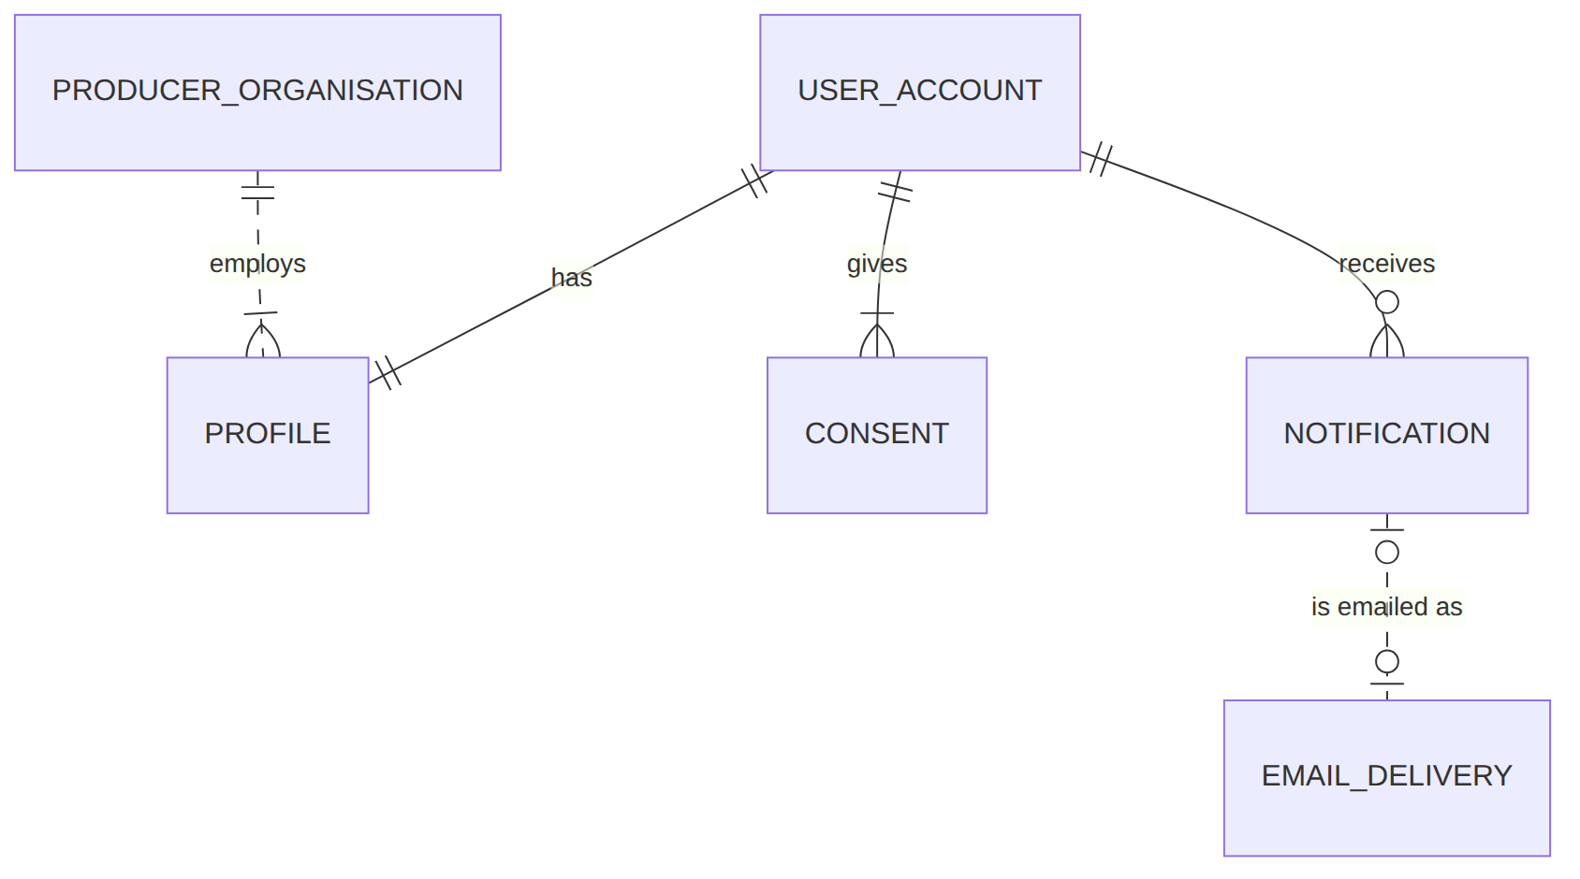
M1 — Segment router (relationships ending in a M1 entity)
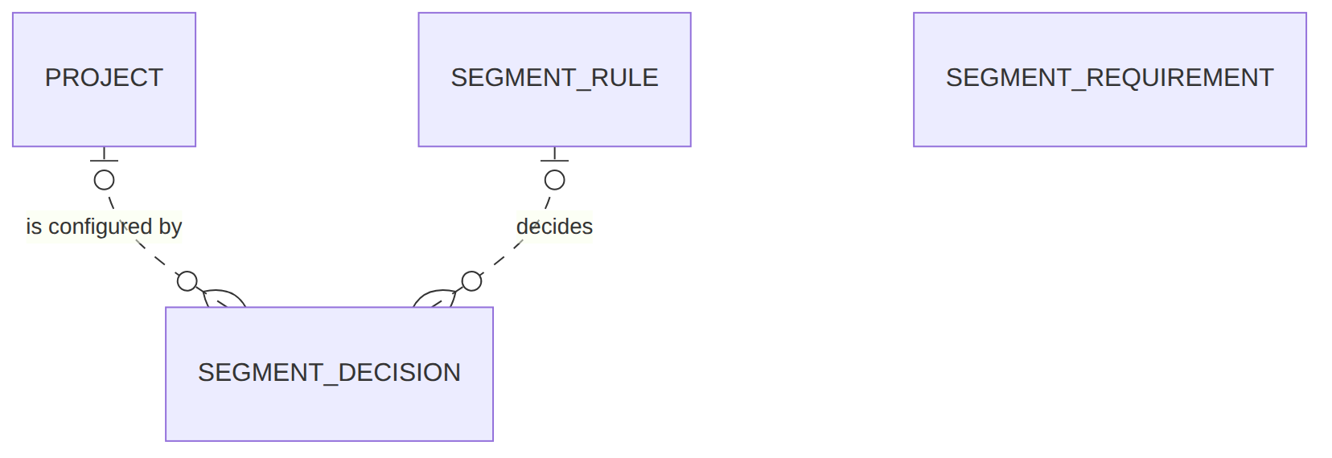
M0 — Project workspace (relationships ending in a M0 entity)
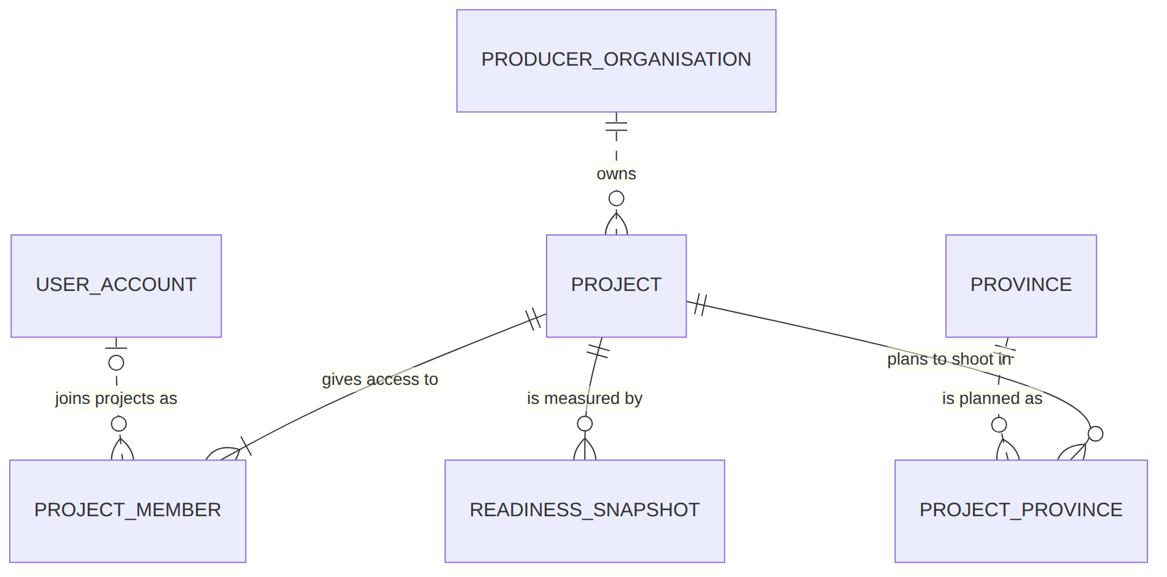
M2 — Content and dossier checks (relationships ending in a M2 entity)
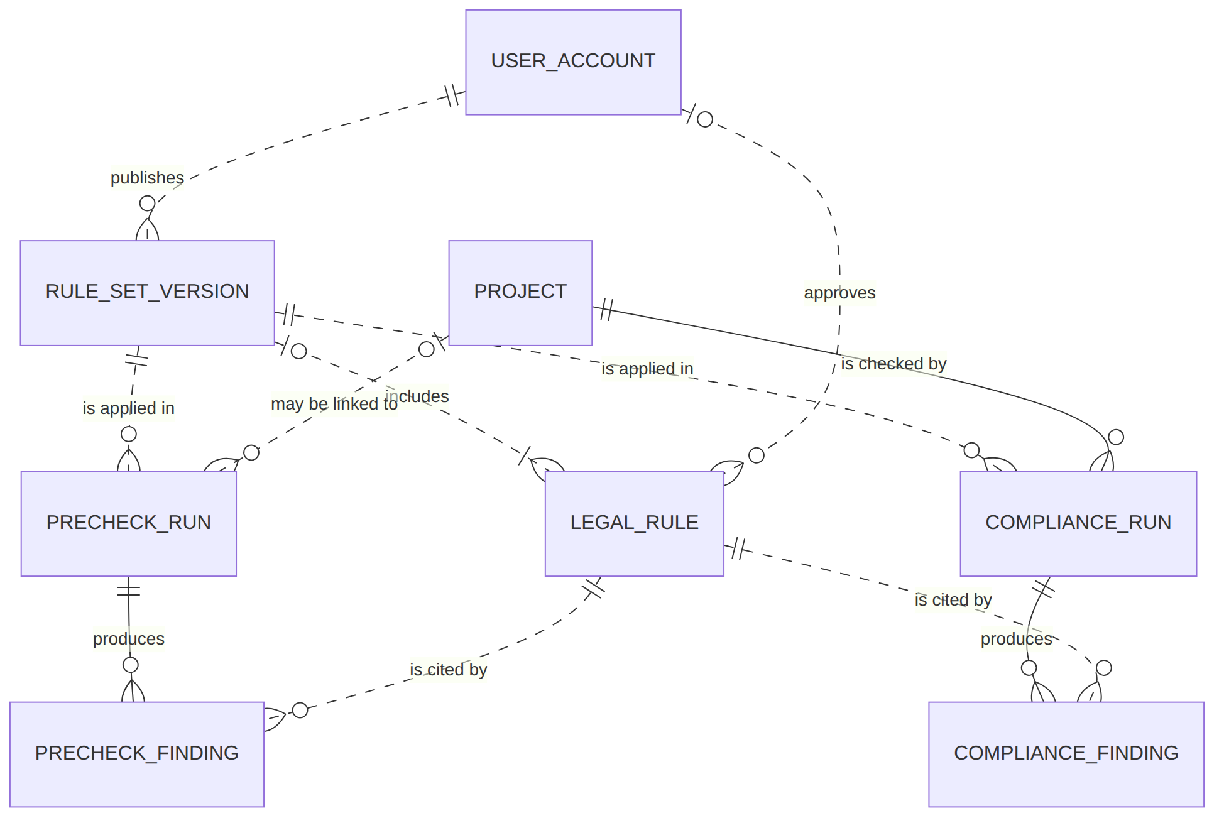
M3 — Location discovery (relationships ending in a M3 entity)
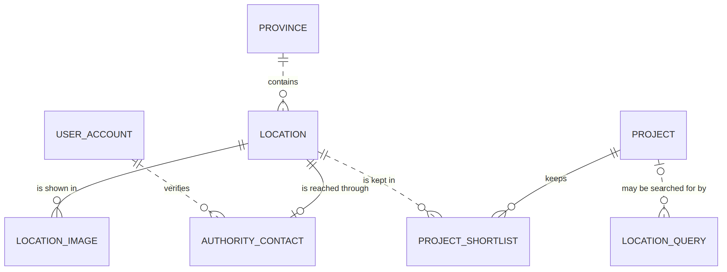
M4 — Vietnamese service partners (relationships ending in a M4 entity)
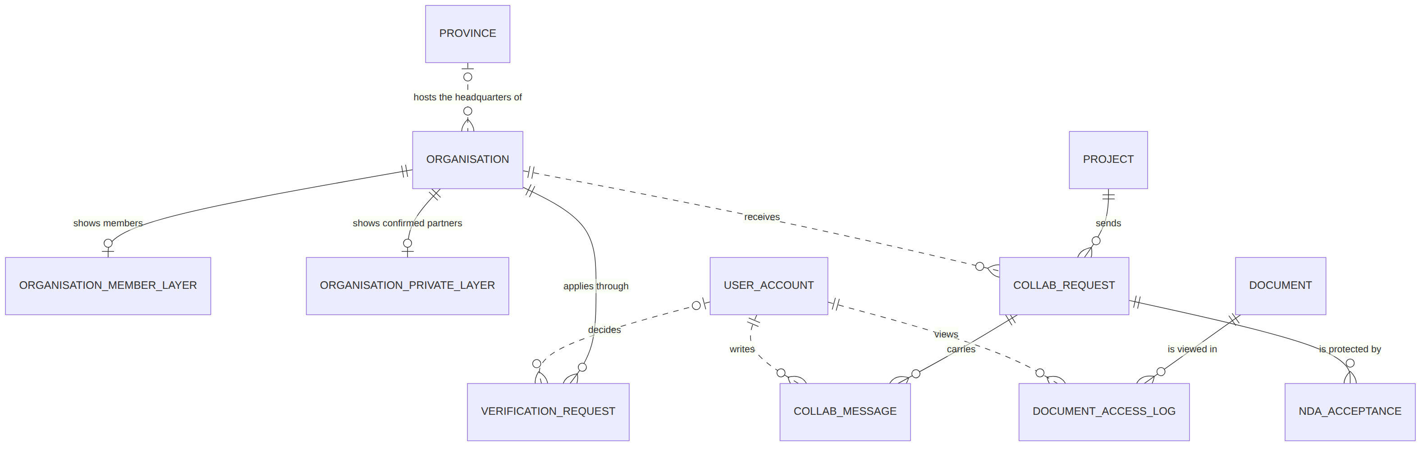
M5 — Dossier kit (relationships ending in a M5 entity)
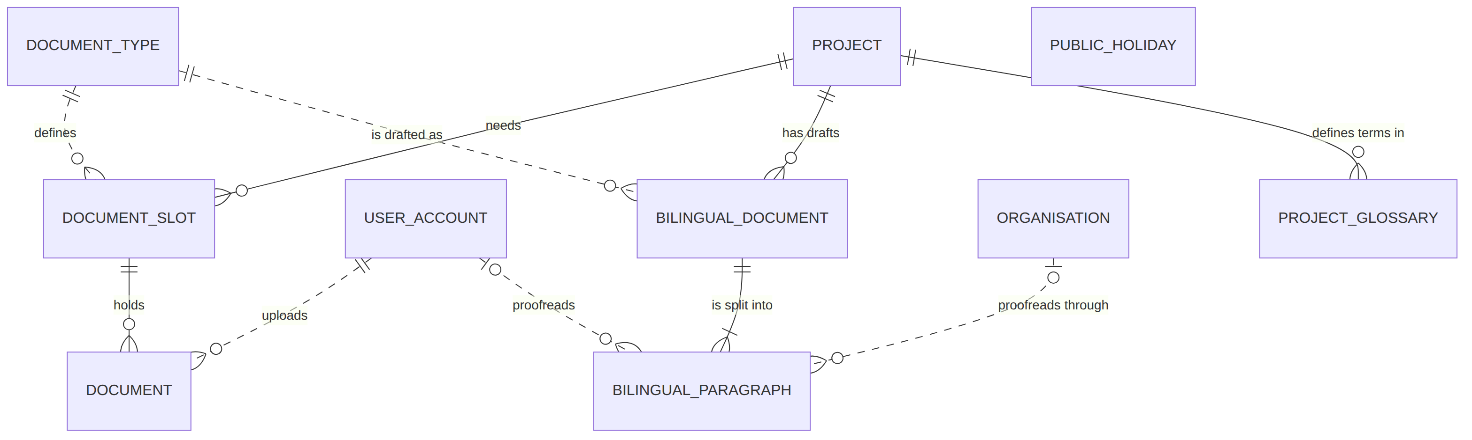
M7 — VFDA support (relationships ending in a M7 entity)
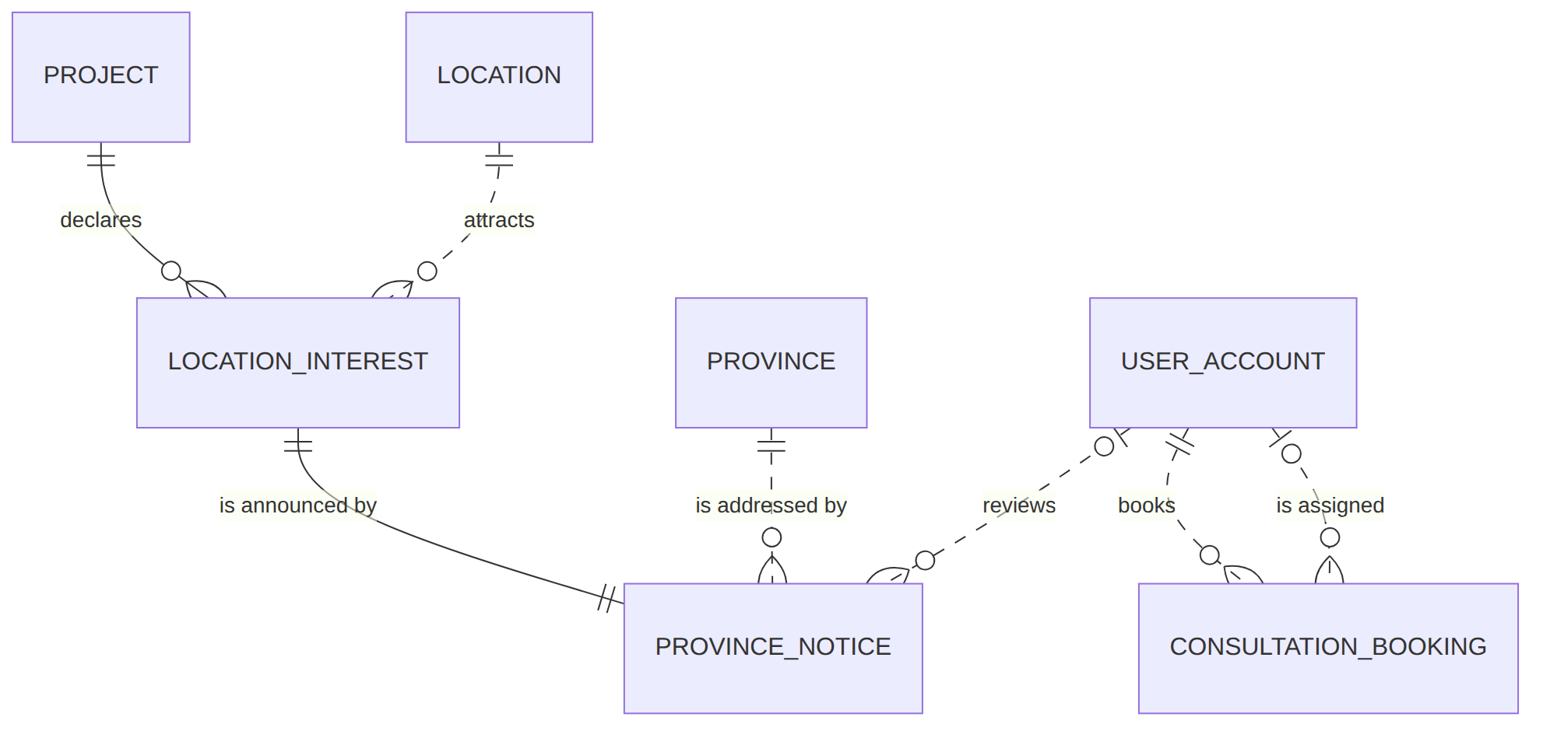

Open questions
# | Question | Blocking? | Owner | Default applied | Consequence if the default is wrong
OQ-04-1 | [NEEDS CLARIFICATION: Must a province notice keep the authority email it was sent to, even if the contact changes later?] | No | M7 owner | Yes — copied at send time as FR-002 already does | Replies cannot be traced to the address actually used.
OQ-04-2 | [NEEDS CLARIFICATION: Is the project summary in a sent notice frozen?] | No | M7 owner | Frozen at send time | The province may see a summary different from what it received.
OQ-04-3 | [NEEDS CLARIFICATION: When an approved rule is edited or retired, is the old text kept so old findings still show what fired?] | Yes | M2 owner (VFDA Legal) | Keep every approved text per rule_version; never overwrite | A producer's saved result would silently change meaning.
OQ-04-4 | [NEEDS CLARIFICATION: Should a segment decision record the decision-table version used?] | No | M1 owner | Yes, add segment_rule_id (drawn) and rely on the rule's version | A table change could not be audited against past decisions.
OQ-04-5 | [NEEDS CLARIFICATION: Does a bilingual draft refresh its project_meta when the project changes?] | No | M5 owner | No — regenerated only on request | Title or dates in the Vietnamese draft may be stale.
OQ-04-6 | [NEEDS CLARIFICATION: What happens to projects, uploads, logs and approvals when an account is deleted (personal data law)?] | Yes | Nam + VFDA Legal | Account disabled, personal fields erased, rows kept with the link | Either orphaned rows or unlawful retention of personal data.
OQ-04-7 | [NEEDS CLARIFICATION: Can a project be deleted or only archived? What happens to its documents, requests and notices?] | Yes | M0 owner | Archive only; no delete | Deleting would break access logs (append-only) and sent notices.
OQ-04-8 | [NEEDS CLARIFICATION: Does unpublishing a location remove it from shortlists and open notices?] | No | M3 owner | No; it is shown as no longer published | Producers lose a shortlisted place without notice.
OQ-04-9 | [NEEDS CLARIFICATION: Can an organisation be removed from the directory, and what happens to its open requests?] | No | M4 owner | No removal; badge expiry only | A closed company keeps receiving requests.
OQ-04-10 | [NEEDS CLARIFICATION: Add owner to PROJECT_MEMBER.permission, and which function accepts an invitation?] | Yes | M0 owner | Owner stored as edit + flag not modelled; acceptance by sign-in with the invited email | "Owner only" rules (M0 FR-004) cannot be enforced in the database.
OQ-04-11 | [NEEDS CLARIFICATION: Is DOCUMENT_SLOT.state stored, or derived from documents, proofreading and partner status each time?] | Yes | M5 + M2 owners | Stored, recomputed on each upload and status change | Stored state can disagree with the rules it summarises.
OQ-04-12 | [NEEDS CLARIFICATION: Which function edits a paragraph (and so clears its proofread status)?] | No | M5 owner | Editing inside SC-28, not specified as a function | The reset in M5 US-2 has no function to hang on.
OQ-04-13 | [NEEDS CLARIFICATION: Initial and cancelled values of CONSULTATION_BOOKING.booking_status?] | No | M7 owner | Status left empty until VFDA confirms; no cancellation (seed follows this) | Unconfirmed bookings are indistinguishable from confirmed ones; a member cannot cancel.
OQ-04-14 | [NEEDS CLARIFICATION: After how many days does an unanswered collaboration request expire, and is expired a status?] | No | M4 owner | No expiry; member withdraws | Requests stay open forever and block a second request to the same partner.
OQ-04-15 | [NEEDS CLARIFICATION: Value sets of PROJECT.stage, LOCATION.intake_status, LOCATION_IMAGE.status, consultation topic, the 12 service groups and scene types.] | Yes | Module owners + VFDA | Values used in the seed are proposals, listed in data/seed/README.md | Code and seed invent their own values; screens and filters disagree.
OQ-04-16 | [NEEDS CLARIFICATION: Drop derivable columns (PROVINCE_NOTICE.province_id, LEGAL_RULE.is_active, BILINGUAL_DOCUMENT.watermark)?] | No | M7, M2, M5 owners | Kept as declared | Two sources of the same truth can disagree.
OQ-04-17 | [NEEDS CLARIFICATION: Declare identifiers for EMAIL_DELIVERY, SEGMENT_DECISION, LOCATION_QUERY (none in the spec).] | No | SYS, M1, M3 owners | Placeholder keys *_id (type not declared) | Rows cannot be referenced from logs or support tickets.
OQ-04-18 | [NEEDS CLARIFICATION: Types for all columns marked type not declared (70 columns).] | Yes | Module owners | Seed uses text; generic diagram type string | The build agent will choose types itself.
OQ-04-19 | [NEEDS CLARIFICATION: The location data-entry template has "18 fields" (M3 FR-002) but the I/O contract lists 17. Which field is missing?] | No | M3 owner | 17 as listed | One template field has nowhere to be stored.

Human gate 4: fill the Decision column of the type conflicts and confirm every natural key. Signed: ____________________ Date: __________

