Screen Spec: SC-04 Sign up / Log in
DBIZ3 Session 4 template — one file per screen. The Screen ID is kept from the DBIZ2 Screen List. The mockup image stays an image; everything around it is text. Each orange numbered badge on the mockup is the row with the same number in section 3 (Element inventory).
Field | Value
Screen ID | SC-04 (also covers SC-05)
Screen name | Sign up / Log in
Actor | Guest
Priority | Must
Belongs to module | docs/spec/spec-SYS.md
Mockup image | img/SC-04.png
Status | Draft
Route: /signup · /login · Screen list file: Onboarding, item #2 (Tier 1 — Must) · Design note from the screen list file: Also collect organisation / production company details.
Notes against Screen List v2.0
- This screen merges SC-04 Sign up and SC-05 Log in per the screen list file (#2). Both share one layout and differ only in the selected tab. Routes stay separate: /signup opens the Create account tab, /login opens the Log in tab. SC-05 has no separate image file.

1. Purpose
Shown when: A guest clicks Log in / Sign up in the navigation bar, or is redirected here when using a feature that requires an account (viewing contacts, sending requests, saving results).
The user leaves this screen when: Account created and email verified, or login successful — returns to the page that led here (the next parameter); defaults to SC-02 for new accounts and SC-10 for existing ones.

2. Mockup
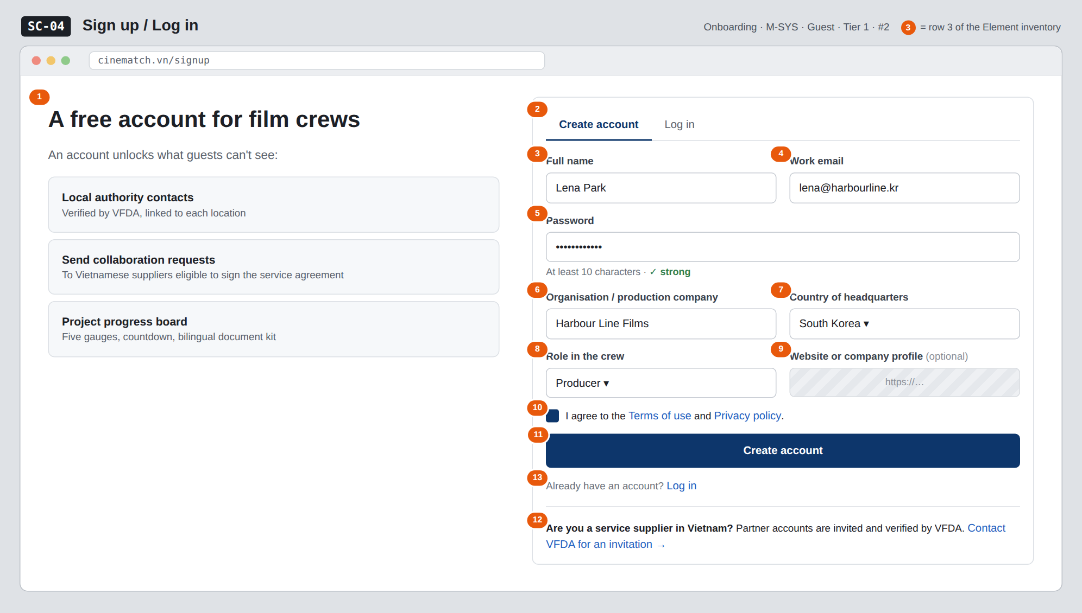
The image is the visual contract (layout, grouping, hierarchy); the tables below are the behavioural contract. All data in the mockup is sample data for one fictional project (The Last Ferry, Harbour Line Films); organisation names, people and phone numbers are examples, not real records.

3. Element inventory
# | Element | Type | Content / data source | Required | Validation
1 | Account value block | List | static: 3 benefits | — | —
2 | Create account / Log in tabs | Toggle | static; tab selected by route | — | —
3 | Full name | Input | profiles.full_name | Yes | 2–80 characters
4 | Work email | Input | auth.users.email | Yes | email format; not already in the system
5 | Password | Input (password) | sent directly to Supabase Auth, not stored by the app | Yes | ≥ 10 characters; strength meter
6 | Organisation / production company | Input | organizations_producer.name | Yes | 2–120 characters
7 | Country of headquarters | Toggle (dropdown) | organizations_producer.country — ISO 3166-1 alpha-2 code | Yes | only codes from the list
8 | Role in the crew | Toggle (dropdown) | profiles.crew_role — Producer / Director / Production coordinator / Line producer / Other | Yes | enum
9 | Website or company profile | Input | organizations_producer.website | No | valid URL if provided
10 | Terms consent checkbox | Toggle (checkbox) | consents — stores terms version and timestamp | Yes | must be ticked to enable the Create account button
11 | Create account button | Button | static | — | disabled while any required field is invalid
12 | Entry for Vietnamese suppliers | Text + link | static | — | —
13 | Already have an account? Log in line | Text + link | static | — | —

4. States
State | What the user sees | Trigger
Default | Create account tab open, empty form (the mockup is pre-filled for illustration). On the Log in tab: Email, Password, a Forgot password? link (→ SC-06), and a Log in button. | Open /signup or /login
Empty (no data) | Not applicable — a form with no data list. | —
Loading | The Create account button changes to Creating… and is disabled; all fields are temporarily locked to prevent double submission. | Click Create account / Log in
Error | Errors under each field (e.g. This email already has an account — Log in?). Wrong password: Email or password is incorrect — without saying which one. Entered data is kept, except the password. | Zod validation fails / Supabase Auth returns an error
Success / confirmation | Check your inbox screen: We've sent a verification link to lena@harbourline.kr, with a Resend button (locked for 60 seconds). | Account created

5. Interactions and navigation
# | Element | User action | System response | Goes to screen
1 | Log in tab | tap | Switches form, changes URL to /login | SC-05 (same layout)
2 | Email field | type | Validates format on blur | stays
3 | Create account button | tap | Calls Supabase Auth signUp, creates profiles + organizations_producer | stays (Check your inbox screen)
4 | Verification link in the email | tap | Verifies and creates a login session | SC-02
5 | Forgot password? (Log in tab) | tap | — | SC-06
6 | Terms / Policy links | tap | Open in a new tab | SC-43 / SC-42
7 | Contact VFDA for an invitation | tap | Opens the booking form with topic Supplier registration | SC-33

6. Screen-level rules
Rule ID | Rule | Source
SR-021 | Passwords, password hashing and JWTs are handled by Supabase Auth; the app does not implement them itself. | TL5 §M-SYS
SR-022 | The default role after sign-up is member. There is no self-registration path for the partner role — suppliers are invited and verified by VFDA. | TL4 §8
SR-023 | Organisation details are mandatory: VFDA needs to know which organisation is preparing to shoot, not just which person. | Screen list file — note #2
SR-024 | Terms consent is stored with the document version and timestamp, so it can be proven later. | Personal data protection
SR-025 | After login, return to the page that led here (next); accept internal paths only, to block open redirects. | Security

7. Linked requirements
FR ID (from the module spec) | What this screen does for it
FR-001 · spec-SYS.md (F-SYS-01) | Account sign-up
FR-002 · spec-SYS.md (F-SYS-02) | Log in
FR-003 · spec-SYS.md (F-SYS-03) | Forgot password entry
FR-004 · spec-SYS.md (F-SYS-04) | Assign default role member
FR-008 · spec-SYS.md (F-SYS-08) | Verification email

8. Responsive and accessibility notes
- Minimum supported width: 360px.
- Narrow screens: the value block on the left collapses into a one-line summary above the form; two-column field pairs stack into one column.
- Every field has a real <label> and the correct autocomplete value (email, new-password, organization).
- Error messages are linked via aria-describedby and announced when they appear.

9. Open questions
# | Question | Blocking? | Status
1 | [NEEDS CLARIFICATION: should the production organisation be verified (e.g. via IMDb Pro or a business licence) before local authority contacts are shown] | Yes | Open
2 | [NEEDS CLARIFICATION: allow Google / Apple sign-in — less friction, but the organisation name is not captured up front] | No | Open

Completion checklist
- ☒ The mockup is a separate cropped image file, named with the Screen ID (img/SC-04.png).
- ☒ Every visible element in the mockup appears in the element inventory — machine-checked: badge numbers on the image = row numbers in section 3.
- ☒ Every input element has a validation rule or an explicit "—".
- ☒ All five states are filled in, or marked "Not applicable" with a reason.
- ☒ Every navigation target is a Screen ID that exists in docs/screen-list.md — machine-checked.
- ☒ Every element that displays data names the field it displays, matching docs/spec/spec-SYS.md section 5.1.
- ☐ Checked by a person: (not signed — a Group C member compares the image with the tables and signs here)

DBIZ3 Session 4 · Group C · CINEMATCH. Built on the DBIZ2 Screen Design (Screen List and Screen Layout).

