Screen Spec: SC-26 Document kit by segment
DBIZ3 Session 4 template — one file per screen. The Screen ID is kept from the DBIZ2 Screen List. The mockup image stays an image; everything around it is text. Each orange numbered badge on the mockup is the row with the same number in section 3 (Element inventory).
Field | Value
Screen ID | SC-26
Screen name | Document kit by segment
Actor | Member
Priority | Must
Belongs to module | docs/spec/spec-M5.md
Mockup image | img/SC-26.png
Status | Draft
Route: /projects/[id]/dossier · Screen list file: M5, item #15 (Tier 1 — Must) · Design note from the screen list file: Checklist changes by A/B/C.

1. Purpose
Shown when: Member clicks Document kit in the sidebar, Upload on SC-27, or Continue your dossier on the dashboard.
The user leaves this screen when: Member uploads documents, opens the bilingual editor (SC-28), or views the partnership request (SC-25).

2. Mockup
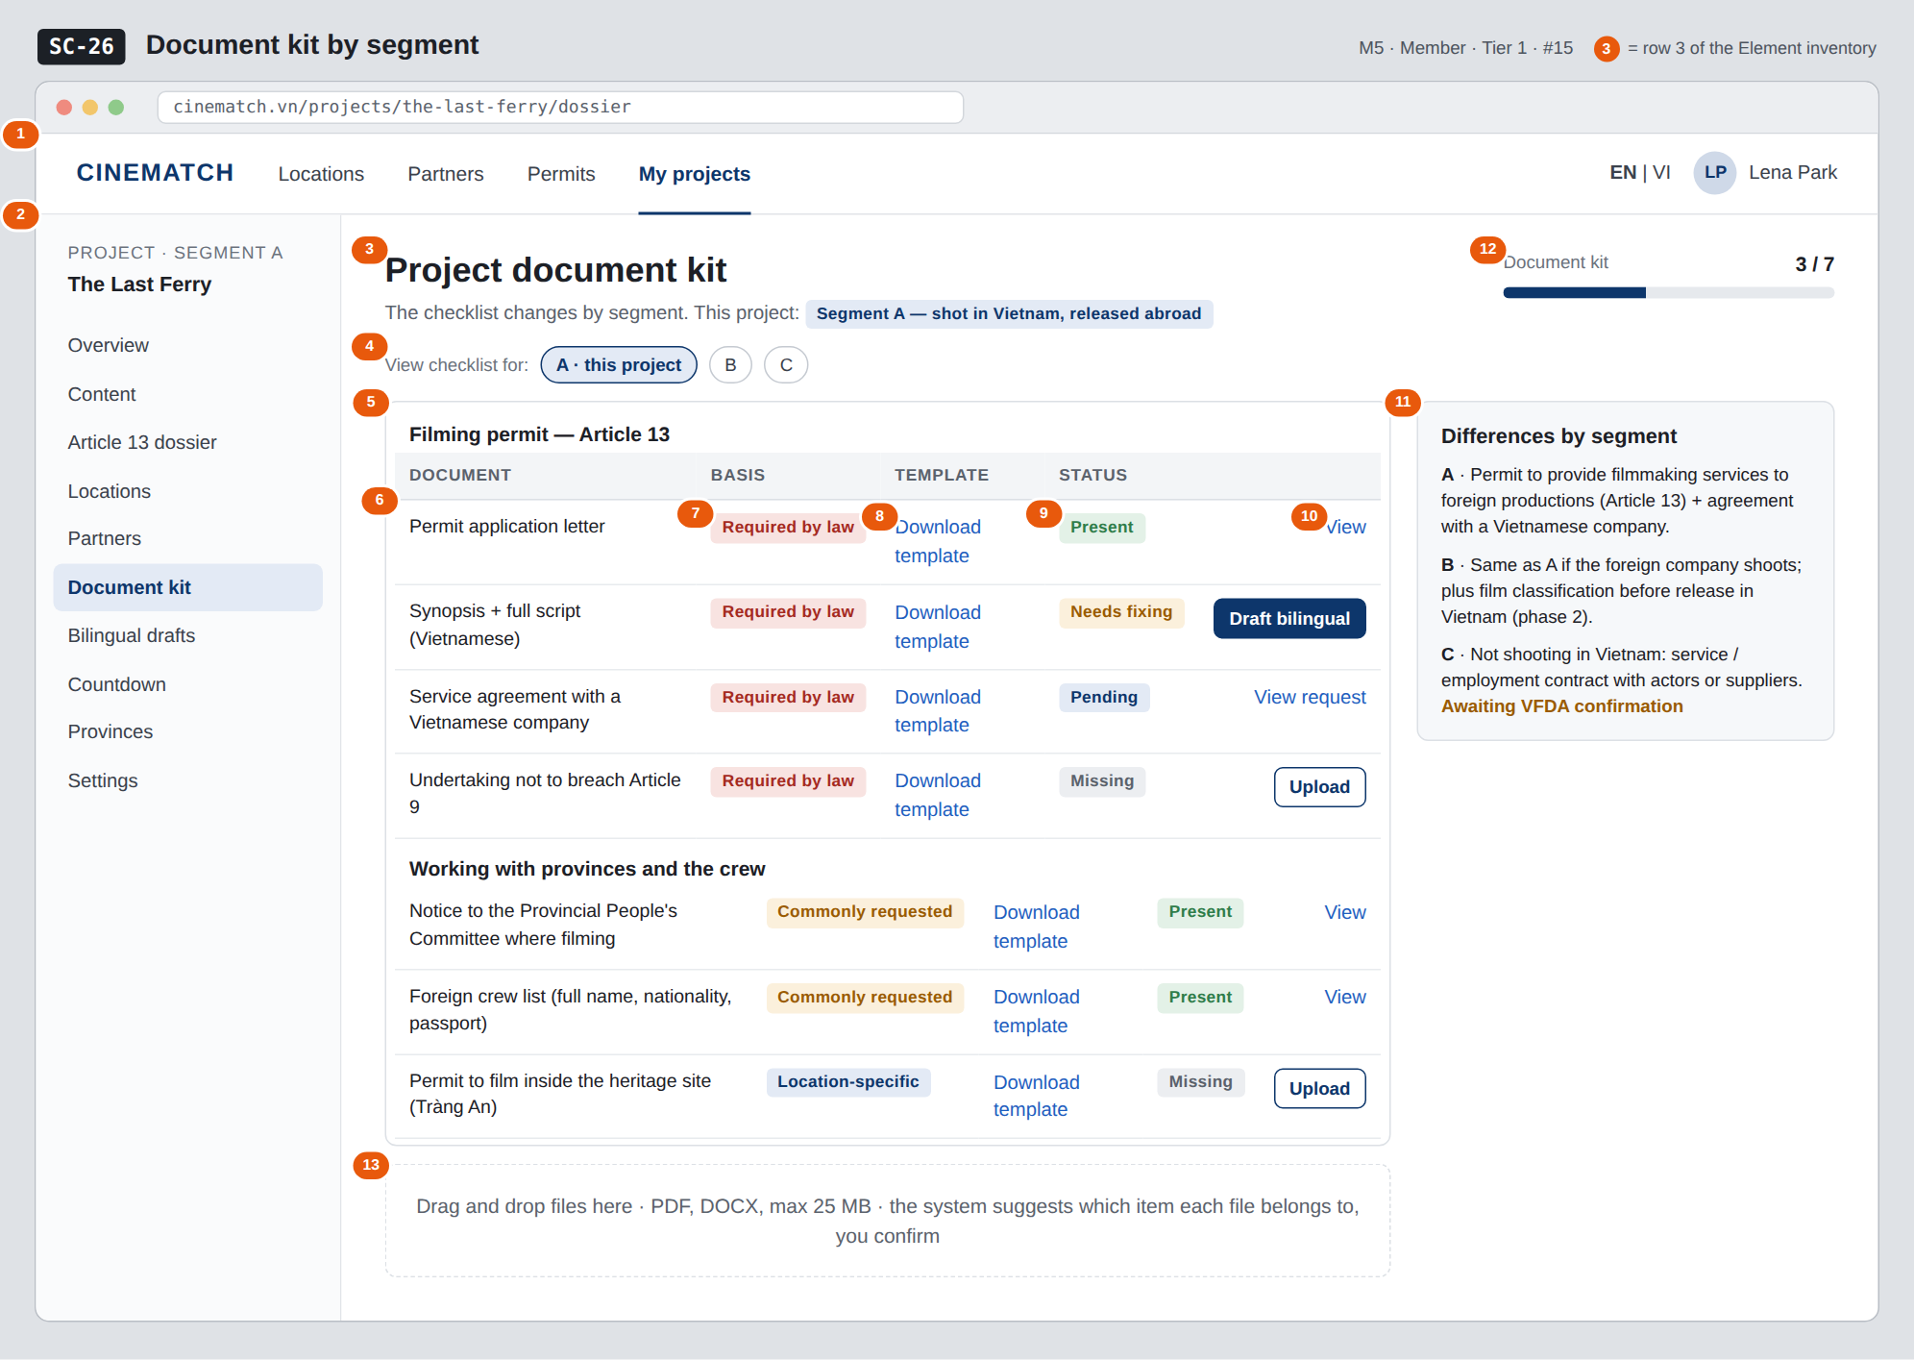
The image is the visual contract (layout, grouping, hierarchy); the tables below are the behavioural contract. All data in the mockup is sample data for one fictional project (The Last Ferry, Harbour Line Films); organisation names, people and phone numbers are examples, not real records.

3. Element inventory
# | Element | Type | Content / data source | Required | Validation
1 | Navigation bar | Header | static | — | —
2 | Project sidebar | List | static; Document kit selected | — | —
3 | Title + project segment | Header | projects.segment | Yes | —
4 | Switch checklist view A / B / C | Toggle | segment_requirements for the selected segment | — | view only; does not change the project's segment
5 | Document group | Container | document_types.group | — | —
6 | Document row | List | document_slots generated from segment_requirements + confirmed locations | Yes | —
7 | Basis label | Text | document_types.basis — Required by law / Commonly requested / Location-specific | Yes | enum, 3 values
8 | Download template link | Link | document_templates provided by VFDA | — | hidden when no template exists
9 | Document status | Text | document_slots.status — Present / Needs fixing / Pending / Missing | Yes | same status set as SC-27
10 | Row action | Button / Link | View / Upload / Draft bilingual / View request | — | —
11 | Differences by segment block | Text | segment_requirements.summary approved by VFDA | Yes | —
12 | Document kit progress | Text + bar | count of Present rows / total rows | Yes | —
13 | Drag-and-drop upload area | Input (file) | Supabase Storage, private bucket per project | — | PDF / DOCX, ≤ 25 MB; suggests item, user confirms

4. States
State | What the user sees | Trigger
Default | Two document groups with basis, template, status and action; segment differences block; upload area. | Screen opens
Empty (no data) | New project: every row Missing; Location-specific rows not shown yet because no location is confirmed — a note reads Added once you confirm a location. | No documents yet
Loading | Grey skeleton for the table; an upload shows a progress bar on its own row. | Loading / uploading a file
Error | Wrong file type or over 25 MB: error right at the upload area, stating the limit. Upload fails midway: Upload incomplete — try again, no empty row is created. | File check failed
Success / confirmation | Upload done: row status changes, green strip Added to document kit — rechecking against Article 13 and SC-27 is re-run. | Upload succeeded

5. Interactions and navigation
# | Element | User action | System response | Goes to screen
1 | Chip A / B / C | tap | View another segment's checklist (read-only) | stays
2 | Download template | tap | Download bilingual template | stays
3 | Draft bilingual | tap | — | SC-28
4 | View request | tap | — | SC-25
5 | Upload / drag-and-drop area | tap / drop | Upload, suggest item, user confirms | stays
6 | Document kit progress | tap | — | SC-27

6. Screen-level rules
Rule ID | Rule | Source
SR-151 | The checklist is generated from the segment_requirements table by segment, plus location-specific documents for confirmed locations — nothing hard-coded. | Function list — note #15
SR-152 | Every document carries a basis label: Required by law / Commonly requested / Location-specific. Never present everything as mandatory. | Honesty principle
SR-153 | Status set shared with SC-27; the 4 Article 13 rows always match across both screens. | Consistency principle
SR-154 | Files are stored in a private bucket; only project members can read them; every download is logged. | Security
SR-155 | The suggested item for a file is only a suggestion — the user confirms before it is assigned. | Human-decides principle

7. Linked requirements
FR ID (from the module spec) | What this screen does for it
FR-001 · spec-M5.md (F-M5-01) | Document checklist by segment
FR-002 · spec-M5.md (F-M5-02) | Upload and replace documents
FR-003 · spec-M5.md (F-M5-03) | Per-item status

8. Responsive and accessibility notes
- Minimum supported width: 360px.
- Narrow screens: the table becomes a list of cards; the segment differences block collapses into an expandable section.
- The drag-and-drop area has a Choose file button for users who don't use a mouse.
- Basis and status labels always include text.

9. Open questions
# | Question | Blocking? | Status
1 | [NEEDS CLARIFICATION: document checklist for segment C — needs confirmation from the VFDA Legal Board] | Yes | Open
2 | [NEEDS CLARIFICATION: are "Foreign crew list" and "Provincial People's Committee notice" mandatory anywhere, or just common practice] | No | Open

Completion checklist
- ☒ The mockup is a separate cropped image file, named with the Screen ID (img/SC-26.png).
- ☒ Every visible element in the mockup appears in the element inventory — machine-checked: badge numbers on the image = row numbers in section 3.
- ☒ Every input element has a validation rule or an explicit "—".
- ☒ All five states are filled in, or marked "Not applicable" with a reason.
- ☒ Every navigation target is a Screen ID that exists in docs/screen-list.md — machine-checked.
- ☒ Every element that displays data names the field it displays, matching docs/spec/spec-M5.md section 5.1.
- ☐ Checked by a person: (not signed — a Group C member compares the image with the tables and signs here)

DBIZ3 Session 4 · Group C · CINEMATCH. Built on the DBIZ2 Screen Design (Screen List and Screen Layout).

