Screen Spec: SC-28 Bilingual draft editor (Vietnamese–English)
DBIZ3 Session 4 template — one file per screen. The Screen ID is kept from the DBIZ2 Screen List. The mockup image stays an image; everything around it is text. Each orange numbered badge on the mockup is the row with the same number in section 3 (Element inventory).
Field | Value
Screen ID | SC-28
Screen name | Bilingual draft editor (Vietnamese–English)
Actor | Member
Priority | Must
Belongs to module | docs/spec/spec-M5.md
Mockup image | img/SC-28.png
Status | Draft
Route: /projects/[id]/bilingual/[doc] · Screen list file: M5, item #16 (Tier 1 — Must) · Design note from the screen list file: Two-column view with editing.

1. Purpose
Shown when: Member clicks Draft Vietnamese version on SC-27 or Draft bilingual on SC-26.
The user leaves this screen when: Member finishes proofreading and exports the PDF, or returns to the document kit.

2. Mockup
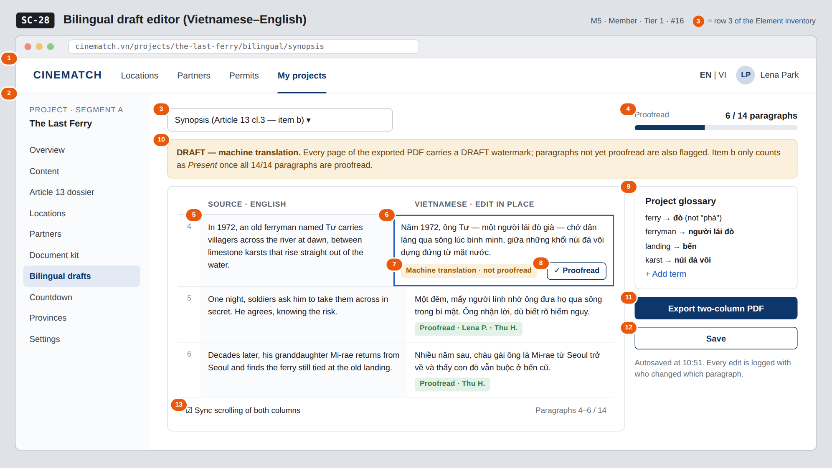
The image is the visual contract (layout, grouping, hierarchy); the tables below are the behavioural contract. All data in the mockup is sample data for one fictional project (The Last Ferry, Harbour Line Films); organisation names, people and phone numbers are examples, not real records.

3. Element inventory
# | Element | Type | Content / data source | Required | Validation
1 | Navigation bar | Header | static | — | —
2 | Project sidebar | List | static; Bilingual drafts selected | — | —
3 | Document picker | Toggle (dropdown) | bilingual_docs — Synopsis / Full script for scenes shot in Vietnam / Application letter / Undertaking | Yes | project documents only
4 | Proofreading progress | Text + bar | count of bilingual_paragraphs.reviewed_by IS NOT NULL | Yes | —
5 | Source column | Text | bilingual_paragraphs.source_text | Yes | read-only
6 | Vietnamese column | Input (textarea per paragraph) | bilingual_paragraphs.target_text | Yes | must not be empty; editing a proofread paragraph resets it to not proofread
7 | Paragraph status | Text | machine / reviewed + proofreader's name | Yes | always has text
8 | ✓ Proofread button | Button | writes reviewed_by, reviewed_at | — | only shown on paragraphs not yet proofread
9 | Project glossary | List | project_glossary | No | one translation per source term
10 | DRAFT warning strip | Text | static + number of paragraphs not proofread | Yes | hidden once 100% proofread
11 | Export two-column PDF button | Button | generated with @react-pdf/renderer | — | every page watermarked DRAFT — REQUIRES PROOFREADING (F-M5-05); unreviewed paragraphs also flagged
12 | Save button | Button | static; autosave enabled | — | —
13 | Sync scroll switch | Toggle | UI preference | — | on by default

4. States
State | What the user sees | Trigger
Default | Two columns aligned by paragraph: source on the left (read-only), Vietnamese on the right (editable), each paragraph with a status. | Open a document that has a source
Empty (no data) | No source yet: Upload the English script to get started + upload area. Source present but not translated: Create Vietnamese draft button. | No source / not translated
Loading | Creating the draft: paragraphs appear one by one with Translating paragraph 4 / 14. | Calls F-M5-04
Error | One paragraph fails to translate: it is left empty with Could not translate — retry this paragraph; other paragraphs remain usable. Save error: Not saved — your text is still on screen. | Translation error / save error
Success / confirmation | All 14/14 paragraphs: the warning strip is replaced by a green strip Fully proofread. Item b has been updated in the dossier check. | Fully proofread

5. Interactions and navigation
# | Element | User action | System response | Goes to screen
1 | Document picker | tap | Open another document | stays
2 | Vietnamese field | type | Autosaves after 2 seconds of inactivity; if the paragraph was proofread → back to not proofread | stays
3 | ✓ Proofread button | tap | Records who proofread and when | stays
4 | + Add term | tap | Adds to the glossary; highlights paragraphs where the term was translated differently | stays
5 | Export two-column PDF button | tap | Download PDF | stays
6 | When 14/14 paragraphs are done | — | Updates item b | SC-27

6. Screen-level rules
Rule ID | Rule | Source
SR-161 | The script for scenes shot in Vietnam must have a Vietnamese version — this is why the screen exists. | Cinema Law 2022 (Law No. 05/2022/QH15), Article 13 cl.3
SR-162 | Machine translation is always a draft. Only a person can mark a paragraph proofread; item b is Present only at 100% of paragraphs. | Human-decides principle
SR-163 | Editing a proofread paragraph clears its proofread mark. | Data integrity
SR-164 | Glossary terms are applied on translation and re-translation. | Terminology consistency
SR-165 | Every page of the exported PDF carries the watermark DRAFT — REQUIRES PROOFREADING; paragraphs not yet proofread are additionally flagged. CINEMATCH never produces a document presented as final. | Function List F-M5-05

7. Linked requirements
FR ID (from the module spec) | What this screen does for it
FR-004 · spec-M5.md (F-M5-04) | Generate Vietnamese draft
FR-005 · spec-M5.md (F-M5-05) | Export two-column comparison PDF
FR-006 · spec-M5.md (F-M5-06) | Mark as proofread

8. Responsive and accessibility notes
- Minimum supported width: 768px — two-column editing needs a wide screen. Below 768px it switches to single-column mode, each paragraph showing the source above and the Vietnamese below.
- Edit fields have lang="vi"; the source column has lang set to the source language.
- Paragraph status is always spelled out in text.

9. Open questions
# | Question | Blocking? | Status
1 | [NEEDS CLARIFICATION: must the proofreader be Vietnamese / a certified translator, and must the proofreader be named in the submitted dossier] | No | Open
2 | [NEEDS CLARIFICATION: which machine translation service to use — the script is the production's confidential document] | Yes | Open

Completion checklist
- ☒ The mockup is a separate cropped image file, named with the Screen ID (img/SC-28.png).
- ☒ Every visible element in the mockup appears in the element inventory — machine-checked: badge numbers on the image = row numbers in section 3.
- ☒ Every input element has a validation rule or an explicit "—".
- ☒ All five states are filled in, or marked "Not applicable" with a reason.
- ☒ Every navigation target is a Screen ID that exists in docs/screen-list.md — machine-checked.
- ☒ Every element that displays data names the field it displays, matching docs/spec/spec-M5.md section 5.1.
- ☐ Checked by a person: (not signed — a Group C member compares the image with the tables and signs here)

DBIZ3 Session 4 · Group C · CINEMATCH. Built on the DBIZ2 Screen Design (Screen List and Screen Layout).

