Screen Spec: SC-48 Content check results
DBIZ3 Session 4 template — one file per screen. The Screen ID is kept from the DBIZ2 Screen List. The mockup image stays an image; everything around it is text. Each orange numbered badge on the mockup is the row with the same number in section 3 (Element inventory).
Field | Value
Screen ID | SC-48
Screen name | Content check results
Actor | Guest / Member
Priority | Must
Belongs to module | docs/spec/spec-M2.md
Mockup image | img/SC-48.png
Status | Draft
Route: /pre-check/r/[id] · Screen list file: M2, item #7 (Tier 1 — Must) · Design note from the screen list file: Highlight risk points, suggest how to adjust.
Notes against Screen List v2.0
- New Screen ID. Screen List v2.0 did not have this screen (results were part of SC-03). SC-48 has been added to docs/screen-list.md.
- The screen list file says "highlight risk points under Article 13". The mockup and spec use Article 9 for content, because Article 9 of the Cinema Law 2022 defines prohibited content; Article 13 defines the dossier components and is checked on SC-27. The team needs to confirm this interpretation.

1. Purpose
Shown when: A pre-check finishes from SC-03, or a member reopens a saved check from the Content & compliance gauge on SC-12.
The user leaves this screen when: The user edits and re-checks (SC-03), saves to a project (SC-12, login required) or books a consultation (SC-33).

2. Mockup
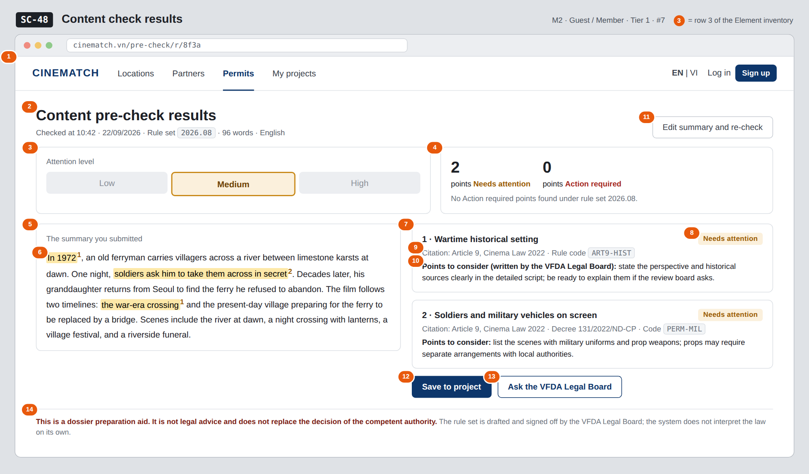
The image is the visual contract (layout, grouping, hierarchy); the tables below are the behavioural contract. All data in the mockup is sample data for one fictional project (The Last Ferry, Harbour Line Films); organisation names, people and phone numbers are examples, not real records.

3. Element inventory
# | Element | Type | Content / data source | Required | Validation
1 | Navigation bar | Header | static | — | —
2 | Title + check run details | Header + Text | precheck_runs.created_at, ruleset_version, word count, language | Yes | must include the rule set version
3 | Attention level scale | Chart (3 levels) | computed deterministically from number of findings × severity (F-M2-06) | Yes | Low / Medium / High — no 0–100 score
4 | Point count by level | Text | count of precheck_findings by severity | Yes | —
5 | Submitted text | Text | precheck_runs.summary_text | Yes | shown verbatim, unedited
6 | Highlighted passage | Text (highlight) | precheck_findings.span_start/end, finding number | — | yellow = Needs attention, red = Action required; always with a number
7 | Finding card | List | precheck_findings + rules.title | — | shown only with a valid citation
8 | Severity label | Text | rules.severity | Yes | Needs attention / Action required
9 | Provision citation + rule code | Text | rules.citation, rules.code | Yes | no citation, no finding shown (F-M2-12)
10 | Points to consider | Text | rules.guidance_vi/en — written by the VFDA Legal Board | Yes | taken verbatim from the rule; not written by a language model
11 | Edit summary and re-check button | Button | static | — | —
12 | Save to project button | Button | static | — | requires login and at least one project
13 | Ask the VFDA Legal Board button | Button | static | — | —
14 | Disclaimer | Text | static | Yes | fixed at the bottom of the screen, never collapsed

4. States
State | What the user sees | Trigger
Default | Attention level scale, point counts by level, numbered highlighted text on the left, finding cards on the right, disclaimer at the bottom. | At least 1 finding
Empty (no data) | No findings: scale at Low, line No content needing attention found under rule set 2026.08. Never say passed, permitted or safe. | 0 findings
Loading | When reopening a saved check: grey skeletons for both columns. (New checks wait on SC-03.) | Loading check run
Error | A finding with an invalid citation is dropped from the list and logged for VFDA; if all findings are dropped: We couldn't complete this check — try again or ask VFDA. Never show a finding without a citation. | Citation verification fails / load error
Success / confirmation | Click Save to project → green strip Saved to The Last Ferry and the Content & compliance gauge is updated. | Saved successfully

5. Interactions and navigation
# | Element | User action | System response | Goes to screen
1 | Highlighted passage | tap | Scrolls to and highlights the finding card with the same number | stays
2 | Finding card | tap | Expands the full rule text; re-highlights the related passage | stays
3 | Edit summary and re-check button | tap | Carries over the previous text | SC-03
4 | Save to project button | tap | Not logged in → SC-04 then back; logged in → choose a project, save the check run | SC-12
5 | Ask the VFDA Legal Board button | tap | Opens booking, topic Script content, attaches the check run ID | SC-33
6 | Rule code | tap | Opens regulation details | SC-31

6. Screen-level rules
Rule ID | Rule | Source
SR-071 | Every finding comes with a cited provision; if it can't be cited, it isn't shown. Citations are matched by code against the rules table before display. | TL5 §M2 — anti-fabrication
SR-072 | Results use a 3-level scale, not a 0–100 score: a precise number from a language model creates false certainty. | No-guessing principle
SR-073 | Adjustment suggestions are only points to consider taken verbatim from VFDA-written rules. The system never rewrites film content itself. | Screen list file — note #7; TL3
SR-074 | Banned wording: approved, accepted, legally compliant, safe — even when there are no findings. | Legal liability principle
SR-075 | Highlights always come with a number — information is never conveyed by colour alone. | Accessibility
SR-076 | Each check run stores ruleset_version so it can be explained later after the rule set changes. | TL5 §M2

7. Linked requirements
FR ID (from the module spec) | What this screen does for it
FR-006 · spec-M2.md (F-M2-06) | Review and return preliminary warnings
FR-011 · spec-M2.md (F-M2-11) | Call the model with the rule set
FR-012 · spec-M2.md (F-M2-12) | Verify citations by code
FR-013 · spec-M2.md (F-M2-13) | Display findings with provisions
FR-014 · spec-M2.md (F-M2-14) | Mark as reviewed (once saved to a project)

8. Responsive and accessibility notes
- Minimum supported width: 360px.
- Narrow screens: submitted text on top, finding cards below; tapping a number in a highlight scrolls to the matching card.
- Highlights use <mark> with a <sup> number; screen readers announce point of attention number 1.
- Provision citations are selectable, copyable text.

9. Open questions
# | Question | Blocking? | Status
1 | [NEEDS CLARIFICATION: team to confirm that content uses Article 9 (prohibited content) instead of Article 13 as stated in the screen list file] | Yes | Open
2 | [NEEDS CLARIFICATION: the specific clause of Article 9 for each rule is to be filled in rules.citation by the VFDA Legal Board; the mockup only goes to Article level] | No | Open
3 | [NEEDS CLARIFICATION: thresholds for mapping number of findings × severity to Low / Medium / High] | Yes | Open

Completion checklist
- ☒ The mockup is a separate cropped image file, named with the Screen ID (img/SC-48.png).
- ☒ Every visible element in the mockup appears in the element inventory — machine-checked: badge numbers on the image = row numbers in section 3.
- ☒ Every input element has a validation rule or an explicit "—".
- ☒ All five states are filled in, or marked "Not applicable" with a reason.
- ☒ Every navigation target is a Screen ID that exists in docs/screen-list.md — machine-checked.
- ☒ Every element that displays data names the field it displays, matching docs/spec/spec-M2.md section 5.1.
- ☐ Checked by a person: (not signed — a Group C member compares the image with the tables and signs here)

DBIZ3 Session 4 · Group C · CINEMATCH. Built on the DBIZ2 Screen Design (Screen List and Screen Layout).

