Screen Spec: SC-16 Location detail
DBIZ3 Session 4 template — one file per screen. The Screen ID is kept from the DBIZ2 Screen List. The mockup image stays an image; everything around it is text. Each orange numbered badge on the mockup is the row with the same number in section 3 (Element inventory).
Field | Value
Screen ID | SC-16
Screen name | Location detail
Actor | Guest / Member
Priority | Must
Belongs to module | docs/spec/spec-M3.md
Mockup image | img/SC-16.png
Status | Draft
Route: /locations/[slug] · Screen list file: M3, item #11 (Tier 1 — Must) · Design note from the screen list file: Location information and the province's readiness.

1. Purpose
Shown when: The user clicks a card on SC-14, a column on SC-17, a featured location on SC-18, or opens a shared link.
The user leaves this screen when: The user adds it to the comparison, clicks I'm interested, opens the province index, or moves to a nearby location.

2. Mockup
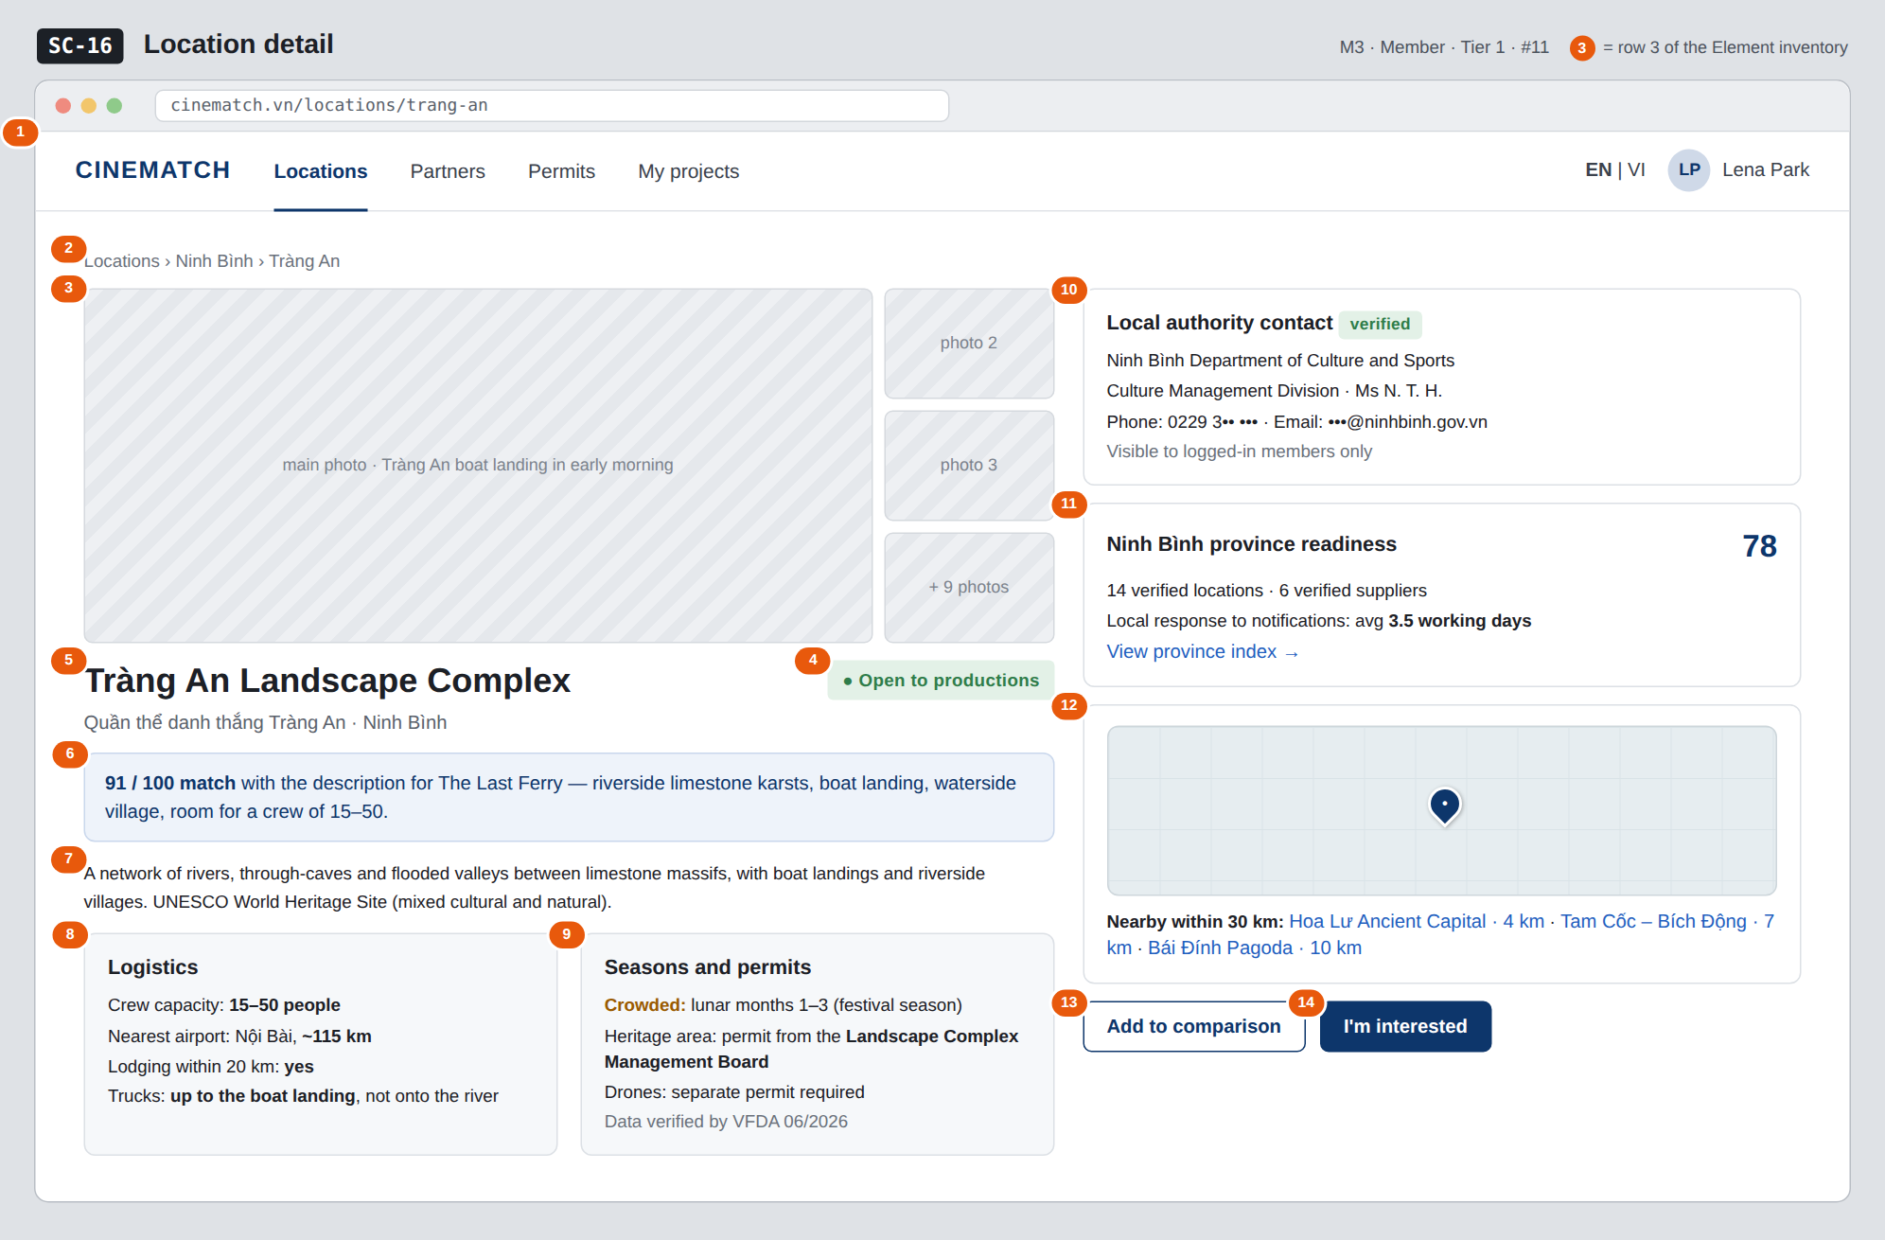
The image is the visual contract (layout, grouping, hierarchy); the tables below are the behavioural contract. All data in the mockup is sample data for one fictional project (The Last Ferry, Harbour Line Films); organisation names, people and phone numbers are examples, not real records.

3. Element inventory
# | Element | Type | Content / data source | Required | Validation
1 | Navigation bar | Header | static | — | —
2 | Breadcrumb | Text | Locations › provinces.name › locations.name | — | —
3 | Photo gallery | Image | locations.cover_image + location_images (approved) | Yes | published photos only
4 | Intake status badge | Text | locations.intake_status — open / scouting crew on site / temporarily closed | Yes | updated by VFDA
5 | English + Vietnamese name + province | Header | locations.name_vi, name_en, provinces.name | Yes | —
6 | Match score for the project | Text | F-M3-08 for the query linked to the open project | No | shown only when arriving from search results
7 | Description | Text | locations.description | Yes | —
8 | Logistics block | List | crew_capacity_band, nearest_airport_km, accommodation_within_20km, truck_access | Yes | missing data → no data yet
9 | Seasons and permits block | List | avoid_months, permit_notes, drone_note, verified_at | Yes | same as above
10 | Local authority contact block | Container | location_authority_contacts | Yes (members) | Guests: RLS returns 0 rows, the table is not queried
11 | Province readiness block | Text | v_province_readiness.score and its 3 main components | Yes | same source as SC-18
12 | Mini map + nearby within 30 km | Map + List | PostGIS ST_DWithin on locations.geom | No | max 5, sorted by distance
13 | Add to comparison button | Button | static | — | disabled when the basket holds 4
14 | I'm interested button | Button | static | — | requires login and a project

4. States
State | What the user sees | Trigger
Default | The mockup shows the member view: the contact is shown in full. For guests, block 10 is replaced by a dashed box Local authority contacts are visible to members only + Sign up free / Log in buttons. | Open a published location
Empty (no data) | No published nearby locations: No published locations within 30 km yet. Province lacks index data: block 11 reads Not enough data to calculate the province index. | Empty query
Loading | Grey placeholders for photos and blocks (page is pre-rendered; only appears on in-app navigation). | Loading
Error | Location does not exist or is unpublished → dedicated 404 page with a button back to SC-14. | status != published
Success / confirmation | I'm interested → green banner Saved to The Last Ferry. VFDA will notify the Ninh Bình Provincial People's Committee + a tracking link. | Writes F-M7-01

5. Interactions and navigation
# | Element | User action | System response | Goes to screen
1 | Thumbnail / + 9 photos | tap | Swaps the main photo / opens the full-screen gallery | stays
2 | Province name in breadcrumb / View province index | tap | — | SC-18
3 | Nearby location | tap | — | SC-16 (another location)
4 | Add to comparison button | tap | Adds to the basket | stays
5 | I'm interested button | tap | Not logged in → SC-04; logged in → pick a project, record interest, create a local notification request | SC-32
6 | Sign up free (guest) | tap | Remembers the page to return to | SC-04

6. Screen-level rules
Rule ID | Rule | Source
SR-111 | The contact block must not be hidden by the UI alone. For guests, the app does not query location_authority_contacts; RLS returns 0 rows. Verification: the page source in a private window shows no phone number. | Database-layer security principle
SR-112 | The province readiness block uses the same view v_province_readiness as SC-18. | Screen list file — note #11
SR-113 | Every logistics and seasonal fact shows when VFDA verified it; if missing, show no data yet. | No-guessing principle
SR-114 | The mockup uses sample organisation names; phone numbers / emails in the image are masked — not real data. | Mockup note

7. Linked requirements
FR ID (from the module spec) | What this screen does for it
FR-013 · spec-M3.md (F-M3-13) | Location profile display
FR-014 · spec-M3.md (F-M3-14) | Map and nearby locations
FR-015 · spec-M3.md (F-M3-15) | Local authority contact block
FR-019 · spec-M3.md (F-M3-19) | Province index from platform data
FR-001 · spec-M7.md (F-M7-01) | Express interest in a location

8. Responsive and accessibility notes
- Minimum supported width: 360px.
- Narrow screens: thumbnails become a horizontal scroll strip; the right column moves below; the two buttons stick to the bottom of the screen.
- Photos have alt text describing the location.
- The status badge has text, not just a coloured dot.

9. Open questions
Open questions are tracked outside this repository until they are resolved.

Completion checklist
- ☒ The mockup is a separate cropped image file, named with the Screen ID (img/SC-16.png).
- ☒ Every visible element in the mockup appears in the element inventory — machine-checked: badge numbers on the image = row numbers in section 3.
- ☒ Every input element has a validation rule or an explicit "—".
- ☒ All five states are filled in, or marked "Not applicable" with a reason.
- ☒ Every navigation target is a Screen ID that exists in docs/screen-list.md — machine-checked.
- ☒ Every element that displays data names the field it displays, matching docs/spec/spec-M3.md section 5.1.
- ☐ Checked by a person: (not signed — a Group C member compares the image with the tables and signs here)

DBIZ3 Session 4 · Group C · CINEMATCH. Built on the DBIZ2 Screen Design (Screen List and Screen Layout).

