Screen Spec: SC-18 Provincial readiness index
DBIZ3 Session 4 template — one file per screen. The Screen ID is kept from the DBIZ2 Screen List. The mockup image stays an image; everything around it is text. Each orange numbered badge on the mockup is the row with the same number in section 3 (Element inventory).
Field | Value
Screen ID | SC-18
Screen name | Provincial readiness index
Actor | Guest / VFDA Staff
Priority | Should
Belongs to module | docs/spec/spec-M3.md
Mockup image | img/SC-18.png
Status | Draft
Route: /provinces/[slug] · Screen list file: Tier 2, item #19 (Tier 2 — Should) · Design note from the screen list file: Source M3·3.
Notes against Screen List v2.0
- Screen List v2.0 puts SC-18 at Must; the function list places it in Tier 2 — Should. This spec follows the function list.

1. Purpose
Shown when: User clicks the Provincial readiness block on SC-16, the Provincial readiness row on SC-17, or the province name in the breadcrumb.
The user leaves this screen when: User views locations in the province (SC-14 filtered), opens a location (SC-16) or a supplier (SC-20).

2. Mockup
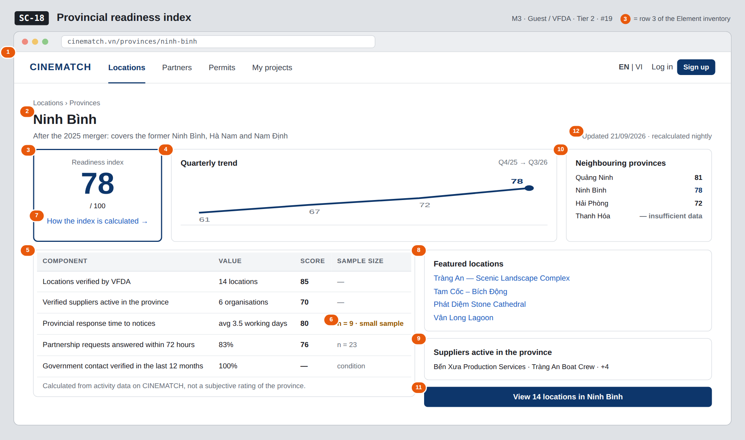
The image is the visual contract (layout, grouping, hierarchy); the tables below are the behavioural contract. All data in the mockup is sample data for one fictional project (The Last Ferry, Harbour Line Films); organisation names, people and phone numbers are examples, not real records.

3. Element inventory
# | Element | Type | Content / data source | Required | Validation
1 | Navigation bar | Header | static | — | —
2 | Province name + 2025 merger note | Header | provinces.name, provinces.merged_from[] | Yes | list of 34 provinces and cities
3 | Composite index | Text | v_province_readiness.score | Yes | 0–100; insufficient data → —
4 | Quarterly trend | Chart (line) | province_readiness_snapshots, last 4 quarters | No | quarterly axis, last point emphasised
5 | Components table | List | 5 components in v_province_readiness | Yes | each component shows raw value and score
6 | Sample size / confidence | Text | number of records used in the calculation | Yes | n < 10 → small sample label
7 | How the index is calculated link | Link | formula explanation page | — | —
8 | Featured locations | List | province's locations, sorted by interest | No | max 4
9 | Suppliers active in the province | List | organization_provinces | No | Verified organisations only
10 | Neighbouring provinces | List | provinces.neighbors[] + score | No | provinces lacking data show insufficient data
11 | View n locations in province button | Button | static | — | —
12 | Last updated line | Text | v_province_readiness.computed_at | Yes | —

4. States
State | What the user sees | Trigger
Default | Large index, trend and neighbouring provinces on the top row; components table and lists below. | Province has enough data
Empty (no data) | Province lacks data: index shows — with Not enough data to calculate (at least 5 verified locations needed); the location list still shows if any. | Below data threshold
Loading | Grey skeleton for the index and table (page is pre-rendered, refreshed nightly). | Internal navigation
Error | Province doesn't exist (e.g. old name) → redirect to the new post-merger province, with the line Quảng Nam is now part of Đà Nẵng City. | Old / wrong slug
Success / confirmation | Not applicable — read-only screen. | —

5. Interactions and navigation
# | Element | User action | System response | Goes to screen
1 | How the index is calculated | tap | Open the explanation page | stays
2 | Featured location | tap | — | SC-16
3 | Supplier | tap | — | SC-20
4 | Neighbouring province | tap | — | SC-18 (other province)
5 | View n locations button | tap | Open results filtered by province | SC-14

6. Screen-level rules
Rule ID | Rule | Source
SR-191 | The index is calculated only from data generated on the platform (first-party), not a subjective rating of the province. | Team idea review — provincial index redefined
SR-192 | Always show the sample size; n < 10 gets a small sample label. Below the minimum threshold, no score is shown. | Data honesty principle
SR-193 | Formula and weights are published at How the index is calculated. | Anti-black-box principle
SR-194 | Province list follows the 34 units after the 2025 merger; old slugs redirect to the new province. | 2025 resolution on merging administrative units
SR-195 | The government contact verified in the last 12 months component is a condition for having a score, not a points component. | TL5 §M3

7. Linked requirements
FR ID (from the module spec) | What this screen does for it
FR-019 · spec-M3.md (F-M3-19) | Calculate index from platform data
FR-020 · spec-M3.md (F-M3-20) | Province page and navigation into search

8. Responsive and accessibility notes
- Minimum supported width: 360px.
- Narrow screens: all blocks stack vertically; the composite index sits on top.
- The trend chart has an alternative data table.
- The small sample label is text, not colour alone.

9. Open questions
Open questions are tracked outside this repository until they are resolved.

Completion checklist
- ☒ The mockup is a separate cropped image file, named with the Screen ID (img/SC-18.png).
- ☒ Every visible element in the mockup appears in the element inventory — machine-checked: badge numbers on the image = row numbers in section 3.
- ☒ Every input element has a validation rule or an explicit "—".
- ☒ All five states are filled in, or marked "Not applicable" with a reason.
- ☒ Every navigation target is a Screen ID that exists in docs/screen-list.md — machine-checked.
- ☒ Every element that displays data names the field it displays, matching docs/spec/spec-M3.md section 5.1.
- ☐ Checked by a person: (not signed — a Group C member compares the image with the tables and signs here)

DBIZ3 Session 4 · Group C · CINEMATCH. Built on the DBIZ2 Screen Design (Screen List and Screen Layout).

