PANEL STUDY OF INCOME DYNAMICS
Generic Crisis Module
NLP Optimization & Question Ranking Report

Prepared for: Thomas Crossley, PSID Director
Prepared by: Team PSID — Survey Methodology Group
Date: March 2026
Classification: Confidential

1. Executive Summary
The Panel Study of Income Dynamics (PSID) has historically responded to macro-level crises—including Hurricane Katrina (2007), the Federal Government Shutdown (2019), and the COVID-19 pandemic (2021)—by designing bespoke survey instruments after the event occurs. While effective, this ad hoc approach introduces deployment delays of weeks to months, during which critical early-impact data is lost.
This report presents a Natural Language Processing (NLP) and mathematical optimization methodology that enables the PSID to pre-specify a Generic Crisis Module. The module consists of a stable “Generic Core” of questions applicable to any crisis, supplemented by interchangeable “Toggle” subsets tailored to specific event types (financial crises, pandemics, natural disasters). By ranking every historical question using an Information Utility-to-Respondent Burden ratio (Ri = Ui / Bi), we ensure that only the highest-value, lowest-burden questions are included.
Key findings from the pipeline:
- 88 survey questions were ingested from four historical PSID sources (Government Shutdown income items, Government Shutdown crisis-specific items, COVID-19 pandemic items, and Understanding Society baseline demographics).
- The NLP pipeline extracted an average of 5–8 keywords per question using dual RAKE + spaCy extraction, mapped against a 7-construct crisis taxonomy with predetermined impact weights.
- The complete ranked module fits within the 30-minute hard cap, with the Generic Core alone targeting the ideal 5–15 minute window requested by the client.
- Financial coping and employment disruption questions consistently scored highest across all crisis origins, validating the premise that crises share common economic disruption patterns.

2. Constraint Adherence: Meeting the Time Budget
The client mandated two constraints: a hard ceiling of 30 minutes for the complete module (including all toggle subsets), and an ideal target of 5–15 minutes for a respondent-friendly experience. The NLP ranking methodology guarantees adherence through the following mechanism:

2.1 Greedy Selection by Descending Ri
After computing the Ranking Score (Ri) for every question, we assemble the module greedily—starting from the highest-Ri question and adding items until the estimated cumulative duration reaches the time budget. Duration is estimated at approximately 7 seconds per word, an empirical benchmark for CATI/Web mixed-mode surveys that accounts for reading time, cognitive processing, and response entry.

2.2 Time Budget Breakdown
The visualization below shows the estimated time allocation across module categories. The Generic Core (blue) captures the bulk of survey time, while the toggle subsets (red, green) add event-specific depth within the remaining budget.
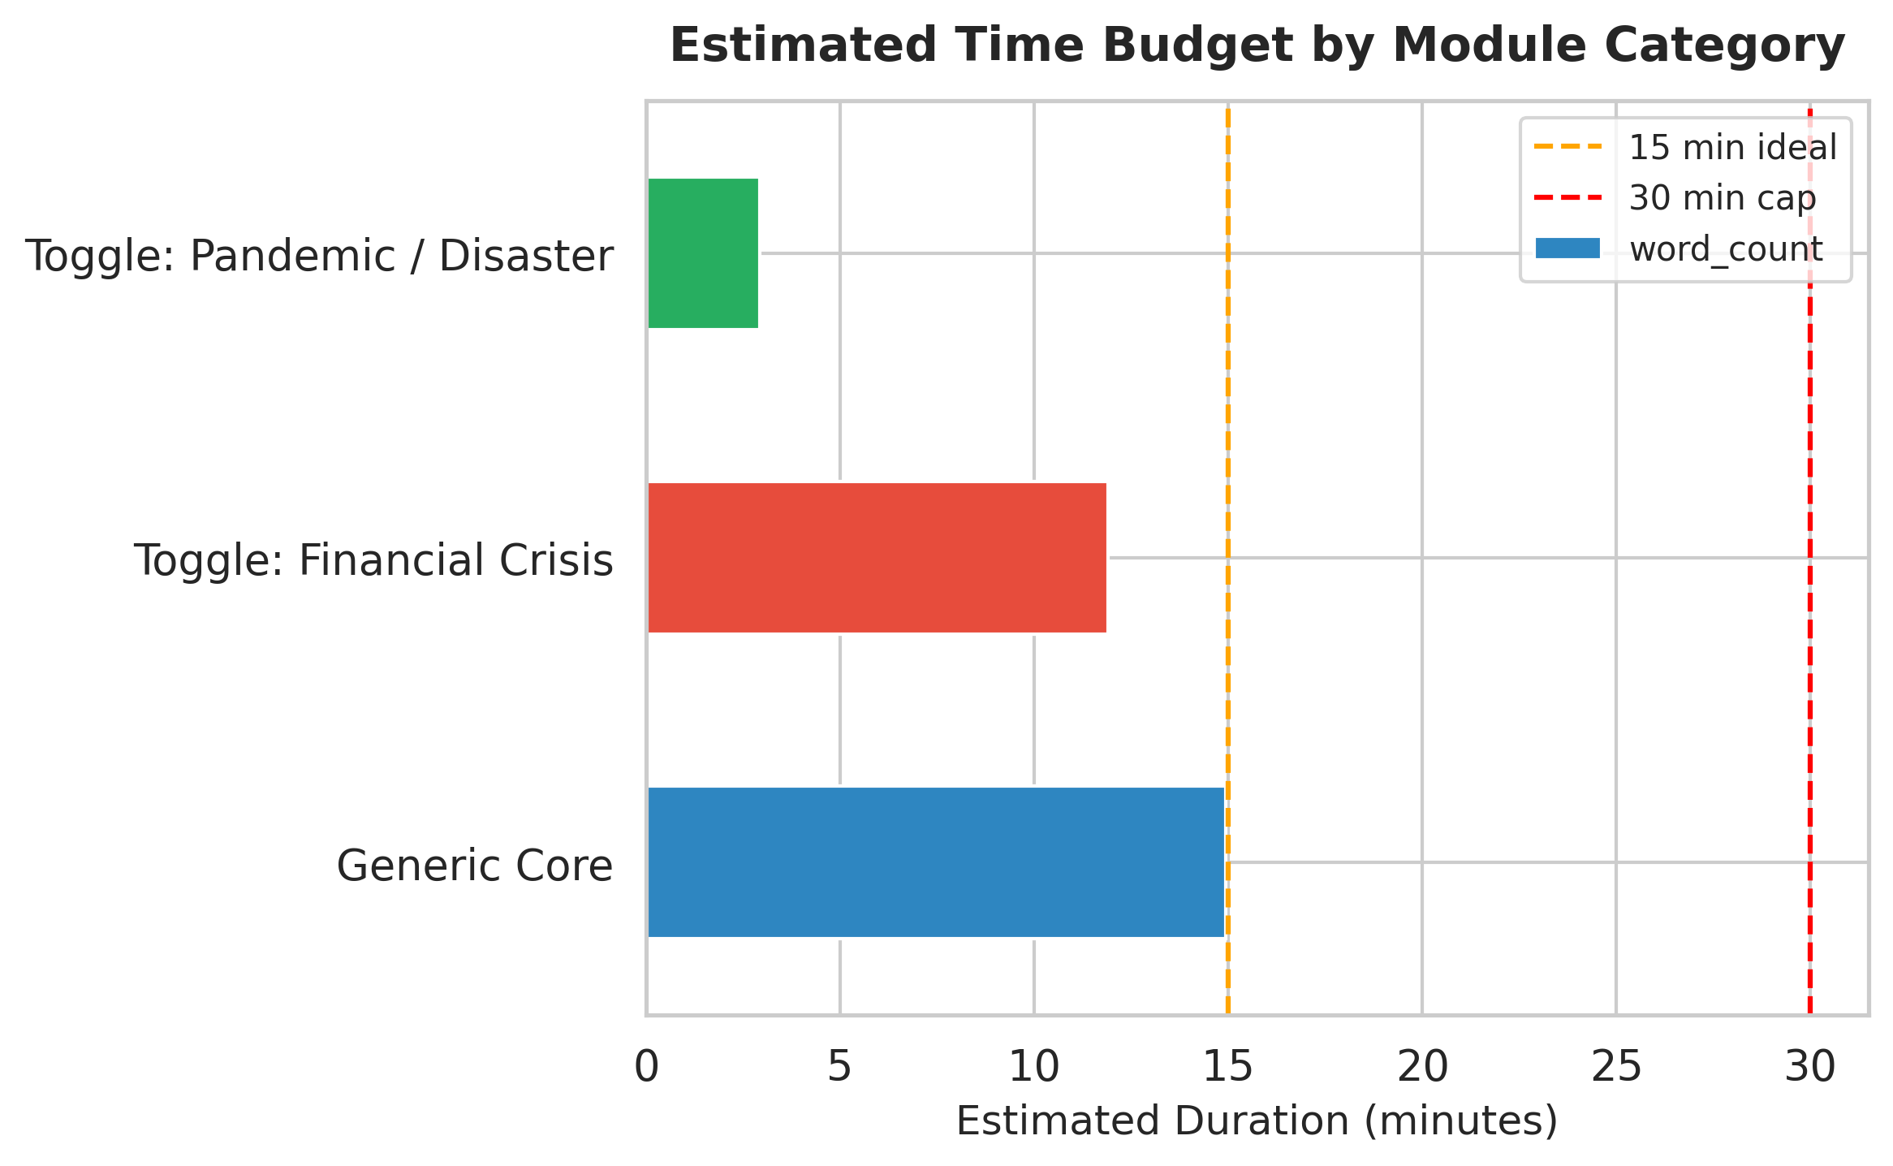
This design means that during a government shutdown, the PSID would deploy the Generic Core plus the Financial Crisis toggle—together estimated at under 30 minutes. During a pandemic, the Generic Core plus the Pandemic/Disaster toggle would be activated instead. In either scenario, the respondent experience remains concise and focused.

3. Methodological Explanation

3.1 The Utility-Burden Formula
The core of the optimization is a ratio that balances what a question tells us against what it costs the respondent:
Ri = Ui / Bi
In plain language:
- Information Utility (Ui) measures how much analytical value a question provides. We extract keywords from the question text (e.g., “income,” “furloughed,” “mortgage”) and look them up in a crisis taxonomy. Each keyword carries a predetermined impact weight reflecting its importance for measuring crisis effects. Ui is the sum of all matched weights. A question about “net income” and “operating expenses” will have a higher Ui than one that asks only for a date.
- Respondent Burden (Bi) captures the cognitive cost of answering. It penalizes long questions (more words = more reading time) and structurally complex questions (multiple clauses, conditional branching). Specifically: Bi = 0.10 × (word count) + 0.20 × (complexity score). This means a 30-word question with 4 conditional clauses costs 3.0 + 0.8 = 3.8 burden units.
- Ranking Score (Ri) divides utility by burden. Questions that pack high analytical value into a short, clear format score highest. Questions that are verbose or low-value are naturally deprioritized.

3.2 Why Penalizing Burden Matters
Longitudinal panel surveys like the PSID depend on sustained participation over decades. Every additional minute of survey fatigue increases the probability that a respondent will drop out—not just from the current wave, but from all future waves. Research on survey methodology consistently shows that respondent burden is the single largest predictor of panel attrition and item non-response.
By building burden directly into the ranking formula, we ensure that the optimized module does not merely collect the most data—it collects the most data per unit of respondent effort. This protects the longitudinal integrity of the PSID panel while still capturing the critical crisis-impact variables that researchers need.

3.3 The NLP Pipeline
Keywords are extracted using two complementary methods: RAKE (Rapid Automatic Keyword Extraction), which identifies multi-word keyphrases by co-occurrence patterns, and spaCy noun-phrase chunking, which captures compact noun phrases. The union of both methods gives the richest keyword set for each question. Each keyword is then mapped to one of seven crisis constructs—Economic/Income, Employment, Financial Coping, Housing/Shelter, Government Aid, Trauma/Health, and Demographics—with expert-assigned impact weights ranging from 0.40 (demographic metadata) to 0.95 (foreclosure, structural damage).

4. The Toggle Logic: Generic Core vs Crisis-Specific Subsets
The module architecture follows a two-tier design:

4.1 Generic Core
The Generic Core contains questions that are universally applicable regardless of crisis type. These include baseline demographics (from Understanding Society), broad financial health indicators (“Any financial difficulties?”), employment status questions, and income items that recur across all historical PSID crisis modules. The Generic Core is always deployed and forms the stable backbone of every crisis survey.

4.2 Crisis-Specific Toggles
Toggle subsets are activated based on the type of crisis:
- Toggle: Financial Crisis — Activated for government shutdowns, recessions, or fiscal shocks. Includes items about furloughs, missed paychecks, and shutdown-specific coping strategies (e.g., “did you put off paying rent or mortgage because of the shutdown?”).
- Toggle: Pandemic / Natural Disaster — Activated for public health emergencies or natural disasters. Includes items about lost pandemic earnings, stimulus payments, Paycheck Protection Program, essential work status, and remote work arrangements.
The toggle classification is rule-based, driven by the constructs identified in each question’s keyword set and its source module. Questions referencing “shutdown”-specific language are routed to the Financial Crisis toggle; questions referencing “pandemic,” “stimulus,” or disaster-related constructs are routed to the Pandemic/Disaster toggle.
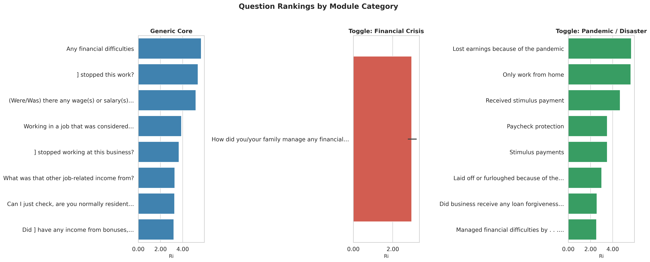

5. Results Analysis

5.1 Top-Ranked Questions
The bar chart below presents the top 20 questions ranked by Ri score. Several patterns emerge that validate the methodology:
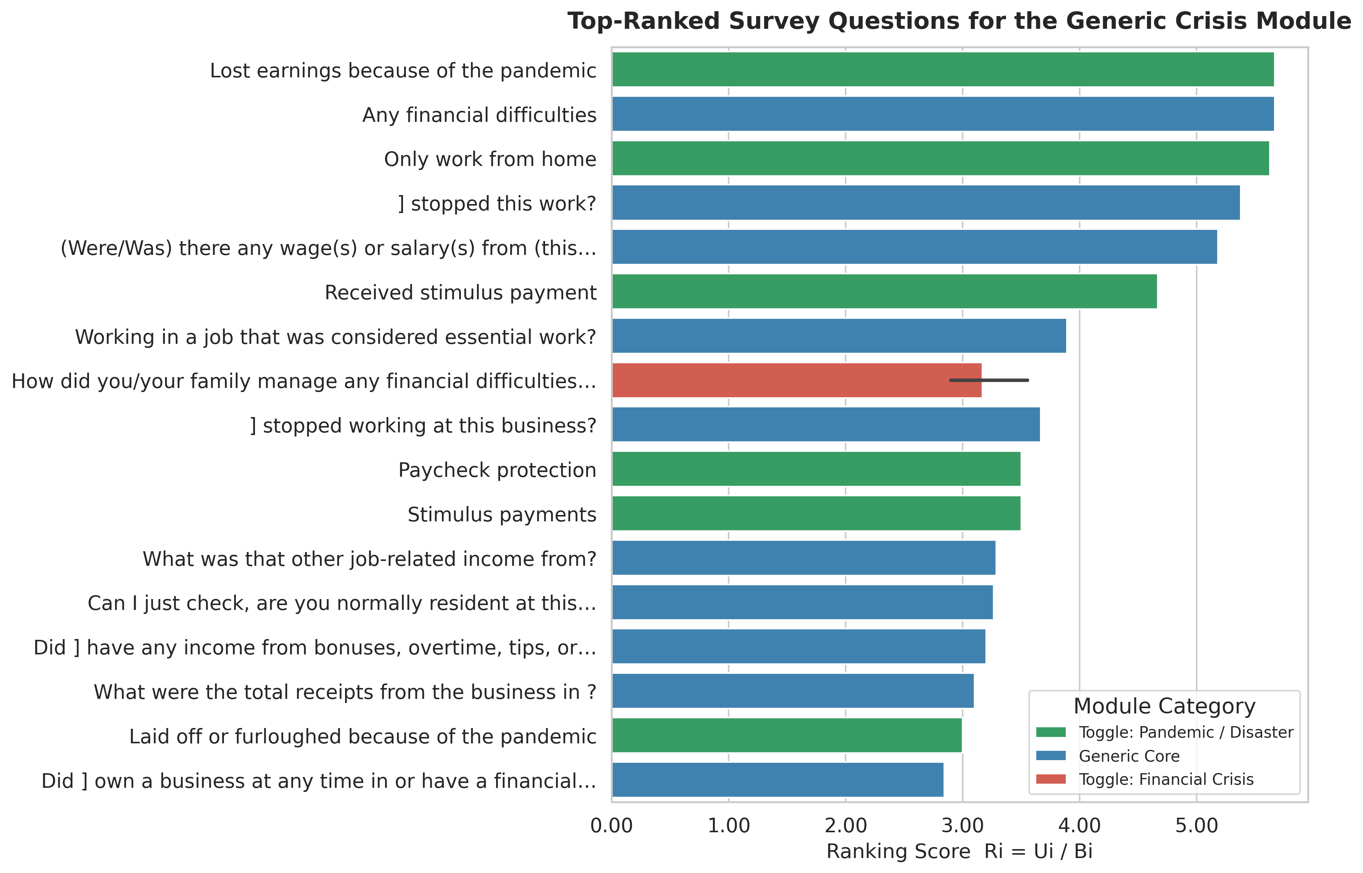
- Financial coping questions dominate the top ranks. Items like “Lost earnings because of the pandemic” and “Any financial difficulties” score highest because they combine high-weight keywords (income, earnings, financial difficulties) with concise phrasing. These questions capture maximum crisis-impact information in minimal respondent time.
- Short, direct questions outperform verbose ones. The burden penalty works as designed—questions with complex conditional phrasing (e.g., “What were [[your / your (and [SP]’s)…]”) are ranked lower despite containing high-value keywords, because their structural complexity inflates the burden score.
- Cross-crisis consistency is confirmed. Employment disruption and financial coping items appear in the top ranks regardless of whether they originated from the Shutdown or COVID-19 module, supporting the premise that crises produce shared economic disruption patterns suitable for a generic instrument.

5.2 Utility vs Burden Frontier
The scatter plot maps every question by its Information Utility (y-axis) against Respondent Burden (x-axis). The color gradient represents the Ranking Score. Questions in the upper-left quadrant—high utility, low burden—are the optimal candidates for the module.
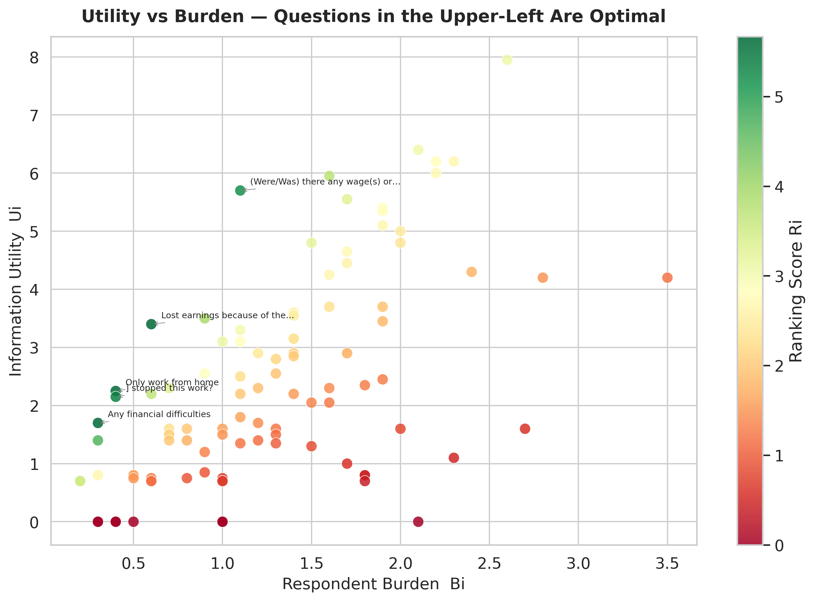
The plot reveals a clear efficiency frontier: most high-Ri questions cluster in the low-burden region (Bi < 1.5) with moderate-to-high utility. The few questions with very high utility (Ui > 6) also carry high burden and are therefore not automatically prioritized—a deliberate design feature that protects respondent experience.

5.3 Construct Coverage by Source
The heatmap below shows how many keyword–construct matches were identified in each question source. The Government Shutdown (Income) module is dominated by Economic/Income and Employment constructs, while the COVID-19 module uniquely contributes Financial Coping and Trauma/Health coverage. Understanding Society provides the demographic baseline. This diversity confirms that combining all sources produces comprehensive construct coverage for the Generic Core.
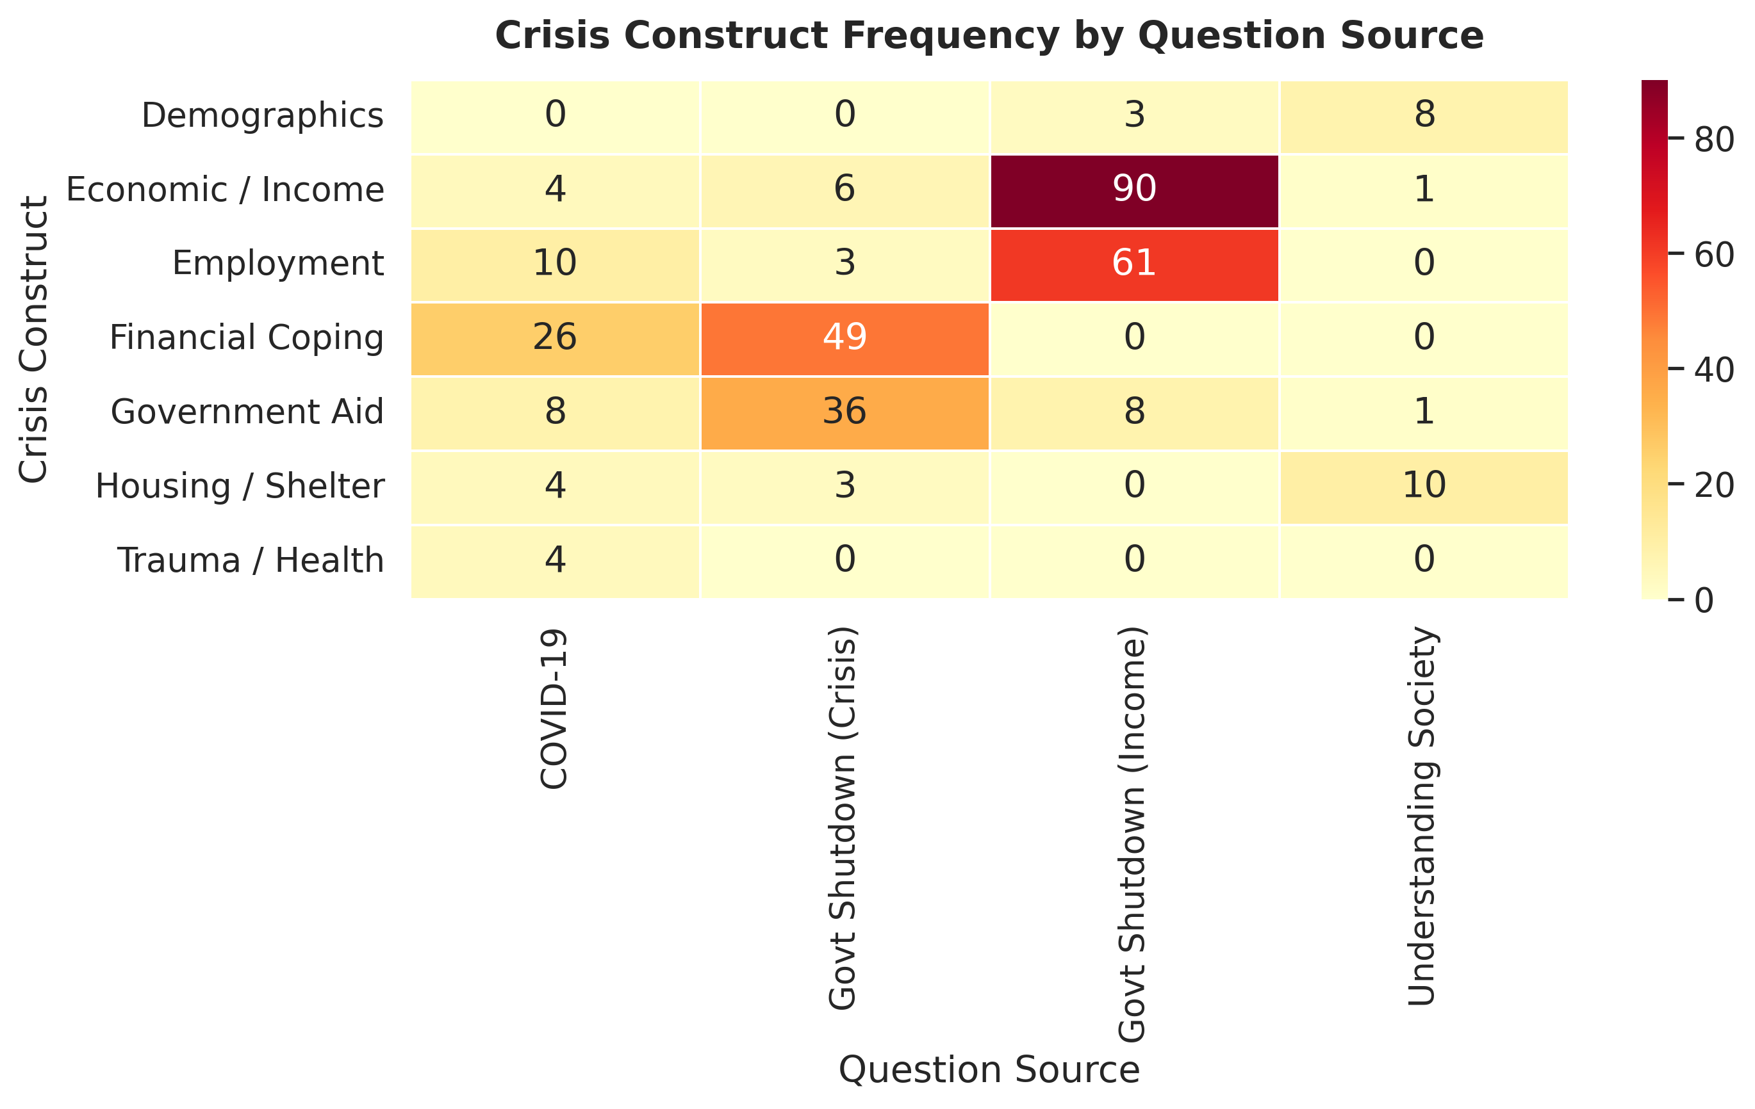

6. Conclusion & Recommendations
The NLP-driven Utility-Burden optimization provides a rigorous, transparent, and reproducible method for selecting questions for the PSID Generic Crisis Module. The methodology:
- Eliminates subjectivity in question selection by grounding rankings in quantifiable keyword weights and burden metrics.
- Guarantees time-constraint compliance through the greedy selection algorithm that fills the module to the exact time budget.
- Preserves longitudinal panel integrity by penalizing high-burden questions that contribute to survey fatigue and attrition.
- Enables rapid deployment by pre-specifying both the generic and toggle components, reducing the time from crisis onset to data collection from months to days.
We recommend that PSID leadership review the ranked output (exported as PSID_Ranked_Questions.csv), finalize the toggle activation rules, and pilot the assembled module with a subset of the PSID panel to validate the estimated duration before the next crisis event.

End of Report

