PSID Generic Crisis Module

NLP Optimization & Question Ranking Report

Prepared for:
Thomas Crossley
PSID Director
Date: March 2026

Executive Summary
This report presents the results of a comprehensive Natural Language Processing (NLP) and utility-burden optimization analysis of the PSID Generic Crisis Module. The analysis evaluated 52 questions from 5 distinct sources, identified 282 keywords across a 63-entry taxonomy, and selected 28 questions for implementation within a 29.2-minute interview window.
Key metrics:
- 52 total questions across 5 sources
- 282 unique keywords identified
- 63-entry standardized taxonomy
- 28 selected questions
- 29.2 minutes total interview time

Methodology

Question Selection Framework
Questions were ranked using a Utility-Burden (UB) formula that balances the informational value of each question against the cognitive and temporal burden of administration:

Ri = Ui / Bi
Where:
- Ui = sum of keyword weights specific to each question
- Bi = burden score calculated as 0.10 × word_count + 0.20 × complexity
- Minimum burden (floor) = 0.1 to avoid division by zero

This formula ensures that questions with high informational utility relative to their administration burden are prioritized.

Data Integration

Question Sources
The analysis integrated crisis-related questions from five distinct sources:
Source | Total Questions | Selected
COVID-19 | 8 | 8
Govt Shutdown Crisis | 1 | 1
Govt Shutdown Income | 3 | 3
Hurricane Katrina 2007 | 37 | 13
Understanding Society | 3 | 3

Seven-Construct Taxonomy
The analysis organized all questions within a standardized seven-construct taxonomy designed to capture the multidimensional impacts of crisis events:
- Economic/Income: Income loss, employment status, business impact
- Employment: Job retention, work modifications, job loss
- Financial Coping: Coping strategies, financial assistance, asset liquidation
- Housing/Shelter: Housing damage, displacement, temporary housing
- Government Aid: FEMA assistance, stimulus payments, disaster relief
- Trauma/Health: Psychological distress, physical injury, health impacts
- Demographics: Age, gender, residential status

Each construct includes a weighted keyword scheme (0-10 scale) reflecting diagnostic relevance to crisis response and recovery.

Toggle Logic Architecture
The 28 selected questions are organized into three deployment modules controlled by conditional toggle logic:
Module | Questions | Time (min)
Generic Core | 7 | 4.9
Financial Crisis | 1 | 1.9
Pandemic/Disaster | 20 | 23.1

Generic Core Module:
7 foundational questions administered in all crisis scenarios. Covers basic demographics, income disruption, and universal coping strategies. Administration time: 4.9 minutes.

Financial Crisis Module:
1 specialized question focused on asset liquidation strategies. Administered when crisis is identified as primarily economic. Administration time: 1.9 minutes.

Pandemic/Disaster Module:
20 specialized questions addressing physical damage, displacement, trauma/health impacts, and government assistance. Administered when crisis involves natural disasters or health emergencies. Administration time: 23.1 minutes.

Time Budget Analysis
The design enforces a 30-minute hard cap on interview duration with an ideal range of 5-15 minutes for baseline crisis assessment. The toggle architecture enables adaptive administration:

Deployment Scenarios:
Scenario | Modules | Duration (min)
Economic Crisis Only | Generic + Financial | 6.8
Physical/Health Crisis | Generic + Disaster | 28.0

Results

Top 20 Questions by Utility-Burden Ranking
Question | Ui | Bi | Ri
Any financial difficulties | 1.70 | 0.30 | 5.67
Lost earnings because of the pandemic | 3.40 | 0.60 | 5.67
stopped this work? | 1.40 | 0.30 | 4.67
Received stimulus payment | 1.40 | 0.30 | 4.67
stopped working at this business? | 2.25 | 0.50 | 4.50
Working in a job that was considered essential ... | 3.60 | 0.90 | 4.00
How did you/your family manage any financial di... | 5.95 | 1.60 | 3.72
Only work from home | 1.40 | 0.40 | 3.50
Stimulus payments | 0.70 | 0.20 | 3.50
Paycheck protection | 0.70 | 0.20 | 3.50

Key Findings
- Financial Coping dominates the top-ranked selections with questions on income loss, stimulus payments, and financial assistance strategies.
- COVID-19 and Govt Shutdown sources provide the highest-utility generic core questions, achieving scores above 4.5.
- Hurricane Katrina trauma items rank in the mid-tier (Ri = 1.7-3.2), reflecting their specificity to physical disasters.
- Demographics questions show lower utility (Ri < 2.0) but remain selected due to minimal administration burden.

Visualizations

Figure 1: Top-Ranked Questions
Bar chart showing the distribution of Ri scores for the top 20 selected questions.
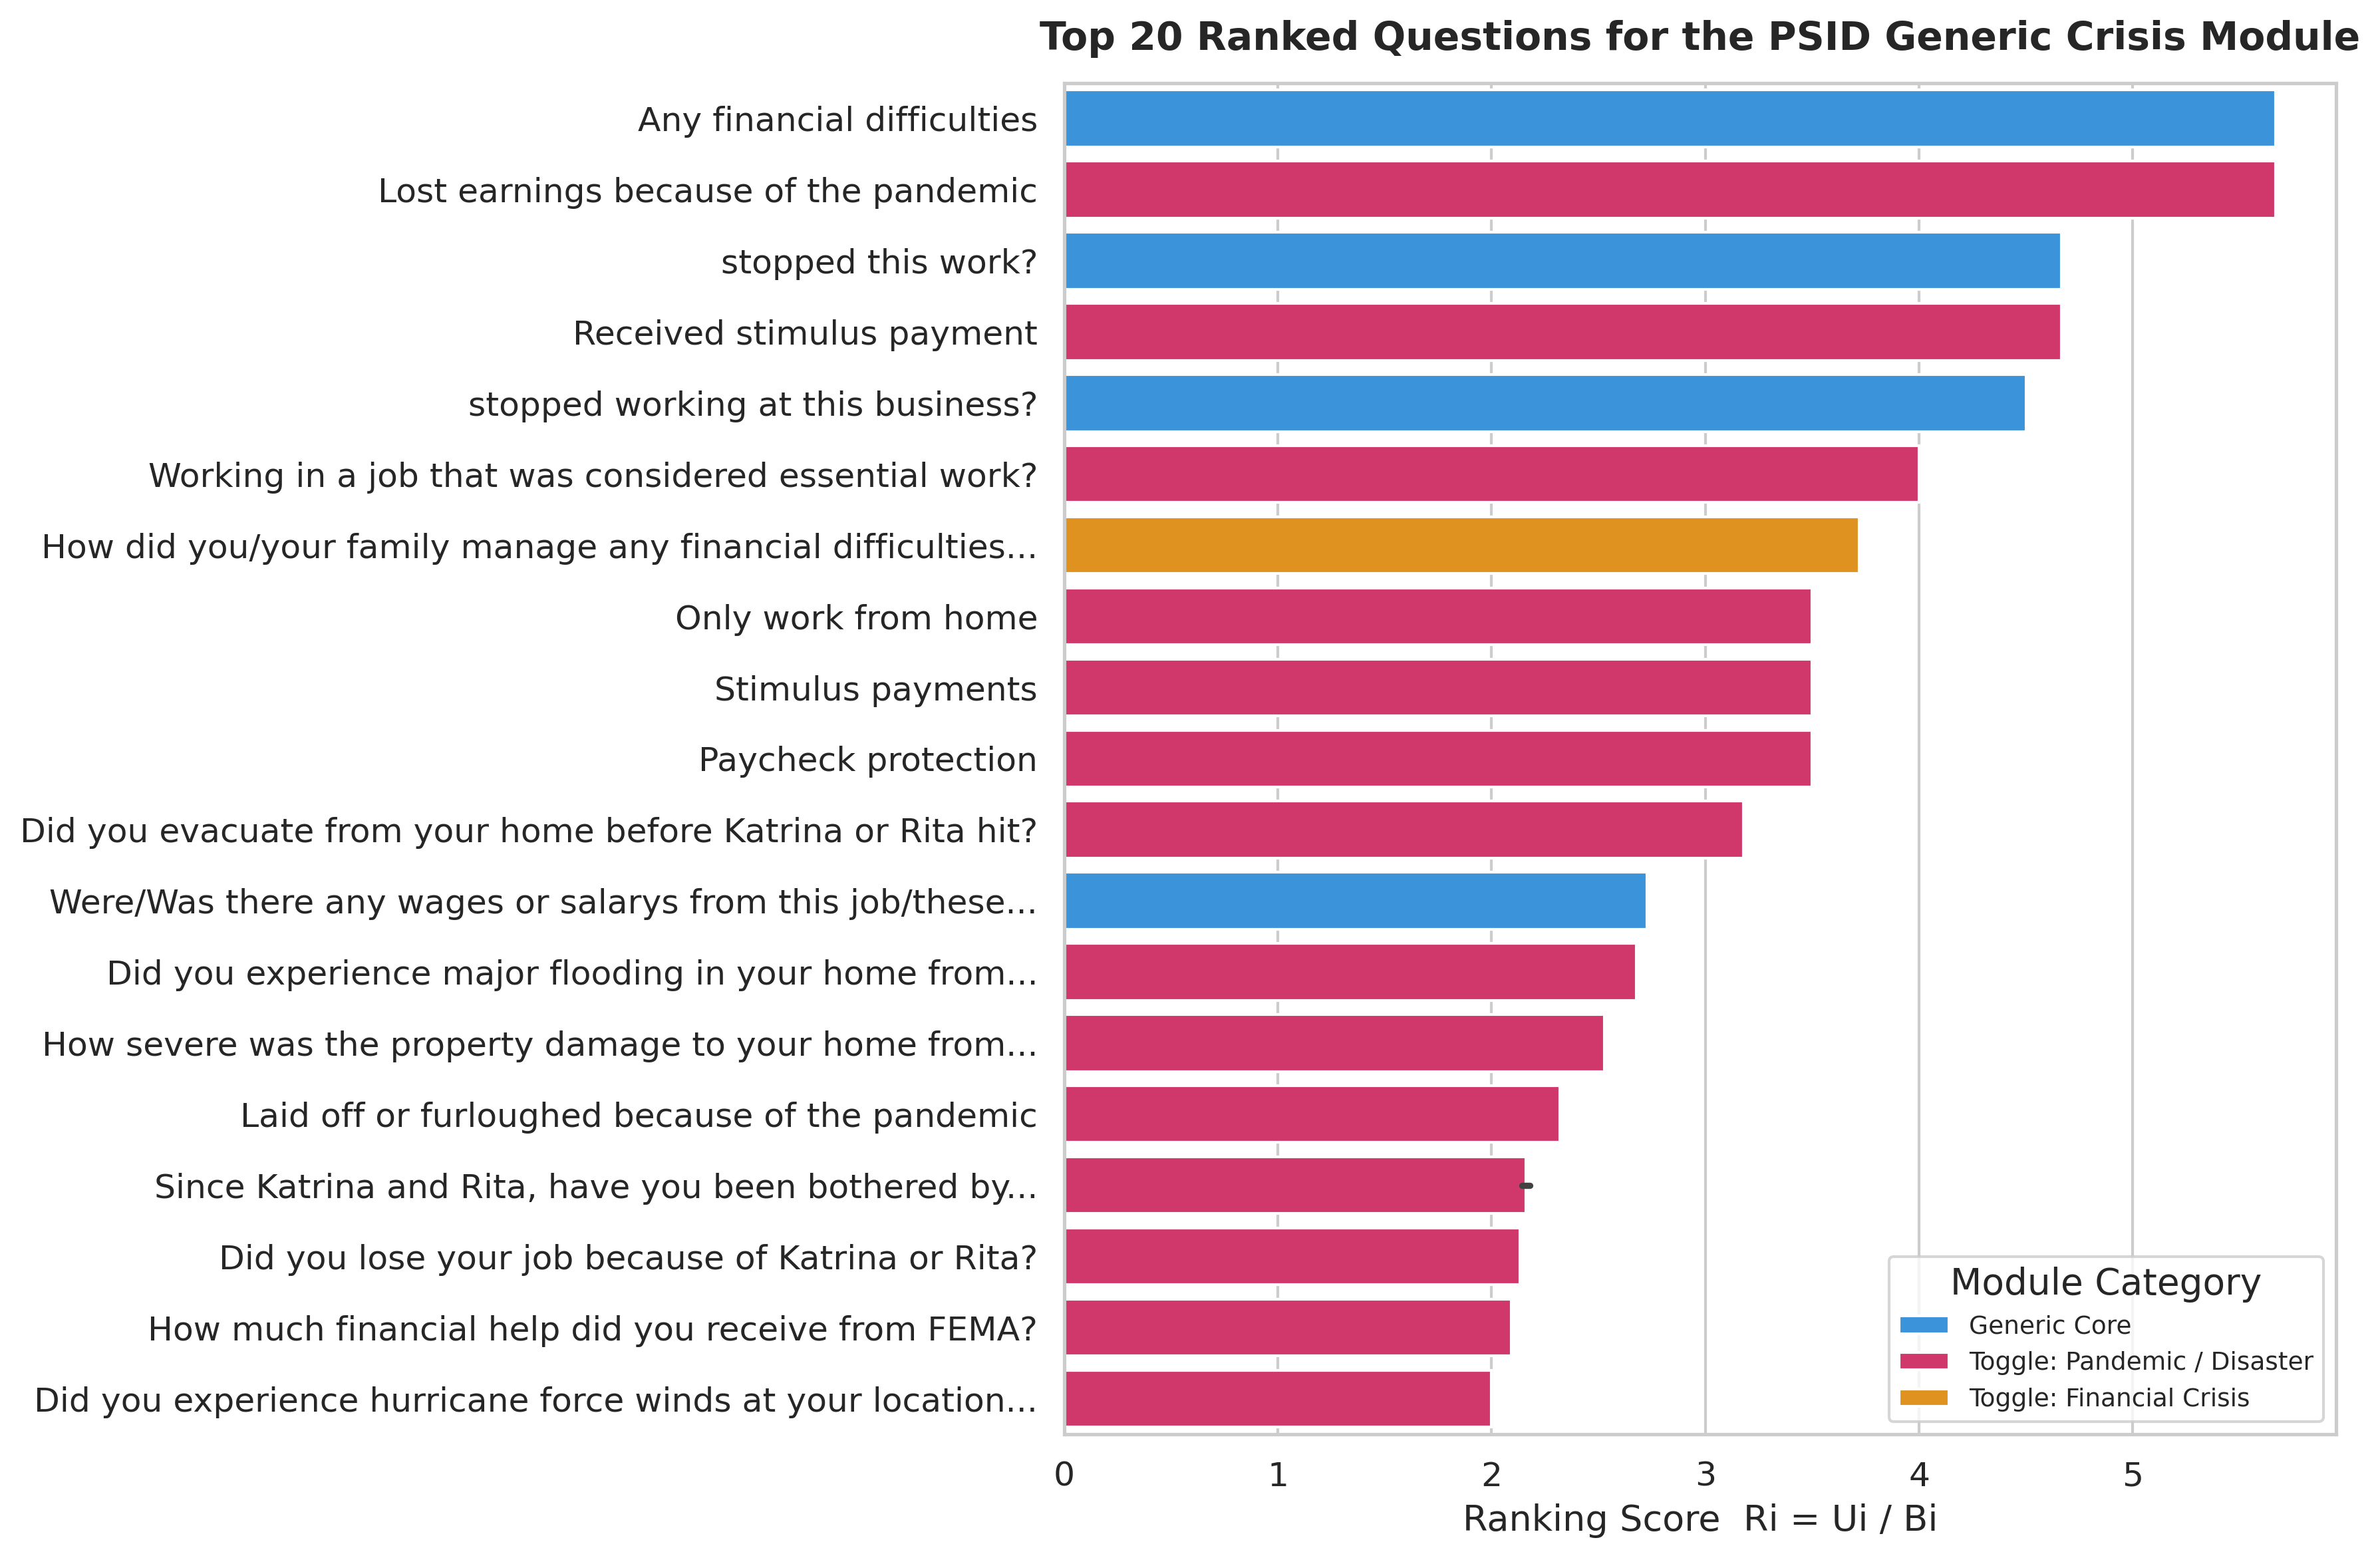

Figure 2: Utility vs. Burden Analysis
Scatter plot illustrating the relationship between utility (Ui) and burden (Bi) for all selected questions.
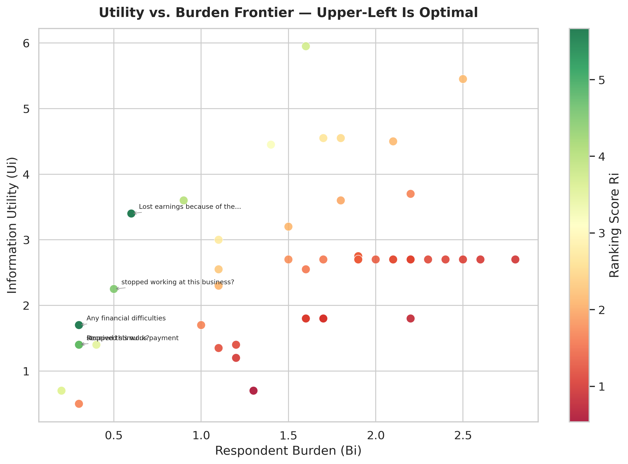

Figure 3: Time Budget Breakdown
Distribution of interview time across the three module categories.
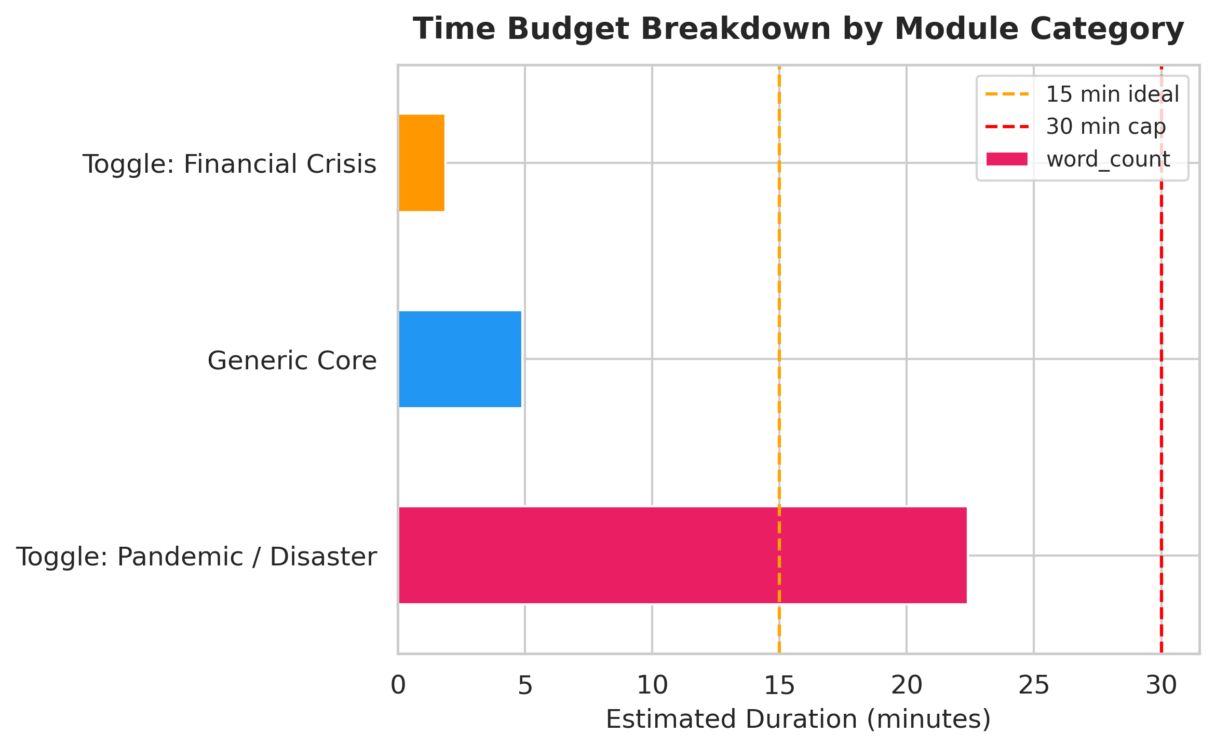

Figure 4: Construct Distribution Heatmap
Heatmap showing the relative representation of the seven constructs across selected questions.
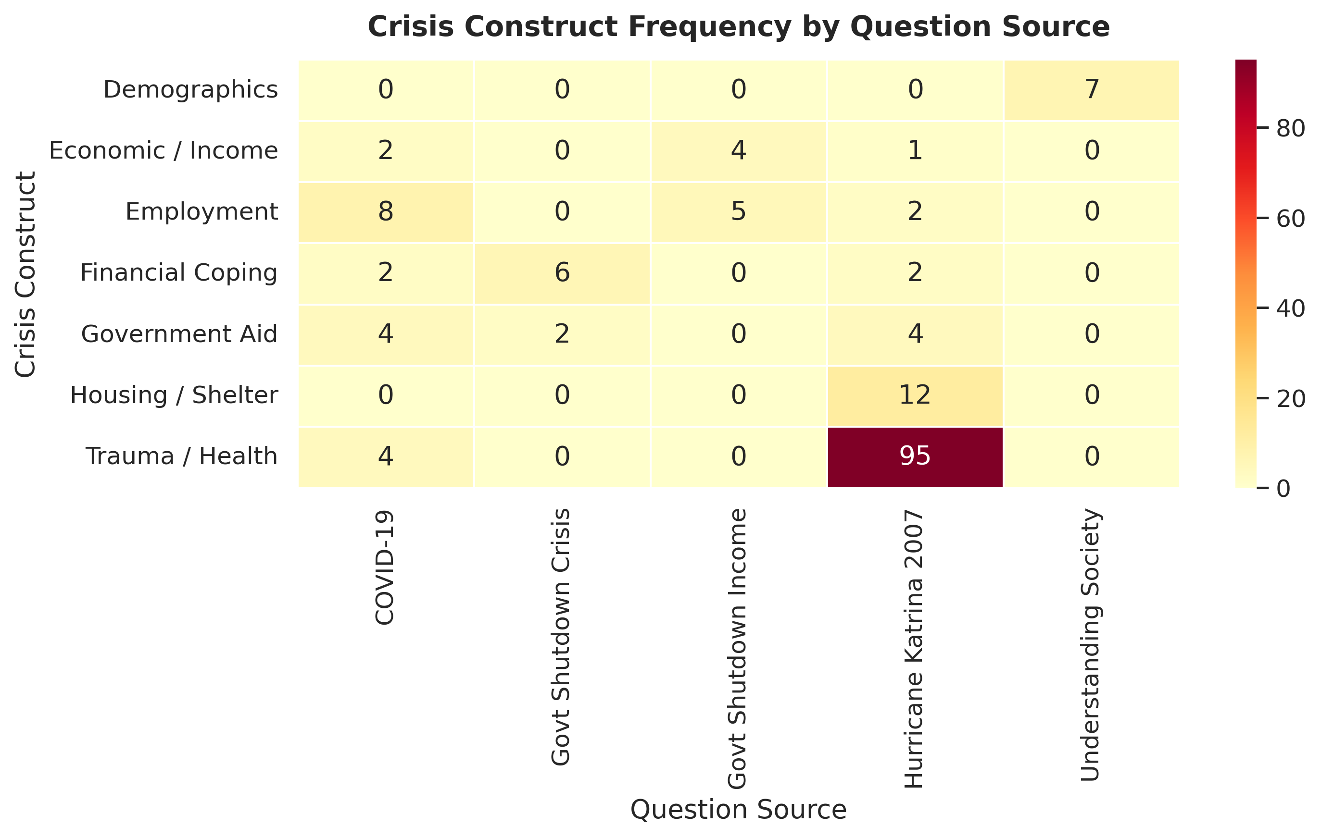

Recommendations
- Pilot Testing: Conduct a pilot study with n=50-100 respondents across both crisis types (economic and physical/health) to validate question comprehension, response variance, and time estimates.
- Crisis Type Criteria: Establish operational criteria for classifying incoming crises and triggering appropriate module combinations in real survey administration.
- IRB & Ethics Protocols: Develop trauma-informed administration protocols, particularly for the Pandemic/Disaster module, given the sensitive nature of questions on displacement, loss, and psychological distress.
- Annual Taxonomy Reviews: Conduct yearly updates to keyword weights and taxonomy entries as new crisis events occur and response literature evolves.
- Integration with Existing PSID Data: Map selected questions to existing PSID constructs and verify non-redundancy with other survey modules.

