#Diet Sentry overview
*** Context sensitive access to this HELP file can be obtained by hovering your mouse pointer over any button that you see. Close this form by pressing the {Enter}, {Esc}, {Del} Keys or the [x] button ***

This application can assist in dieting and healthy nutrition by enabling the user to record the food they eat during the day. In particular the energy (in kJ) and a range of nutrients and ingredients.
This application can assist in dieting and healthy nutrition by enabling the user to record the food they eat during the day. In particular the energy (in kJ) and a range of nutrients and ingredients.
To record the eating of a food the user selects its row from the Food DataGrid in the <Food> tab and double clicks the mouse or presses the {Enter} Key. They can then enter the amount consumed in either grams or millilitres (if the food is a liquid). Once the {Enter} key is pressed the details of this food are copied with a time stamp to a row of the DataGrid in the <Eaten> tab to which focus is then passed.
Below is a food item with Id 2,323 being selected:
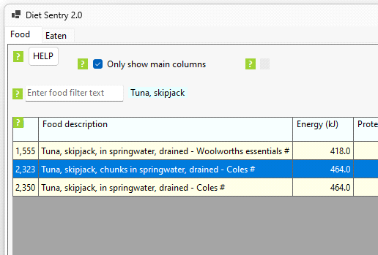
When the {Enter} key is pressed, the following dialog (with blue background) appears:
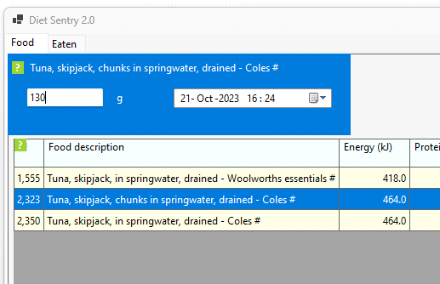
When the amount and time stamp are entered press the {Enter} key again to add the eaten food to the Eaten table. The focus then shifts to the Eaten tab:
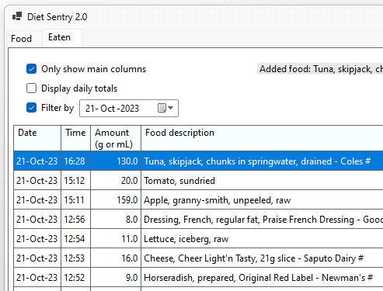
It displays all the eaten foods recorded so far today.
The foods displayed in the DataGrid of the <Eaten> tab can then be totalled for a particular day. This shows how much energy, nutrients and ingredients where consumed in total:
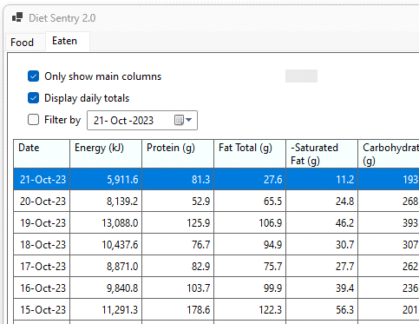
The database of foods is quite comprehensive however the user can add new foods. The editing, detailed viewing and deleting of foods is also possible. There a three types of foods: Liquids, Solids and Recipies.
The foods database and units are unashamedly based on Australian standards with energy recorded in kJ and not Calories, while other quantities are measured in millilitres (mL) or grams (g) or even mg and µg as appropriate. Dates are in the sensible dd-MMM-yyyy format and the time of day is based on 24 hours (not AM and PM).

#Foods table
Each record (table row) stores details of a particular food item. In particular a text description and then energy content and amounts of various nutrients and quantities. In all cases these are based on either 100g or 100mL of the food. If the foods description ends with the characters "mL*" or "mL" the food is measured in millilitres (mL), otherwise in grams (g).
This table is stored in the SQLiite foods.db database distributed with this application. It can be directly examined or edited with many available applications. Eg. DB Browser for SQLite. The table is visible via a DataGrid component in the <Food> tab of the applications main form, with the assumed units visible in the headers.
Below are the self explanatory internal names and details of a records fields.
CREATE TABLE "Foods" (
"FoodId" INTEGER NOT NULL,
"FoodDescription" TEXT NOT NULL,
"Energy" REAL NOT NULL,
"Protein" REAL NOT NULL,
"FatTotal" REAL NOT NULL,
"SaturatedFat" REAL NOT NULL,
"TransFat" REAL NOT NULL,
"PolyunsaturatedFat" REAL NOT NULL,
"MonounsaturatedFat" REAL NOT NULL,
"Carbohydrate" REAL NOT NULL,
"Sugars" REAL NOT NULL,
"DietaryFibre" REAL NOT NULL,
"SodiumNa" REAL NOT NULL,
"CalciumCa" REAL NOT NULL,
"PotassiumK" REAL NOT NULL,
"ThiaminB1" REAL NOT NULL,
"RiboflavinB2" REAL NOT NULL,
"NiacinB3" REAL NOT NULL,
"Folate" REAL NOT NULL,
"IronFe" REAL NOT NULL,
"MagnesiumMg" REAL NOT NULL,
"VitaminC" REAL NOT NULL,
"Caffeine" REAL NOT NULL,
"Cholesterol" REAL NOT NULL,
"Alcohol" REAL NOT NULL,
CONSTRAINT "FoodId" PRIMARY KEY("FoodId" AUTOINCREMENT)
);

#Food DataGrid
This DataGrid displays records from the Foods table and enables interaction with it. On a selected row press:
{Enter} Key: Adds selected food to Eaten table (or double click mouse)
{Delete} or {Del} Key: Deletes selected food from the Foods table
{Insert} or {Ins} Key: Adds new food to the Foods table (selected row is irrelevant)
{F2} Key: Edits selected food item
{F4} Key: Creates Solid food from selected Liquid food

By default all records from the Foods_table are displayed in the DataGrid, however to make selection more convenient what is displayed can be filtered by using the Food filter TextBox.
The fields displayed are controlled by the Food CheckBox.

#Food filter TextBox
There is a TextBox above the Food DataGrid (in the <Food> tab).
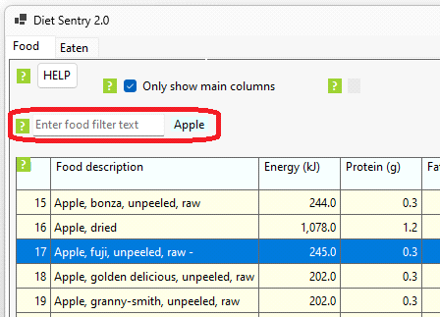
You type text into it and press the {Enter} key. As a result the DataGrid only displays those foods whose "Food Description" field contains that text. The TextBox is then cleared, with the filter text now displayed to its right and focus shifting to the now selected top row in the DataGrid. Sorting is ascending with respect to the <Id> field (internally called "FoodId"). Note: if the filter gives no results the focus remains in the TextBox.

#Food CheckBox
There is one CheckBox above the Food DataGrid (in the <Food> tab). It is titled "Only show main columns".
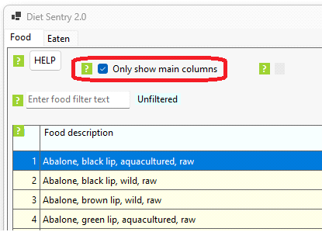
When Unchecked the DataGrid displays all fields from the foods table.
When Checked a subset of nutritional information is displayed. In particular only the fields :
"FoodId"
"FoodDescription"
"Energy"
"Protein"
"FatTotal"
"SaturatedFat"
"Carbohydrate"
"Sugars"
"DietaryFibre"
"SodiumNa"

These fields include the core nutrients required to be displayed by Australian regulators and are shown here using the internal food table names (and not the actual headers).
#Food info Label
There is a Label above the Food DataGrid (in the <Food> tab). It displays a summary description of any activity related to this DataGrid.
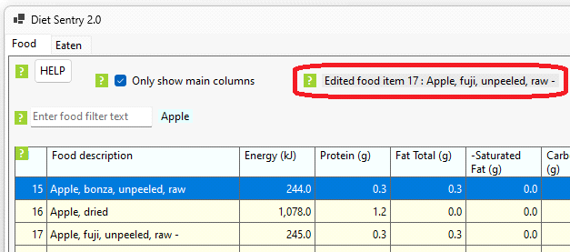
Eg. the above shows the message after food item 17 had been edited.

#Eaten food dialog
When a food is selected from the Food DataGrid and the {Enter} key pressed (or the mouse double clicked) the following dialog (with blue background) appears:
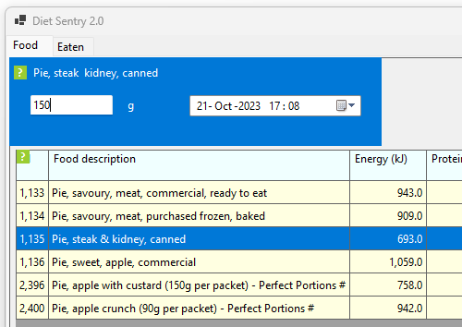
At the top it displays the desciption of the food you selected. Type the amount of food you have consumed into the TextBox. This will be in grams (g) if the food is a solid or millilitres (mL) if a liquid. If necessary adjust the time stamp in the DateTimePicker, by default it will display "now". When satisfied with the inputs press the {Enter} Key. This will close the dialog and add the eaten food's details to the Eaten table. Focus is then transferred to the Eaten DataGrid in the <Eaten> tab.
If you input an invalid amount eg. the string "e1..2" or just leave it blank then this dialog form closes and nothing is processed when you press the {Enter} Key. Pressing the {Escape} or {Delete} Key also just closes this form, returning focus to the food previously selected in the DataGrid.

#Liquid density dialog
When a liquid is selected in the Food DataGrid and the {F4} key pressed the following dialog (with blue background) appears:

#Eaten table
Each record (table row) stores details of a particular amount of food consumed. In particular a time stamp of when consumption occured (or was recorded), the amount eaten in grams or millilitres, the foods text description and then the actual amounts of Energy, nutrients and ingredients consumed.

#Eaten DataGrid
This DataGrid displays data from the Foods table and enables interaction with it.
This application can assist in dieting and healthy nutrition by enabling the user to record the food they eat during the day. In particular the energy (in kJ) and a range of nutrients and ingredients.
To record the eating of a food the user selects its row from the dataGrid in the <Food> tab and double clicks the mouse or presses the {Enter} Key. They can then enter the amount consumed in either grams or millilitres (if the food is a liquid). Once the {Enter} key is pressed the details of this food are copied with a time stamp to a row of the dataGrid in the <Eaten> tab to which focus is then passed.
The foods displayed in the dataGrid of the <Eaten> tab can then be totalled for a particular day. This shows how much energy, nutrients and ingredients where consumed in total.
The database of foods is quite comprehensive however the user can add new foods. The editing, detailed viewing and deleting of foods is also possible. There a three types of foods: Liquids, Solids and Recipies.
The foods database and units are unashamedly based on Australian standards with energy recorded in kJ and not Calories, while other quantities are measured in millilitres (mL) or grams (g) or even mg and µg as appropriate. Dates are in the sensible dd-MMM-yyyy format and the time of day is based on 24 hours (not AM and PM).
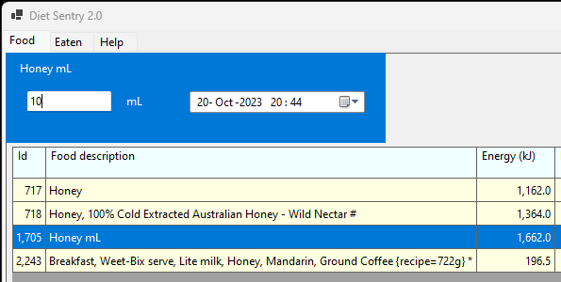

#Help system error
This DataGrid displays data from the Foods table and enables interaction with it.
This application can assist in dieting and healthy nutrition by enabling the user to record the food they eat during the day. In particular the energy (in kJ) and a range of nutrients and ingredients.

