Python ანბანი:

A Python identifier is a name used to identify a variable, function, class, module or other object. An identifier starts with a letter A to Z or a to z or an underscore (_) followed by zero or more letters, underscores and digits (0 to 9). Python does not allow punctuation characters such as @, $, and % within identifiers. Python is a case sensitive programming language. Thus, Manpower and manpower are two different identifiers in Python. Here are naming conventions for Python identifiers-

• Class names start with an uppercase letter. All other identifiers start with a lowercase letter.

• Starting an identifier with a single leading underscore indicates that the identifier is private.

• Starting an identifier with two leading underscores indicates a strong private identifier.

• If the identifier also ends with two trailing underscores, the identifier is a languagedefined special name.

Reserved Words

The following list shows the Python keywords. These are reserved words and you cannot use them as constants or variables or any other identifier names. All the Python keywords contain lowercase

letters only.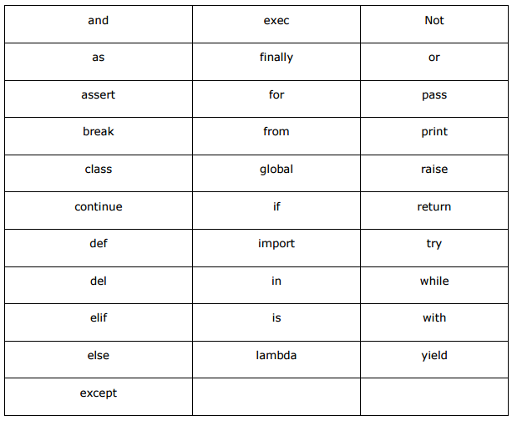

Variable Types

Variables are nothing but reserved memory locations to store values. It means that when you create a variable, you reserve some space in the memory.

Based on the data type of a variable, the interpreter allocates memory and decides what can be stored in the reserved memory. Therefore, by assigning different data types to the variables, you can store integers, decimals or characters in these variables.

**Assigning Values to Variables**

Python variables do not need explicit declaration to reserve memory space. The declaration happens automatically when you assign a value to a variable. The equal sign (=) is used to assign values to variables. The operand to the left of the = operator is the name of the variable and the operand to the right of the = operator is the value stored in the variable. For example-

In put:

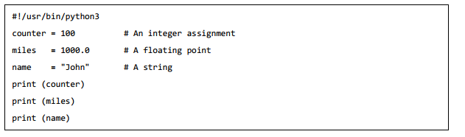

Out put:

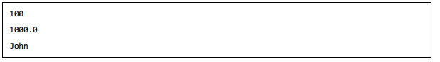

**Multiple Assignment**

Python allows you to assign a single value to several variables simultaneously. For example-



Here, an integer object is created with the value 1, and all the three variables are assigned to the same memory location. You can also assign multiple objects to multiple variables.



