SELECT \* FROM world.city; 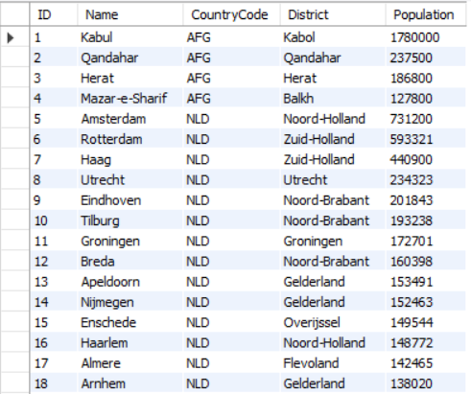

SELECT \* FROM world.city where Name like 'hanoi';

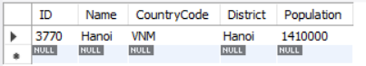

INSERT INTO world.city (Name, CountryCode, District, Population)

VALUES ('Hanoi', 'VNM', 'Ba Vi', "69000");

SELECT \* FROM world.city where District like "Ba Vi";

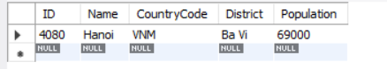

UPDATE world.city SET Population = 69690 where ID = 4080;

SELECT \* FROM world.city where District like "Ba Vi";

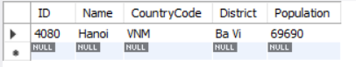

delete from world.city where id=4080;

SELECT \* FROM world.city where District like "Ba Vi";

