**LAB5&6**

* You are provided with one file containing data named**: database.json** in the **given** directory.
* You must use the solution provided (**resource** folder) in given folder and install the additional library included in the accompanying request.

**Exam results:**

- URL: http://localhost:3000

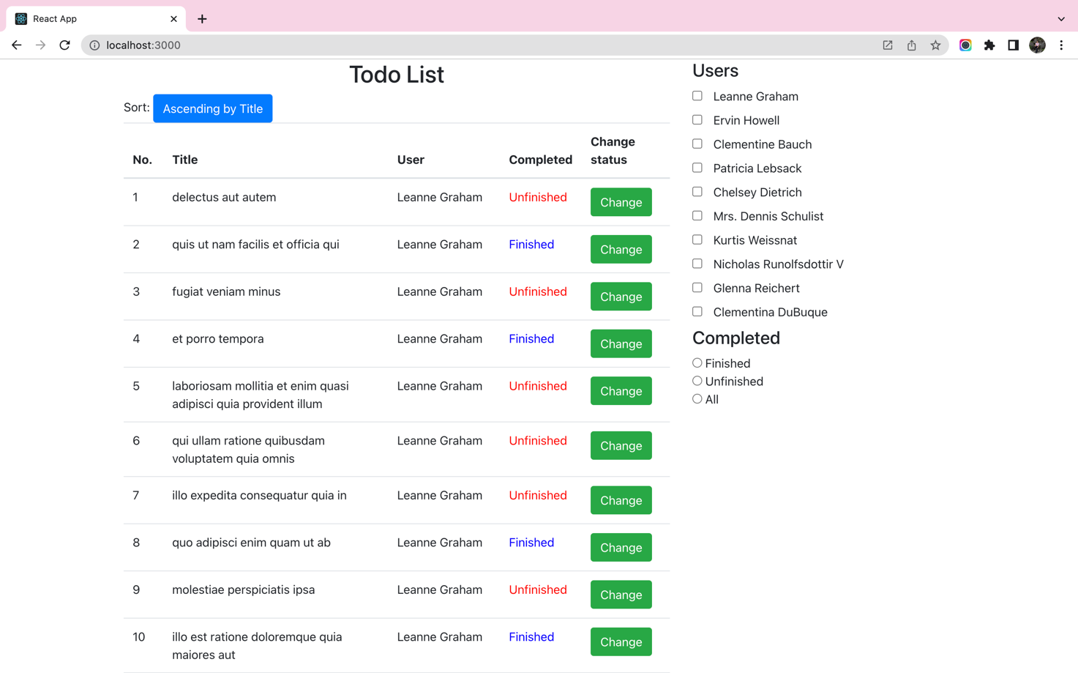

*Figure 1 - Exam result screen*

**Requirements:**

* Copy the file “**database.json**” in the given folder to your exam.
* Open two Terminal Command windows on your exam to execute commands:



**1.** **Create a component named “Index”:**

* Fetch data from **http://localhost:9999/user** to create the "**Users**" filter.

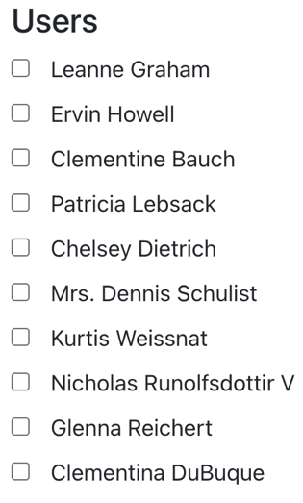

* Design the filter according to the “**Completed**” state as shown below:

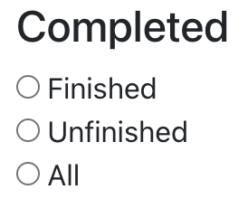

* Fetch all data from **http://localhost:9999/todo** and **http://localhost:9999/user** presented in tabular format.

*(Reduce by* ***0.5*** *points without the "Ascending by Title" and "Change" buttons; Reduce* ***1*** *point if the data of 2 columns "User" and "Completed" is not displayed correctly)*

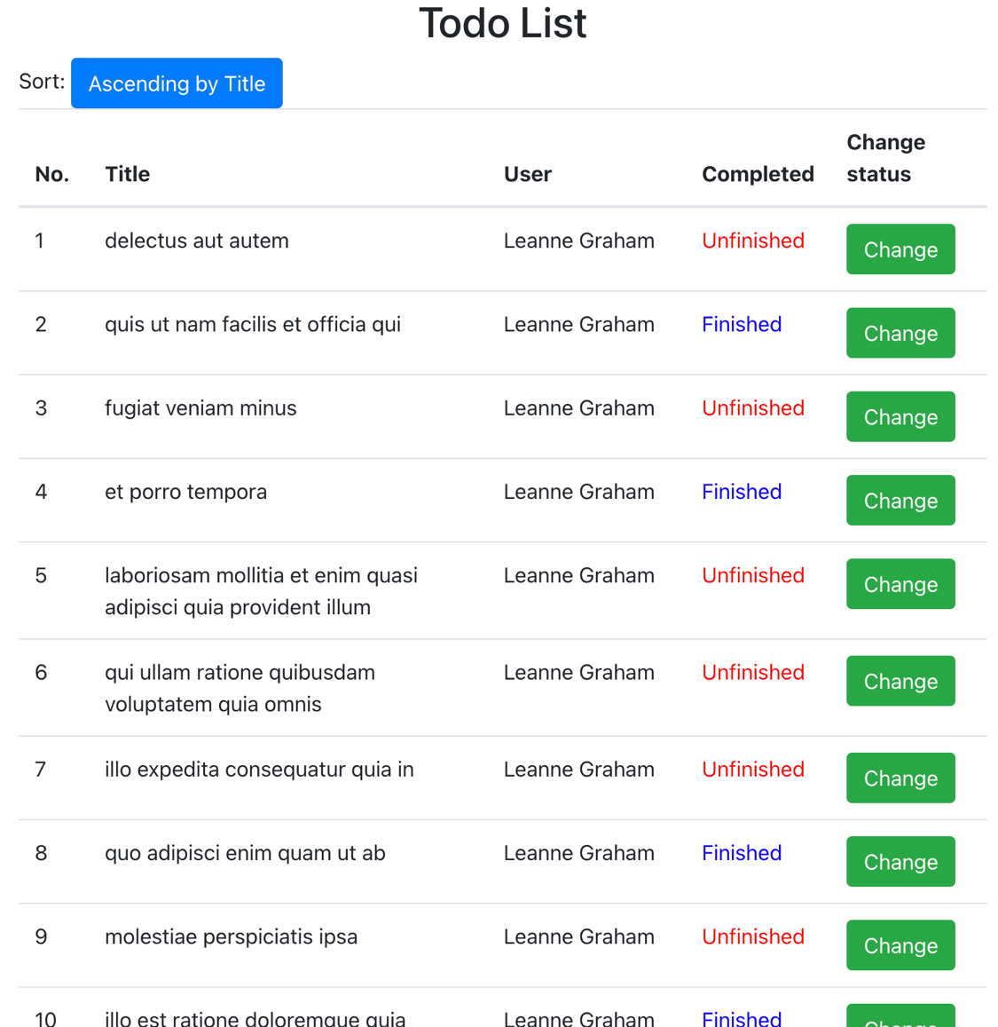

**2. Event handing**

* When the user clicks the "**Ascending by Title**" button, the data will be sorted in ascending order by "**Title**"
* When user clicks "**Change**" button the job status is updated of the respective record. If it is from "**Finished**" will change to "**Unfinished**" and vice versa.

*After:*

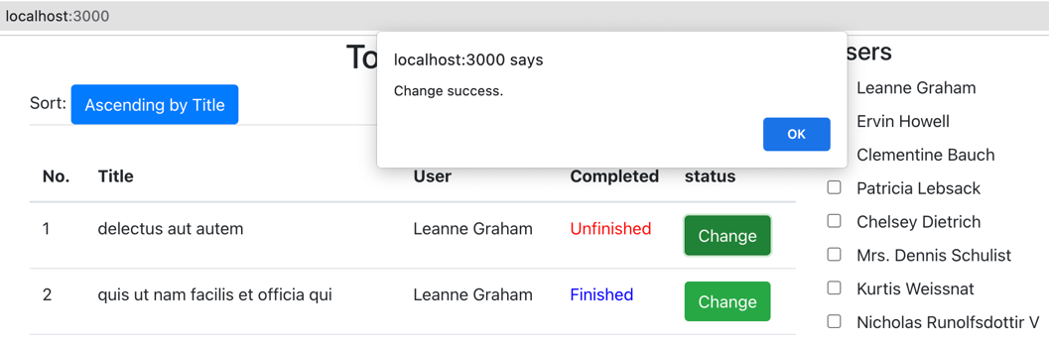

*Before:*

