**PRN222 Assignment 01**

**Building a News Management System with ASP.NET Core Web App (Model View Controller)**

# 1. Introduction

A News Management System (NMS) is a software application that helps universities and educational institutions to efficiently manage, organize, and publish news and content to their website and other channels. The NMS typically includes features such as content creation, approval workflow, scheduling, publishing, and analytics. This can help universities to arrange appropriately their news operations, improve communication with students and the wider community, and better engage with their target audience.

Imagine you're a developer of a News Management System named **FUNewsManagementSystem**. To implement a part of this system your tasks include:

* Manage account information.
* Manage news article.

The application has a default account (admin account) whose email is “**admin@FUNewsManagementSystem.org**” and password is “**@@abc123@@**” that stored in the **appsettings.json**.

# 2. Assignment Objectives

In this assignment, you will:

* Use the Visual Studio.NET to create ASP.NET Core MVC and Class Library (.dll) projects.
* Perform CRUD actions using Entity Framework Core.
* Use LINQ to query and sort data.
* Apply 3-Layers architecture to develop the website.
* Apply Repository pattern and Singleton pattern in a project.
* Add CRUD and searching actions to the website.
* Apply to validate data type for all fields.
* Run the project and test the Web application actions.

# 3. Database Design

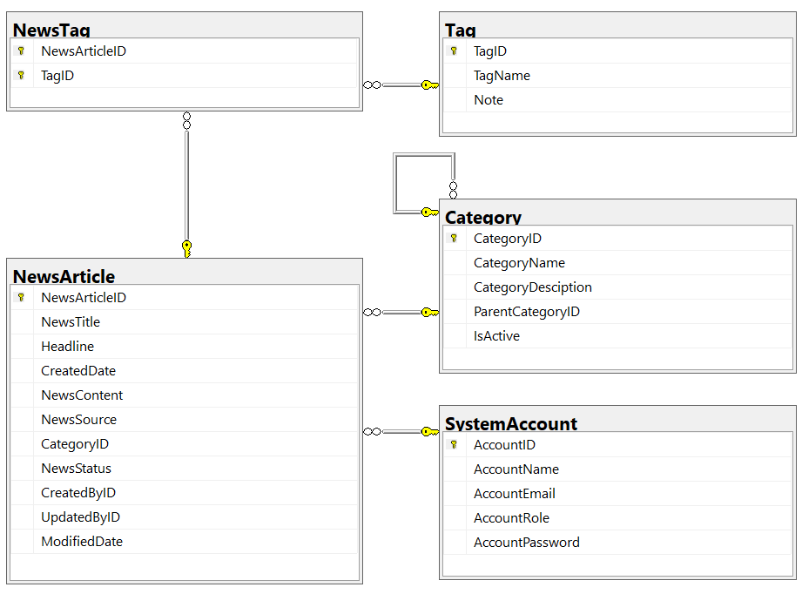

* A news article will belong to only one news category (Category).
* An account with staff’s role can create many news articles in this system. (Staff role = 1, Lecturer role = 2; Admin role will get from appsettings.json file).
* A news article will have many tags and one tag will belong to zero or one news article (News status = active(1)/inactive(0)).
* Category status = active(1)/inactive(0).

# 4. Main Functions

* *Do not need authentication to view the news article (news status must be active) in this system.*
* Member (Admin/Staff/Lecturer) authentication by Email and Password.
* *If user is a “****Lecturer****”, this role is allowed to view the news article (news status must be active) in this system.*
* If the user is an “**Admin**”, this admin role is allowed to:
  + Manage account information.
  + Create a report statistic by the period from StartDate to EndDate (it depends to the news’ created date), and sort data in descending order.
* If user is a “**Staff**”, this staff role is allowed to:
  + Manage category information. (The delete action will delete an item in the case this item is not belong to any news articles. If the item is already stored in a news article cannot delete.)
  + Manage news article (includes tags).
  + Manage his/her the profile.
  + View news history created by him/her.
* Note that: News article Management, Account Management, and Category Management: Read, Create, Update, Delete and Search actions. Creating and Updating actions must be performed by popup dialog. Delete action always combines with confirmation.

# 5. Note

* You must use **Visual Studio 2019 or above (.NET5/.NET6/.NET7/.NET8), MSSQL Server 2012 or above** for your development tools.
* To do your program, you must use **ASP.NET Core Web App (Model-View-Controller). Note that** *you are not allow to connect direct to database from Controller, every database connection must be used through Service, Repository and Data Access Objects. The database connection string must get from appsettings.json file.*
* Create Solution in Visual Studio named **StudentName_ClassCode_A01.sln**. Inside your Solution, the Project WPF must be named: **StudentNameMVC.**
* Create your MS SQL database named **FUNewsManagement** by running code in script **FUNewsManagement.sql.**
* Set the default user interface for your project as **Login** window.