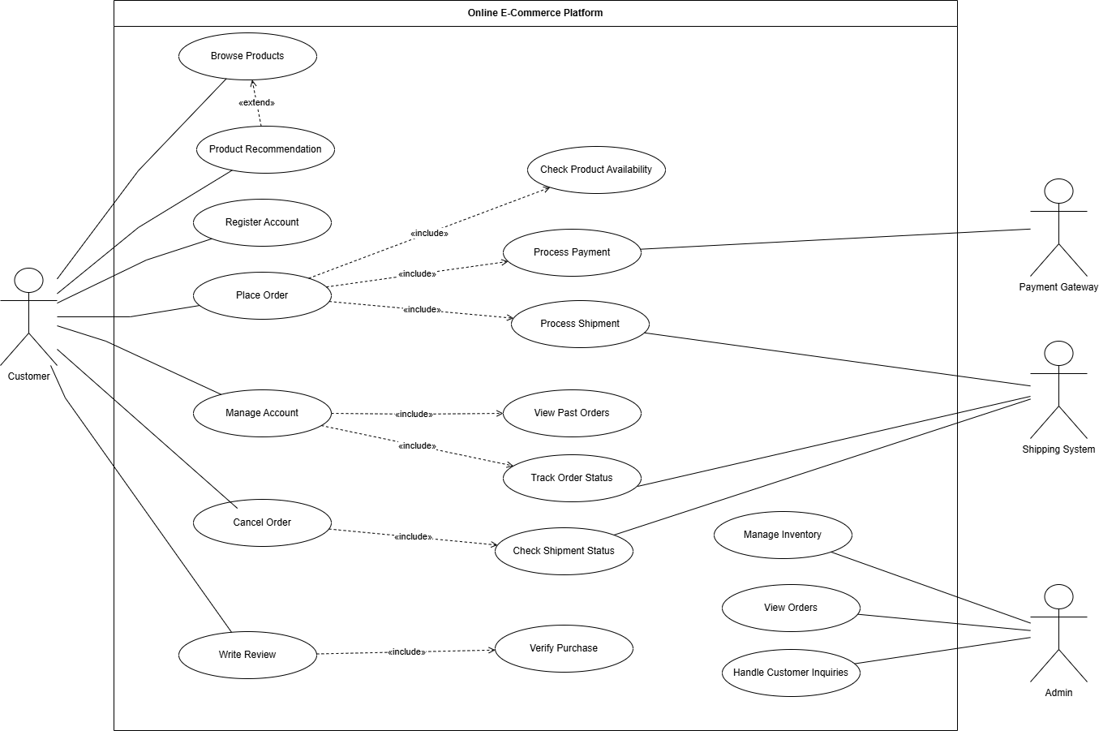

Summary
This diagram shows what an online shopping website can do. Customers can look at products make an account buy things manage their account cancel orders and write what they think about products. The Admin takes care of products looks at orders and helps customers with questions. The Payment Gateway handles money and the Shipping System helps with sending products and checking where they are.
The include relationship is used for things that have to happen. For example when you buy something the website has to check if the product's available and take your money. When you write a review the website has to make sure you actually bought the product.
The extend relationship is used for things that can happen but do not have to. For example when you look at products the website might suggest products you could like.. You can still look at products even if the website does not suggest anything.
Overall the diagram shows how customers, the admin, the payment gateway and the shipping system work with the shopping website. It shows the steps of shopping and how all these parts interact with each other. The online shopping website is, like a system where customers can do things and the diagram explains how it all works together.

