**Lab Practical #01:**

Study of basic networking commands and IP configuration.

**Practical Assignment #01:**

1. Perform and explain various networking commands listed below:
   1. ipconfig
   2. ping
   3. getmac
   4. systeminfo
   5. traceroute / tracert
   6. netstat
   7. nslookup
   8. hostname
   9. pathping
   10. arp

## ipconfig

### Description:

**ipconfig shows your computer’s internet details—like IP address and connection info. It helps check, fix, and understand how your device connects to a network or internet.**

|  |  |  |
| --- | --- | --- |
| No. | Option | Description |
| 1 | ipconfig -displaydns | Shows the list of recently visited website addresses stored in your computer's DNS cache to speed up future access. |
| 2 | ipconfig -all | Shows full network details, including IP address, MAC address, and DNS info for all adapters. |
| 3 | ipconfig -release | Removes the current IP address from your computer, disconnecting it from the network temporarily. |
| 4 | ipconfig -renew | Requests a new IP address from the network, reconnecting your computer with fresh connection settings. |
| 5 | ipconfig -flushdns | Clears the DNS cache on your computer, helping fix website loading or name resolution problems. |

### Implementation:

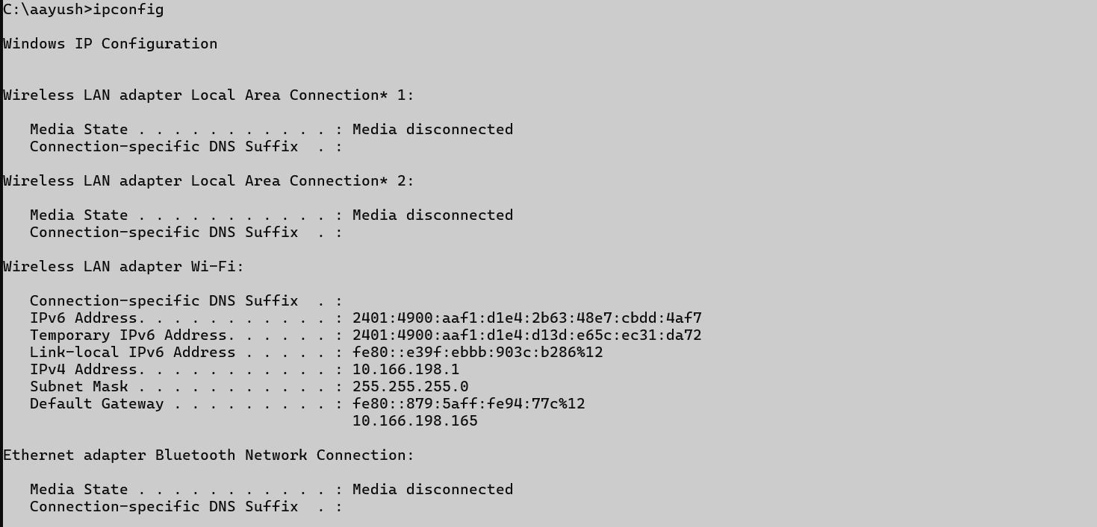

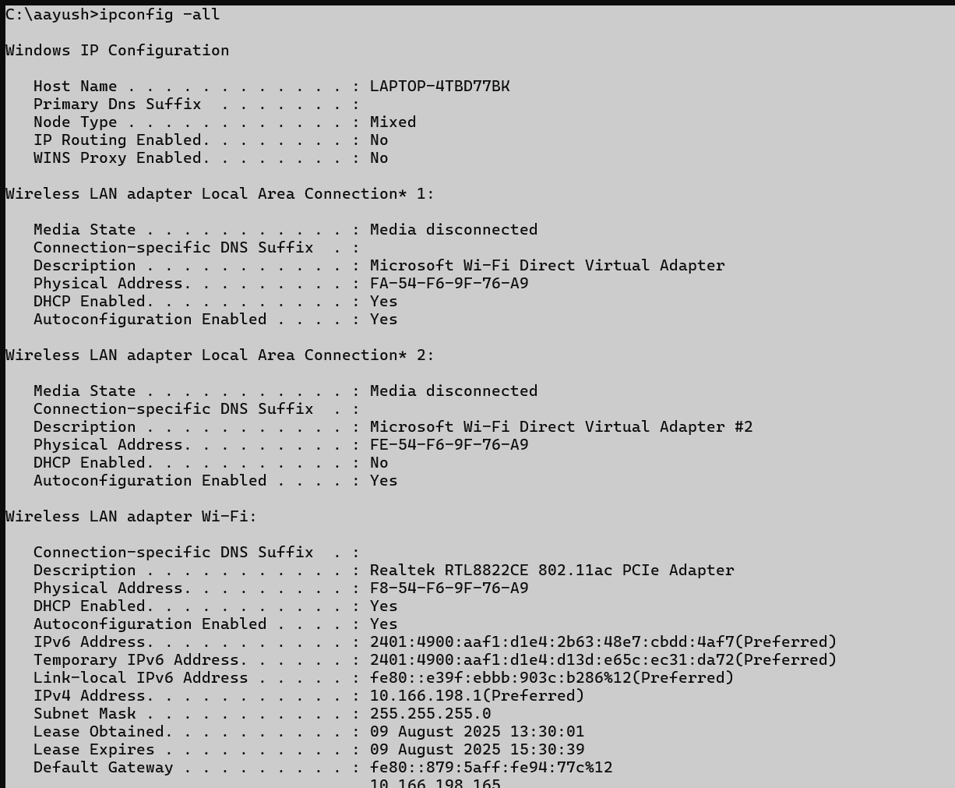

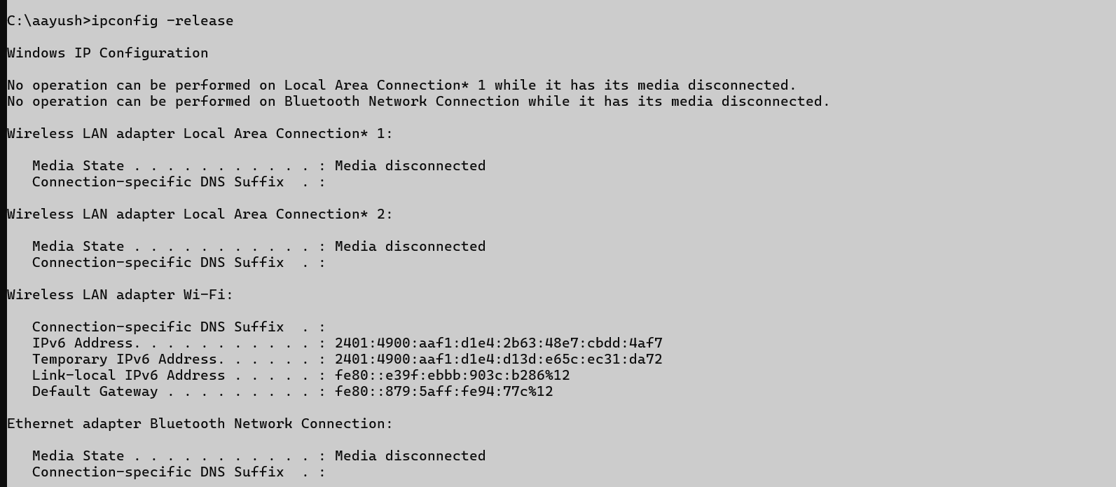

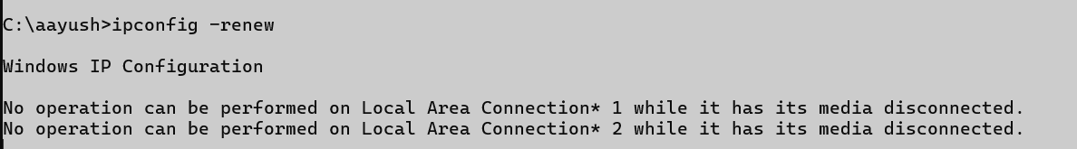



## ping

### Description:

**The ping command checks if another computer or device is reachable over a network. It sends a signal and waits for a reply to test connection and speed.**

|  |  |  |
| --- | --- | --- |
| No. | Option | Description |
| 1 | -a | Finds the hostname of an IP address by sending a network signal and showing its name if available. |
| 2 | -t | Ping the specified host until stopped. To see statistics and continue - type Control-Break; |
| 3 | -l | Sets the size of the packet sent, useful for testing with bigger or smaller data packets. |
| 4 | -n | Sets how many times to ping the target instead of the default 4 times. |
| 5 | -f | Sends ping packets without allowing fragmentation, used to test network’s ability to handle large packets without breaking. |

### Implementation:



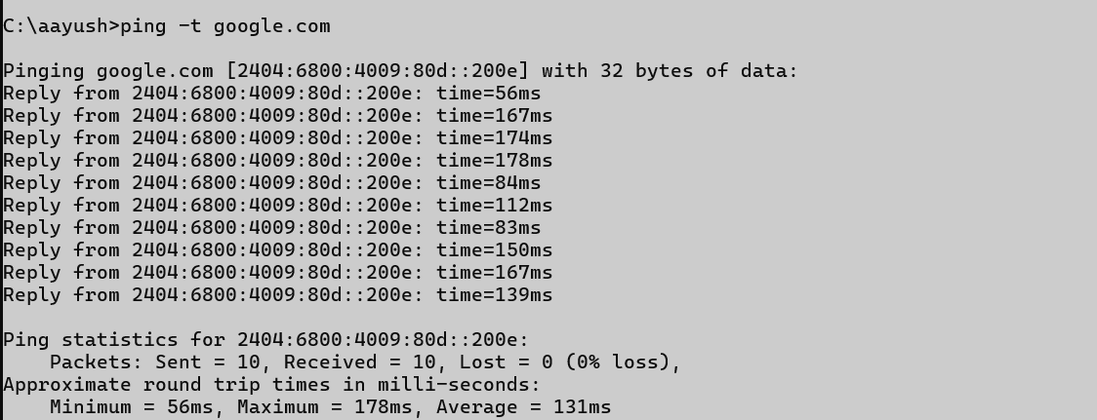

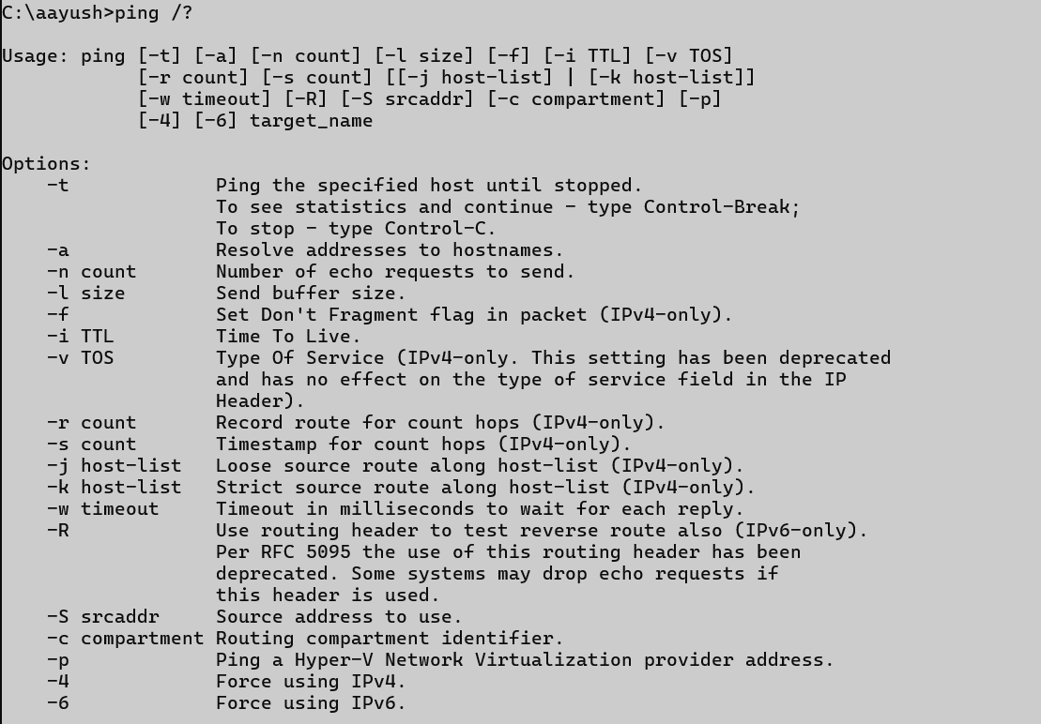

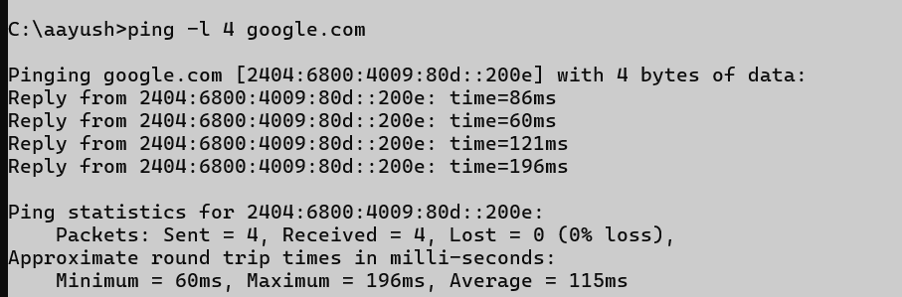

## getmac

### Description:

**getmac is a command used to show the MAC (Media Access Control) address of your computer's network adapter. It helps identify devices connected to a network.**

|  |  |  |
| --- | --- | --- |
| No. | Option | Description |
| 1 | /s | Connects to a remote computer by name or IP address to get its MAC address information from your system. |
| 2 | /nh | Specifies that the "Column Header" should not be displayed in the output. Valid only for TABLE and CSV formats |
| 3 | /p | Provides the password for the specified user. If not included, it asks you to type the password manually. |
| 4 | /fo | Changes how results are displayed. Options are: TABLE (grid), LIST (detailed), or CSV (comma-separated values for Excel use). |
| 5 | /v | Specifies that verbose output is displayed. |

### Implementation:











## systeminfo

### Description:

**systeminfo is a command that shows detailed information about your computer, like system name, OS version, memory, processor, network, and more — helpful for checking system details quickly.**

|  |  |  |
| --- | --- | --- |
| No. | Option | Description |
| 1 | /s | Connects to a remote computer using its name or IP to get system information from that remote machine. |
| 2 | /u | Lets you enter a specific username to access the remote computer and view its system information securely. |
| 3 | /? | It shows the help manual for any command in the Command Prompt (CMD) |
| 4 | /fo | Changes how the system info is displayed. Options are: table, list, or CSV (for spreadsheet use). |
| 5 | /nh | Hides column headers from the output. Useful when using the data in scripts or for simpler output. |

### Implementation:

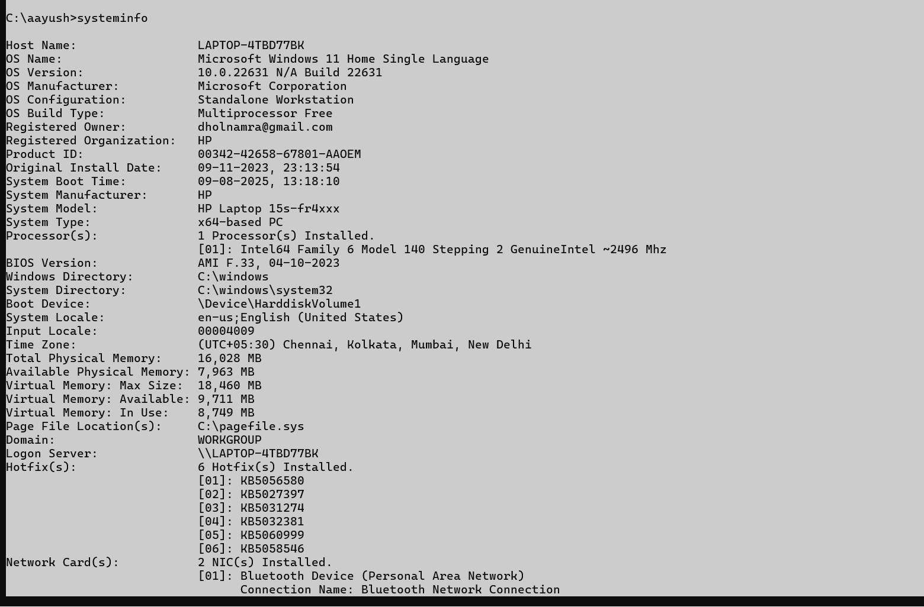

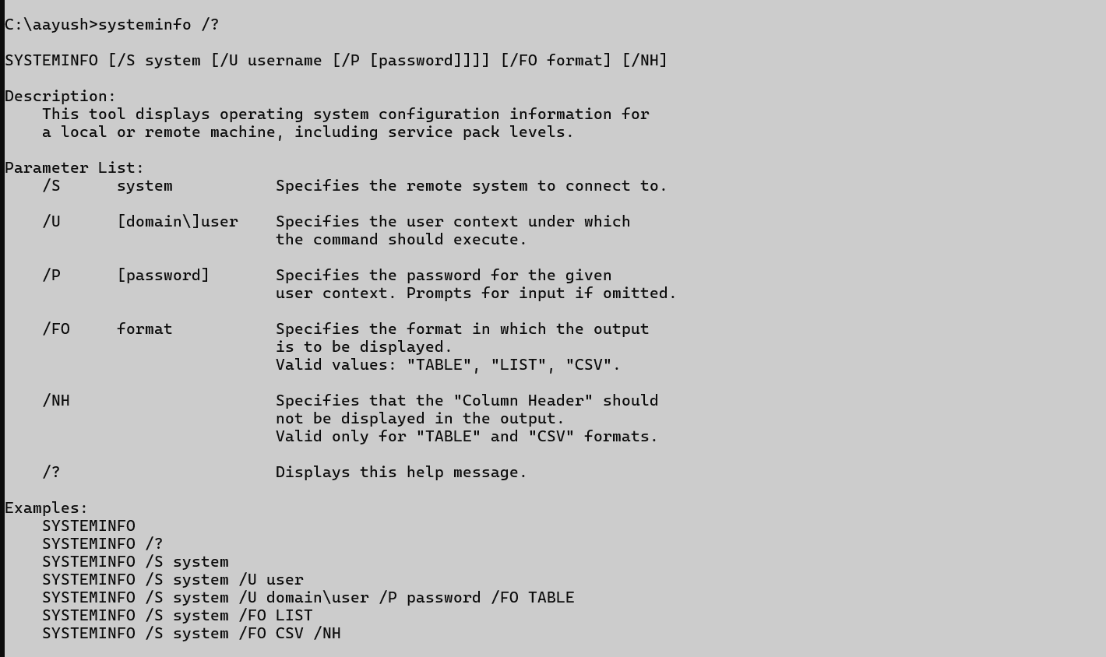

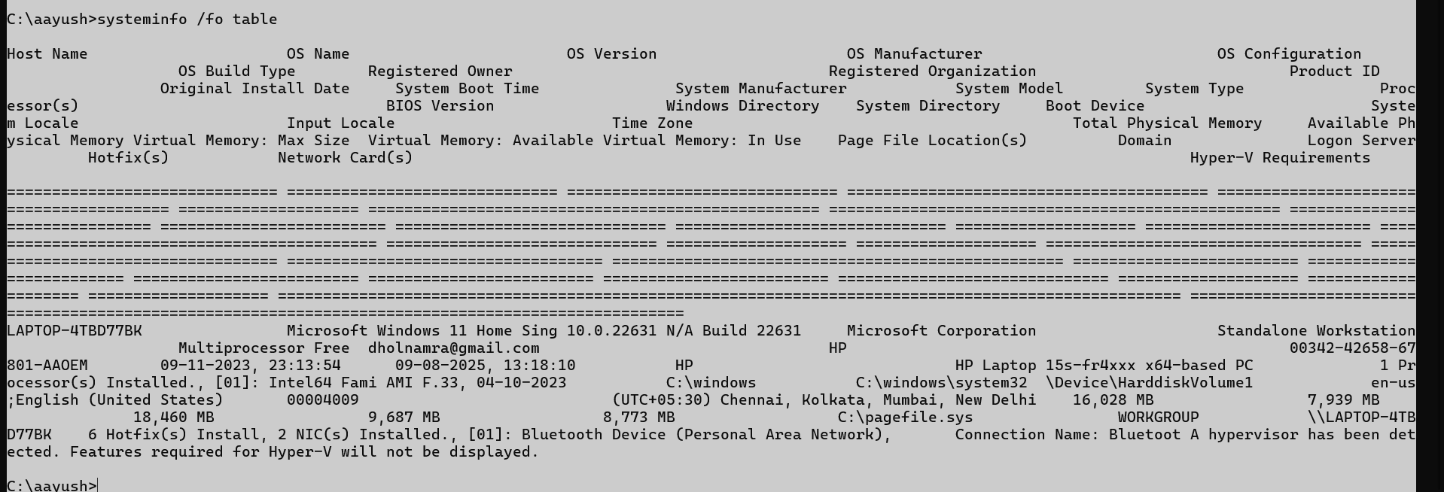

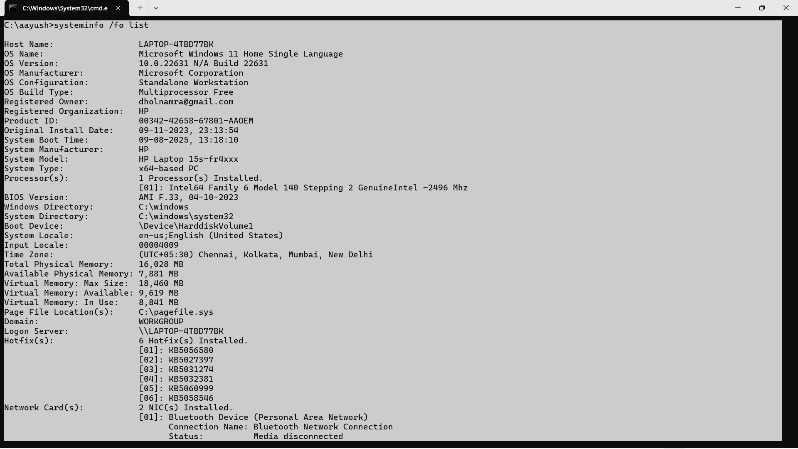

## Tracert

### Description:

**tracert is a command that shows the path your data takes to reach another computer or website, including all the stops (hops) between your system and the destination.**

|  |  |  |
| --- | --- | --- |
| No. | Option | Description |
| 1 | /R | Traces the route to a destination and back (round trip), showing the path in both directions. Windows-only option. |
| 2 | /d | Do not resolve hostnames (faster output by skipping DNS lookups). |
| 3 | /h | |  | | --- | |  |  |  | | --- | | Set maximum number of hops | |
| 4 | /w | Timeout in milliseconds to wait for each reply. |
| 5 | /4 | Forces IPv4 tracing |

### Implementation:

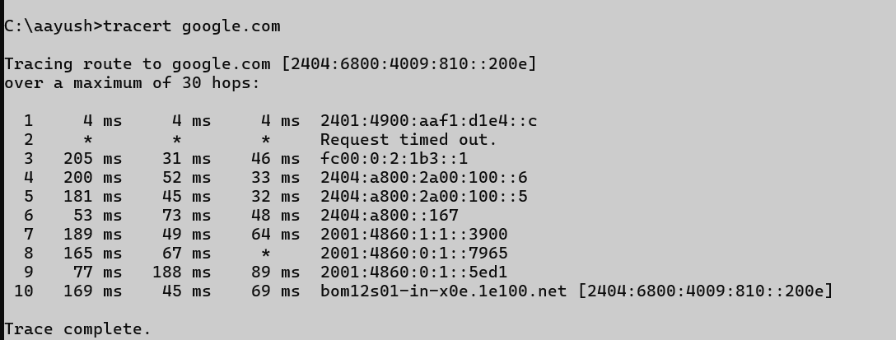

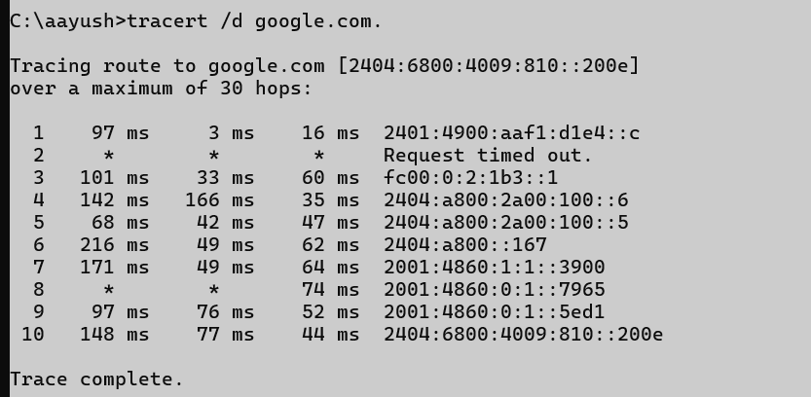

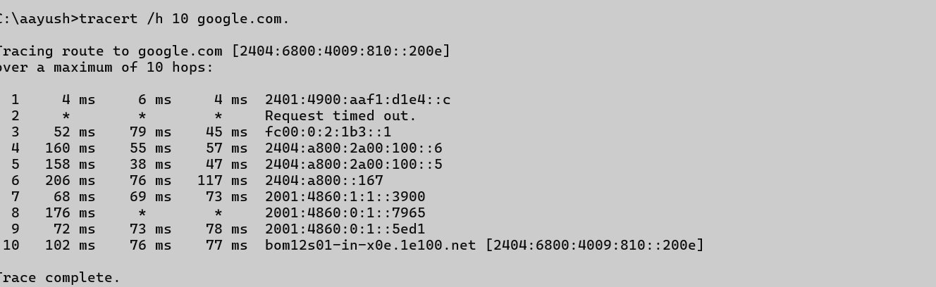

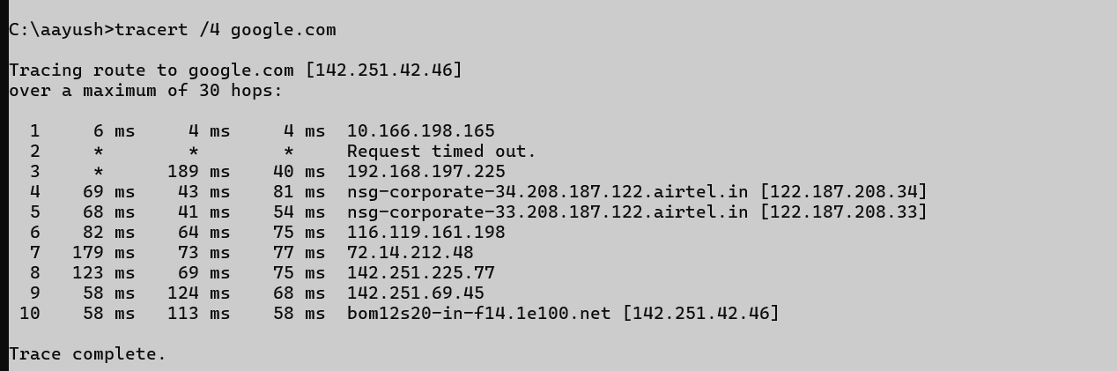

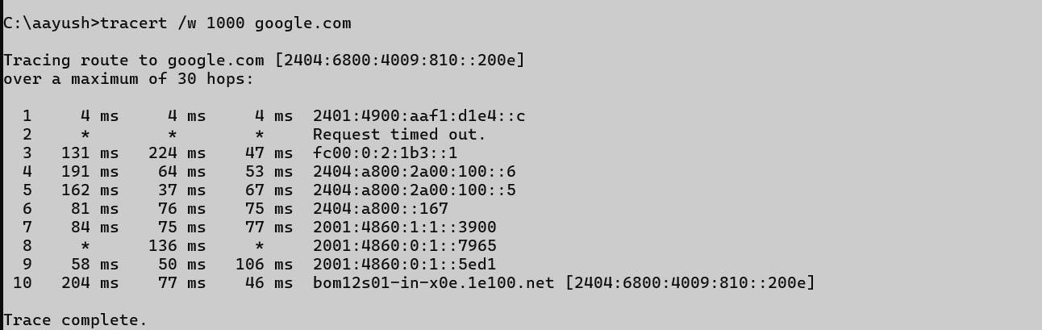

## Netstat

### Description:

**netstat is a command that shows network connections, open ports, and network statistics. It helps check which programs are using the internet or network on your computer.**

|  |  |  |
| --- | --- | --- |
| No. | Option | Description |
| 1 | -d | Displays DSCP (priority) value**s** for each connection, showing how network traffic is being handled or prioritized. |
| 2 | -a | |  | | --- | |  |  |  | | --- | | Shows all connections and listening ports | |
| 3 | -n | |  | | --- | |  |  |  | | --- | | Shows IP addresses and port numbers without DNS names (faster) | |
| 4 | - r | |  | | --- | |  |  |  | | --- | | Displays the routing table (same as route print). | |
| 5 | - o | |  | | --- | |  |  |  | | --- | | Displays the owning process ID (PID) for each connection. | |

### Implementation:

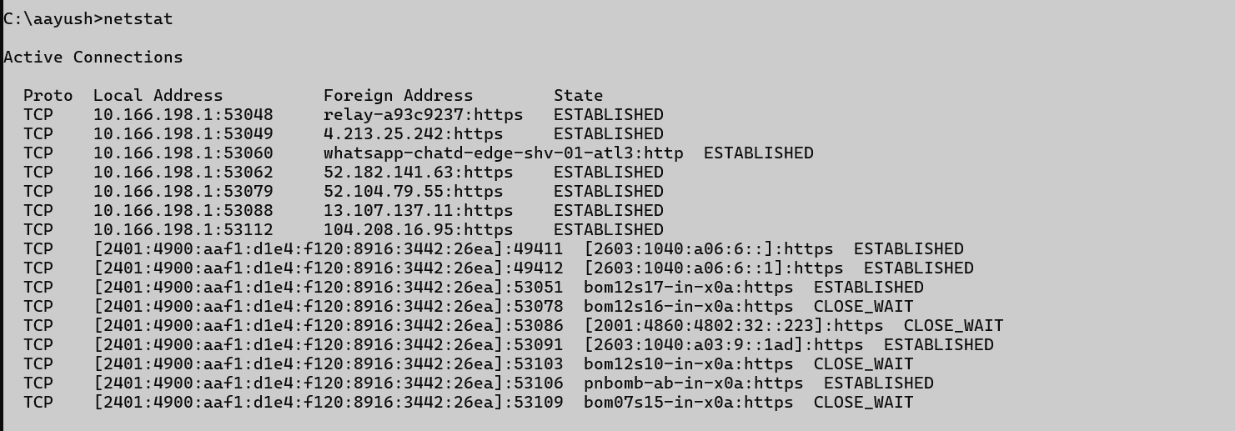

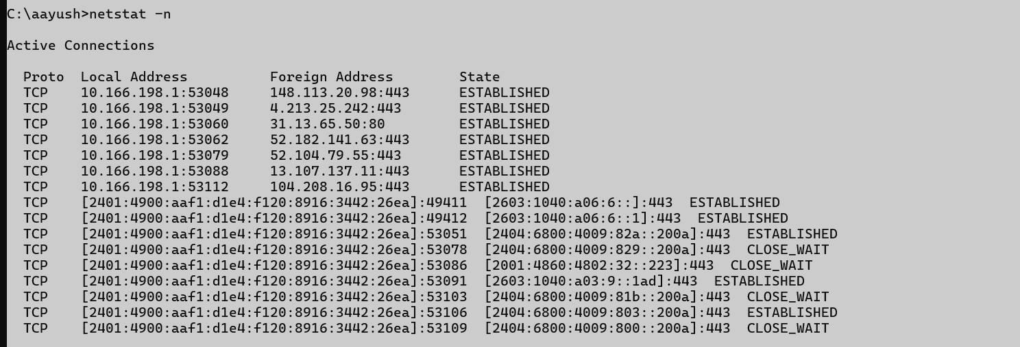

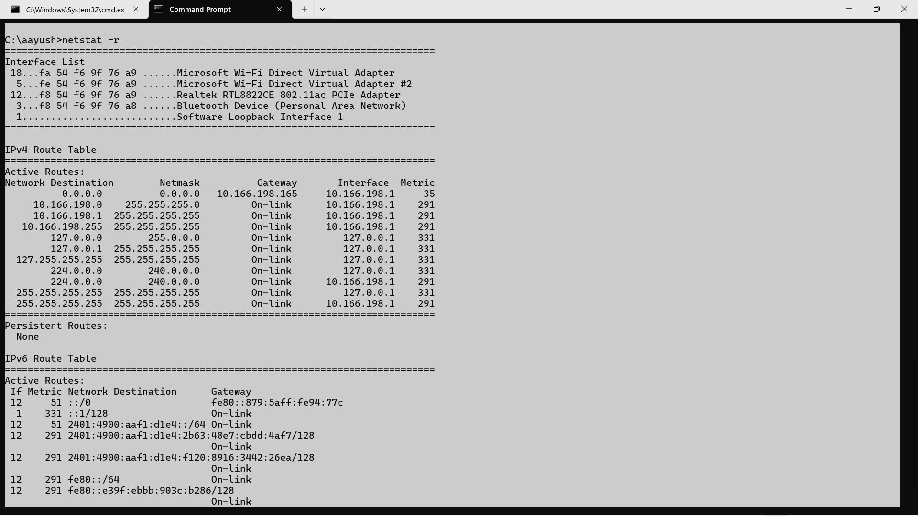

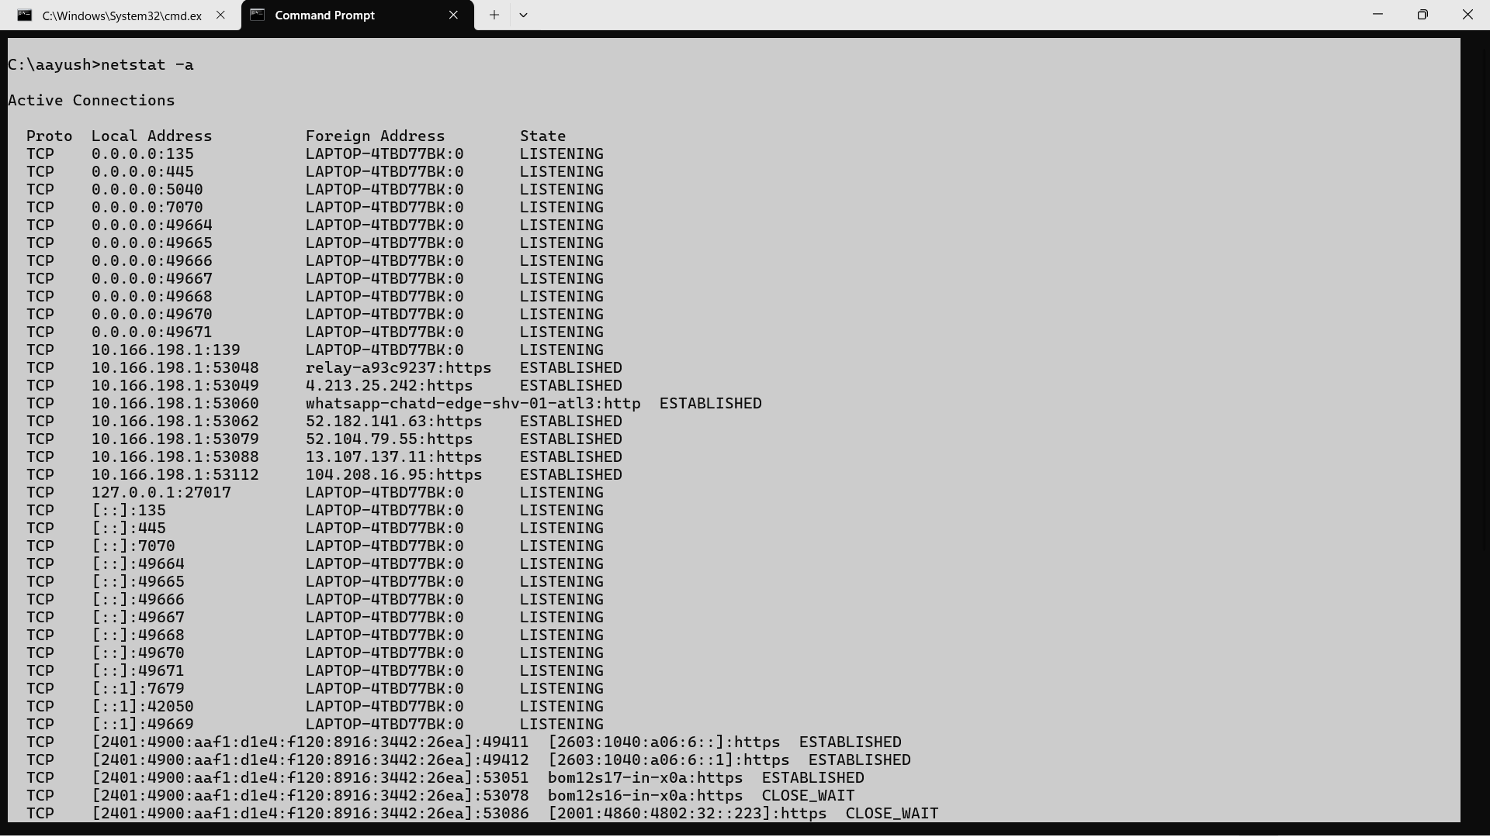

## Nslookup

### Description:

**nslookup is a command used to find the IP address of a website or domain name. It helps check and troubleshoot DNS (Domain Name System) problems easily.**

|  |  |  |
| --- | --- | --- |
| No. | Option | Description |
| 1 | Nslookup | is a command-line tool used to query DNS servers and retrieve information about domain names, IP addresses, mail servers, and more |
| 2 | -type=A | |  | | --- | |  |  |  | | --- | | Lookup IPv4 address records (default). | |
| 3 | -type=AAAA | |  | | --- | |  |  |  | | --- | | Lookup IPv6 address records | |
| 4 | -type=MX | |  | | --- | |  |  |  | | --- | | Displays the routing table (same as route print). | |
| 5 | 8.8.8.8 | |  | | --- | |  |  |  | | --- | | Reverse IP lookup | |

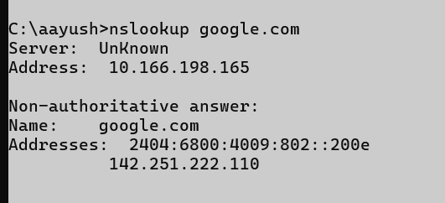

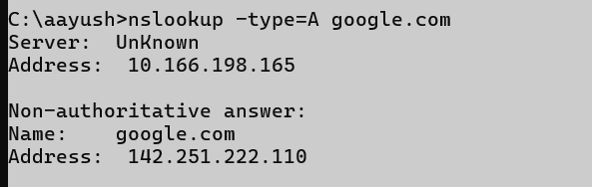



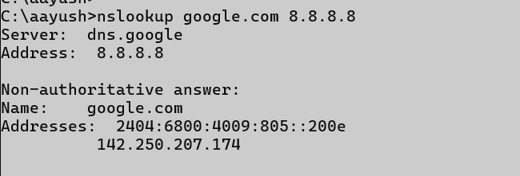

## Hostname

### Description:

|  |  |  |
| --- | --- | --- |
| No. | Option | Description |
| 1 | Hostname | The hostname command is used to display the name of the current computer (host) on a network. |



## 9.Pathping

### Description:

|  |  |  |
| --- | --- | --- |
| No. | Option | Description |
| 1 | Pathping | pathping is especially helpful for detecting where in a network path packet loss occurs.  Let me know if you want a comparison with ping and tracert or want results explained. |
| 2 | /n | Do not resolve IP addresses to hostnames (faster output) |
| 3 | /h | |  | | --- | |  |  |  | | --- | | Limit the maximum number of hops (default is 30) | |
| 4 | /g | Specify a list of gateways (routers) the packet must go through. |
| 5 | /p | |  | | --- | |  |  |  | | --- | | Set the wait time (in milliseconds) between pings (default is 250ms). | |

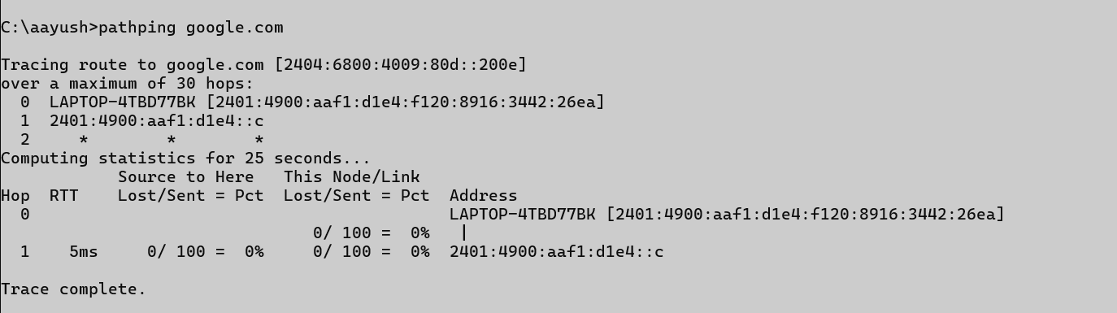

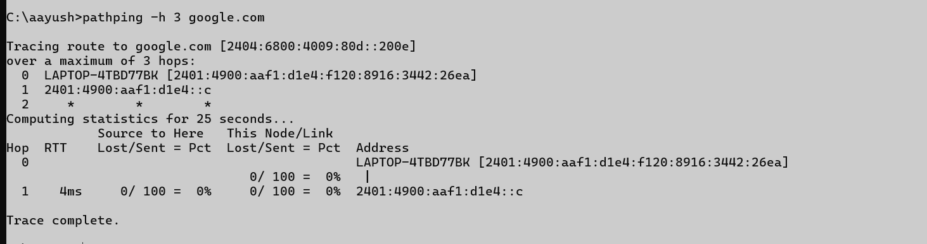

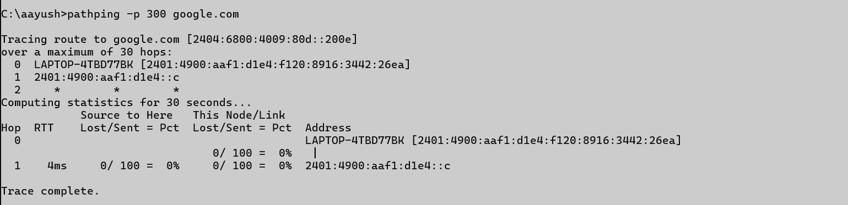

## 10 . Arp

### Description:

|  |  |  |
| --- | --- | --- |
| No. | Option | Description |
| 1 | Arp | The arp command is used to view and manage the ARP (Address Resolution Protocol) cache on a computer. It helps map IP addresses to MAC (hardware) addresses, which is essential for network communication within a local subnet |
| 2 | -a | Display current ARP entries |
| 3 | -g | |  | | --- | |  |  |  | | --- | | Same as -a | |
| 4 | -v | Verbose mode – show more details |
| 5 | -d* | |  | | --- | |  |  |  |  |  | | --- | --- | --- | | |  | | --- | |  |  |  | | --- | | Delete all ARP entries | | |

