Assignment -1

Module-1 ( introduction & fundamental )

Que:1 What Is Software Testing ?

Ans: Software testing is the process to verify that the all requirements are fulfilled or not.

* Software testing is the process which is use to identify the currectness, completeness, & quality of the developed software.
* Software testing is the process of evaluating a software product to ensure it meets requirements, works as expected, & is free for defects.

* There are two types of testing :--
* (1) MANUAL TESTING
* (2) AUTOMATION TESTING

* Manual testing :- To execute the test case manually by the test engineer that is called manual testing.

* Automation testing :- To execute the test case by the test engineer with using automation tool that is called automation testing.

QUE-2_What is SDLC ?

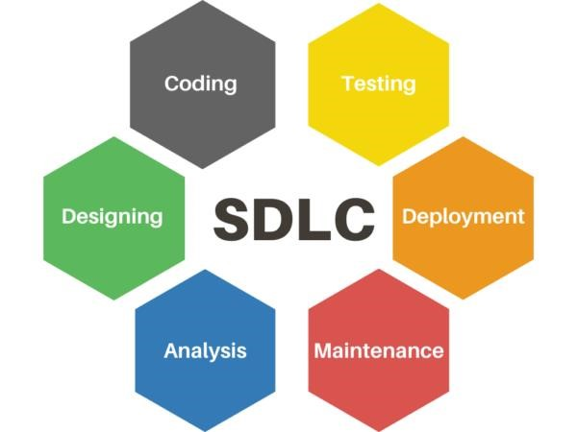

* + SDLC :- SOFTWARE DEVELOPMENT LIFE CYCLE.

* + SDLC is stand for software development life cycle.
  + SDLC is a step by step approach to develop any software / product with high quality, with the time, & within the cost.
  + SDLC :- within time + within cost + quality = successful development.
  + There are the six phases of SDLC :-
* PLANNING
* ANALYSIS
* DESIGN
* CODING
* TESTING
* MAINTENANCE

QUE-3_What is SRS ?

* SRS :- Software Requirements Specification.
* SRS is a fully description of the behavior of the system to be developed.
* It is detailed document that outlines the requirements for a software product/system.
* The SRS document provides a comprehensive description of the software’s functional & nonfunctional requirements.
* Use cases are also known as a functional requirement.
* In addition to use cases , the SRS also contains nonfunctional requirements.

QUE-4_Write SDLC phases with basic introduction.

* There are six phases of SDLC.
  1. Planning
  2. Analysis
  3. Design
  4. Coding
  5. Testing
  6. Maintenance

1. Planning :-  Lack of clarity.
   * + Requirement confusion (functional / non-functional)  Requirement group.
     + Identify stakeholders & their roles.
     + Determine project timeline, budget, &resources.
     + Develop a project plan & schedule.

1. Analysis :-
   * + How the requirements can be executed.
     + Gather & document software requirements.
     + Develop a details specification document.
     + Review & validate requirement with stakeholders.

1. Design :-
   * + Create a detailed design & architecture.
     + Create a detailed design & document.
     + Visualize the software/system by designing.
     + Like – DFD (Data Flow Daigram), Use Case daigram, ER (entity relationship diagram).
     + Review & validate design with stakeholders.

1. Coding :-
   * + Software implemented by the technology like java, python, php, etc…….
     + Write the software code.
     + Develop & integrate software components.
     + Document code & development process.

1. Testing :-
   * + Verified that the user requirements fullfill or not.
     + All resources are working or not.
     + Identify & report, defects & bugs.
     + Fix defects & retest software.

1. Maintenance :-

❖ There are three types of maintenance:-

* + - * + Corrective maintenance -- identifying & repair the defects.
        + Adaptive maintenance – adapting the existing solution to the new platform.
        + Perfective maintenance – implementing the new requirements.

QUE-5_WHAT IS OOPS ?

* + OOPS – OBJECT ORIENTED PROGRAMMING SYSTEM.
  + Set of instructions that can be executed by the developer.
  + It is a programming paradigm that revolves around the concept of object & classes, which are used to create reusable & modular code.
  + OOPS is used in many programming languages, such as JAVA, C++, PYTHON, C#.

* + - Basic concept of OOPS:-
      1. Class
      2. Object
      3. Encapsulation
      4. Inheritance
      5. Polymorphism
      6. Abstraction

QUE-6_What is Class?

* + A blueprint or template which is collection of data member function.
  + A design pattern or template that defines the characteristics & actions of an object.

Example :- • Class :- fruit

Object :- mango

QUE-7_What is object ?

* + - An object is an instance of a class, which represents a real-world entity or concept.
    - It has its own set of attributes(data) & methods(function) that describe & define its behavior.
    - Object will give the memory to the class
    - Object will always represent the relavent class.
    - Objects interact with each other to perform tasks, making programming more intuitive & modular.

QUE-8_What is Encapsulation ?

* + - Encapsulation is a fundamental concept in OOPS that binds together the data& methods that manipulate that data within a single unit, called a class or object.
    - Encapsulation in java is the process of wrapping up of members & member functions into single unit.
    - It is also hiding the data & implementation details & exposing only the necessary information through control access points.

QUE-9_What is Inheritance ?

* + - In OOPS to drive the properties / features / attributes / of one class to another class.
    - To reusability of code.
    - Inheritance describe the relationship between two class.
    - Main class :- parent class / base class / super class.
    - Another class :- child class / derived class / sub class.

* + - 5 types of inheritance :- 1) Single inheritance

Multilevel inheritance

Multiple inheritance

Hierarchical inheritance

Hybrid inheritance

QUE-10_What is polymorphism ?

* + Polymorphism means having a many forms.
  + One name having many forms.
  + It allows different objects to respond to the same message in different ways, the response specific to the type of the object.

* + - 2 types of polymorphism :-

Compile time / static binding / overloading.

Run time / dynamic binding / overriding.

QUE-11_Write basic concept of OOPS ?

* + - OOPS :- Object Oriented programming system.
    - Set of instructions that can be executed by the developer.
    - 6 types of OOPS :-

Class

Object

Encapsulation

Inheritance

Polymorphism

Abstraction

QUE-12_Expline phases of waterfall model.

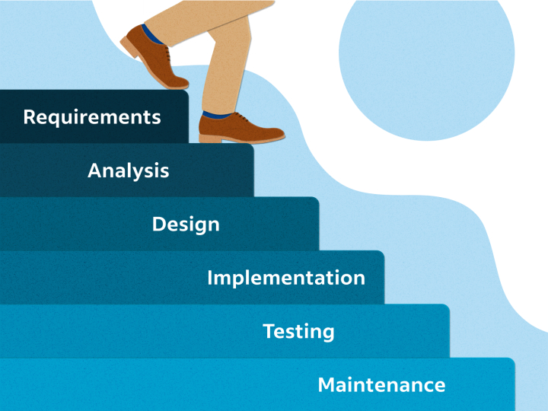

* + - * It is classic software lifecycle models like step “waterfall”, so it is called waterfall model.
      * The waterfall model is a traditional & linear approach to software development, where each phases of the project is completed before the next phase begins.

* + - * 6 phases of waterfall model :-
      * Gathering :- it describe as gathering information, total cost & time to require to develop any software/product.
      * Analysis :- it is short document that define entire lifecycle project.
      * Design :- it is a visualization of software of product by designing.
      * Coding :- it is a programming code for software.

* + - * Testing :- it is performing if there is no bug in the software or verify the quality, completeness, & correctness of software/product.
      * Maintenance :- in simple form, it is sales after service , fixing bugs.

QUE-13_Write phases of spiral model.

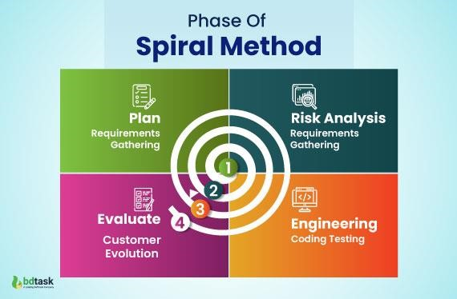

* + - * The spiral model is a software development life cycle(SDLC). Model that provides a systematic & iterative approach to software development.
      * In its diagrammatic representation, looks like a spiral with many loops.
      * The exact number of loops of the spiral is unknown & can vary from project to project.
      * Each loop of the spiral is called a phase of the software development process.

* + - * Phases of spiral model :-

* + - * Planning :- The next iteration of the spiral begins with a new planning phases, based on the results of the evaluation.
      * Risk analysis :- in the risk analysis phase, the risks associated with the project & identified & evaluated.
      * Engineering :- in the engineering phase, the software is developed based on the requirements gathered in the previous iteration.
      * Evaluation :- in the evaluation phase, the software is evaluated to determine if it meets customer’s requirements & if it is of high quality.

QUE-14_What is agile methodology ?

* 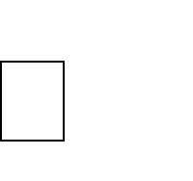 Agile model believes that every project needs to be handled differently and the existing methods divided into small time frames to deliver specific feature of a release.
*  Agile methodology is a structured approach into manageable phases, focusing on continuous improvement. It is an iterative process that involves planning, execution, and evaluation. Each iteration typically lasts from about one to three weeks.
*  Agile Methods break the product into small incremental builds.

QUE-15_Write agile manifesto principles.

* Individuals and interactions :- in agile development, self-organization and motivation are important, as are interactions like co-location and pair programming.

Working software :- Demo working software is considered the best means of communication with the customer to understand their requirement, instead of just depending on documentation.

* Customer collaboration :- As the requirements cannot be gathered completely in the beginning of the project due to various factors, continuous customer interaction is very important to get proper product requirements.
* Responding to change :- agile development is focused on quick responses to change and continuous development.

QUE-16_ Explain working methodology of agile model and, also write pros and cons?

* Agile development model is also a type of Iterative Incremental model. Software is developed in incremental, rapid cycles. This results in small incremental releases with each release building on previous functionality. Each release is thoroughly tested to ensure software quality is maintained. It is used for time critical applications.
* Promotes teamwork and cross training.
* Functionality can be developed rapidly and demonstrated.
* Resource requirements are minimum  Suitable for fixed or changing requirements.
* Delivers early partial working solutions.
* Good model for environments that change steadily.
* Minimal rules, documentation easily employed.
* Enables concurrent development and delivery within an overall planned context.
* Little or no planning required.
* Easy to manage.
* Gives flexibility to developers.

➢ Cons :-

* Not suitable for handling complex dependencies.
* More risk of sustainability, maintainability and extensibility.
* An overall plan, an agile leader and agile PM practice is a must without which it will not work.
* Strict delivery management dictates the scope, functionality to be delivered, and adjustments to meet the deadlines.
* There is very high individual dependency, since there is minimum documentation generated.
* Depends heavily on customer interaction, so if customer is not clear, team can be driven in the wrong direction.

QUE-17_Draw use case on online shopping product using payment gateway.

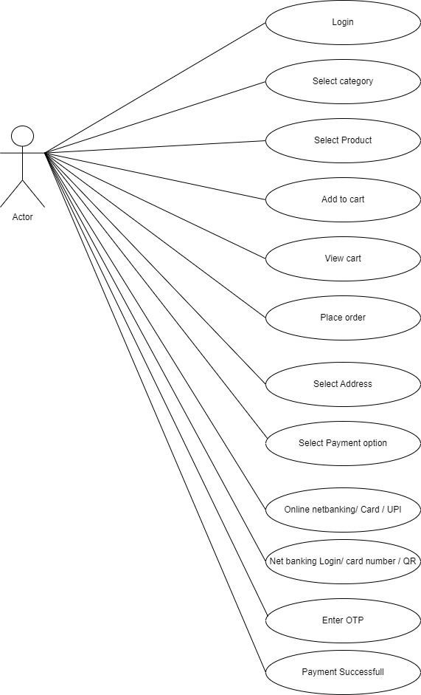

QUE-18_Draw use case on online shopping product using COD.

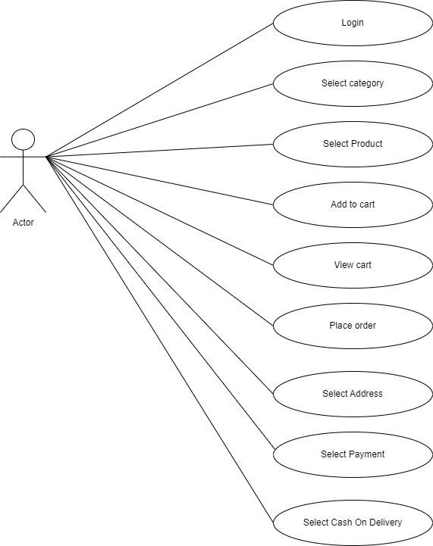

QUE-19_Draw use case on online bill payment system (paytm).

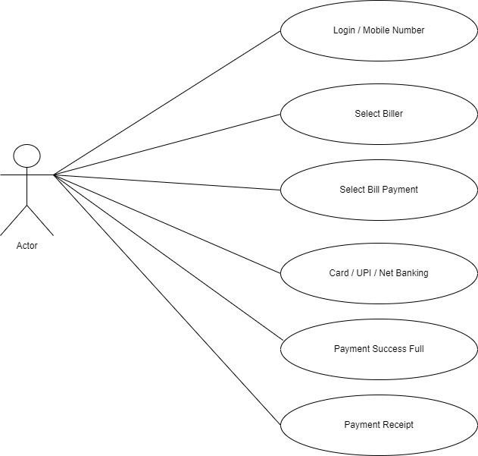

QUE-20_Draw use case on online book shopping.

