Machine and Deep Learning Intrusion Detection for IoT Networks: A Literature Review with a CICIoT2023 Focus
Namrata Kothari
School of Computer Science and Engineering
Manipal University Jaipur, Jaipur, India

Abstract—The rapid growth of Internet of Things (IoT) deployments has widened the attack surface for network intrusions, and machine learning (ML) and deep learning (DL) are now the dominant approaches to detecting them. This paper reviews 20 recent studies on ML/DL-based intrusion detection for IoT, comprising eight reviews and surveys, eleven experimental studies and one benchmark, with emphasis on the CICIoT2023 dataset. We synthesise the evolution of IoT intrusion detection, compare reported methods across boosted trees, deep neural architectures and ensembles, and examine how evaluation choices shape reported results. Reported CICIoT2023 accuracy ranges from 76.88% to 99.995%, but this spread mainly reflects differences in label sets, sampling and test regimes rather than differences in method quality. Boosted-tree models with feature selection are the most consistent top performers, whereas deep models show clear advantages mainly against weak baselines. Explainability, adversarial robustness, privacy-preserving training, cross-dataset generalisation, edge-resource measurement and production validation remain thinly evidenced. We identify eleven research gaps and argue for a standard CICIoT2023 evaluation protocol that reports macro-averaged metrics, natural-distribution testing and computational cost.
Index Terms—CICIoT2023, deep learning, intrusion detection system, Internet of Things, literature review, class imbalance, network security.

I. Introduction
The Internet of Things (IoT) connects sensors, cameras, gateways and controllers that are often resource-constrained and widely exposed, which multiplies the entry points available to attackers. Intrusion detection systems (IDS) monitor network or host activity for malicious behaviour. Signature-based systems recognise only patterns that have already been encoded, so learning-based IDS, which learn statistical patterns directly from traffic, have become the focus of recent research [1], [2].
The CICIoT2023 dataset has emerged as a frequently used modern benchmark for this task. However, published results on it are difficult to interpret: reported accuracy varies from 76.88% [3] to above 99.9% [4], [5], and the studies differ in label sets, sample sizes, rebalancing and test design. A reader comparing headline accuracies would conclude that the problem is nearly solved, or alternatively that some methods are far worse than others, and both conclusions would be unsupported.
This paper makes three contributions:
- A structured synthesis of 20 recent studies (eight reviews and surveys, eleven experimental studies and one benchmark) covering methods, datasets, results and limitations.
- An analysis of why reported CICIoT2023 results are not directly comparable, and what a comparable protocol would need to report.
- A consolidated list of eleven research gaps, with the studies that raise each one.
The remainder of the paper is organised as follows. Section II describes the review corpus and its limits. Section III gives background on IoT intrusion detection and datasets. Section IV summarises prior reviews, and Section V reviews experimental studies. Section VI analyses evaluation practice, efficiency and emerging themes. Section VII lists research gaps, Section VIII gives illustrative evidence from a controlled experiment, and Section IX concludes.

II. Review Methodology and Corpus
The corpus consists of 20 papers supplied for this review. It is not the product of a systematic database search, so all counts below describe this corpus only and should not be read as statistics of the field. For each paper we extracted the aim, datasets, methods, main results and main limitation, and flagged eight themes (ML and ensembles, deep learning, explainable AI, federated or privacy-preserving learning, adversarial robustness, class imbalance, edge efficiency, and multi-dataset benchmarking) according to whether the paper substantively covers them. Theme flags are the author's judgement. Figures are quoted as reported by the original authors and were not reproduced. Thirteen of the 20 papers were read from extracted text, focusing on abstracts, methods, results and conclusions; where a detail was not stated in the text read, it is recorded as not recorded rather than as an omission by the authors.
Table I summarises the corpus. Four items are not standard journal articles: a conference paper [3], an MSc project [6], a preprint [7], and a paper with no stated venue or date [8]. One experimental study [9] addresses mobile social networks using simulated data rather than IoT benchmark data; it is retained for completeness but contributes little to the CICIoT2023 analysis.
TABLE I
Composition of the review corpus
Item | Studies
Reviews and surveys | 8
Experimental studies | 11
Benchmark studies | 1
Peer-reviewed journal articles | 16
Conference, MSc, preprint or unstated venue | 4
Published 2024 / 2025 / 2026 | 2 / 9 / 8
No stated date | 1
Experimental studies using CICIoT2023 | 10 of 11

Fig. 1 shows theme coverage. ML and ensemble methods appear in 17 studies (85%) and multi-dataset benchmarking in 13 (65%), whereas explainability, federated learning and adversarial robustness are each covered by only five (25%). The average study covers 3.7 of the eight themes.
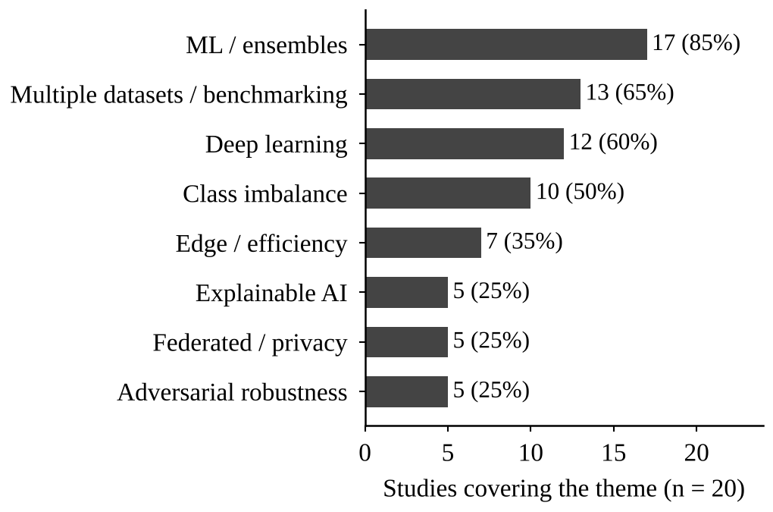
Fig. 1. Theme coverage across the 20 reviewed studies. Theme flags are the author's judgement.

III. Background

A. IoT Intrusion Detection
IDS research has progressed from rule- and signature-oriented systems toward anomaly detection and learning-based approaches, increasingly using CNNs, LSTMs, Transformers, federated learning, explainable AI and edge-oriented deployment [1], [8], [10]. Reviews consistently stress that benchmark accuracy should be complemented by metrics such as macro-F1, MCC and AUC-PR, and by operational measures such as latency, throughput and memory [1].

B. The CICIoT2023 Dataset
As described in the reviewed studies, CICIoT2023 was collected from 105 IoT devices and contains 47 features, 33 attack types plus benign traffic (34 classes) and about 45.8 million flows in its full form, with extreme class imbalance [4], [11]. It was listed by 12 of the 20 studies and used by 10 of the 11 experimental studies. Older benchmarks such as KDD-Cup'99, NSL-KDD and UNSW-NB15 remain in use [12], [10], and KDD-Cup'99 in particular is criticised as outdated and synthetic. Other datasets appearing in the corpus include TON_IoT, N-BaIoT, BoT-IoT, IoT-23, CICIDS2018 and CIC-IDS2017 [5], [13], [7], [14], [10].
Because the full label space is large, studies derive different tasks from the same data: binary (benign versus attack), six-class, eight-class (attack families), 20-class (DoS, DDoS and Mirai subtypes plus benign) and 34-class [14], [6], [11], [4], [12]. Section VI-A shows why this matters.

IV. Prior Reviews and Surveys
Eight reviews and surveys are in the corpus (Table II). Two follow PRISMA procedures with reported screening counts: Winanto and Idris [15] screened 5,890 records and included 216 studies, and Ahmed et al. [2] screened 22,558 records and included 125. The others are narrative or targeted reviews with no reported screening counts.
TABLE II
Reviews and surveys in the corpus
Review | Method | Period | Included
Poltoratskyi [1] | Narrative (PRISMA stated) | 2020–2025 | n/r
Salakhutdinov [8] | Targeted critical review | n.d. | n/a
Winanto [15] | PRISMA 2020 SLR | Jan 2020–Mar 2026 | 216 of 5,890
Diana [16] | Narrative review | n/r | n/r
Ahmed [2] | PRISMA SLR | Jan 2022–May 2025 | 125 of 22,558
Bunko [17] | Survey | n/r | n/r
Mallidi [18] | SLR | n/r | n/r
Hozouri [10] | Survey | n/r | n/r
SLR: systematic literature review; n/r: not recorded; n/a: not applicable; n.d.: no date.
Poltoratskyi and Gavrylenko report that accuracy above 98% is common on benchmarks, yet imbalance, zero-day detection, scalability and privacy remain open. Salakhutdinov separate anomaly detection from intrusion classification and argue that benchmark success does not equal robustness, stressing concept drift, explainability and defence in depth. Winanto and Idris [15] find that FGSM is used in 76.9% of the robustness studies and adversarial training in 61.6%, while black-box attacks and certified defences are rare and CICIoT2023 features in under 5% of that corpus.
Ahmed et al. [2] identify five themes (ensemble and hybrid, context-specific, data-centric, deep architectures, and trustworthiness) and report that only about 2% of papers use explainable AI, about 4% test robustness, and none validates in production. Bunko et al. [17] observe that most federated IDS work only keeps raw data local, leaving inference and poisoning attacks open. Mallidi and Ramisetty [18] conclude that federated learning improves scalability and privacy and that hybrid cloud-fog-edge deployment balances resources, while Hozouri et al. [10] note that deep learning improves detection of complex attacks but depends on labelled data and is hampered by imbalance and legacy datasets. Diana et al. [16] identify scalability and false alarms as persistent problems.

V. Experimental Studies

A. Boosted Trees and Feature Selection
Hajjouz and Avksentieva [4] trained CatBoost on the full 45.8 million-flow dataset after Spearman clustering reduced the features to 23, using class weights and six-fold stratified validation, and reported 99.96% accuracy on 20 classes at 7.16×10⁻⁷ s per flow, with SHAP analysis; the study excludes other attack families and does not report macro-F1. Almahaqeri et al. [11] compared XGBoost, LightGBM and CatBoost on binary, eight-class and 34-class tasks after stratified undersampling and gain-based selection that halved the features from 46 to 23. XGBoost reached 99.61% binary accuracy and 0.995 macro-F1 at 0.355 µs per sample, with inference latency reduced by 30–51% and accuracy changing by no more than 0.014 points; the evaluation is undersampled and limited to one dataset. Khan et al. [13] combined Boruta, greedy forward selection, SMOTE and LightGBM and obtained 98.88% on CICIoT2023, 99.94% on CICIDS2018 and 99.91% on a Raspberry Pi dataset, with the best efficiency ratio among compared methods.

B. Deep Learning
Meena and Indian [12] proposed a two-layer LSTM with 100 units per layer and reported 98.58% accuracy on 34 classes against 98.26% for a plain DNN and 98.25% for an RNN; figures differ between tables in the paper, and the margin over simple baselines is small. Yaras and Dener [5] combined a 1D-CNN with an LSTM in PySpark, with correlation-based feature reduction, and reported 99.995% binary and 99.96% multiclass accuracy on CICIoT2023 and 98.75% binary on TON_IoT, outperforming ten comparison algorithms; training on large data is long and balancing is not recorded.
Imran et al. [14] compared six models on 18,000 samples with six harmonised classes drawn from CICIoT2023 and IoT-23. An LSTM was best with 96.02% accuracy, 94.69% F1 and ROC-AUC of 0.97, ahead of XGBoost, and SHAP and LIME highlighted flow duration, packet rate and bytes per second. Erskine [19] proposed a combined detection-and-prevention MLP that exceeded 85% accuracy with 99% precision on Mirai traffic, but evaluated prevention only through confusion-matrix values rather than a blocking test.

C. Ensembles
Kwari and Rajkumar [3] evaluated a soft-voting ensemble of logistic regression, random forest and AdaBoost on a 100,000-sample subset (80,000 training, 20,000 test) with no resampling, obtaining 76.88% accuracy and 0.54 macro-F1 (weighted F1 0.74). Flooding and Mirai classes were detected near F1 of 1.00 whereas rare classes scored 0.00, a clear illustration of how accuracy hides minority-class failure. Mughogho [6] used mutual-information feature selection with decision tree, random forest, XGBoost and soft voting, reaching 99.80% binary and 99.25% multiclass accuracy, but gains over the best single member were only 0.1–0.3 points and members passed only 89–93% of benign flows in binary detection. Across these three comparisons the ensemble gain over the best member averages 0.66 points.

D. Benchmarks and Hybrid or Federated Frameworks
Mondragon et al. [20] benchmarked seven algorithm categories on 14 flow datasets with fixed splits using macro-F1. CFC performed best overall, followed by LCCDE and a fully connected network, and the real-traffic LITNET dataset gave the lowest scores, indicating that benchmark rankings do not transfer to realistic traffic. Mishra and Reddy [7] evaluated CNN, LSTM, BiLSTM, attention, tiny Transformer, random forest, XGBoost and deep-feature XGBoost on N-BaIoT, CICIoT2023 and BoT-IoT; XGBoost-based models were strongest and CICIoT2023 was the hardest multiclass setting, though the work is a preprint whose federated stage has not yet been run.
TABLE III
Method families and best reported results
Family | Best reported result | Typical cost
Boosted trees with feature selection | 99.96% (20 classes), 99.61% binary, 98.88% multiclass [4], [11], [13] | 0.36–0.72 µs per sample; 23 features
Deep learning (CNN/LSTM hybrids) | 99.995% binary, 99.96% multiclass, 98.58% on 34 classes [5], [12] | 8–95 ms per detection [14]
Voting ensembles | 76.88% (34 classes), 99.80% binary [3], [6] | Low
Figures as reported by the authors; setups differ.

VI. Cross-Cutting Analysis

A. Comparability of Reported Accuracy
Across 13 CICIoT2023 results from nine experimental studies, reported accuracy spans 23.1 percentage points (76.88% to 99.995%), the median is 99.4%, and eight results (62%) are at or above 99%. Only two results use a natural-distribution test set: Kwari and Rajkumar [3] at 76.88% and Hajjouz and Avksentieva [4] at 99.96%. Fig. 2 shows the spread. Two entries are lower bounds only (“above 85%” [19] and “above 99.4%” [11]). The 23-point range therefore cannot be attributed to method quality, because label sets (binary to 34 classes), sample sizes (18,000 to 45.8 million), rebalancing (none, class weights, undersampling, SMOTE) and test regimes all differ.
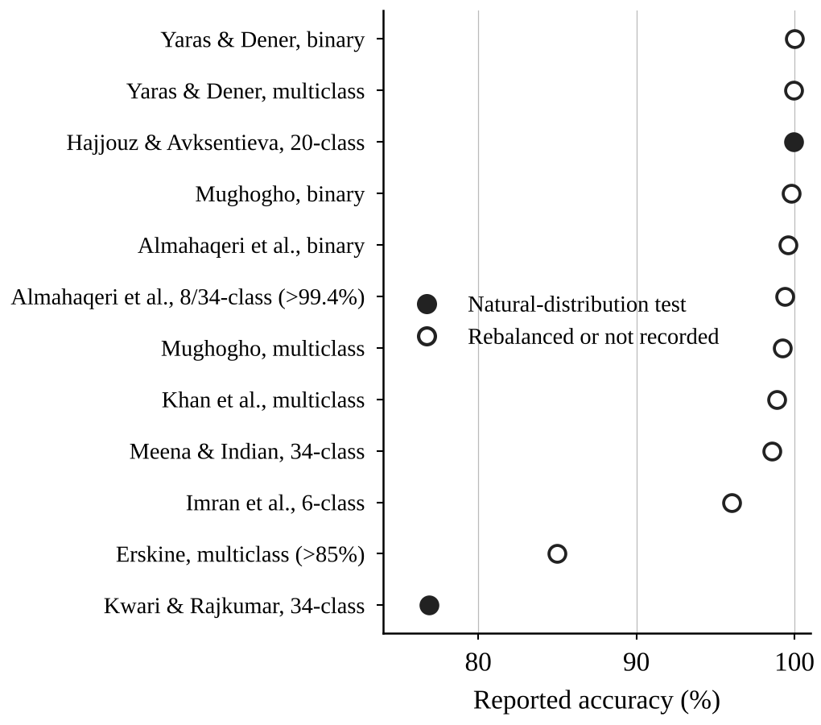
Fig. 2. Reported CICIoT2023 accuracy by study and task. Filled markers denote natural-distribution test sets; open markers denote rebalanced or unrecorded test regimes. Lower bounds are marked with “>” in the labels.

B. Class Imbalance and Rare Classes
Imbalance is the most consistent confound. Kwari and Rajkumar [3] found that rare classes scored F1 of 0.00 without mitigation while accuracy looked acceptable, and other studies mitigate imbalance with class weights [4], undersampling [11] or SMOTE [13], each of which changes the reported numbers. Mondragon et al. [20] compare methods by macro-F1 for exactly this reason, and Poltoratskyi and Gavrylenko [1] recommend MCC, F1 and AUC-PR over accuracy. Of the six studies scored for evidence quality in Section VI-F, only three report macro or per-class metrics in full.

C. Deep Learning versus Tree-Based Models
The two head-to-head comparisons in the corpus disagree. Imran et al. [14] found an LSTM ahead of XGBoost by 3.64 points (96.02% versus 92.38%), whereas Mishra and Reddy [7] found a deep-feature XGBoost model ahead of a hybrid CNN-BiLSTM-attention-Transformer by 2.31 points (92.11% versus 89.80%, macro-averaged). In Meena and Indian [12], the proposed LSTM leads a plain DNN by only 0.32 points. The evidence thus supports no universal winner; boosted trees have the most consistent top results at low cost, while deep models are strong mainly against weak baselines.

D. Efficiency and Edge Deployment
Cost reporting is uneven and units differ. Almahaqeri et al. [11] report 0.355 µs per sample and Hajjouz and Avksentieva [4] 0.716 µs per flow in batch evaluation, whereas Imran et al. [14] report per-detection times of 8 ms (decision tree), 45 ms (CNN), 78 ms (LSTM) and 95 ms (Transformer). These groups should be compared only within themselves. Feature reduction is a consistent lever: halving features cut inference latency by 30–51% and training time by 33–40% with at most 0.014 points of accuracy change [11]. Memory, energy and on-device tests are rarely reported.

E. Explainability, Robustness and Privacy
SHAP and LIME were used in two experimental studies [14], [4], but only qualitatively, and the top features they identify differ between studies (flow duration, packet rate and bytes per second in one; inter-arrival time, SYN flag count and total size in the other). Robustness is rarely tested on CICIoT2023 [15], [2], and federated results are not yet validated [17], [7].

F. Evidence Quality
We scored six experimental or benchmark studies on five criteria: natural-distribution testing, macro or per-class metrics, repeated runs, cost reporting and multiple datasets. No study met all five and the highest score was three, putting all six in the medium band (two to three criteria). This is based on the text read and “not recorded” is not a finding of omission, but it indicates that current claims rest on partially documented evaluations.

VII. Research Gaps
Synthesising the corpus yields eleven gaps. The studies that raise each are cited.
- Standard CICIoT2023 protocol. Label set, splits and metrics are not fixed; accuracy ranges from 76.88% to 99.995% depending on setup [1], [3], [20].
- Cross-dataset generalisation. The best method changes by dataset, and no study trains on one dataset and tests on another [1], [8], [20].
- Rare-class detection. Rare-class F1 can be 0.00 without mitigation, and rebalancing choices change results [1], [3], [2], [11].
- Fair deep versus tree comparisons. Head-to-head studies disagree [14], [20], [7].
- Quantified explainability. SHAP and LIME are used qualitatively and top features differ [1], [8], [14], [4], [2].
- Resource-aware edge evaluation. Memory, energy and edge tests are rarely reported [1], [8], [11], [13].
- Drift and adversarial robustness. Few studies test robustness, and CICIoT2023 is under 5% of the robustness corpus [1], [8], [15], [2].
- Privacy beyond data locality. Differential privacy and secure aggregation are rare, and one preprint's federated stage is unrun [8], [17], [18], [7].
- Production and streaming validation. None of 125 reviewed papers validates in production [2], [11].
- Measured prevention and response. Prevention claims are judged only by classification metrics [19].
- Realistic operational benchmarks. Real-traffic LITNET gives the lowest macro-F1 [20].

VIII. Illustrative Evidence from a Controlled Experiment
To illustrate the evaluation issues above, we ran a controlled comparison of seven deep models on an eight-class CICIoT2023 configuration: DNN, DNN with Dropout, DNN with L2 regularisation, a combined regularised DNN, GRU, LSTM and a Transformer. All models used the same 39 standardised features and a balanced 80,000-flow training sample (10,000 per class, split 80/20), and were evaluated on the supplied 268,463-flow test set with its natural class distribution. Results are single runs on a CPU (Table IV).
TABLE IV
Test results for seven deep models (eight classes)
Model | Acc. (%) | Macro-F1 (%) | Train (s)
DNN | 75.44 | 63.46 | 19.48
DNN + L2 | 75.08 | 63.05 | 18.46
Proposed DNN | 74.07 | 62.26 | 25.70
DNN + Dropout | 73.73 | 62.10 | 21.84
Transformer | 72.53 | 62.63 | 3,497.91
GRU | 69.82 | 58.68 | 668.69
LSTM | 55.24 | 45.71 | 173.61
Single run per model; training time is CPU wall-clock.
The plain DNN was best on accuracy and macro-F1, and the Transformer achieved the highest macro-precision (65.39%) and macro-recall (71.05%) but needed about 180 times the DNN's training time. GRU clearly outperformed LSTM (69.82% versus 55.24%). Two classes, BruteForce and Web-based, together only 2.8% of test flows, had F1 below 0.30 for every model, so macro-F1 trails accuracy by roughly 10 to 12 points for every model. The best accuracy of 75.44% is close to the 76.88% that Kwari and Rajkumar [3] report on a natural-distribution 34-class subset, and its macro-F1 of 0.63 compares with 0.54 there, whereas Hajjouz and Avksentieva [4] report 99.96% on 20 classes using the full dataset and class weights. Because label sets, sample sizes and rebalancing differ, this positions the experiment rather than ranking methods. With one run per model, no significance test and training budgets that may have limited GRU, LSTM and the Transformer, differences of one or two points should not be treated as meaningful.

IX. Conclusion
This review of 20 studies finds that CICIoT2023 results cannot be ranked from headline accuracy: label sets, sampling, rebalancing and test design differ so widely that a 23-point spread tells us little about methods. Boosted trees with feature selection are the most consistent strong performers at low cost, deep models are competitive but not clearly superior, and ensembles add small gains. Explainability, robustness, privacy-preserving training, cross-dataset generalisation, edge-resource measurement and production validation remain weakly evidenced.
We recommend that future CICIoT2023 studies (i) fix and publish label sets and splits, (ii) test on natural-distribution data and report macro-averaged and per-class metrics alongside accuracy, (iii) report repeated runs, (iv) report training and inference cost, memory and energy in consistent units, and (v) test generalisation across datasets and under adversarial perturbation. A shared protocol of this kind would allow the accumulated work to be compared directly for the first time.

References
[1] V. Poltoratskyi and S. Gavrylenko, “The evolution of intrusion detection systems: A comprehensive review of modern datasets, deep learning approaches, and architectural challenges,” Adv. Inf. Syst., vol. 10, no. 2, pp. 100–116, 2026, doi: 10.20998/2522-9052.2026.2.11.
[2] A. Ahmed, R. Mostafa, M. H. Qutqut, and N. Ragab, “A systematic literature review on machine learning for intrusion detection systems,” Future Internet, vol. 18, p. 470, 2026, doi: 10.3390/fi18090470.
[3] M. I. Kwari and N. Rajkumar, “An enhanced voting ensemble model for IoT intrusion detection using the CICIoT2023 dataset,” in Proc. IGCAI, 2025, pp. 67–77, doi: 10.63169/IGCAI2025.p9.
[4] A. Hajjouz and E. Avksentieva, “Optimizing intrusion detection for DoS, DDoS, and Mirai attacks subtypes using hierarchical feature selection and CatBoost on the CICIoT2023 dataset,” Data Metadata, vol. 3, p. 577, 2024, doi: 10.56294/dm2024.577.
[5] S. Yaras and M. Dener, “IoT-based intrusion detection system using new hybrid deep learning algorithm,” Electronics, vol. 13, p. 1053, 2024, doi: 10.3390/electronics13061053.
[6] E. Mughogho, “Enhancing IoT network security through intrusion detection using machine learning,” MSc research project, National College of Ireland, 2025.
[7] S. Mishra and R. V. S. Reddy, “Federated hybrid deep learning framework for IoT intrusion detection using N-BaIoT, CICIoT2023, and BoT-IoT datasets,” Research Square, preprint, 2026, doi: 10.21203/rs.3.rs-10580856/v1.
[8] R. Salakhutdinov, “Artificial intelligence and deep learning for network intrusion detection in Internet of Things environments,” n.d. (venue not stated).
[9] E. Rivandi and R. J. Oskouei, “A novel approach for developing intrusion detection systems in mobile social networks,” J. Soft Comput. Decis. Anal., vol. 3, no. 1, pp. 158–170, 2025, doi: 10.31181/jscda31202576.
[10] A. Hozouri, A. Mirzaei, and M. Effatparvar, “A comprehensive survey on intrusion detection systems with advances in machine learning, deep learning and emerging cybersecurity challenges,” Discover Artif. Intell., vol. 5, p. 314, 2025, doi: 10.1007/s44163-025-00578-1.
[11] S. A. Almahaqeri et al., “An optimized gradient boosting framework for IoT intrusion detection: A comprehensive evaluation on the CICIoT2023 dataset,” Sci. Rep., 2026, doi: 10.1038/s41598-026-47399-5.
[12] G. Meena and A. Indian, “IDS-IoT: Intrusion detection system for the Internet of Things using enhanced long-short term memory,” Artif. Intell. Appl., 2025, doi: 10.47852/bonviewAIA52025066.
[13] M. Z. Khan et al., “A resource efficient IoT intrusion detection model using hybrid feature selection for edge computing,” Sci. Rep., 2026, doi: 10.1038/s41598-026-59156-9.
[14] S. Imran, M. Yousaf, Z. Shabeer, M. Sarwar, and N. Zainab, “An explainable AI-driven intrusion detection framework for IoT networks using deep learning and machine learning models,” J. Computers Intell. Syst., vol. 4, no. 2, pp. 99–116, 2026.
[15] E. A. Winanto and M. Y. Idris, “Adversarial robustness of deep learning-based intrusion detection systems: A systematic literature review,” IEEE Access, vol. 14, 2026, doi: 10.1109/ACCESS.2026.3733985.
[16] L. Diana, P. Dini, and D. Paolini, “Overview on intrusion detection systems for computers networking security,” Computers, vol. 14, p. 87, 2025, doi: 10.3390/computers14030087.
[17] T. Bunko, M. N. Johnstone, W. Yang, and B. A. Scott, “A survey of privacy-preserving federated learning for intrusion detection systems,” Artif. Intell. Rev., vol. 59, p. 125, 2026, doi: 10.1007/s10462-026-11519-4.
[18] S. K. R. Mallidi and R. R. Ramisetty, “Advancements in training and deployment strategies for AI-based intrusion detection systems in IoT: A systematic literature review,” Discover Internet Things, vol. 5, p. 8, 2025, doi: 10.1007/s43926-025-00099-4.
[19] S. K. Erskine, “Real-time large-scale intrusion detection and prevention system (IDPS) CICIoT dataset traffic assessment based on deep learning,” Appl. Syst. Innov., vol. 8, p. 52, 2025, doi: 10.3390/asi8020052.
[20] J. C. Mondragon et al., “Advanced IDS: A comparative study of datasets and machine learning algorithms for network flow-based intrusion detection systems,” Appl. Intell., vol. 55, p. 608, 2025, doi: 10.1007/s10489-025-06422-4.

