**BUSINESS PLAN PRESENTATION**

**Marks: 25**

Note: 1. This assignment can be done in a group of 5-6 students

2. Plagiarized ideas will not be considered for evaluation (will be marked 0)

4-8 - Namrata

9-12 - Atyant

13-16 - Akhil

17-20 - Aniket

**Use the following questions to make decision about a business idea of your choice. Proper justification is required while providing answers.**

1. What is your product, or service?
   1. An online publishing platform cum consulting services provider that specializes in recycling and related eco-friendly practices.
2. Assess the business environment (SWOT, PESTLE, Porter’s five forces)
   1. Done in PPT
3. How can you describe the business?
   1. A startup for startups. We want to bridge the gap between the startups that are based on recycling business of various kinds (Glass, plastic, metal, wood, etc.) and the knowledge of industry skills and the latest available technology in the market, needed to support the particular eco-friendly practice they aspire to adopt. Various types of startups based on some type of recycling business are coming up fast in India as it is undeniably the need of the hour. Often times they do not have the right understanding of the best tools, technology and practices that they can adopt or find in the market or even where should they start. This is where we come in. We are the firm to whom they can outsource their initial research work.
   2. As the initial phase of the company, we plan on setting up an online platform that publishes articles related to the latest developments in the field of recycling of various types, such as technology trends, best practices, and pioneers who are leading the industry. These are available for anyone on the Internet to read and also serve as advertisements for our work. On this same platform, we want to provide a paid subscription service, and people who subscribe can have access to even better articles and excess content.
   3. As we progress to the second phase, we start to put in focus, what we really aspire to do- give one-on-one consulting service to startups who want to become our clients. This would be catered to their particular business and idea. It involves us helping them get in touch with industry experts, provide them with the best practices available in the market with regards to their particular work (For example- we may start with helping one particular kind of recycling business, like single-use plastic and then expand our area of expertise to others as well).
   4. Based on the success of phase 1 & 2, in the third phase of the company's development, we may start lending our waste management consultancy services to other companies as well working at a larger scale. As a scope for future work, we may plan on coming up with and patenting our own recycling technology.
4. Who will buy it?
   1. So the first phase- online platform- subscribers can range from students to new recycling business starters to professionals in the recycle industry who want to improve their knowledge.
   2. The second phase- consultancy service to new businesses- the clients are typically recycle start-up owners who want to set up the initial research work, feasibility study, etc.
5. Where should you locate the business?
   1. Not too much infrastructure is needed, as we mainly do consultancy and online publishing. An office space in a city booming with start-ups and waste management opportunities makes sense. Delhi/Noida
6. How can you attract customers?
   1. Mainly social media. Our first phase work- the publishing platform will serve as an advertisement in itself for our phase 2 work- specialized consultancy service.
   2. Targeted ads on google.
7. What is your competition?
   1. Phase 1- other online portals, with advices, technology forums.
   2. Phase 2- there are other firms that can carry out market research and feasibility study, analytics firms. But we are a specialized service, so an advantage.
8. How much money is needed to borrow to start this business?
   1. Phase 1- Not much, we can do it without raising loans or attracting investors-as it only involves buying a domain, setting up a website and populating it with recycling articles. We will add subscription service to this and premium content.
      * Buy domain, web development, server set-up
      * trade mark
      * Content churning- articles, expert interviews, need to find and pay good writers, at least 2 extra.
      * All over- 10 lakhs to start, till it starts producing profits through subscribers.
   2. Phase 2- phase 1 success can be used to attract investors and raise loans.
      * A good office space, office furniture, computers, printers, fax machine, router, etc.
      * Hiring outside experts, industry advisors.
      * Hiring inhouse experts.
      * Finance dept & legal dept
      * Data engineers and scientists for analytics
      * If we can raise 5 crore to begin- it can work.
9. What advice do you need and who can provide it?
   1. Industry pioneers.
   2. Someone with business experience who is willing to act as a guide. The mentor would help through their advice, guidance and support to help us run and improve our business.
   3. Legal advisors could help resolve labor or contract disputes, compensation issues, harassment suits or other workplace conflicts. They also provide general legal advice about corporate decisions.
   4. Like – can a subscription based online platform become self-sustaining & produce profits? How much should an outside expert brought in, must be paid?
10. How much does it cost to make the product or provide the service?
11. Not much, there will be online meeting (so zoom or other video conferencing app subscription ), pamphlets or other advertising charges
12. url renewal charges, server charges etc.
13. What are the operating costs?
14. cost of domain address, server cost, salaries to employees(writers, lawyers and experts[only for talks and advice])
15. advertise and promote (adsense)
16. Phase 2 - rent for office space, house care employee payroll
17. How much should you charge for the products or service?

Phase1 -> Subscription charges ??

“The market rate” is the average price and range of pricing a typical customer will pay for your type of consulting service. The average business consultant charges and receives $100 per hour, then the “market rate” is likely between $50 to $150 per hour.

→ ₹ 1,000 /hr

Phase2 -> 1. hourly based consultancy-

2. project-based consultancy (>50 hours studies)

project based feasibility studies and research

1-2 week → ₹50,000 - 75,000 (8hr*10days = 80hrs*1000)

1-2 months → 2-5 lakhs

6months or more → 5 lakhs and above

1. How will you organize the managers and/or workers of the business?

Has to be functional organizational structure

1. Industry experts
   1. For client consulting
   2. For blog writing
   3. R&D dept.
2. HR team
3. Finance
4. Marketing
5. IT Team

Sample group org. struct:

**CEO**

**CFO**

**CTO**

**COO**

**R&D and Consultancy Head**

**IT Head**

**Technical Content Creation Head**

**Accounting Department**

**Marketing Manager**

**HR and operations Manager**

**Web developers**

**Research Professionals**

**Content writers**

**Business Analyst**

**Employees**

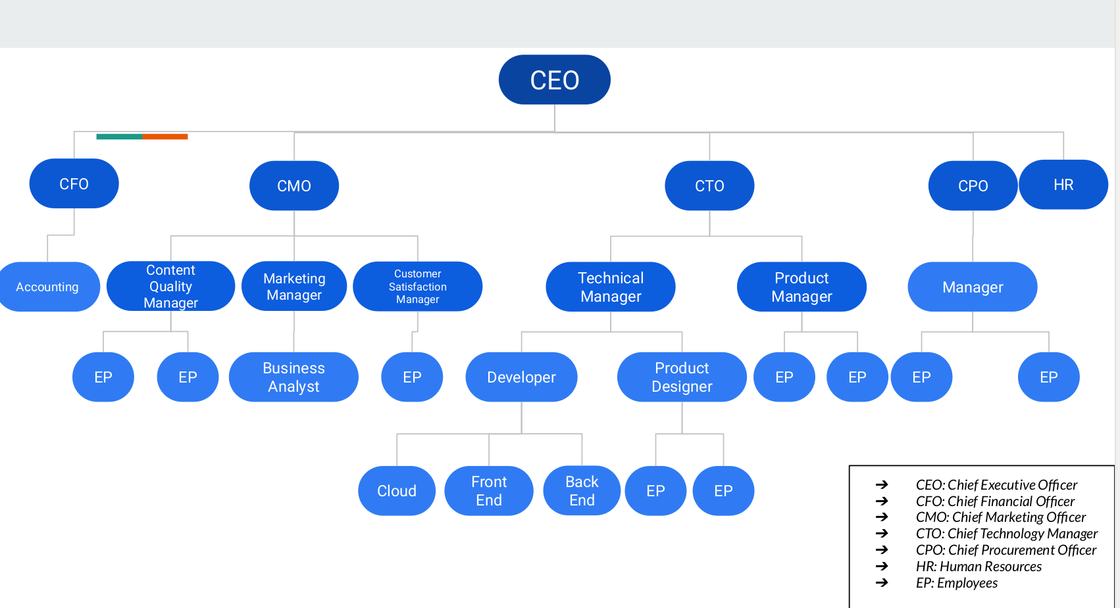

1. How will you split the profits? Who is responsible for the losses?

**Some more research needed.**

Can be the same as the sample ppt group.

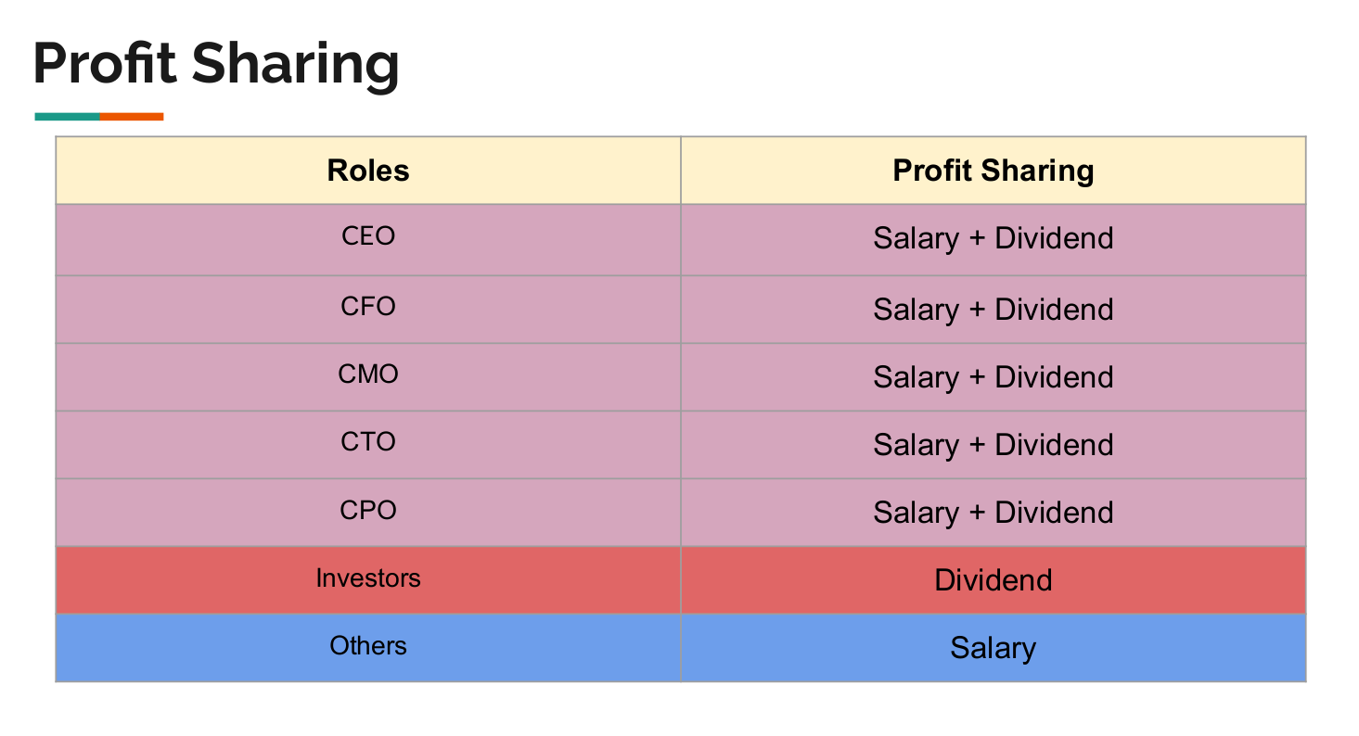

1. How much money is needed to get the business started?

Blogging in phase 1 or the starting stage of the company will be the main earner.

* 1. Trademark, registration, etc stuff will require some money.
  2. Web hosting
  3. Bloggers need to be paid part-time salaries
  4. Website designers and development cost
  5. Advertising costs

1. How many customers will you have per month and how much will they buy per month?

Maybe discuss for the first year timeframe. Initially the customers will be the online traffic on our website and monthly subscriptions will be the earnings. Subscribers will be subscribing for recycling related blogs from industry experts. After around 6 months, tying up with startups can become another way to start earning.

YT channel earnings can also be useful in a long-run.

1. How much money will the business earn each month by selling your product or service?

Sources of revenue:

    1. Google Adsense (Depends on views and click on ads)

    2. Paid subscription

    3. Consultancy charges from startups

1. How much investment is needed to keep the business going until you make a profit?

Money invested into business:

    1. Setting up website:

Domain: $15/year

Hosting: $240/year

One time purchase(themes, plugins): $500

    2. Office space: Rs. 50000/month for 10-15 seater

    3. Partnership with some industry experts

    4. Employee Cost [Content writer, proofreading: $100/month]

    5. Office maintenance: Rs. 7000-10000/month water n electricity bills

Let's say after x years we reach break-even point then

Investment Needed for running the business until it makes profit:

One time cost + (YC1 - R1) + (YC2 - R2) + (YC3 - R3) + …….  + (YCx - Rx)

[YCn means Nth year cost & Rn means Nth year revenue]

1. What is potential profit per year for Year I, Year II, and Year III?

Depends on the year that we are taking to reach break-even point

1. How can you make the business grow in the future?
   1. Increase its presence in the market through advertising and feedback from our clients.
   2. Partnering with big recycling companies and extending our services to them.
   3. Expanding our consulting for different types of waste, such as e-waste, paper waste, plastic, organic, etc.
   4. Expanding our reach to municipalities for the proper door to door collection, source segregation and disposal of waste.
   5. Partnering with the different product companies on how they can properly manage the disposal and collection of their old used, retired product.