Screenshots
- Home page
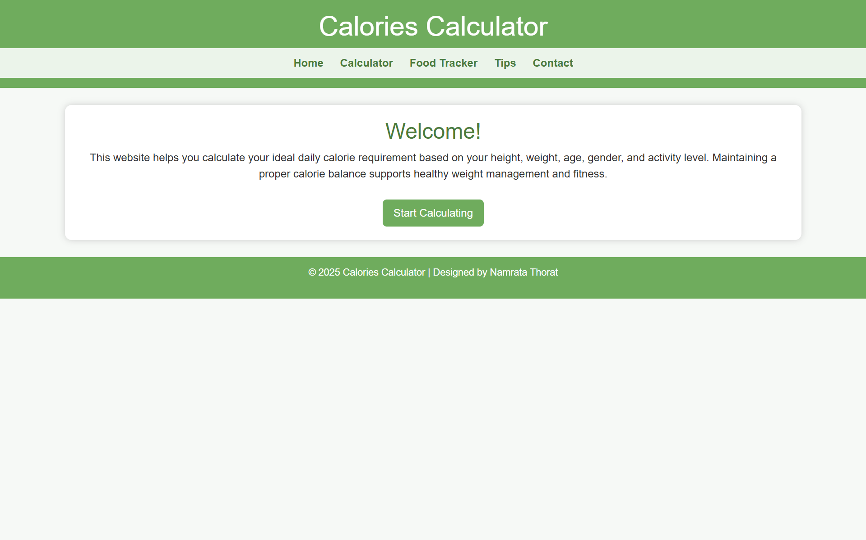
- Calculator page
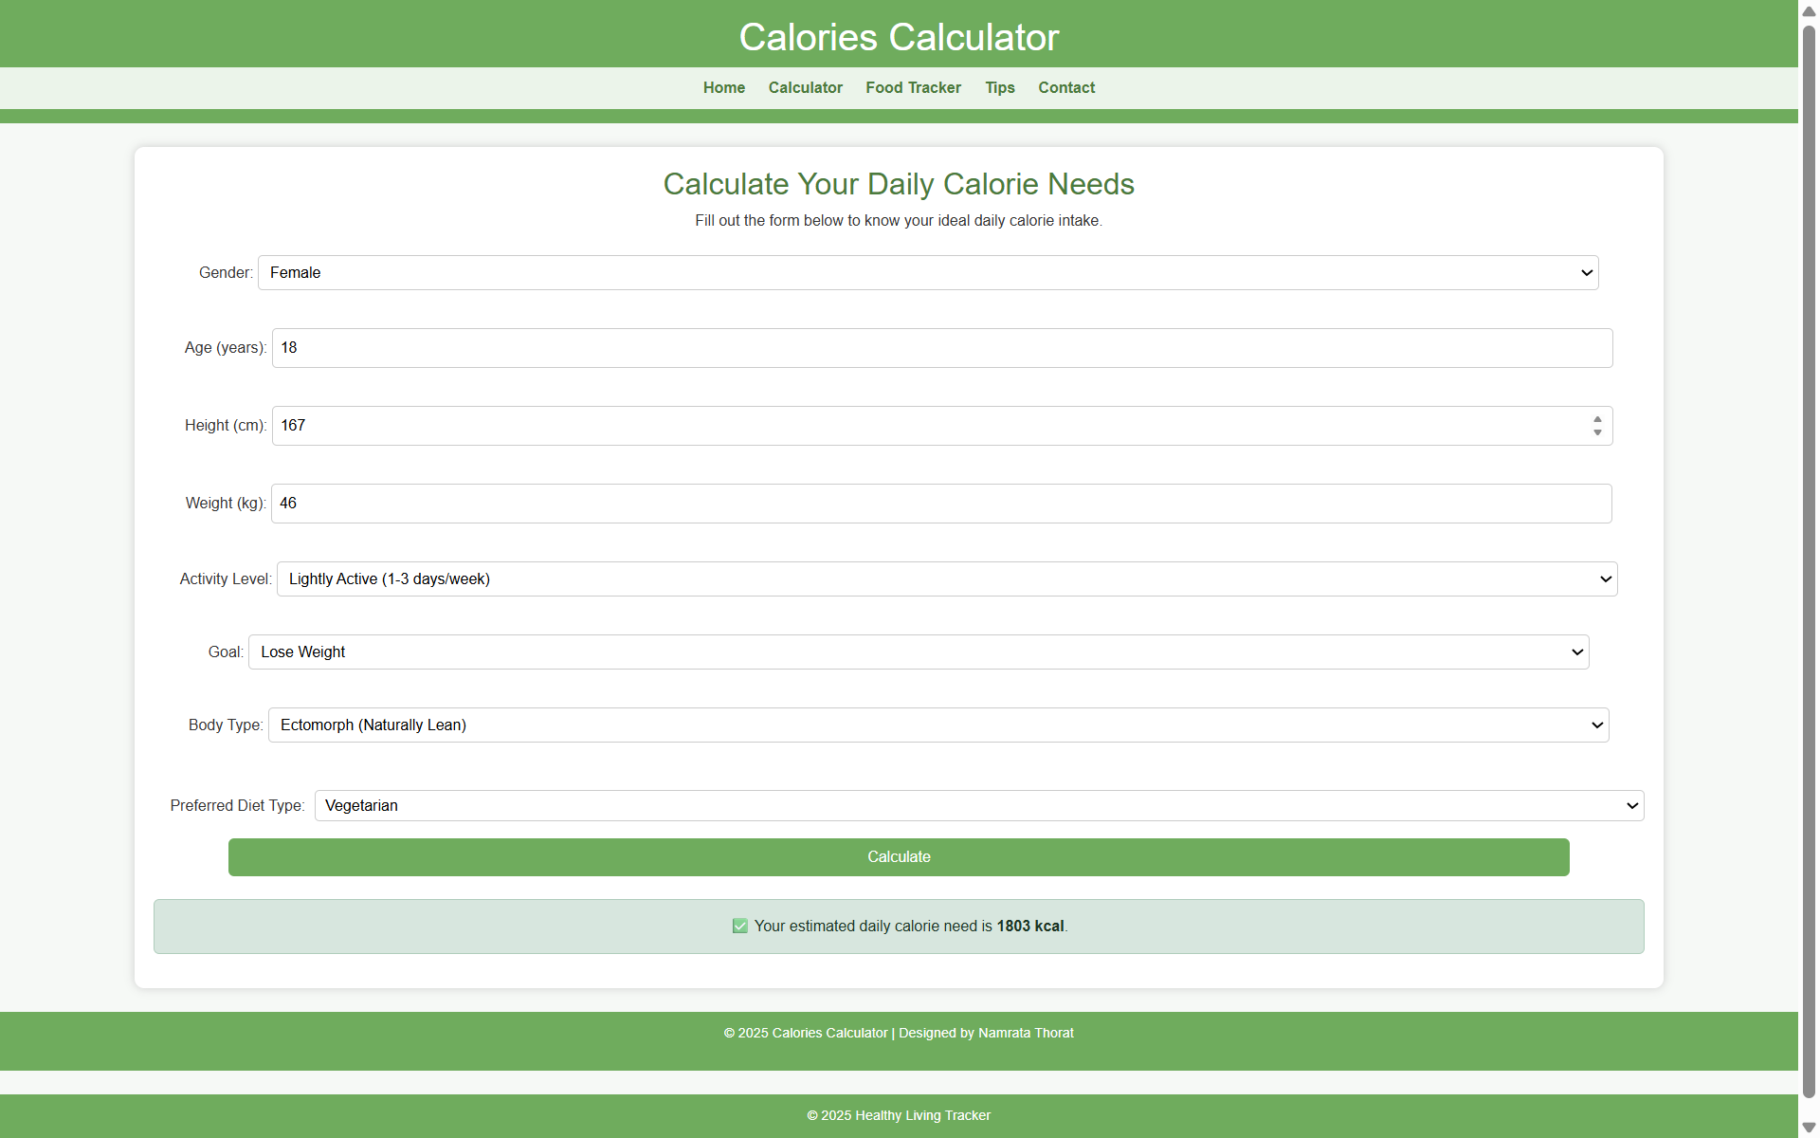

- Food Tracker
(Dropdown shows SELECT FOOD ITEM. When a food is selected and added, it appears in the daily log below with its calories. JavaScript automatically updates the total calorie count each time a new item is added.)
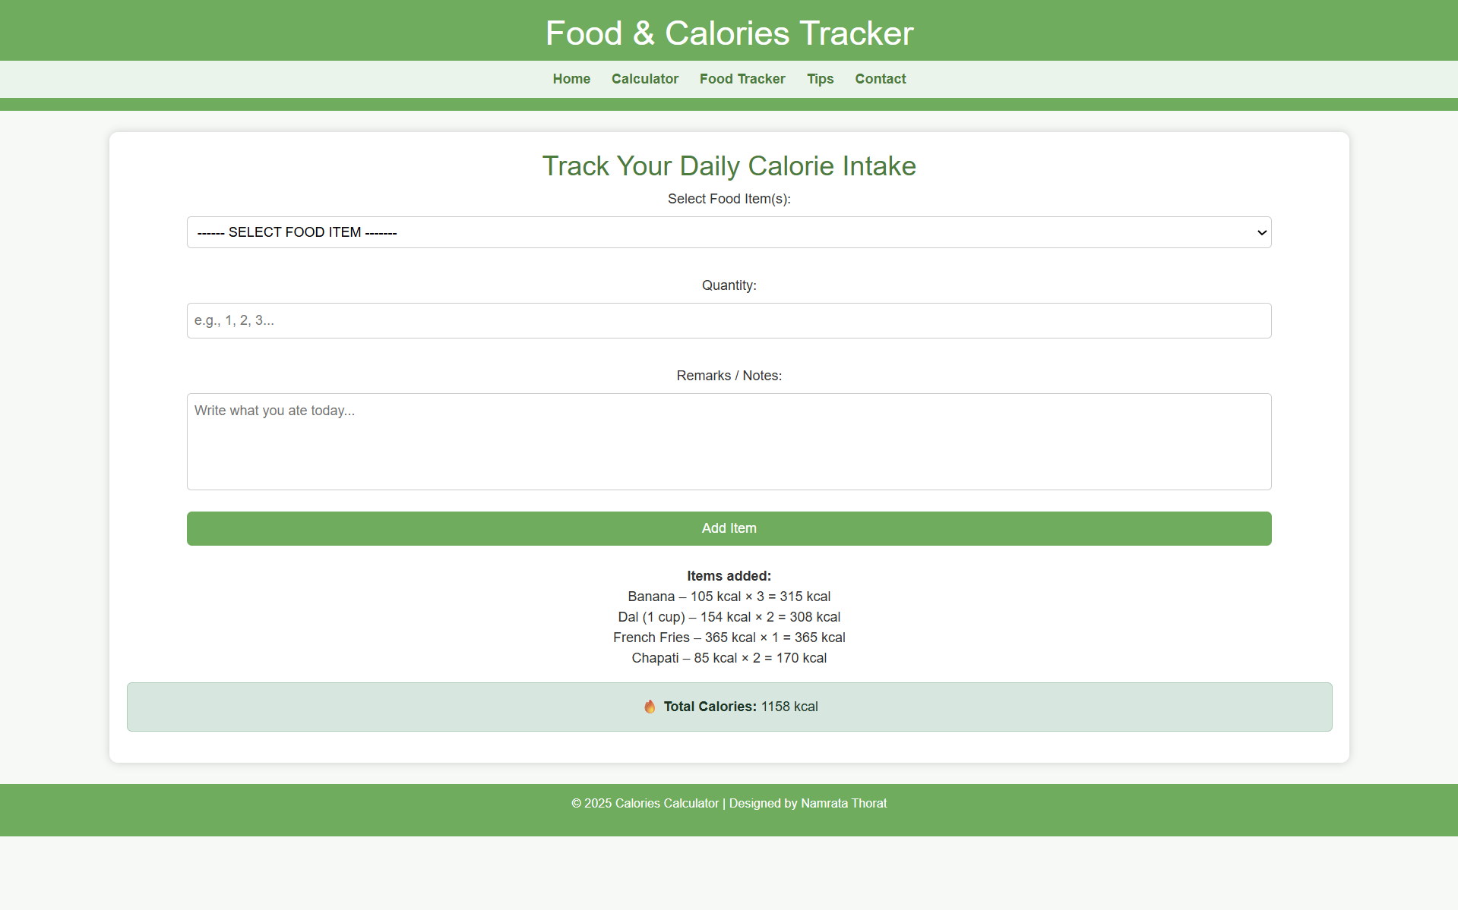
- Tips
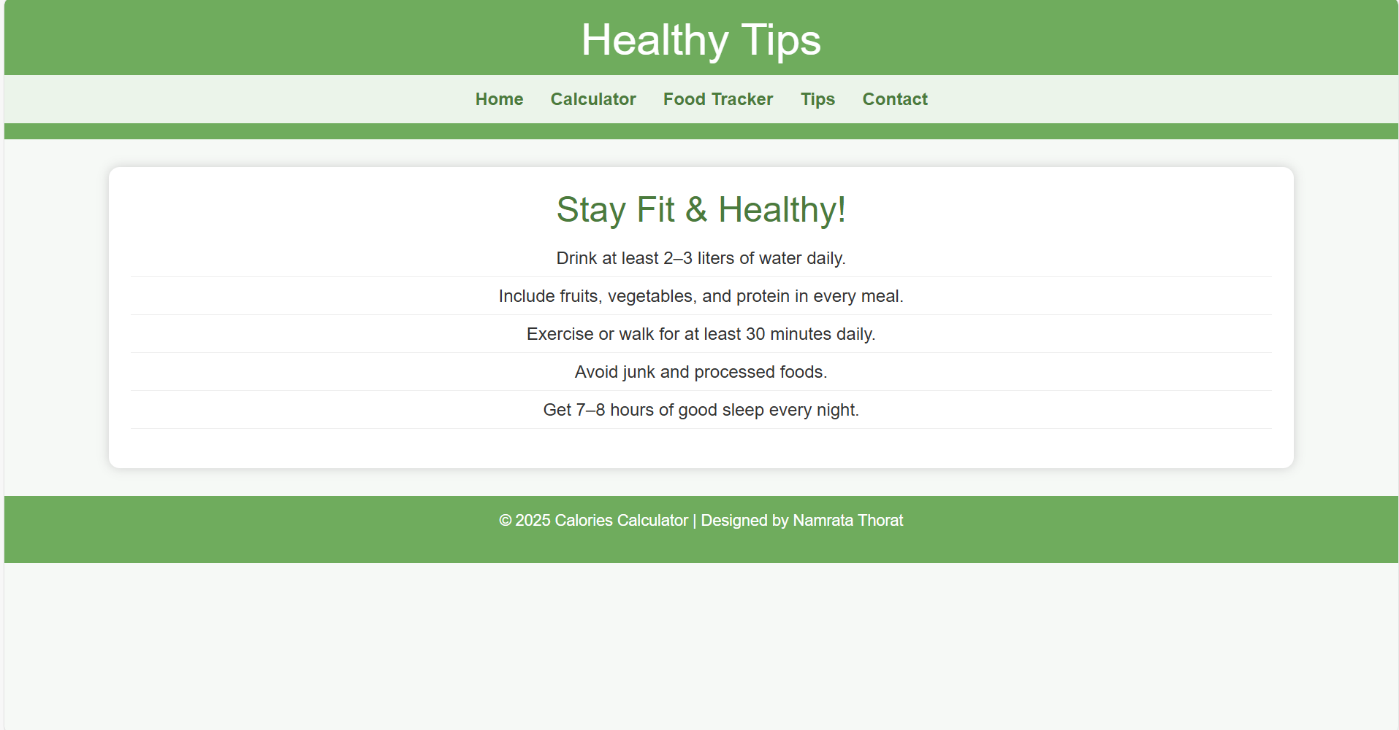

- Contact
