MongoDB Practical: Basic Queries and Operations

1.use("student_practical")
Selects the database for performing MongoDB operations. If the database does not exist, MongoDB creates it when data is first stored.
Query:
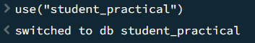
2. db.createCollection("students")
Creates a new collection named students in the current database.
Query:
Output:
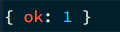
3. insertOne()
Inserts a single document into the specified collection.
Query:
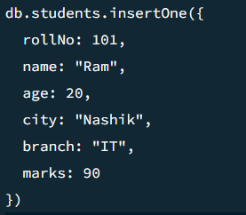
Output:
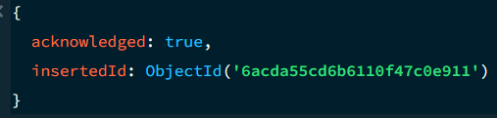

4. insertMany()
Inserts multiple documents into a collection in one operation.
Query:
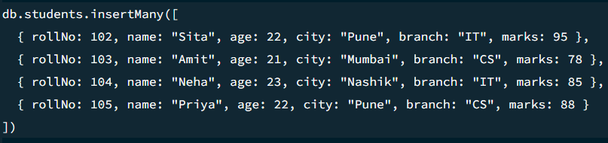
Output:
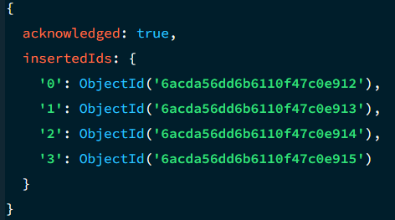

5. find()
Retrieves all documents or documents matching specified conditions.
Query:
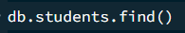
Output:
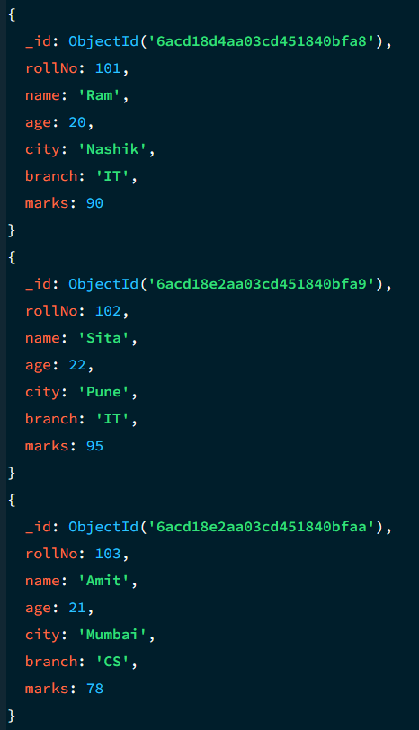
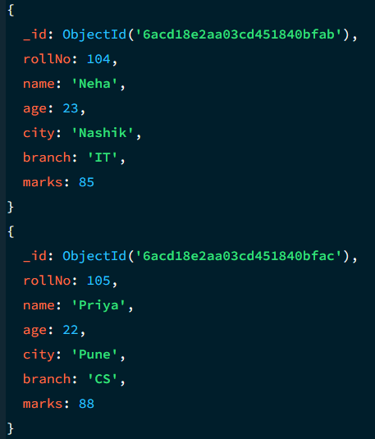

6. findOne()
Retrieves the first document matching the specified condition.
Query:
Output:
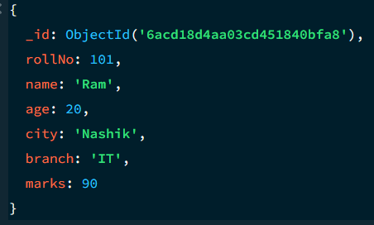

7. Greater Than ($gt)
Retrieves documents with field values greater than the specified value.
Query:
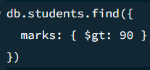
Output :
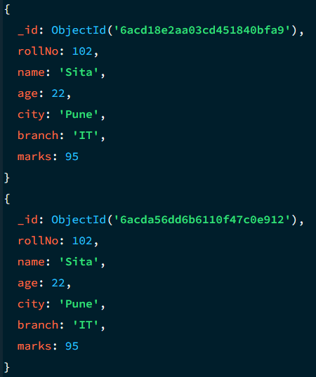

8. Greater Than or Equal To ($gte)
Retrieves documents with values greater than or equal to the specified value.
Query:
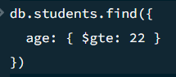
Output :
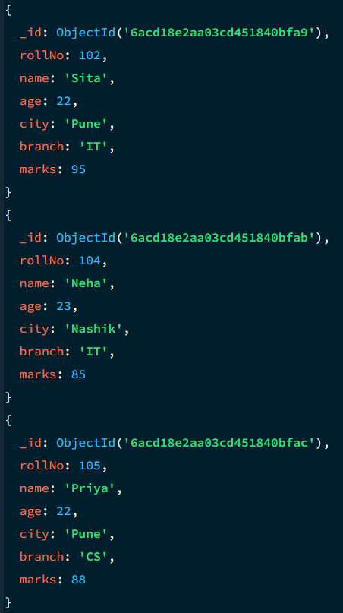

9. Less Than ($lt)
Retrieves documents with field values less than the specified value.
Query:
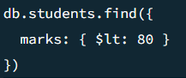
Output :
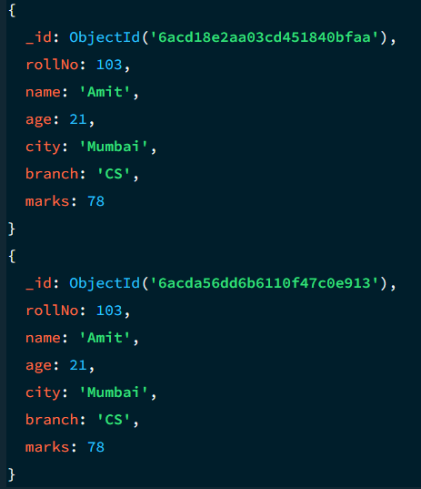

12. limit()
Restricts the number of documents returned by a query.
Query:
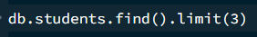
Output:
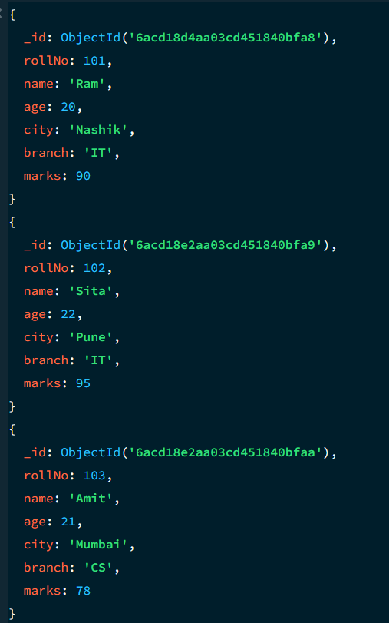

14. updateOne()
Updates the first document matching the specified condition.
Query:
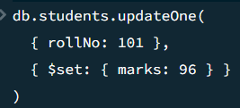
Output:
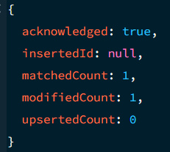

15. updateMany()
Updates all documents matching the specified condition.
Query:
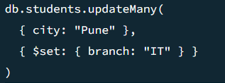
Output :
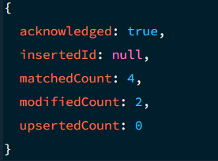

16. deleteOne()
Deletes the first document matching the specified condition.
Query:
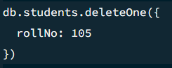
Output:
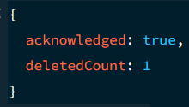

17. deleteMany()
Deletes all documents matching the specified condition.
Query:
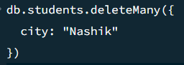
Output:
