**Dbms**

**Name: Ajay Nirmal**

**MoodleId:20102170**

**Div:B Roll.No:53**

**Experiment No:06**

**Natural Join**

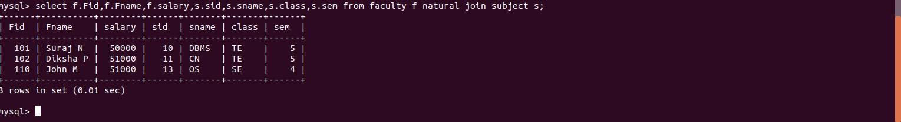

**left outer join**

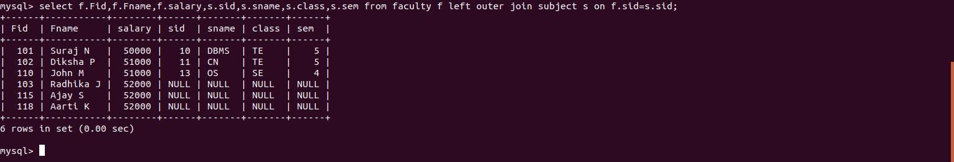

**right outer join**

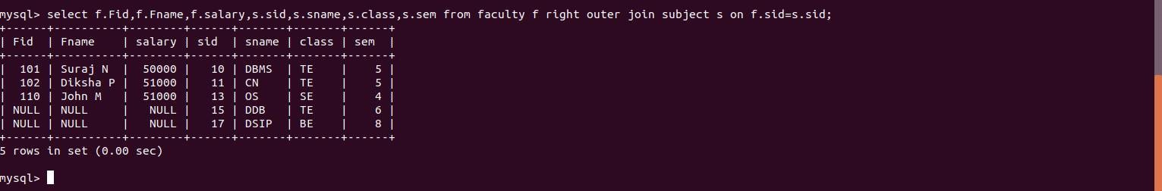

**inner join**

