**DR. D. Y. PATIL SCHOOL OF SCIENCE & TECHNOLOGY DR. D. Y. PATIL VIDYAPEETH, PUNE**

**(Deemed to be University)**

**(Accredited (3rd cycle) by NAAC with a CGPA of 3.64 on four-point scale at ‘A++’ Grade)**

**(Declared as Category - I University by UGC Under Graded Autonomy Regulations, 2018) (An ISO 9001: 2015 and 14001:2015 Certified University and Green Education Campus)**

# Date: 11/3/24

**Assignment No: 8**

**Problem Statement:**

1. Design, Develop and Implement a menu driven Program in for the following operations on Binary

Search Tree(BST) of Integers

1. Create a BST of N Integers: 6, 9, 5, 2, 8, 15, 24, 14, 7, 8, 5, 2
2. Traverse the BST in Inorder, Preorder and Post Order
3. Search the BST for a given element (KEY) and report the appropriate message

**Algorithm:**

1. Define a structure Node to represent a node in the Binary Search Tree (BST) where each node

contains: An integer data to store the value. Pointers left and right to point to the left and right child nodes, respectively.

1. Define a class ‘BinarySearchTree’ to encapsulate BST operations. Declare a pointer root to represent the root of the BST.
2. Implement the ‘insert‘ function to insert a new node with a given value into the BST.

* Start from the root and recursively traverse the tree.
* If the tree is empty, create a new node and make it the root.
* If the value is less than the current node's value, move to the left subtree.
* If the value is greater than the current node's value, move to the right subtree.
* Repeat the process until finding a suitable position to insert the new node.

4. Implement three traversal functions: ‘inorderTraversal‘,‘preorderTraversal‘, and ‘postorderTraversal‘.

* Each traversal function recursively visits all nodes in the BST.
* In inorder traversal, visit the left subtree, then the root, then the right subtree.
* In preorder traversal, visit the root, then the left subtree, then the right subtree.
* In postorder traversal, visit the left subtree, then the right subtree, then the root.

5. Implement the ‘search‘ function to search for a given key in the BST. - Start from the root and recursively traverse the tree.

* If the key matches the current node's value, return true.
* If the key is less than the current node's value, search in the left subtree.
* If the key is greater than the current node's value, search in the right subtree. - Repeat the process until finding the key or reaching a null pointer 6. Create an object of ‘BinarySearchTree‘.
* Insert the provided elements into the BST.
* Call the traversal functions to print the elements in inorder, preorder, and postorder.
* Perform a search operation for a given key and print the result.

**Source Code:**

#include <stdio.h>

#include <stdlib.h>

// Define the structure of a node in the BST struct node { int data; struct node *left; struct node *right;

};

// Function to create a new node struct node *createNode(int value) {

struct node *newNode = (struct node *)malloc(sizeof(struct node)); newNode->data = value;

newNode->left = newNode->right = NULL;

return newNode;

}

// Function to insert a new node into BST

struct node *insert(struct node *root, int value) {

if (root == NULL) {

return createNode(value);

}

if (value < root->data) { root->left = insert(root->left, value);

} else if (value > root->data) { root->right = insert(root->right, value);

} return root;

}

// Function to perform inorder traversal of BST

void inorder(struct node *root) {

if (root != NULL) {

inorder(root->left); printf("%d ", root->data);

inorder(root->right);

}

}

// Function to perform preorder traversal of BST void preorder(struct node *root) { if (root != NULL) {

printf("%d ", root->data); preorder(root->left);

preorder(root->right);

}

}

// Function to perform postorder traversal of BST

void postorder(struct node *root) {

if (root != NULL) {

postorder(root->left); postorder(root->right); printf("%d ", root->data);

}

}

// Function to search for a key in BST struct node *search(struct node *root, int key) {

if (root == NULL || root->data == key) { return root; } if (root->data < key) {

return search(root->right, key);

} return search(root->left, key);

}

int main() {

struct node *root = NULL; int choice, key;

// Creating the BST with given elements int elements[] = {6, 9, 5, 2, 8, 15, 24, 14, 7, 8, 5, 2}; int numElements = sizeof(elements) / sizeof(elements[0]);

for (int i = 0; i < numElements; i++) { root = insert(root, elements[i]);

}

do {

printf("\nMenu:\n"); printf("1. Traverse BST (Inorder)\n"); printf("2. Traverse BST (Preorder)\n"); printf("3. Traverse BST (Postorder)\n"); printf("4. Search for a key\n"); printf("5. Exit\n"); printf("Enter your choice: "); scanf("%d", &choice);

switch (choice) {

case 1:

printf("Inorder traversal: "); inorder(root); printf("\n"); break;

case 2:

printf("Preorder traversal: "); preorder(root); printf("\n"); break;

case 3:

printf("Postorder traversal: "); postorder(root); printf("\n"); break;

case 4: printf("Enter key to search: "); scanf("%d", &key); if (search(root, key) != NULL) {

printf("Key found in BST.\n");

} else { printf("Key not found in BST.\n");

} break;

case 5: printf("Exiting program.\n"); break;

default:

printf("Invalid choice. Please enter a number between 1 and 5.\n");

}

} while (choice != 5);

return 0;

}

**Sample Output:**

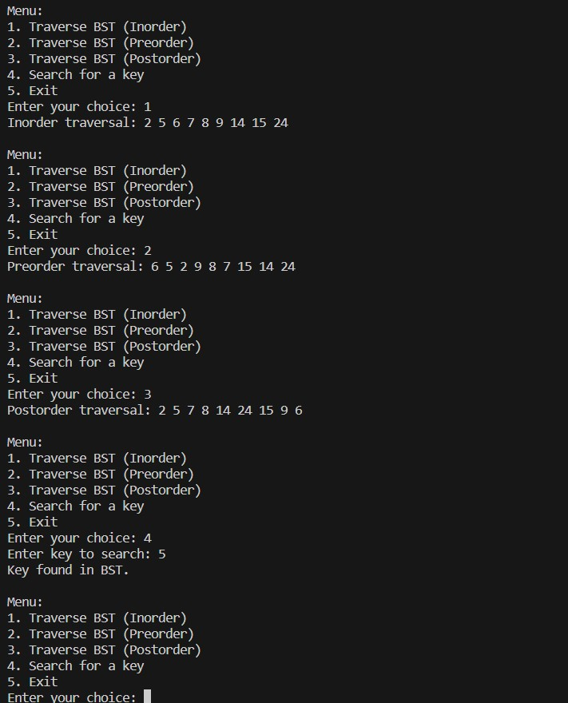

**GITHUB:**