**Results for 1st dataset:**

I had to make 5 runs to get the result. I had made various changes with the number of chromosomes and the number of generations. I had initially set the number of chromosomes to maximum because of which I could not attain the result.

I had set number of chromosomes set to 501 and number of generations to 1000 in order to achieve a fitness value of 1000.

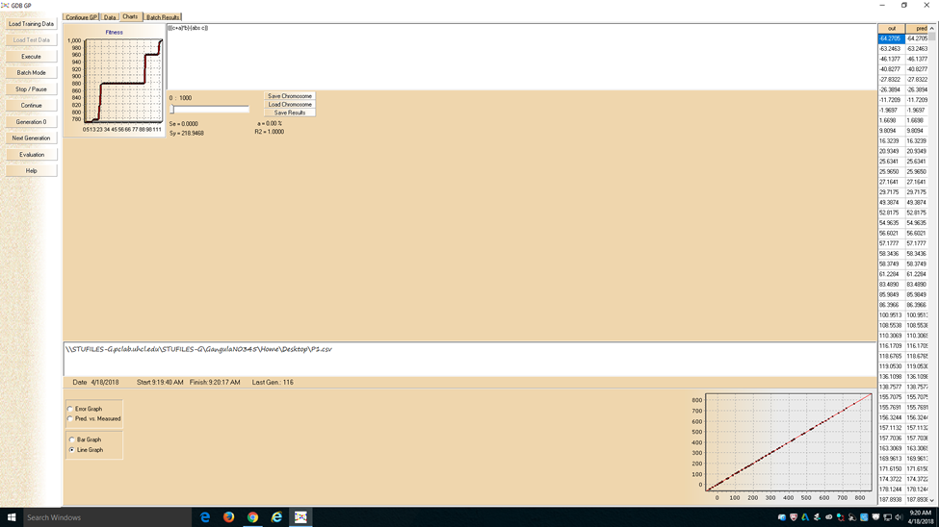

The equation is b*(a+c)-c

**Results for 2nd dataset**:

I had performed 8 runs in order to achieve the result. I had modified the number of chromosomes and the number of generations to attain the result.

I had set the number to chromosomes to 302 and the number of generations to 100 to attain the result.

The equation is ((b*c)+((exp (sin (sin (sin ((exp (sin (sin ((exp (sin (sin (sin (sin ((exp (sin (sin (sin (sin ((exp (sin (sin (sin (sin (exp (sin (sin (sin (sin (sin (sin (sin (sin (sin (sin (((((b*c)/e)/e)+((abs b)/e))/e)))))))))))))))))/e))))))/e))))))/e))))/e)))))/e))

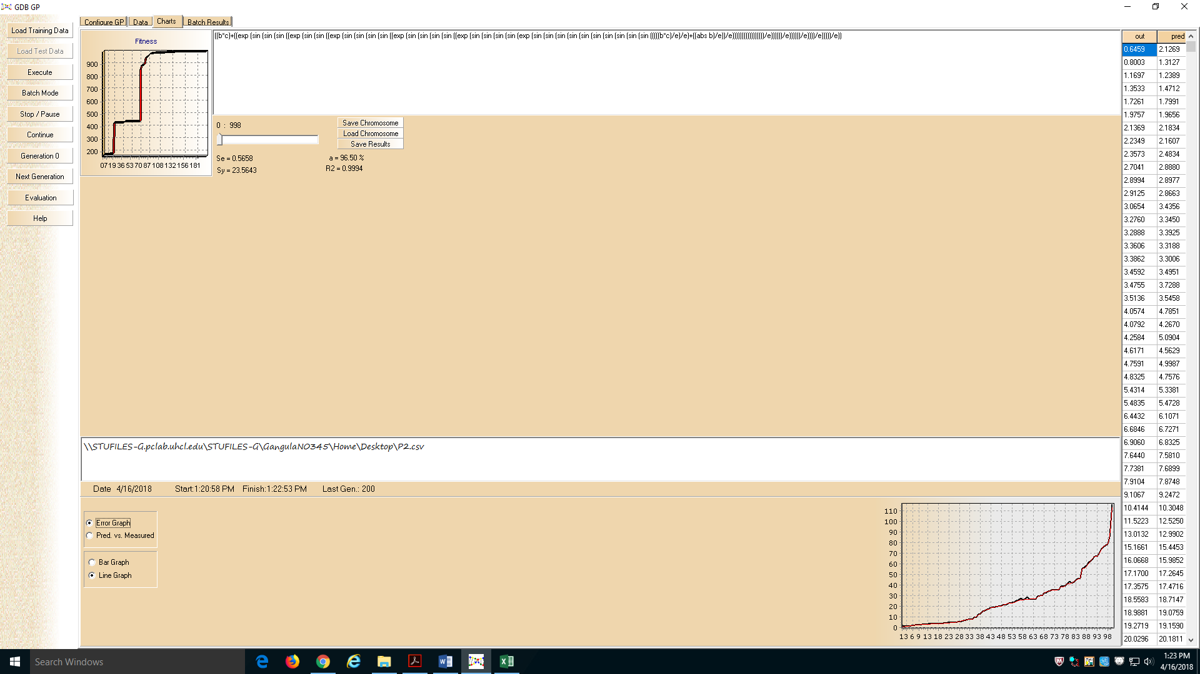

**Results for 3rd dataset:**

I had to make 3 runs to get the result. I had made various changes with the number of chromosomes and the number of generations. I had initially set the number of chromosomes to maximum because of which I could not attain the result.

I had set number of chromosomes set to 216 and number of generations to 1000 in order to achieve a fitness value of 1000.

The equation is b*((sin c)*(abs a)))

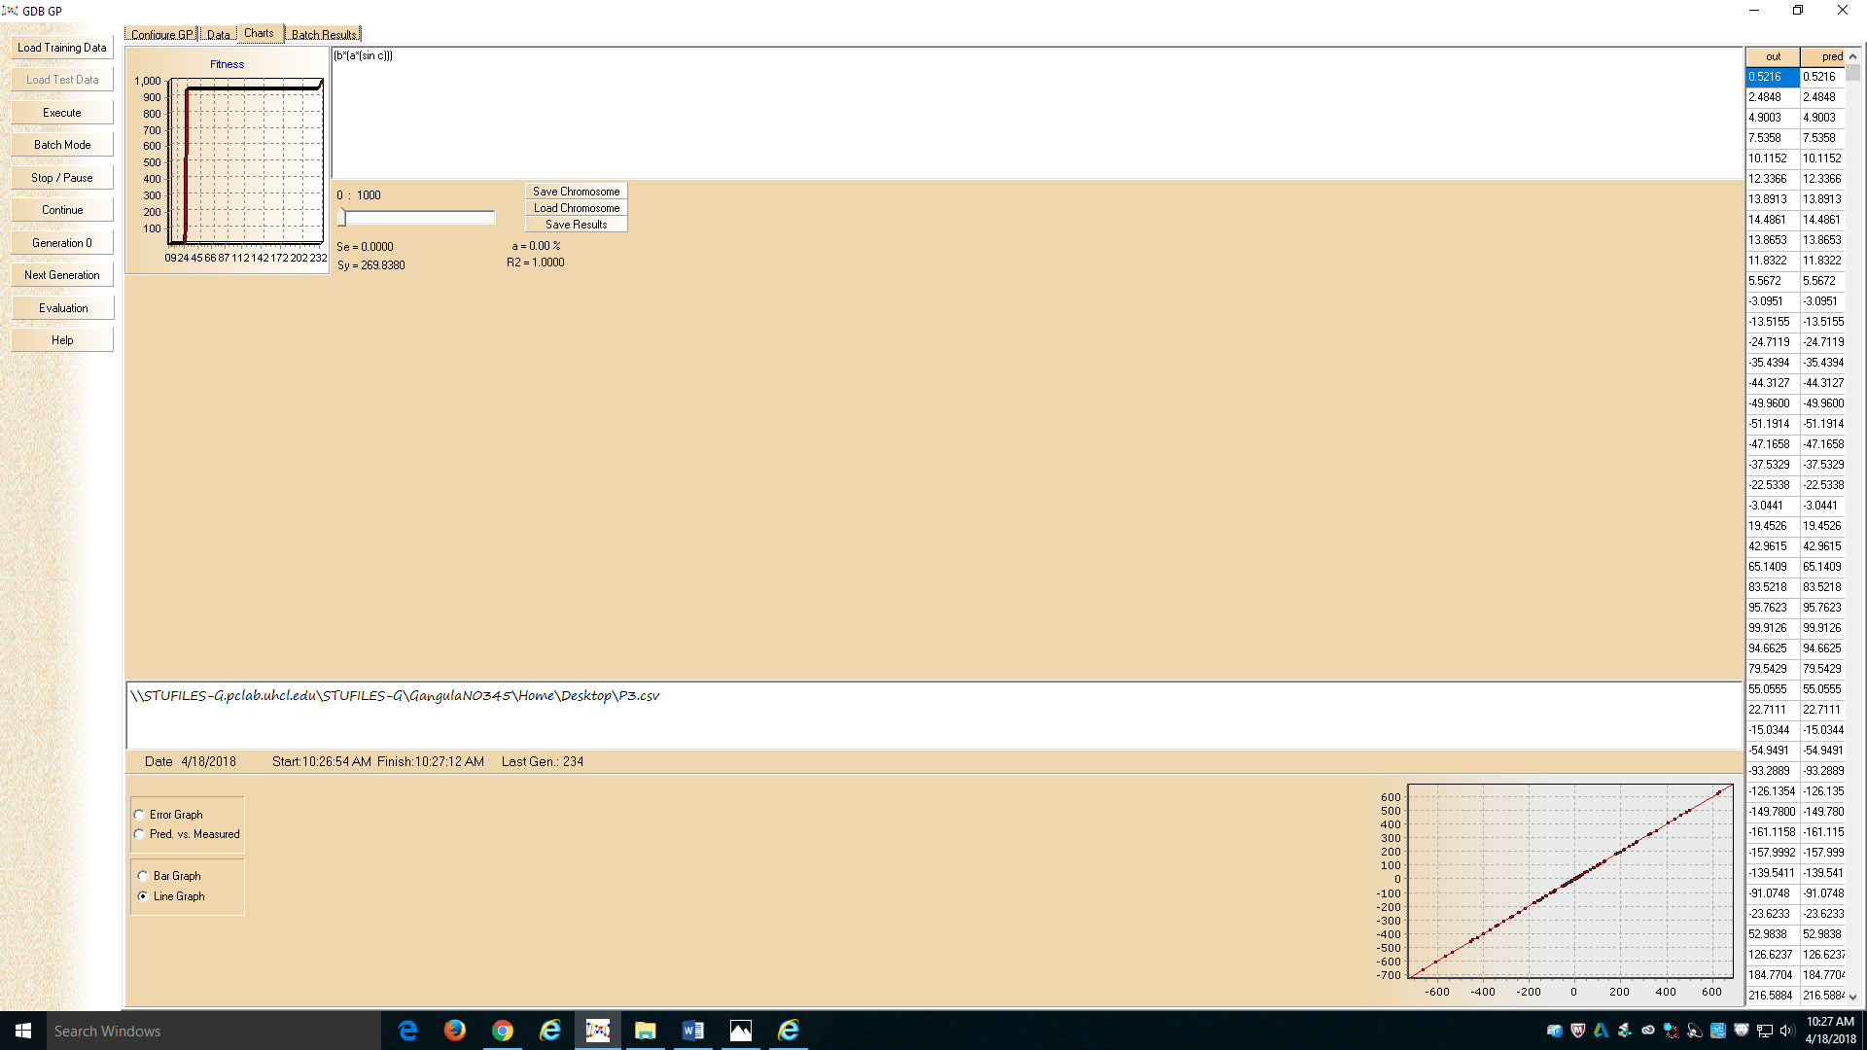

**Results for 4th dataset:**

I had to make 15 runs to get the result. I had made various changes with the number of chromosomes and the number of generations. I had not achieved the result early on inspite of making innumerable changes.

I had set number of chromosomes set to 700 and number of generations to 650 in order to achieve a fitness value of 990.

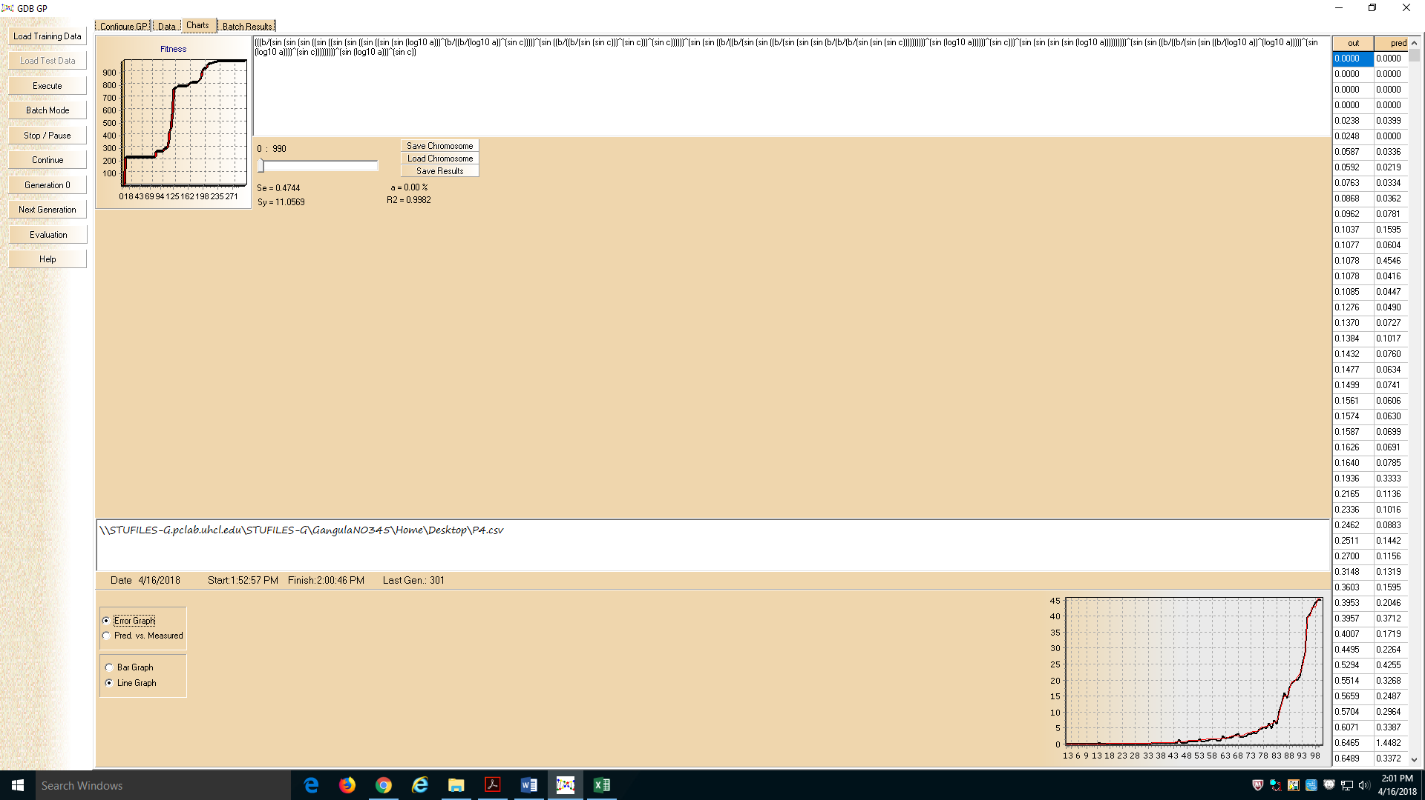

The equation is 