**1. Introduction**

Traffic management has become an important daily routine in cities today with the exponential growth of traffic on roads. Automatic vehicle detection from traffic scenes and extracting essential parameters related to vehicular traffic can help better management of traffic on busy highways and road intersections. Monitoring traffic flow and estimating traffic parameters can be carried out using sensors [1, 2] as well as through image processing techniques. With the advances in technology, monitoring traffic through image processing techniques yield a wide range of traffic parameters such as flow of traffic, speed of vehicles, number of vehicles, classification of vehicles, density of vehicles etc. Since the vehicles can be tracked over a selected segment of a roadway, rather than at a single point, it is possible to measure the “true” density of vehicles for each lane. Image processing techniques can also be applied to traffic video surveillance to detect the vehicles in motion, number plate identification, recognition of obstacles etc. Traffic monitoring through image processing techniques can lead to better control of the flow of traffic as well as to identification of reckless users and speed violators. In the past, many research studies have been conducted on automated vehicle detection using image processing techniques. The focus of this project was to test the performance in identifying the moving vehicles from a traffic scene and to count and classify vehicles within a given time period.

The following are the required processing steps:

* Converting a video stream to a sequence of single frames.
* Detecting a stable image from a dynamically changing background image.
* Calibration of the camera.

Identification of vehicles.

* Tracking moving vehicles in each lane.
* Counting vehicles.
* Classifying vehicles

. The paper starts with a brief overview of related work followed by a description of the approach including segmentation, calibration, tracking, and classification. The paper concludes with results and final conclusions.

Vehicle counting is carried out using the virtual line method. This virtual line acts as a counter from which the count is updated. For each vehicle that enters into the frame and crosses the virtual line, the count is incremented. The virtual line is a baseline that cuts the frame in two parts. In traffic, when the vehicles are close to each other, there is a risk to count two adjacent vehicles being counted as one , which reduces the accuracy of the solution. This shortcoming can be overcome by using an accurate object segmentation algorithm. These methods based on virtual line can effectively perform counting with traffic.

Vehicle detection and statistics in highway monitoring video scenes are of considerable significance to intelligent traffic management and control of the highway. With the popular installation of traffic surveillance cameras, a vast database of traffic video footage has been obtained for analysis. Generally, at a high viewing angle, a more-distant road surface can be considered. The object size of the vehicle changes greatly at this viewing angle, and the detection accuracy of a small object far away from the road is low. In the face of complex camera scenes, it is essential to effectively solve the above problems and further apply them. In this article, we focus on the above issues to propose a viable solution, and we apply the vehicle detection results to multi-object tracking and vehicle counting.

* 1. **OVERVIEW**

In reference [3], a system for detection and classification of vehicles is described. It uses a self adaptive background subtraction technique to separate vehicles from the background. The resulting connected regions are then tracked over a sequence of images using a spatial matching method. The tracked regions are grouped together to form vehicles. Reference [4] also uses adaptive background detection method to identify vehicles. The vehicles are tracked based on contour extraction. Prewitt filter kernel is used for edge detection. The contour linking method used for connecting separated edge parts of the original object into one closed contour. A contour labelling method is used to mark and calculate vehicles within frames. In reference [5], feature based tracking algorithm has been used. Offline camera calibration has been carried out to detect the parameters such as line correspondences for a projective mapping, detection region and multiple fiducially points for camera stabilization. Here, projective transformation is necessary as the features are tracked in world coordinates to exploit known physical constraints on vehicle motion. The transformation is used to calculate distance based measures such as position, velocity and density. In reference [6], adaptive background learning for vehicle detection and spatio-temporal tracking is described. A framework is proposed to analyze the traffic video sequence using unsupervised vehicle detection and spatio-temporal tracking that includes an image/video segmentation method, a background learning/subtraction method and an object tracking algorithm. In reference [7], a system on vehicle detection under day and night illumination is described. Vehicle detection at day time is done by using consecutive three frame subtraction method by detecting moving points. The moving points are classified and labelled as vehicles. Vehicle detection at night time is done by identifying vehicles in terms of pair of headlights. To detect only the objects related headlights, the system perform detection via morphological analysis, by taking into account aspects like shape, size and minimal distance between vehicles. Finally, the verification is based on the correlation between headlights belonging to the same pair. In reference [8], a system for fast vehicle detection with probabilistic feature grouping and its application to vehicle tracking is described. The images were obtained from three cameras installed on a roof of a 30-story building alongside a freeway in order to avoid overlapping of vehicles. System introduces a new vehicle tracking approach based on a modelbased 3-D vehicle detection and description algorithm. The proposed algorithm uses a probabilistic “line” feature grouping method to detect vehicles. The tracking is performed based on the zero-mean cross correlation matching technique. System detects vehicles at the entrance area and track the detected vehicles based on their intensity profiles. In reference [9], a system for vehicle detection and tracking is described. This system is fully based on the Block Matching Algorithm (BMA), which is the motion estimation algorithm employed in the MPEG compression standard. BMA partitions the current frame in small, fixed size blocks and matches them in the previous frame in order to estimate displacement of blocks between two successive frames. The detection and tracking approach is as follows. BMA provides motion vectors, which are then regularized using a Vector Median Filter. After the regularization step, motion vectors are grouped based on their adjacency and similarity, and a set of vehicles is identified per singular frame. Finally, the tracking algorithm establishes the correspondences between the vehicles detected in each frames of the sequence, allowing the estimation of their trajectories as well as the detection of new entries and exits. The tracking algorithm is strongly based on the BMA. It consider the BMA output as the basic tracking information associated with each block and combine this information with the already available block-level tracking as a grouped output in order to achieve the desired result.

**1.2 APPLICATIONS**

We opt to work on this project to minimize traffic congestion and its negative effects. Traffic management systems are composed of a set applications and management tools to improve the overall the traffic efficiency and safety of the transportation systems. And also it

* Reduces day-to-day congestion by improving traffic flow
* Prioritize traffic according to real- time changes in traffic conditions
* Reduce pollution by limiting traffic jams
* Fully automated traffic analysis in real-time, applicable for large-scale use.
* Detect anomalies and dangerous events effectively, using the video of common CCTV cameras.
* Insights to detect and monitor peak hours, bottlenecks and compare different locations
* Quantify and track changes over time and how measures (to reduce traffic congestion or lower urban traffic to reduce emissions) effectively impact traffic flow

**2. LITERATURE REVIEW**

In the past few decades researchers had a great interest in vehicle detection and tracking. The topic attracted the attention quit much. Different sensing modalities have been used for detecting the objects or specifically vehicles. These modalities are LIDAR, radar, and computer vision. The attraction caused by immense progress of image processing. The very first signs and models of image processing goes back to the 1960s’ and 1070s’, after that various methods and techniques have been invented and proposed (Chen, 2015). This chapter briefly discuss the recent related works by researchers regarding vehicle detection and tracking. At the very beginning we can say that any approach in this topic are classified. At a glance we have four sections: • Object recognition and identification from the appearance • Classifying the object into one of the categories. • Object detection or target detection • Tracking the object or the target Object detection presents some unique attributes of an object that a computer can identify distinctly from other objects. Meanwhile the object classification intend to identify the similarities of an object with an object category at all. From the object detection result, we can assign an object tracker, the tracker is following the target by re-detecting it in the sequence frame following the first point of the target. The primary goal and target of the thesis is to develop a system in which the system should be able to detect and track the vehicles automatically whether they are static or moving in images and videos.

This section presents the essential steps in project implementation, starting from a video clip of a traffic scene and ending in vehicle classification and counting. The work was carried out with freely available video clips of traffic scenes. 3.1 Background Detection To extract stable background image, adaptive background detection method was used [3]. This method uses mean value of pixels within a range of frames to detect the background. If the variance of a given pixel is below a predefined threshold, then the pixel is considered to be stable. The background image is updated according to the equation given below. Bt+1 = Bt + St ×Mt Here, Bt is old background image, St is a mask which varies between 0 and 1 depending on the variance and Mt is mean value of pixels.

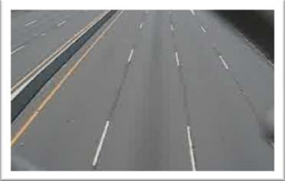

Fig 1: Stable background image

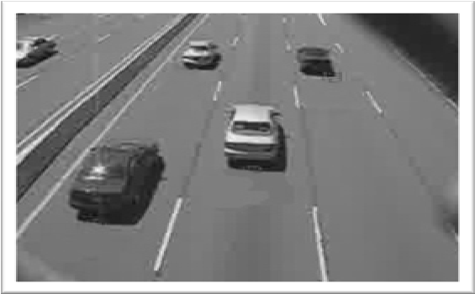

Fig 2: Image under investigation

**2.1 Camera Calibration**

Camera calibration plays an important role in the identification process. Camera calibration is carried out to transform the image coordinates to world coordinates [5]. This is essential for the vehicle classification. It is also important if one wishes to extract the speed of the vehicles. In this work following assumptions were taken.

* Road is straight
* Road is flat
* *X* axis of the road space correspond to the direction perpendicular to the traffic flow and the *Y* axis is parallel to the traffic flow.

The transformation that has been carried out from the image space to world space is the projection transformation. Assume that the width and the length of the selected area in road space (which are known) are *w* and *h* respectively. The equation to find the projective transformation matrix that maps the image space coordinates (*ax,ay; bx,by; cx,cy; dx,dy*) to their corresponding road space coordinates

is;

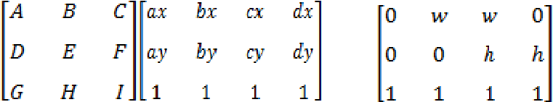 =

To optimize the results of projection transformation matrix, least squares optimization method was used. The projection transformation was used as the initial guess and the best projection matrix was found by using the following objective function [5].

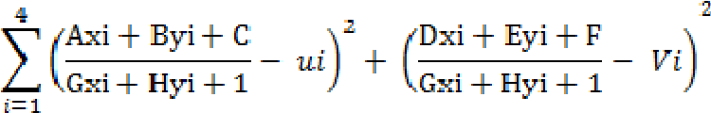

**2.2 Lane Calibration**

Since the goal of the project is to identify the vehicles in each lane separately, the lanes must be defined and the center line of each lane must be identified. User is allowed to select the region of interest by selecting the center of lanes first and then the starting and ending points on each lane to define the tracking region. The screen space coordinates were first transformed into road space coordinates and then projected onto the lane line.

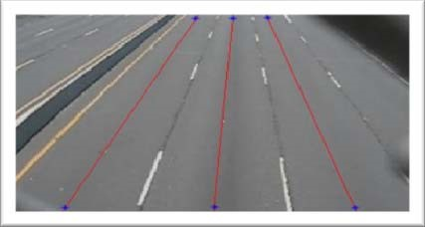

Fig.3Selected center line on each lane

Vehicles were tracked alone the centerline on each lane within the user define tracking area.

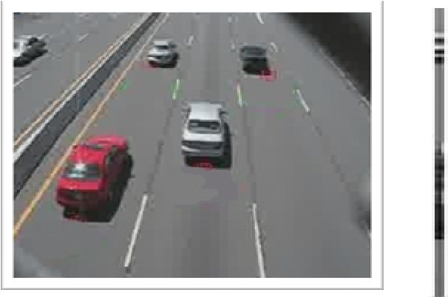

Fig 4: Current frame and extracted pixels on lane lines

**2.3 Vehicle Tracking**

Numerous techniques have been developed to track moving objects in tracking regions such as tracking points, tracking centroids, tracking rectangles etc. In this work, the bottom coordinates of the identified objects have been used to track moving vehicles in the selected area.

While reading new frame, beginning of the center line of interest has been examined and if a positive value (here it is 1) is seen, the algorithm considers it as the bottom coordinate of a vehicle. If a positive value was seen in the previous frame and it has now changed, it suggests that the vehicle is in motion in the selected region of interest. By detecting the column vector having top to bottom positive stream of values the vehicle could be detected. Figure 5 illustrates the stated algorithm.

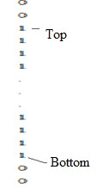

Binary pixel value of column vector of an identified vehicle

By calculating the length of the positive column vector which is the difference between the top and the bottom pixel values of the positive stream of numbers and convert it to the world coordinate space, minimum length of vehicle could be verified. Vehicles that do not satisfy the minimum length requirement were rejected. If a new vehicle is found, it is added to the vehicle array of the lane.

For each vector in the vehicle array, algorithm starts from the last known position of the bottom of the vector and search forward along the center line to find the next position of the vector in the next frame. If the search ended up in reaching the end of the region, the vehicle is considered to be exited from the region of interest. This process is repeated for all defined centerlines.

### 2.4 Vehicle Classification

Classification is done by categorizing the vehicles into three classes according to the size of the vehicles, namely, large, medium and small. Since it is easy to find the length of vectors, the length has been taken as the parameter to classify vehicles according to the defined sizes. The following table shows the classification used in this work.

|  |  |
| --- | --- |
| Large | Containers, Lorries, Buses |
| Medium | Cars, Vans, Pickups |
| Small | Two wheelers, Three wheelers |

Table 1: Classification of vehicles

For each new vehiclethat enters into the line on the region of interest, the length of vector has been calculated and subjected to the minimum length requirement. Classification was carried out for those vehicles that pass the length requirement.

**2.5 Vehicle Counting Concept**

Vehicle counting is one of the most basic challenges during the development and establishment of transport systems. The main reason for vehicle counting is the necessity of monitoring and maintaining the transport infrastructure, preventing different kinds of faults such as traffic jams. The applied solution to this problem is

* Detector
* Counter
* Tracker

These three systems will work accordingly. The detector will detect the presence or movement of vehicles and the term “Counter” will count the total number of vehicles on the street and the “Tracker” will

Track the closest vehicle which passes from the blue lines in the monitoring video.

The moving objects foreground masks are first extracted from the foreground background subtraction technique. After the foreground background subtraction, morphological operations are applied to get the close contours to identify blobs. Once the blobs are identified, object enrolling is done. Object enrolment and maintaining of the confirmed and unconfirmed list of objects are done in the object management module. After enrolling of the object, tracking and prediction of the object positions are carried out. Using these tracked objects, vehicle counting is carried out. Vehicle counting is carried out using the virtual line method. This virtual line acts as a counter from which the count is updated. For each vehicle that enters into the frame and crosses the virtual line, the count is incremented. The classification and counting results are shown below, along with their counts.

The virtual line is a baseline that cuts the frame in two parts. In traffic, when the vehicles are close to each other, there is a risk to count two adjacent vehicles being counted as one, which reduces the accuracy of the solution. This shortcoming can be overcome by using an accurate object segmentation algorithm. These methods based on virtual line can effectively perform counting with traffic.

Once an object is detected and identified, the object in a video feed/sequence is tracked. To predict the object positions, the Kalman tracking algorithm is used. Classification task is accomplished using an SVM model, which returns the predicted class label on the basis of the trained support vector machine (SVM) classification model. This model also returns a score matrix to indicate the label coming from a particular class. For each observation, the maximum score among all the class models corresponds to the predicted class label and respective experimental vehicle class results are presented on the system.

**2.6 Vehicle Tracking**

It can be considered that the method of vehicle object detection has been transferred from research on traditional methods to that on deep convolutional network methods. Moreover, there are fewer public datasets for specific traffic scenes. The sensitivity of convolutional neural networks to scale changes makes small object detection inaccurate. It is challenging to conduct multi-object tracking and subsequent traffic analysis when highway surveillance cameras are used. In summary, our contributions include the following:

\

* A large-scale high definition dataset of highway vehicles is established that can provide many different vehicle objects fully annotated under various scenes captured by highway surveillance cameras. The dataset can be used to evaluate the performance of many vehicle detection algorithms when dealing with vehicle scale changes.
* A method for detecting small objects in highway scenes is used to improve vehicle detection accuracy. The highway road surface area is extracted and divided into the remote area and the proximal area, which are placed into the convolution network for vehicle detection.
* A multi-object tracking and trajectory analysis method is proposed for highway scenes. The detection object feature points are extracted and matched by the ORB algorithm, and the road detection line is determined to count the vehicle movement direction and the traffic flow.

**2.7 Steps for Vehicle Detection and Classification Using OpenCV**

* Import necessary packages and Initialize the network.
* Read frames from a video file.
* Pre-process the frame and run the detection.
* Post-process the output data.
* Track and count all vehicles on the road
* Save the final data to a CSV file.

**2.8 Statement of the Problem**

The major traffic problem in the recent scenario is the traffic congestion and the road rash case which is increasing in a blink of an eye. In the context of Kathmandu, which is the capital city of Nepal, people have to go through traffic congestion every single day. A proper system should be adopted in order to control this problem. By exploring various papers related to the subject matter, the problems are stated below:

- The existing traffic is controlled manually by traffic policeman.

- The complexity of road networks is increased to service the growing demand for road users.

- The dependency on the manual service of the traffic policeman communicating to the people which are not good in terms of efficiency and safety

**3. SOFTWARE REQUIREMENTS**

**3.1 SOFTWARE’S REQUIRED/VERSIONS**

* Python - 3.x (we used python 3.9.6 in this project)
* OpenCV – 4.4.0. it is strongly recommended to run DNN models on GPU.
* NumPy – 1.20.3

**4. HARDWARE REQUIREMENTS**

**4.1 Hardware Required**

* Smart Vehicles
* Camera
* ADAS & DSM system

ADAS (Advanced Driver Assistance Systems) & DSM (Driver Status Monitoring Systems). ADAS & DSM system is product geared towards scanners in commercial vehicles. Based on deep learning technology, the product is equipped with forward collision warning (FCW) and driver fatigue monitoring, greatly reducing accidents and saving lives.

5. **FRONT END SNAP SHOTS**

**5.1 FRONT END USED:**

Python

**5.2 SNAP SHOT**

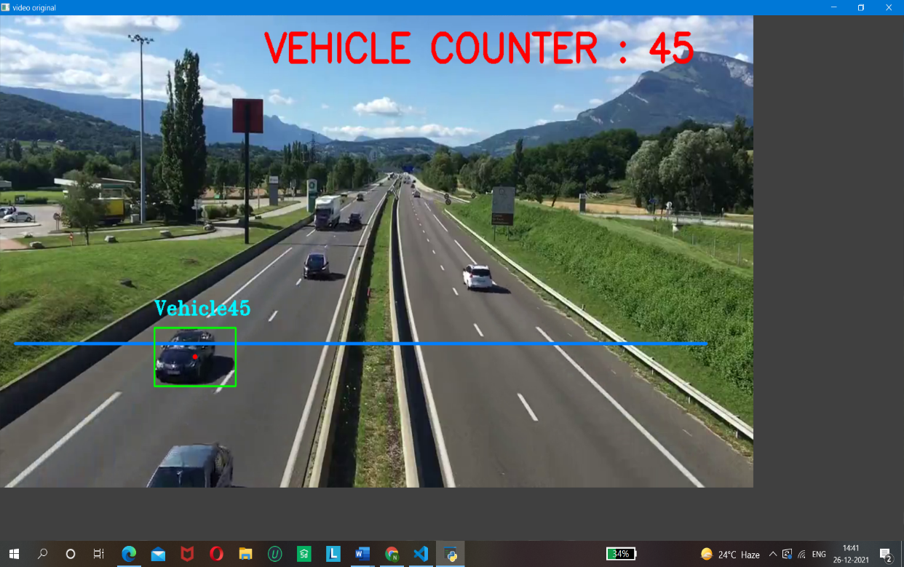

Fig 5: Interface of Vehicle Detection

. **6. RESULTS AND ANALYSIS**

Since the success of the project depend on providing a proper line of site for the camera view, placing the camera on an overhead bridge directly over the flow of traffic route was necessary to minimize the vehicle occlusion. Due to security situation in the country, tests were carried out (to debug the developed algorithms and to evaluate the performance) with freely available video clips on internet, one with vehicles moving away from the camera view and another with vehicles moving towards the camera view (see Figure 6).

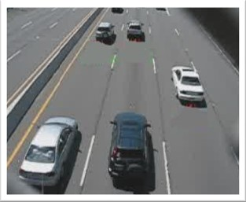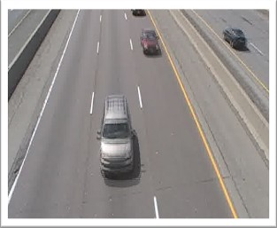

Fig 6: Video clips used to test the developed algorithms

The accuracy of the results depends on the camera calibration which takes place to find the projection matrix between the image coordinate and the world coordinate, lane selection and the tracking region. The system has been tested with several camera calibrations to find the optimum results. Figure 7 illustrates results of two camera calibrations for the video clip 1

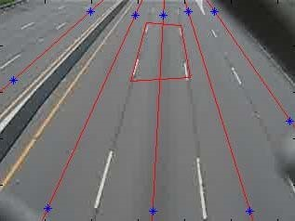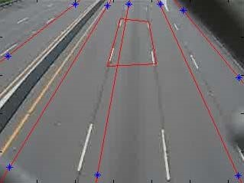

1. (2)

Fig 7: Camera calibrations

(1) Optimum calibration

(2) Improper lane selection

In order to reach the desired goal, the video clips were subjected to a series of independent tests that were discussed earlier to carry out vehicle identification, tracking, classification and counting.

For the video clip 1, manually counted results and counting results of the developed system (CCT system) for each lane is given in Table 2. Here, in lane 1, vehicles are moving towards the camera and in lane 2, lane 3, lane 4 and lane 5, vehicles are moving away from the camera view.

|  |  |  |  |  |  |
| --- | --- | --- | --- | --- | --- |
| Calibration | Lane 1 | Lane 2 | Lane 3 | Lane 4 | Lane 5 |
| Manual | 32 | 36 | 38 | 41 | 4 |
| CCT System | 32 | 37 | 42 | 36 | 12 |

Table 2: Comparison between actual counting and CCT system counting

It can be seen that except for lanes 4 and 5, other 3 lanes produce results within 10% of the manual counting. As expected, errors increase when the lanes are skewed in the camera view. The developed system tends to produce errors especially when the vehicles do not travel within the selected lanes and when tall vehicles (such as containers) tend to be in the side lanes often covering two lanes in the camera view.

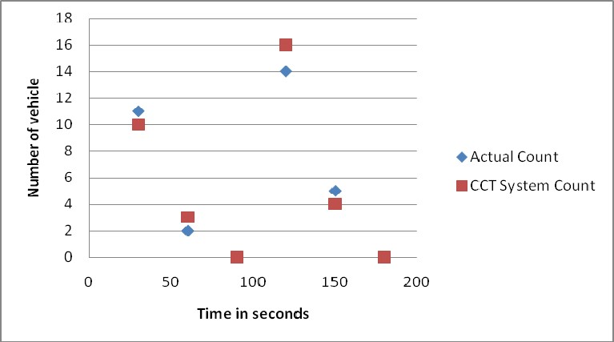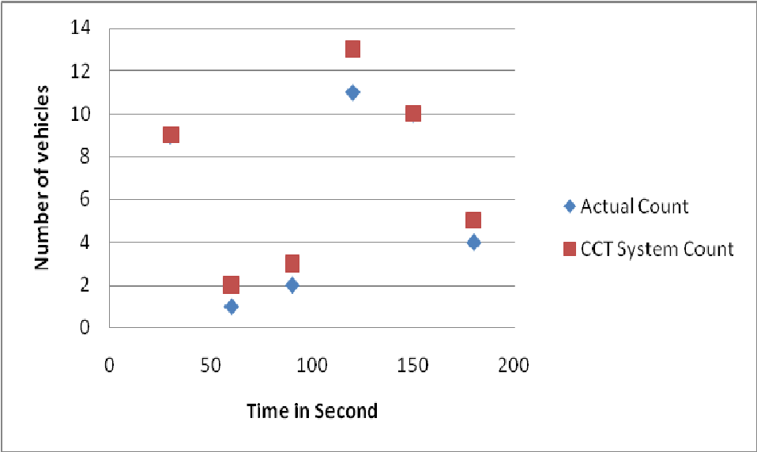

Fig 8: Comparison of counting results for different time intervals for lane 1 and 3

In order to check the performance of the CCT system with the traffic flow rate, data were collected for time intervals of 30 seconds. Figure 8 shows the results obtained for different time intervals for lane 1 and lane 3 for video clip 1.

Financial assistance given by the National Science Foundation, Sri Lanka for the research grant number RG/07/E/03 is greatly acknowledged.

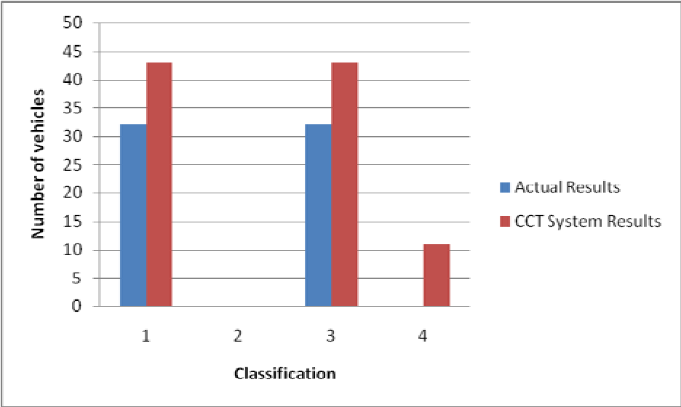

vehicles is the length of the vehicles. Figure 9 shows the comparison of vehicle classification between actual classification (visual) and CCT system classification for total (1), large (2), medium (3) and misidentification (4).

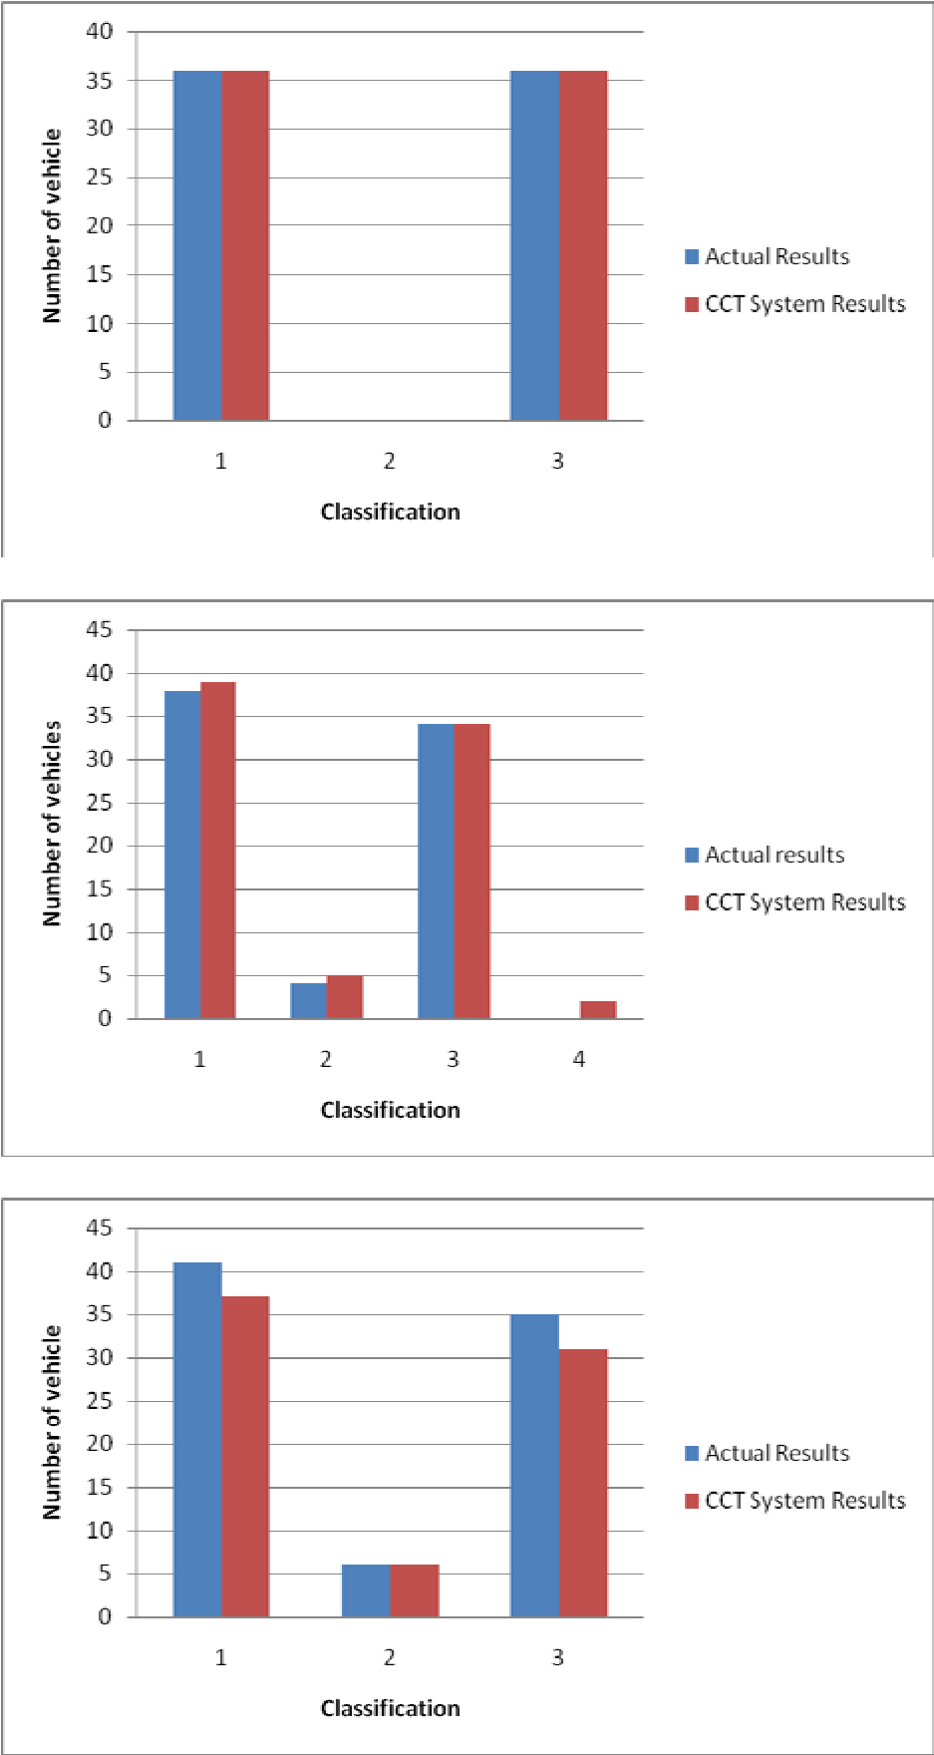

Fig 9: Comparison of classification between actual and CCT system for each lane

**7. FEATURES AND ADVANTAGES**

**7.1 FEATURES**

* Detect and classify multiple vehicle types (truck, bus, bicycle, car) automatically and contactless.
* Track multiple detected objects and count them in real-time as they pass a specific area.
* Aggregate counting data over time with custom logic and send it to third-party systems.
* Edge AI allows full data privacy and robustness with on-device machine learning for image processing

**7.2 ADVANTAGES**

The major advantage of proposed system is to make automated driving more risk free in combination with no requirement of traffic light if everything is executed properly. By doing so, time and money will be saved as well.

* traffic control signals provide for an orderly movement of traffic.
* They help in reducing the frequency of an accident of some special nature i.e. of right angles accidents.
* They intercept heavy traffic to allow other traffic to cross the road intersection safety.
* They provide authority to the drivers to move with confidence.
* They control the speed of vehicles on main as well as on secondary roads.
* They direct traffic on different routes without excessive congestion.
* The provide economy over manual control at the intersection.

**7.3 The Limitations of the Study**

Despite the fact that the thesis reached to its goals, it would have been more accurate if the dataset is improved and the number of objects in vehicles and non-vehicles class increased. At the same time it would be more complete and proper claim if the comparison would have conducted between many more options in the algorithms which are used in computer visionary problems.

**8. CONCLUSION**

Preliminary results for developing an automated system for counting and classification of vehicles in motion, based on image processing techniques were presented in this paper. The developed system was able to track vehicles and classify them with a reasonable accuracy. The system is capable of handling video clips of traffic scenes with 15 frames per second in real time.

The results strongly depend on the camera calibration used. If the camera calibration is not optimal, it can easily affect the system performance. When the camera calibration is optimal, developed system showed an accuracy of 93% for lane 1, 97% for lane 2 and 90% for lane 3. As expected, lane 5, which is the furthest lane from camera view and often obstructed due to heavy vehicles showed poor performance in counting.

The vehicle traffic data from this application can be used in real-time to count and classify vehicles on busy routes. Once this application is used to gather the data of vehicle types, a heat map can be generated to get different traffic flows and to help in better management of city traffic. This gives a quantified way to measure the vehicle traffic in the city. One such direct use would be to divert traffic for reducing the load on a particular choke point in the city. This kind of data can also be used to predict the wear and tear on the road and a maintenance schedule can be derived from it.

The results obtained through the developed system show that with further improvements it can be used in real-time to count and classify vehicles on busy traffic routes. Especially, if an obstructed view of the traffic movement can be obtained, the system can perform quite accurately.

Road safety and reducing accidents is a very crucial issue and must be considered at utmost priority. One must abide the rules of maintaining appropriate speed guidelines. Technoogical tools and tracking devices which help in monitoring the motion and speed of vehicles can help reduce the number of accidents on roads as well as trace the origins of the mishap. In this paper, we have discussed the challenges and obstacles faced while implementing a system which detects a vehicle and monitors its speed and motion. The separation of foreground and background objects and commonly preferred approaches to solve this issue. In addition, to this we have also suggested a possible formulation which can be used to detect the motion of vehicle. Furthermore, the paper also talks about the speed tracking algorithm and tried to elucidate the working of these algorithm and mathematics involved behind it. To support our thesis, we have also mentioned snippets from the system we designed for vehicle detection. Several nations are already using such systems to detect the speed and direction of vehicle. Moreover, some systems have advanced to the capacity of detecting the number plates of vehicles which are blurred for normal cameras and uses image processing algorithms to sharpen the image and extract the number plate which makes it even easier to locate the vehicle. Also, the speed breakers can be designed in such a way that they only rise when the vehicles speed is above the permissible limit.

**8.1 Future Enhancement**

Future work directions may include extending the proposed algorithm for global traffic management, including the optimization of all the intersections in Smart Cities. Furthermore, handling the pedestrian in the intersection using Vehicle-to-Pedestrian (V2P) communication and the wearables is one of the possible important future works. This may include the development of an extra communication model, namely, Pedestrian-to-Infrastructure (P2I). Another work direction is to use Deep Learning and AI in the optimization process for the traffic management process using the current location, destination, and speed of each vehicle to provide better and efficient traffic management

**REFERENCES**

1. R. Chellappa “Vehicle detection and tracking using acoustic and video sensors”, 2004
2. Sensor Line, Classax, Traffic Data Acquisition System, Germany, www.sensorline.de
3. S. Gupte, “Detection and Classification of Vehicles”, University of Minnesota 2002.
4. E. Atkociunas, "Image Processing in Road Traffic Analysis", Vilnius University, 2005
5. B. Coifman "A Real-Time Computer Vision System for Vehicle Tracking and Traffic Surveillance" University of California, 1998
6. C. Zhang "Adaptive Background Learning for Vehicle Detection and Spatio- TemporalTracking", IEEE, 2003
7. R. Cucchiara “Vehicle Detection under Day and Night Illumination" Proc. of ISCS-IIA, Special session on vehicle traffic and surveillance, 1999
8. Z.W. Kim "Fast Vehicle Detection with Probabilistic Feature Grouping and its Application to Vehicle Tracking", CiteSeer, 2001
9. L. Di Stefano, ”Vehicle Detection and Tracking Using the Block Matching Algorithm", Department of Electronics, Computer Science and Systems (DEIS) University of Bologna.