# [WORKAROUND] RapidMiner Extensions – proxy issue

If NamSor extension for RapidMiner returns an error 500, it may be an issue with the proxy.

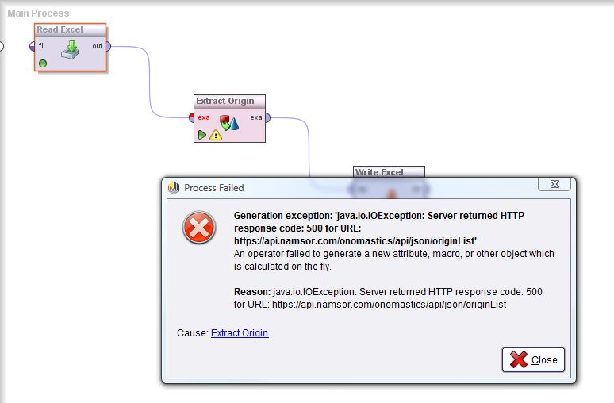

In the directory

C:\Program Files\RapidMiner\RapidMiner Studio

Make a copy of RapidMiner-Studio.bat and add **-Djava.net.useSystemProxies=true** to the launch command:

echo Launching RapidMiner Studio GUI now...

"%JAVA%" %JVM_OPTIONS% **-Djava.net.useSystemProxies=true** -cp *[...]*

Click on the modified file to launch RapidMiner, with the system proxy used as default.

NB/ You may need to change the permissions to write / edit

C:\Program Files\RapidMiner\RapidMiner Studio

(select and right click to edit permissions)

