A FINAL PROJECT REPORT ON
RAPID FIRE FIGHTING ROVER


SCHOOL OF ENGINEERING AND TECHNOLOGY
B.TECH CSE(1ST YEAR)

Submitted to:
Dr. Akhilesh kumar Singh

Submitted by:
Sooraj TM 2023555230
Mourad Abdou 2023826269
Usman Alhassan Mohammed 2023000016

CONTENTS:

S/No | Contents | Pages
1 | Abstract | 3
2 | Introduction | 4
3 | Circuit Diagram | 5
4 | Components list | 6
5 | Tools and methodology | 7-8
6 | Work progress | 9-12
7 | Members role | 13
8 | Final outcome | 14
9 | Reference | 15

Abstract

The proposed rover presents the design and development of an Arduino-based fire extinguisher rover for autonomous fire suppression in indoor environments. The rover integrates sensors for fire detection, obstacle avoidance, and navigation, along with a fire extinguishing mechanism controlled by Arduino microcontrollers. Experimental results demonstrate the effectiveness and reliability of the Arduino-based fire extinguisher rover in detecting and extinguishing fires autonomously.

Introduction

The rapid fire fighting rover is a robotic vehicle that uses an Arduino microcontroller and sensors to detect and extinguish fires.
It is programmed to navigate autonomously or controlled remotely, depending on the design. The rover is equipped with fire detection sensors that can detect the presence of flames or high temperatures.
Once a fire is detected, the rover moves towards the source and activates a fire extinguishing mechanism, such as a water or foam spray. This can help to quickly suppress small fires and prevent them from spreading.
The Arduino platform allows for flexibility and customization, making it a popular choice for projects like this. It's an exciting and practical application of technology to enhance fire safety.

Circuit Diagram

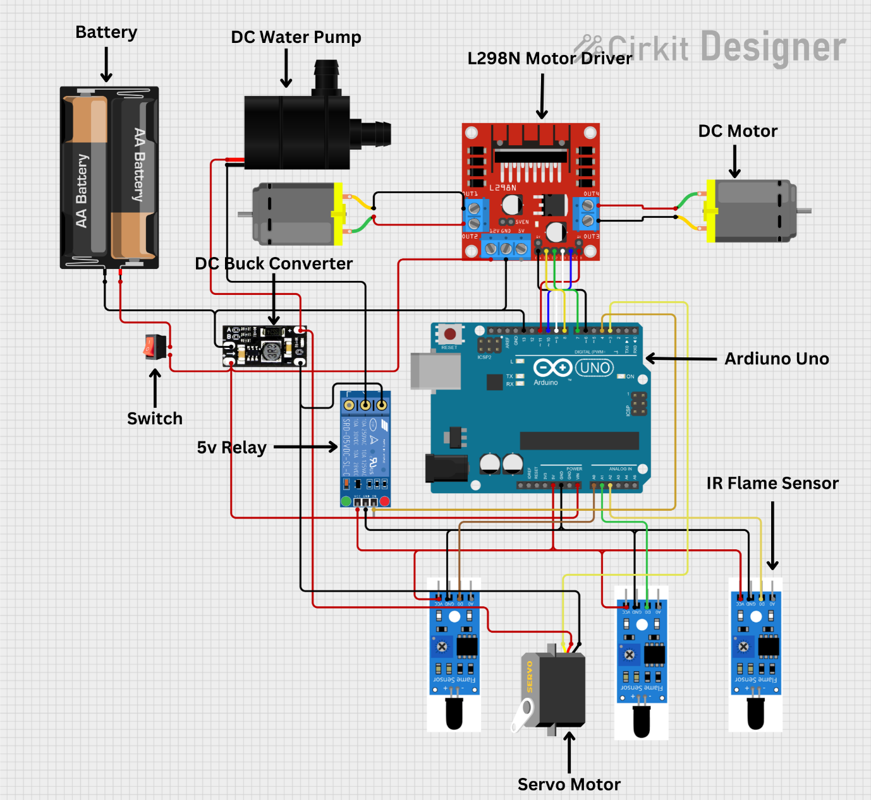
Figure: circuit diagram for the rapid fire fighting rover

Components List

s/no | Name | Quantity
1 | DC Bo Motor | 2
2 | IR flame Sensors | 3
3 | Water Pump | 1
4 | Servo Motor | 1
5 | Switch | 1
6 | Ardiuno UNO | 1
7 | DC Buck Converter | 1
8 | Batteries | 2
9 | 5V Single Channel Relay | 1
10 | L298N Motor Driver | 1

Tools and Methodology

Tools Used:

1.Arduino microcontroller board: This served as the brain of our rover and controls its actions.
2. Flame sensors: These sensors will detect the presence of flames and trigger the extinguishing mechanism.
3. DC buck converter: These sensors will ensures efficient power conversion and extends battery life.
4. Motors and motor drivers: These will enable the movement of our rover, allowing it to navigate towards fires.
5. Fire extinguishing mechanism: Based on our design, we used water spray as the extinguishing method.
6. Power supply: we used two 3.7v batteries to power the rover.
7. Chassis and wheels: This formed the physical structure of our rover and allowed it to move.
8. Jumper wires, breadboard, and resistors: They were essential for connecting and integrating the various components.

Methodology

1. Define the objectives: Clearly outline what we want in our rover to achieve, such as detecting fires and extinguishing them.
2. Gather the components: We collected all the necessary hardware components like Arduino board, flame sensors, temperature sensors, motors, and more.
3. Design the circuit: We created a circuit diagram to connect all the components and ensure they work together properly.
4. Write the code: We used the Arduino programming language to write the code that will control the rover's behaviour. This includes fire detection, movement, and activating the extinguishing mechanism.
5. Test and iterate: We did small-scale tests to ensure each component is functioning correctly. Gradually build up to full-scale tests, making adjustments and improvements as needed.
6. Assemble the rover: We put together the physical structure of the rover, incorporating the Arduino board, sensors, motors, and other components.
7. Calibrate and optimize: We fine-tuned the sensors and adjust the code to optimize the rover's performance in detecting and extinguishing fires.
8. Ensure safety: We took necessary precautions to ensure the safety of the rover's operation, such as using proper fire extinguishing methods and materials.

Work Progress till Analysis

Week –1 : Project startup and planning.
In the first week of our firefighting rover project, we started on a journey to understand the intricacies of our undertaking, with the goal of utilizing Arduino as the central nervous system for our project, identifying key components, and get the fundamental requirements. The core objective was to precisely describe the scope of our project and create a plan for the upcoming weeks.
We gathered a list of components essential for our rover, consisting of sensors, motors, chassis, notably and Arduino board. This paved the way for week 2, where our primary focus was the Acquisition of these components. While finding a way to balance quality and affordability we engaged in the research to ensure we had the right tools at our disposal additionally we took the crucial step of installing the Arduino integrated development environment to work on our programming skills with some help from YouTube tutorials, and also gearing up for the coding challenges that lay ahead.

Week-2
In the second week our plan concentrated on the acquisition and research of components that were important for the construction of our rover. A careful balance restriction helped our selection process, making sure that we were going to secure reliable sensors, motors and suitable chassis. The Arduino board, chosen as the brain of our creation, played an initial role in shaping the trajectory of our project.
Simultaneously, we made progress in setting up the Arduino software environment. This involved installing Arduino IDE, a platform for programming and our robot. We dedicated time to start familiarizing ourselves with the basic Arduino programming, laying a solid foundation for the week ahead.
The period within the second week left us with a well-rounded understanding of our project components and a workspace for coding

Week-3
In the third week we didn't make much progress because we were expecting the parts for our project to arrive.
What we planned for the week was to start assembling the rover and designing the chassis but due to those parts not delivered we could not do anything
And also, the reason we could not move forward with the design is because we needed the parts for measurement and fitting
We also did research on the materials that we were going to use, and we found at least three materials we could possibly need which are wood, acrylic or sheet metal. Though we haven’t decided yet.

Week-4
In these past few days, we started studying the sensors and which sensor is important to make an Arduino-based firefighting rover.
Infra-red flame sensor is the most suited for this project. Therefore, we are going to use 3 IR flame sensors which are continuously learning for fire or flame. Infra-red flame sensor senses the warmth and heat from anybody. And we can code this sensor so that it can sense the flame around it. All three sensors are always searching for fire. If any of the sensors will find it. The robot will turn and start moving towards the fire.
The flame sensor senses the fire and sends the information to the Arduino which is the brain of this robot. The brain will take the action according to the condition and information getting from the sensor. Arduino will give the command to the motors to start and move towards the desired direction.
If the left sensor gives the information about the fire, then the Arduino will run the motor towards the left direction. Same for front and right-side motor

Week-5
In this week, we assembled all the component that is must require to make the fire extinguisher rover, we bought Arduino nano, servo, flame sensors, B0 motor, chassis, etc. After assembling the components, we run the code in the Arduino nano.
Then we have faced an issue in the selection of chassis because there are several materials used as chassis. But at the end we selected a wooden chassis.
After that we made the base of the rover by fixing four B0 motors, and four wheels on the wooden chassis. We are taking too much time to make it cause a small mistake will affect the whole work

Week-6
In this week we tried to fix our rover. Because the rover doesn’t turn 360 degree. It will only move 180 degrees from its original point. And the flame sensors were responding against the fire but the information from the sensors was not delivered to pump and once it reaches towards the fire it doesn’t pump water. We checked what’s the problem behind it was, but we suspected it was because of the battery.
Now we are trying to troubleshoot the problem, we are trying to give different battery supplies to relay, servo and pump. We also checked the code to check if there was any problem but it’s not the problem. We are still looking for the solution.

Week –7,
In week 7, we were testing all the components of the rover, then after some issues we had to switch from Arduino nano to Arduino uno.
Also, the 2 motors on the front were not really usable. In order to maximize the rover, we change the two motors to caster wheel

Week-8
In this week we finished our project successfully, after changing the rover from 4 wheels to 3 wheels the rover started working smoothly and before we had a trouble like the rover goes through fire, so we fixed those issues in this week. Now our project is completed

Individual Contributions of Group Members

Member 1: Sooraj TM
- Conducted research on the Arduino based technology and methodologies.
- Contributed to the initial design and planning stages of the project.
- Participated in team meetings and discussions, providing valuable insights and suggestions.
.

Member 2: Mourad Abdou
- Contributed to selecting and assembling the hardware components needed for the rover.
- Evaluated the effectiveness in integrating these components to ensure proper functionality.
- Sourcing the components for the rover and helping with the code

Member 3: Usman Alhassan Mohammed
- Documented the project's progress, including writing code.
- Contributed in the troubleshooting and testing of the rover.
- Conducted testing and debugging procedures to ensure the rover’s performance.

Final Outcomes

The final outcome of our Arduino-based Rapid Fire Fighting Rover would be a fully functional robot that can detect and extinguish fires. It is equipped with sensors to detect flames and temperature, and an algorithm to accurately identify fires. The rover would then move towards the fire and use its extinguishing mechanism to suppress it. The mechanical design of the rover ensure smooth and safe movement, allowing it to navigate autonomously. Overall, the final outcome is a reliable and effective fire-fighting solution using Arduino technology. Overall, it is a fully functional and life-saving device for firefighting purposes.

References

- Youtube
- Google

