library(dplyr)

##   
## Attaching package: 'dplyr'

## The following objects are masked from 'package:stats':  
##   
## filter, lag

## The following objects are masked from 'package:base':  
##   
## intersect, setdiff, setequal, union

dataServiceA = read.csv("A.csv")

churn <- c(mean(dataServiceA[dataServiceA$churn==1,]$sum_t_A._times_tn_5),  
 mean(dataServiceA[dataServiceA$churn==1,]$sum_t_A._times_tn_4),  
 mean(dataServiceA[dataServiceA$churn==1,]$sum_t_A._times_tn_3),  
 mean(dataServiceA[dataServiceA$churn==1,]$sum_t_A._times_tn_2),  
 mean(dataServiceA[dataServiceA$churn==1,]$sum_t_A._times_tn_1),  
 mean(dataServiceA[dataServiceA$churn==1,]$sum_t_A._times_tn))  
non_churn <- c(mean(dataServiceA[dataServiceA$churn==0,]$sum_t_A._times_tn_5),  
 mean(dataServiceA[dataServiceA$churn==0,]$sum_t_A._times_tn_4),  
 mean(dataServiceA[dataServiceA$churn==0,]$sum_t_A._times_tn_3),  
 mean(dataServiceA[dataServiceA$churn==0,]$sum_t_A._times_tn_2),  
 mean(dataServiceA[dataServiceA$churn==0,]$sum_t_A._times_tn_1),  
 mean(dataServiceA[dataServiceA$churn==0,]$sum_t_A._times_tn))  
months = c("n-5", "n-4", "n-3", "n-2", "n-1", "n")  
data = data.frame(months, churn, non_churn)  
data

## months churn non_churn  
## 1 n-5 284.7559 335.9346  
## 2 n-4 276.3845 331.2496  
## 3 n-3 281.1059 343.4910  
## 4 n-2 257.3020 324.1875  
## 5 n-1 224.5489 322.0912  
## 6 n 130.6179 321.3059

mydf = t(data[-1])  
colnames(mydf) <- data[, 1]  
barplot(mydf, beside = TRUE, main = "Sum total time used service A", col=c('darkblue', 'red'))  
legend("bottomright", legend = c('churn', "non churn"), fill=c('darkblue', 'red'))

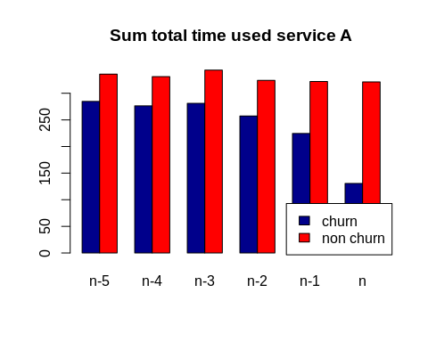

churn <- c(mean(dataServiceA[dataServiceA$churn==1,]$sum_total_use_A.s_tn_5),  
 mean(dataServiceA[dataServiceA$churn==1,]$sum_total_use_A.s_tn_4),  
 mean(dataServiceA[dataServiceA$churn==1,]$sum_total_use_A.s_tn_3),  
 mean(dataServiceA[dataServiceA$churn==1,]$sum_total_use_A.s_tn_2),  
 mean(dataServiceA[dataServiceA$churn==1,]$sum_total_use_A.s_tn_1),  
 mean(dataServiceA[dataServiceA$churn==1,]$sum_total_use_A.s_tn))  
non_churn <- c(mean(dataServiceA[dataServiceA$churn==0,]$sum_total_use_A.s_tn_5),  
 mean(dataServiceA[dataServiceA$churn==0,]$sum_total_use_A.s_tn_4),  
 mean(dataServiceA[dataServiceA$churn==0,]$sum_total_use_A.s_tn_3),  
 mean(dataServiceA[dataServiceA$churn==0,]$sum_total_use_A.s_tn_2),  
 mean(dataServiceA[dataServiceA$churn==0,]$sum_total_use_A.s_tn_1),  
 mean(dataServiceA[dataServiceA$churn==0,]$sum_total_use_A.s_tn))  
months = c("n-5", "n-4", "n-3", "n-2", "n-1", "n")  
data = data.frame(months, churn, non_churn)  
data

## months churn non_churn  
## 1 n-5 483.5667 609.9700  
## 2 n-4 464.6304 598.2538  
## 3 n-3 479.5313 624.3048  
## 4 n-2 446.9689 596.8444  
## 5 n-1 395.6813 601.5380  
## 6 n 225.7752 598.4141

mydf = t(data[-1])  
colnames(mydf) <- data[, 1]  
barplot(mydf, beside = TRUE, main = "Sum total used service A", col=c('gray', 'red'))  
legend("bottomright", legend = c('churn', "non churn"), fill=c('gray', 'red'))

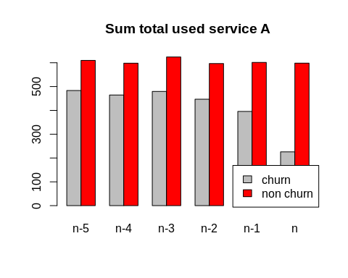

churn <- c(mean(dataServiceA[dataServiceA$churn==1,]$sum_t_A._duration_tn_5),  
 mean(dataServiceA[dataServiceA$churn==1,]$sum_t_A._duration_tn_4),  
 mean(dataServiceA[dataServiceA$churn==1,]$sum_t_A._duration_tn_3),  
 mean(dataServiceA[dataServiceA$churn==1,]$sum_t_A._duration_tn_2),  
 mean(dataServiceA[dataServiceA$churn==1,]$sum_t_A._duration_tn_1),  
 mean(dataServiceA[dataServiceA$churn==1,]$sum_t_A._duration_tn))  
non_churn <- c(mean(dataServiceA[dataServiceA$churn==0,]$sum_t_A._duration_tn_5),  
 mean(dataServiceA[dataServiceA$churn==0,]$sum_t_A._duration_tn_4),  
 mean(dataServiceA[dataServiceA$churn==0,]$sum_t_A._duration_tn_3),  
 mean(dataServiceA[dataServiceA$churn==0,]$sum_t_A._duration_tn_2),  
 mean(dataServiceA[dataServiceA$churn==0,]$sum_t_A._duration_tn_1),  
 mean(dataServiceA[dataServiceA$churn==0,]$sum_t_A._duration_tn))  
months = c("n-5", "n-4", "n-3", "n-2", "n-1", "n")  
data = data.frame(months, churn, non_churn)  
data

## months churn non_churn  
## 1 n-5 22127.460 23961.51  
## 2 n-4 21454.931 23553.71  
## 3 n-3 21792.887 24351.55  
## 4 n-2 19861.679 22811.61  
## 5 n-1 17361.376 22779.62  
## 6 n 9864.031 22561.45

mydf = t(data[-1])  
colnames(mydf) <- data[, 1]  
barplot(mydf, beside = TRUE, main = "Sum duration used service A", col=c('gray', 'red'))  
legend("bottomright", legend = c('churn', "non churn"), fill=c('gray', 'red'))

