library(dplyr)

##   
## Attaching package: 'dplyr'

## The following objects are masked from 'package:stats':  
##   
## filter, lag

## The following objects are masked from 'package:base':  
##   
## intersect, setdiff, setequal, union

dataServiceB = read.csv("B.csv")

churn <- c(mean(dataServiceB[dataServiceB$churn==1,]$sum_t_dịch.vụ.B_charge_tn_5),  
 mean(dataServiceB[dataServiceB$churn==1,]$sum_t_dịch.vụ.B_charge_tn_4),  
 mean(dataServiceB[dataServiceB$churn==1,]$sum_t_dịch.vụ.B_charge_tn_3),  
 mean(dataServiceB[dataServiceB$churn==1,]$sum_t_dịch.vụ.B_charge_tn_2),  
 mean(dataServiceB[dataServiceB$churn==1,]$sum_t_dịch.vụ.B_charge_tn_1),  
 mean(dataServiceB[dataServiceB$churn==1,]$sum_t_dịch.vụ.B_charge_tn))  
non_churn <- c(mean(dataServiceB[dataServiceB$churn==0,]$sum_t_dịch.vụ.B_charge_tn_5),  
 mean(dataServiceB[dataServiceB$churn==0,]$sum_t_dịch.vụ.B_charge_tn_4),  
 mean(dataServiceB[dataServiceB$churn==0,]$sum_t_dịch.vụ.B_charge_tn_3),  
 mean(dataServiceB[dataServiceB$churn==0,]$sum_t_dịch.vụ.B_charge_tn_2),  
 mean(dataServiceB[dataServiceB$churn==0,]$sum_t_dịch.vụ.B_charge_tn_1),  
 mean(dataServiceB[dataServiceB$churn==0,]$sum_t_dịch.vụ.B_charge_tn))  
months = c("n-5", "n-4", "n-3", "n-2", "n-1", "n")  
data = data.frame(months, churn, non_churn)  
data

## months churn non_churn  
## 1 n-5 14810.912 16900.34  
## 2 n-4 15177.956 16669.67  
## 3 n-3 15942.909 17734.45  
## 4 n-2 15850.450 17362.73  
## 5 n-1 13708.606 17313.86  
## 6 n 6957.338 16729.59

mydf = t(data[-1])  
colnames(mydf) <- data[, 1]  
barplot(mydf, beside = TRUE, main = "Sum total charge used service B", col=c('darkblue', 'red'))  
legend("bottomright", legend = c('churn', "non churn"), fill=c('darkblue', 'red'))

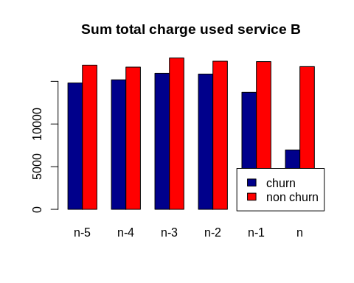

churn <- c(mean(dataServiceB[dataServiceB$churn==1,]$sum_t_dịch.vụ.B_times_tn_5),  
 mean(dataServiceB[dataServiceB$churn==1,]$sum_t_dịch.vụ.B_times_tn_4),  
 mean(dataServiceB[dataServiceB$churn==1,]$sum_t_dịch.vụ.B_times_tn_3),  
 mean(dataServiceB[dataServiceB$churn==1,]$sum_t_dịch.vụ.B_times_tn_2),  
 mean(dataServiceB[dataServiceB$churn==1,]$sum_t_dịch.vụ.B_times_tn_1),  
 mean(dataServiceB[dataServiceB$churn==1,]$sum_t_dịch.vụ.B_times_tn))  
non_churn <- c(mean(dataServiceB[dataServiceB$churn==0,]$sum_t_dịch.vụ.B_times_tn_5),  
 mean(dataServiceB[dataServiceB$churn==0,]$sum_t_dịch.vụ.B_times_tn_4),  
 mean(dataServiceB[dataServiceB$churn==0,]$sum_t_dịch.vụ.B_times_tn_3),  
 mean(dataServiceB[dataServiceB$churn==0,]$sum_t_dịch.vụ.B_times_tn_2),  
 mean(dataServiceB[dataServiceB$churn==0,]$sum_t_dịch.vụ.B_times_tn_1),  
 mean(dataServiceB[dataServiceB$churn==0,]$sum_t_dịch.vụ.B_times_tn))  
months = c("n-5", "n-4", "n-3", "n-2", "n-1", "n")  
data = data.frame(months, churn, non_churn)  
data

## months churn non_churn  
## 1 n-5 54.97964 61.93681  
## 2 n-4 55.91340 61.03582  
## 3 n-3 59.12314 65.32771  
## 4 n-2 58.52528 64.01670  
## 5 n-1 50.61077 63.76898  
## 6 n 24.72709 61.43546

mydf = t(data[-1])  
colnames(mydf) <- data[, 1]  
barplot(mydf, beside = TRUE, main = "Sum total times used service B", col=c('darkblue', 'red'))  
legend("bottomright", legend = c('churn', "non churn"), fill=c('darkblue', 'red'))

