library(dplyr)

##   
## Attaching package: 'dplyr'

## The following objects are masked from 'package:stats':  
##   
## filter, lag

## The following objects are masked from 'package:base':  
##   
## intersect, setdiff, setequal, union

dataServiceH = read.csv("H.csv")

churn <- c(mean(dataServiceH[dataServiceH$churn==1,]$sum_H_times_tn_5),  
 mean(dataServiceH[dataServiceH$churn==1,]$sum_H_times_tn_4),  
 mean(dataServiceH[dataServiceH$churn==1,]$sum_H_times_tn_3),  
 mean(dataServiceH[dataServiceH$churn==1,]$sum_H_times_tn_2),  
 mean(dataServiceH[dataServiceH$churn==1,]$sum_H_times_tn_1),  
 mean(dataServiceH[dataServiceH$churn==1,]$sum_H_times_tn))  
non_churn <- c(mean(dataServiceH[dataServiceH$churn==0,]$sum_H_times_tn_5),  
 mean(dataServiceH[dataServiceH$churn==0,]$sum_H_times_tn_4),  
 mean(dataServiceH[dataServiceH$churn==0,]$sum_H_times_tn_3),  
 mean(dataServiceH[dataServiceH$churn==0,]$sum_H_times_tn_2),  
 mean(dataServiceH[dataServiceH$churn==0,]$sum_H_times_tn_1),  
 mean(dataServiceH[dataServiceH$churn==0,]$sum_H_times_tn))  
months = c("n-5", "n-4", "n-3", "n-2", "n-1", "n")  
data = data.frame(months, churn, non_churn)  
mydf = t(data[-1])  
colnames(mydf) <- data[, 1]  
barplot(mydf, beside = TRUE, main = "Sum times used service H", col=c('darkblue', 'red'))  
legend("bottomright", legend = c('churn', "non churn"), fill=c('darkblue', 'red'))

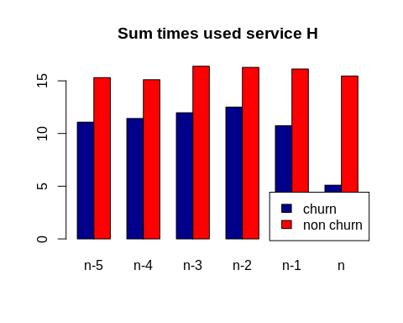

churn <- c(mean(dataServiceH[dataServiceH$churn==1,]$sum_H_charge_tn_5),  
 mean(dataServiceH[dataServiceH$churn==1,]$sum_H_charge_tn_4),  
 mean(dataServiceH[dataServiceH$churn==1,]$sum_H_charge_tn_3),  
 mean(dataServiceH[dataServiceH$churn==1,]$sum_H_charge_tn_2),  
 mean(dataServiceH[dataServiceH$churn==1,]$sum_H_charge_tn_1),  
 mean(dataServiceH[dataServiceH$churn==1,]$sum_H_charge_tn))  
non_churn <- c(mean(dataServiceH[dataServiceH$churn==0,]$sum_H_charge_tn_5),  
 mean(dataServiceH[dataServiceH$churn==0,]$sum_H_charge_tn_4),  
 mean(dataServiceH[dataServiceH$churn==0,]$sum_H_charge_tn_3),  
 mean(dataServiceH[dataServiceH$churn==0,]$sum_H_charge_tn_2),  
 mean(dataServiceH[dataServiceH$churn==0,]$sum_H_charge_tn_1),  
 mean(dataServiceH[dataServiceH$churn==0,]$sum_H_charge_tn))  
months = c("n-5", "n-4", "n-3", "n-2", "n-1", "n")  
data = data.frame(months, churn, non_churn)  
mydf = t(data[-1])  
colnames(mydf) <- data[, 1]  
barplot(mydf, beside = TRUE, main = "Sum charge used service H", col=c('darkblue', 'red'))  
legend("bottomright", legend = c('churn', "non churn"), fill=c('darkblue', 'red'))

