MINISTRY OF EDUCATION AND TRAINING



**Capstone Project Document**

**Automatic Work-Finding System**

Report 2 – version 1.0

|  |  |  |
| --- | --- | --- |
| AWFS Team | | |
| Group members | Tuong Thi Thuy | SE02678 |
|  | Ly Hai Nam | SE03045 |
|  | Duong Dang Duy | SE03254 |
|  | Tran Ha Nam | SE03311 |
|  | Pham Tuan Son | SE03230 |
| Supervisor | Mr. Tran Dinh Tri | |
| Capstone Project Code | AWFS | |

**Hanoi, 5th September, 2016**

Table of Contents

1 Software project management 4

1.1 Software development process 4

1.2 Project Organization 5

1.2.1 Organizational Structure 5

1.2.2 Project Team 5

1.2.3 External Interfaces 7

1.3 Project schedule 8

1.4 Project Millstones 9

1.5 Project Deliverables 9

1.6 Resource 11

1.6.1 Human resource 11

1.6.2 Non-human resource 11

1.7 Risk Management 11

1.7.1 Schedule Risk 11

1.7.2 Scope Risk 12

1.7.3 Resource Risk 12

1.8 Communication Management 13

1.8.1 Communication between Team Members 13

1.8.2 Communication with Supervisor 13

1.8.3 Communication with iOS Technical Supporters 13

1.8.4 Communication with and Chemical Data Consultant 13

1.9 Configuration Management Process 14

1.9.1 CI Identification and Naming Convention 14

1.9.2 Project Infrastructure 15

1.9.3 Version Numbering Rule 17

1.9.4 Directory structure 18

1.9.5 Coding convention 19

1.9.6 Other CM Rules 19

Definition and acronyms

|  |  |  |
| --- | --- | --- |
| Acronym | Definition | Note |
| AWFS | Automatic Work Finding System |  |
| CI | Configuration Item |  |
| CM | Configuration Management |  |
| PM | Project Manager |  |
| PTL | Project Technical Leader |  |

# Software project management

In this section, we will describe our organization and plan of project. Each member of team must use this section as a guideline tracking assigned tasks and deadlines. In addition, we introduce our team and overview about project. Meeting minute also present in this section. Moreover, we will describe risks of project and the way communication of our team.

## Software development process

This figure below will describe the information and products flow lifecycle process model.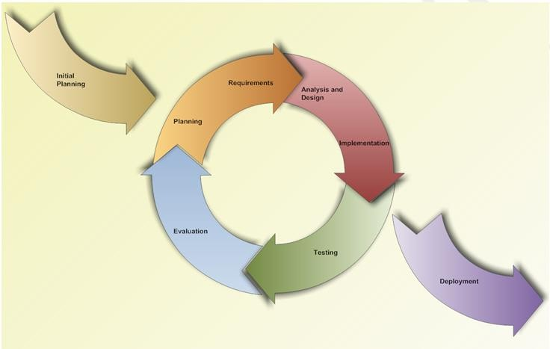

Figure : Iterative and Incremental software process model

AWFS project uses the Iterative and Incremental Software Process Model. We have chosen the Iterative and Incremental Software Process Model because the scope of our project is big, the major requirements were defined clearly, some more detail will be added in time, and for the newbie group in software development. By using this software process model, we generates working software quickly and early during the software life cycle. This model is more flexible – less costly to change scope and requirements. We easier to manage risk because risky pieces are identified and handled. Besides, the iterative model is easier than other models when the issues are discovered. All issue will be raised to the team. They will be solved while the project is still developed.

In our project, we have two cycles:

Cycle 1: Start Monday 05st – September – 2016 to Tuesday 15st – November – 2016. In this iterative we will to analyze, design, code and test the main feature of project.

Cycle 2: Start Wednesday 16th – November – 2016 to Monday 12th – December – 2016. In this iterative we will to fix bug in iterative 1, complete other feature, test again and packing product.

## Project Organization

### Organizational Structure

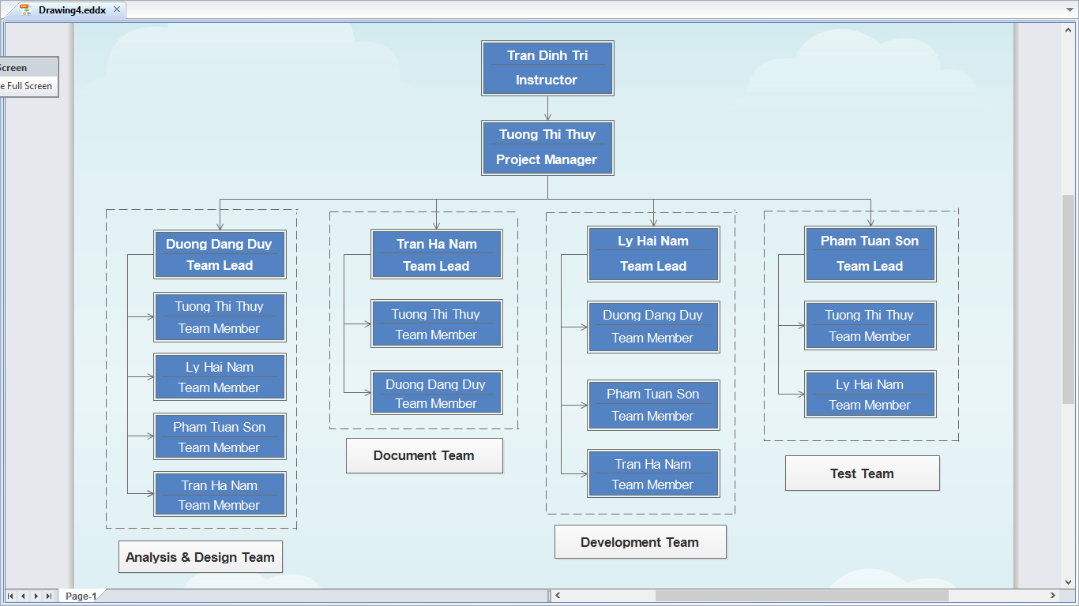

Figure 2: Organizational structure chart

### Project Team

|  |  |  |  |  |  |
| --- | --- | --- | --- | --- | --- |
| Role | Responsibility | Full name | % Effort | Start date | End date |
| Instructor | * Provide templates & tool * Review deliverables * Review project status * Resolve escalated issues * Consultant | Trần Đình Trí | 10% | September 5th, 2016 | December 17th, 2016 |
| PM | * Planning and defining scope * Developing schedule * Review and Tracking document * Identify resources and assign individual responsibilities * Assign task team * Coordinating communication | Tường Thị Thúy | 100% | September 5th, 2016 | December 17th, 2016 |
| Analysis and Design Team | | | | | |
| Team Leader | * Review and Tracking design * Identify main UI * Draw prototype, Architecture Design * Database Design | Dương Đăng Duy | 100% | September 5th, 2016 | December 9th, 2016 |
| Team member #1 | * Database Design * Draw prototype, Architecture Design | Lý Hải Nam | 100% | September 5th, 2016 | December 9th, 2016 |
| Team member #2 | * Database Design | Trần Hà Nam | 100% | September 5th, 2016 | December 9th, 2016 |
| Team member #3 | * Design | Tường Thị Thúy | 100% | September 5th, 2016 | December 17th, 2016 |
| Team member #4 | * Design | Phạm Tuấn Sơn | 100% | September 5th, 2016 |  |
| Documentation Team | | | | | |
| Team Leader | * Review and Tracking Requirement | Trần Hà Nam | 100% | September 5th, 2016 | December 15th, 2016 |
| Team member #1 | * Create SRS document | Dương Đăng Duy | 100% | September 5th, 2016 | December 15th, 2016 |
| Team member #2 | * Create SRS document | Tường Thị Thúy | 100% | September 5th, 2016 | December 15th, 2016 |
| Development Team | | | | | |
| PTL | * Define coding convention * Developing * Solve issue of project | Lý Hải Nam | 100% | September 5th, 2016 | November 15th, 2016 |
| Developer #1 | * Developing | Trần Hà Nam | 100% | September 5th, 2016 | November 15th, 2016 |
| Developer #2 | * Developing | Dương Đăng Duy | 100% | September 5th, 2016 | November 15th, 2016 |
| Developer #3 | * Developing | Phạm Tuấn Sơn | 100% | September 5th, 2016 | November 15th, 2016 |
| QA and Test Team | | | | | |
| Test Leader | * Define coding convention * Responsible for test execution * Test results recording * Evaluation of test run and error recovery | Phạm Tuấn Sơn | 100% | November 16th, 2016 | December 12th, 2016 |
| Tester #1 | * Testing | Tường Thị Thúy | 100% | November 5th, 2016 | December 12th, 2016 |
| Tester #2 | * Testing | Lý Hải Nam | 100% | November 5th, 2016 | December 12th, 2016 |

## Project schedule

Below are the image of task list used to assign and tracking tanks. Refer to AWFS_MasterSchedule.mpp to see more detail.

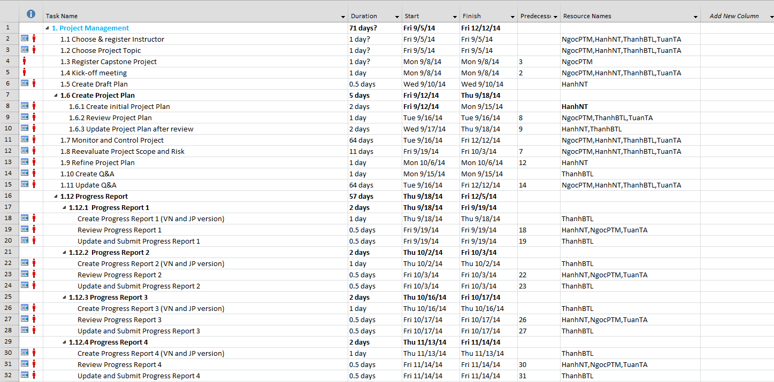

Figure : Task list

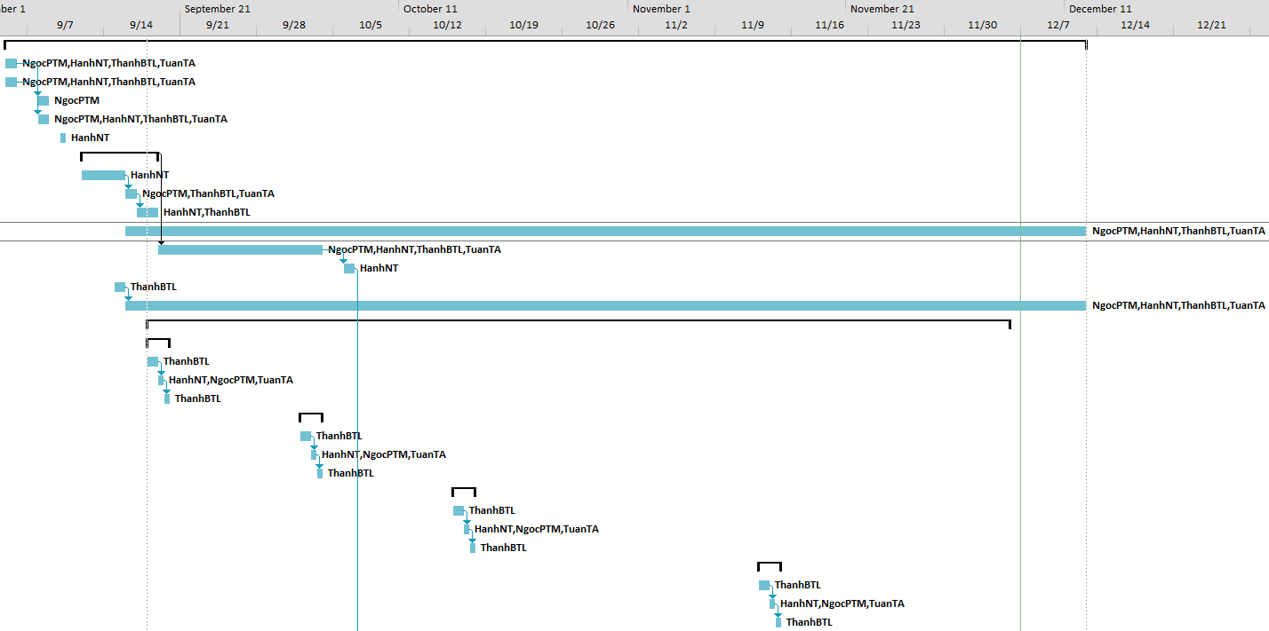

Figure : Gantt chart

## Meeting minutes

In all meeting minutes will be written follow this template:

|  |  |  |  |
| --- | --- | --- | --- |
| **Meeting Minutes 1** | | | |
| **Subject** | Comment on Report 1 | **Date** | 2016/09/08 |
| **Conductor** | Prof. TriTD | **Time** | 13 P.M |
| **Location** | P310 ALFA | **Secretary** | Duydd |
| **Attendees** | ThuyTT, NamLH, NamTH, SonPT | | |
| **Absent** | No | | |

|  |  |  |
| --- | --- | --- |
| Key Points Discussed | | |
| No. | Topic | Highlights |
| 1 | Common work progress. | Done writing report 1, report 2 in progress |
| 2 | Assigning someone to write meeting minutes. | Assign Duydd |
| 3 | Review report 1 | Something needs to be fixed:   * Incorrect grammar, vocabulary |
| 4 | Setup working environment :  Tools managa source code, documents, database… | Done |
| 5 | Learn the business.  Learn about web advertising business.  Learn about online payment. | In progress |
| 6 | Submit report 2 | In progress |

|  |  |  |  |
| --- | --- | --- | --- |
| Action Plan | | | |
| No. | Action Item(s) | Owner | Target Date |
| 1. | Define the roles & responsibilities of each team member | ThuyTT | 08/09/2016 |
| 2. | Analyze requirement, make project plan => written  in template format | ThuyTT, NamLH, DuyDD | 10/09/2016 |
| 3. | Design: ERD, System architecture, Class diagram, Sequence diagram, Use case diagram… | DuyDD + NamLH + NamTH | 10/09/2016 |
| 4. | Estimate number of use case, 50 use case is appropriate | NamLH + NamTH + SonPT | 11/09/2016 |
| 5. | Write the report 2, report 3 | SonPT | 11/09/2016 |

## Project Millstones

|  |  |  |  |
| --- | --- | --- | --- |
| No | Milestone | Completion Date | Verification |
| 1 | Project Start | September 5th,2016 | Instructor approval |
| 2 | Submit report 1 | September 12th,2016 | Instructor approval |
| 3 | Submit report 2 | September 19th, 2016 | Instructor approval |
| 4 | Submit report 3 | September 29th, 2016 | Instructor approval |
| 5 | Submit report 4 | October 13th, 2016 | Instructor approval |
| 6 | Submit report 5 | October 27th, 2016 | Instructor approval |
| 7 | Submit report 6 | November 10th, 2016 | Instructor approval |
| 9 | Defend project | December 10th,2016 | Instructor approval |

## Project Deliverables

|  |  |  |  |  |
| --- | --- | --- | --- | --- |
| No | Deliverable | Committed Delivery date | Description of Deliverable | Delivery media |
| 1 | Capstone project register | September 5th, 2016 |  | Hard copy |
| 2 | Software Requirement Specifications - SRS | December 12th, 2016 |  | Hard copy |
| 3 | Project plan | September 15th, 2016 |  | Hard copy |
| 4 | Q&A Management | December 12th, 2016 | Written in English | Hard copy |
| 5 | Progress report 1 | September 12th, 2016 | Written in English | Hard copy |
| **Subproject 1** | | | | |
| 6 | Architecture design | September 19th, 2016 |  | Hard copy |
| 7 | Screen design | September 26th, 2016 |  | Hard copy |
| 8 | Database design | September 26th, 2016 |  | Hard copy |
| 9 | Detail Design | September 26th, 2016 |  |  |
| 10 | Progress report 2 | October 3rd, 2014 | Written in English and Japanese | Hard copy |
| 11 | Test plan | October 7th, 2014 |  | Hard copy |
| 12 | Test case | October 10th, 2014 |  | Hard copy |
| 13 | Progress report 3 | October 17th, 2014 | Written in English and Japanese | Hard copy |
| 14 | Source code | October 31st, 2014 |  | Hard copy |
| 15 | Unit test report | October 31st, 2014 | Unit test case | Hard copy |
| 16 | Test report | October 31st, 2014 |  | Hard copy |
| 17 | Quality report | October 31st, 2014 |  | Hard copy |
| **Subproject 2** | | | | |
| 18 | Architecture design | November 4th, 2014 |  | Hard copy |
| 19 | Screen design | November 4th, 2014 |  | Hard copy |
| 20 | Database design | November 4th, 2014 |  | Hard copy |
| 21 | Detail Design | November 6th, 2014 |  | Hard copy |
| 22 | Test plan | November 10th, 2014 |  | Hard copy |
| 23 | Test case | November 11th, 2014 |  | Hard copy |
| 24 | Progress report 4 | November 14th, 2014 | Written in English and Japanese | Hard copy |
| 25 | Source code | December 5th, 2014 |  | Hard copy |
| 26 | Unit test report | December 5th, 2014 | Unit test case | Hard copy |
| 27 | Test report | December 5th, 2014 |  | Hard copy |
| 28 | Quality report | December 5th, 2014 |  | Hard copy |
| 29 | Progress report 5 | November 28th, 2014 |  | Hard copy |
| 30 | Source code | December 10th, 2014 |  | Hard copy |
| 31 | User manual | December 12th, 2014 |  | Hard copy |
| 32 | Installation guide | December 12th, 2014 |  | Hard copy |
| 33 | Progress report 6 | December 12th, 2014 |  | Hard copy |

## Resource

Human resource

* Team members
* Supervisor

### Non-human resource

* Equipment: Desktop, laptop, iphone 7, galaxy tabs, window phone.
* Building: ALFA Building - FPT University.

## Risk Management

|  |  |  |  |  |  |  |
| --- | --- | --- | --- | --- | --- | --- |
| No | Name | Root Cause | Probability | Avoidance plan | Contingency plan | Impact |
| 1 | Team doesn’t keep the deadline more time | Member lack of responsibility, have bad habit.  Lack of management. | Medium | Make a rule and penalty for people who don’t meet the deadline | Working overtime to complete on time  Punish member as lost money... | High |
| 2 | Requirement changed while project is processing | SRS is not provide all information about user requirement as: lack customer requirement, misunderstand requirement of customer | High | SRS should be review carefully by PM and the supervisor.  Always brainstorming carefully to design detail system. Hole all meeting and make minimize effort to change and improve design by requirement changes.. | Team member will meeting with supervisor to analyze the requirement change. So make a specific action to resolve that problem | High |
| 3 | Delivery not meet the deadline | Team member work late, lack of responsible causing not meet project schedule | High | Assign tasks to suitable team members depending on their strength and weakness. | Team leader should regularly care about deadline and project schedule to inform members  Break down task to smaller tasks and assign new tasks to team members. | Medium |
| 4 | Lack of knowledge about technology need for project | With some member, they want study new technology through this project | Medium | Each team member must study to understand the technology, framework, which need for project | Technical leader need support carefully for team member in group to develop required skills and knowledge  Review complete task to make comment for team member | Medium |
| 5 | Conflict among team members | Team member doesn't understand each other | Medium | Plan some game or team building to improve teammate, understand each other  Clear role and responsibility between members | Have a meeting to resolve conflict problems | High |
| 6 | Data or Source Code Lost | Delete Brand in GitHub  Delete wrong source code | Medium | Back up source code carefully Commit all small tasks after complete to GitHub | Restore data from backed up data  Restore source code from history versions | High |

## Communication Management

### Communication between Team Members

* **Face-to-face meeting:** at least twice a week at Monday and Thursday. This is the fastest way of communication to solve big problems in the project and members can help out each other easily.
* **E-mail and message:** Email, Skype and Facebook are used for members to keep tracking other team member’s progress and team members can also help each other online.
* **Mobile Phone:** is using for emergency situation to directly contact to others.
* **Collaboration tool:** GitHub is used for document and source code management.

### Communication with Supervisor

* **Face-to-face meeting:** Weekly on every Thursday afternoons to make sure that supervisor can keep tracking of the team’s progress.
* **E-mail:** Gmail is the fastest way to get advice and document checking from supervisor.
* **Mobile phone:** is used to get time and place arranged for the meeting every weeks.

## Configuration Management Process

### CI Identification and Naming Convention

|  |  |  |
| --- | --- | --- |
| No | Configuration Items | Naming convention |
| **Project Management** | | |
| 1 | Project Plan | AWFS_ProjectPlan_v[version number]  For example: AWFS _ProjectPlan_v1.1 |
| **Requirement & Design** | | |
| 2 | SRS | AWFS _SoftwareRequirementsSpecification_v[version number]  For example: AWFS _SoftwareRequirementsSpecification_v1.0 |
| 3 | Architectural Design | AWFS_ArchitectureDesign_v[version number]  For example: AWFS_ArchitectureDesign_v0.2 |
| 4 | Screen Design | AWFS_ScreenDesign_ v[version number]  For example: AWFS_ScreenDesign_v1.2 |
| 5 | Data Design | AWFS_DataDesign_v[version number]  For example: AWFS_DataDesign_v10.2 |
| **Source Code** | | |
| 6 | Source Code | AWFS_SourceCode_ v[version number][Tested/Untested]  For example: AWFS_SourceCode_v1.0Tested |
| **Support Document** | | |
| 7 | User Manual | AWFS_UserManual_v[version number]  For example: AWFS_UserManual_v12.1 |
| **Test** | | |
| 8 | Unit Test Plan | AWFS_UnitTestPlan_v[version number]  For example: AWFS_UnitTestPlan_v1.0 |
| 9 | Integration Test Plan | AWFS_IntegrationTestPlan_v[version number]  For example: AWFS_IntegrationTestPlan_v1.0 |
| 10 | System Test Plan | AWFS_SystemTestPlan_v[version number]  For example: AWFS_SystemTestPlan_v1.0 |
| 11 | Unit Test Case | AWFS_UnitTestCase-[Test Name]_v[version number]  For example: AWFS_UnitTestCase-Search_v1.0 |
| 12 | Integration Test Case | AWFS_IntegrationTestCase-[Test Name] v[version number]  For example: AWFS_IntegrationTestCase-Search_v1 |
| 13 | System Test Case | AWFS_SystemTestCase-[Test Name]_v[version number]  For example: AWFS_SystemTestCase-Search_ v1.0 |
| 14 | Test data | AWFS_TestData_v[version number]  For example: AWFS_TestData_v1.0 |
| 15 | Test Result | AWFS_TestReport_v[version number]  For example: AWFS_TestReport_v1.0 |
| **Process** | | |
| 16 | Guideline | AWFS_ [Name Of Guideline]Guideline_v[version number]  For example: AWFS_UnitTestGuideline_v1.0 |
| 17 | Convention | AWFS_[Name Of Convention]Conventions_v[version number]  For example: AWFS_CodingConventions_v1.0 |
| 18 | Template | AWFS_Template-[Name Of Template]_v[version number]  For example: AWFS_Template-ChangeRequestForm_v1.0 |
| 19 | Checklist | AWFS_[Name Of Checklist]Checklist_v[version number]  For example: AWFS_ReviewChecklist_v1.0 |
| **File Type** | | |
| 20 | MS Word | *.doc |
| 21 | MS Excel | *.xls |
| 22 | MS PowerPoint | *.mpp |
| 23 | MS Project Plan | *.mpp |
| 24 | Images | *.png or *.jpg or *.jpeg or *.bmp or *.gif |

### Project Infrastructure

Below is the list of tools and infrastructure requirements needed for development environment.

#### Software

|  |  |
| --- | --- |
| Programming languages | PHP, HTML, CSS, Javascript |
| Framework | Laravel, Bootstrap |
| Version Control | Github |
| IDEs | PHPStorm, SublimeText |
| DBMS | MySQL |
| Deployment tools | Heroku |
| Communication tools | Trello, Skype, Facebook, Phone, Email. |
| UML tools | Astah Professional 7.0 |
| Management tools | Microsoft Project Professional 2013 |
| Web server | Xampp |
| Other | Microsoft Office 2013 |

#### Hardware

* Personal computer for developing and testing with the configuration: 4GB RAM, 256GB of hard disk, Intel Core 5 Dou.
* The smart phone and tablet for testing.
* Internet network connection with minimum speech 512kbit/s.

#### Other infrastructure

* Rooms for meeting and working.
* Internet and mobile phone services for communication.

### Directory structure

|  |  |  |
| --- | --- | --- |
| Main folder | Sub-folder | Purpose |
| Documents | Meeting minutes | Store project meeting minutes |
| Q&A | Store QA Management Sheet version English and version Japanese |
| Report | Store project report |
| Final deliverable | Report 1 | Store final deliverables of phase 1 |
| Report 2 | Store final deliverables of phase 2 |
| Report 3 | Store final deliverables of phase 3 |
| Report 4 | Store final deliverables of phase 4 |
| Report 5 | Store final deliverables of phase 5 |
| Report 6 | Store final deliverables of phase 6 |
| Plan |  | Store project plan, Task list |
| Resource | Reference materials | Store Reference materials needed in project |
| Template | Store template needed in project |
| Tool | Store tool needed in project |
| WIP | middy  ( m=month, d=day, y= year )  ( Example: 090814 ) | Tracking working process  Store project deliverable |
| Working space | Each team members has a folder.  ( Example: Them) | Team member’s working area |
| Archive | Baseline Name | To released versions of CIs at baselines |

### Coding convention

#### Naming convention

* Using prefix “AWFS” (means Automatic Work-Finding System) for each classes or constants
  + For example: AWFSPaymentController
* Naming class: Use the uppercase letter for the first character
* Naming variables:
* Start the name with a lowercase letter and capitalize the first letter of embedded words.
* Start the name with a verb.
* Don’t use prefixes

For example:

|  |
| --- |
| - (void)invokeWithTarget:(id)target;  - (void)selectTabViewItem:(NSTabViewItem *)tabViewItem; |

* Use keywords before all arguments.

|  |  |
| --- | --- |
| - (void)sendAction:(SEL)aSelector toObject:(id)anObject forAllCells:(BOOL)flag; | Right. |
| - (void)sendAction:(SEL)aSelector :(id)anObject :(BOOL)flag; | Wrong. |

* Make the word before the argument describe the argument.

|  |  |
| --- | --- |
| - (id)viewWithTag:(NSInteger)aTag; | Right. |
| - (id)taggedView:(int)aTag; | Wrong. |

#### Comment convention

- Write comment for all methods and important logic