마이크로 컨트롤러 4주차 과제

SWITCH Project No. 2

201921280 김남훈

순서

SourceCode 2

Implementation 3

# SourceCode

#define *F_CPU* 16000000UL

#include <avr/io.h>

#include <util/delay.h>

#include <avr/interrupt.h>

#define IDLE 0

#define STOP 1

#define GO 2

volatile int state = IDLE;

volatile unsigned int count=9999;

unsigned int number[10]={0x3f,0x06,0x5b,0x4f,0x66,0x6d,0x7d,0x27,0x7f,0x6f};

unsigned int fnd_sel[4] = {0x01, 0x02, 0x04,0x08};

ISR(INT4_vect) //STOP OR GO

{

*_delay_ms*(50);

if((PINE & 0x10) == 0x10)

return;

EIFR |= 1 << 4;

if(state == IDLE || state == STOP) state = GO;

else{

state = STOP;

}

}

ISR(INT5_vect) //PLUSE 1000

{

*_delay_ms*(50);

if((PINE & 0x20) == 0x20) return;

EIFR |= 1 << 5;

if(count + 1000 > 9999) count = 9999;

else count += 1000;

}

void display_fnd(int count){ // 함수 전체 실행시간은 약 0.01초

int i, k, fnd[4]; // 배열 선언

fnd[3] = (count/1000)%10; // 1000 자리

fnd[2] = (count/100)%10; // 100 자리

fnd[1] = (count/10)%10; // 10 자리

fnd[0] = count%10; // 1 자리

for (k = 0; k<10; k ++){

for (i=0; i<4; i++) {

PORTC = number[fnd[i]];

PORTG = fnd_sel[i];

if (i%2) *_delay_ms*(2); // 2ms 지연

else *_delay_ms*(3); // 3ms 지연, 총 10ms 지연

}

}

}

int main(void)

{

DDRC=0xff; //FND

DDRG=0x0f; //COM OUT

DDRE = 0x00; //SWITCH

sei();

EICRB = 0x0a;

EIMSK = 0x30;

int n4,n3,n2,n1;

while (1)

{

if(state == IDLE || state == GO)

{

display_fnd(count);

count--;

}

else if(count == 0 & (state == IDLE || state == GO ))

{

count = 0;

}

else

{

n4 = (count/1000)%10; // 1000 자리

n3 = (count/100)%10; // 100 자리

n2 = (count/10)%10; // 10 자리

n1 = count%10; // 1 자리

PORTC = number[n4]; PORTG = 0x08; *_delay_ms*(5);

PORTC = number[n3]; PORTG = 0x04; *_delay_ms*(5);

PORTC = number[n2]; PORTG = 0x02; *_delay_ms*(5);

PORTC = number[n1]; PORTG = 0x01; *_delay_ms*(5);

}

}

}

# Implementation

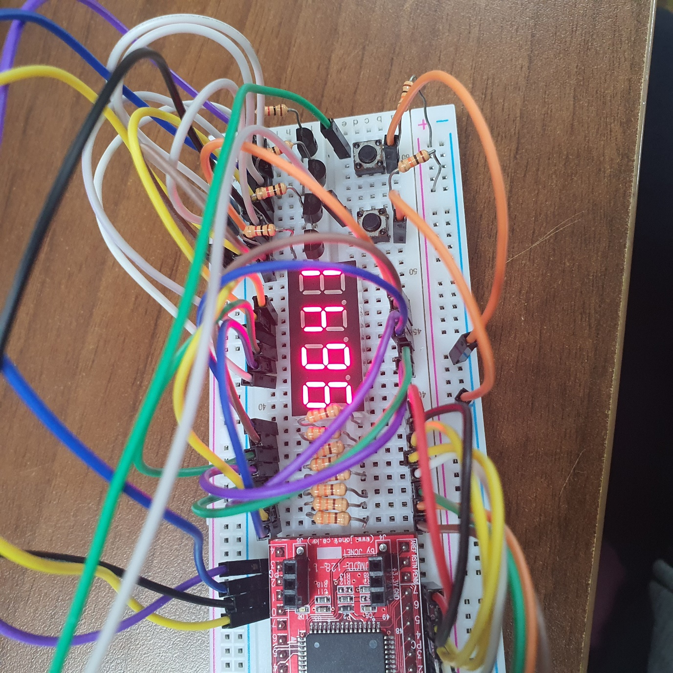

[다운카운팅]

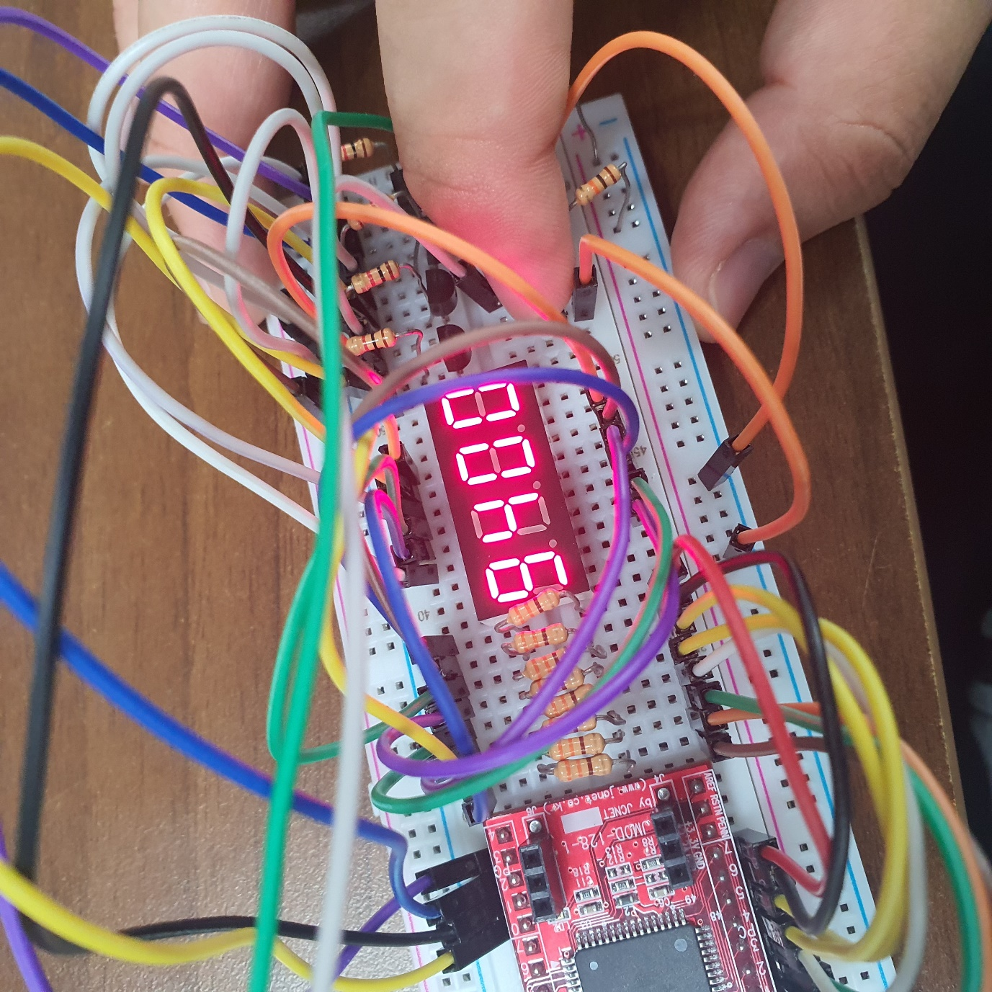

[STOP]

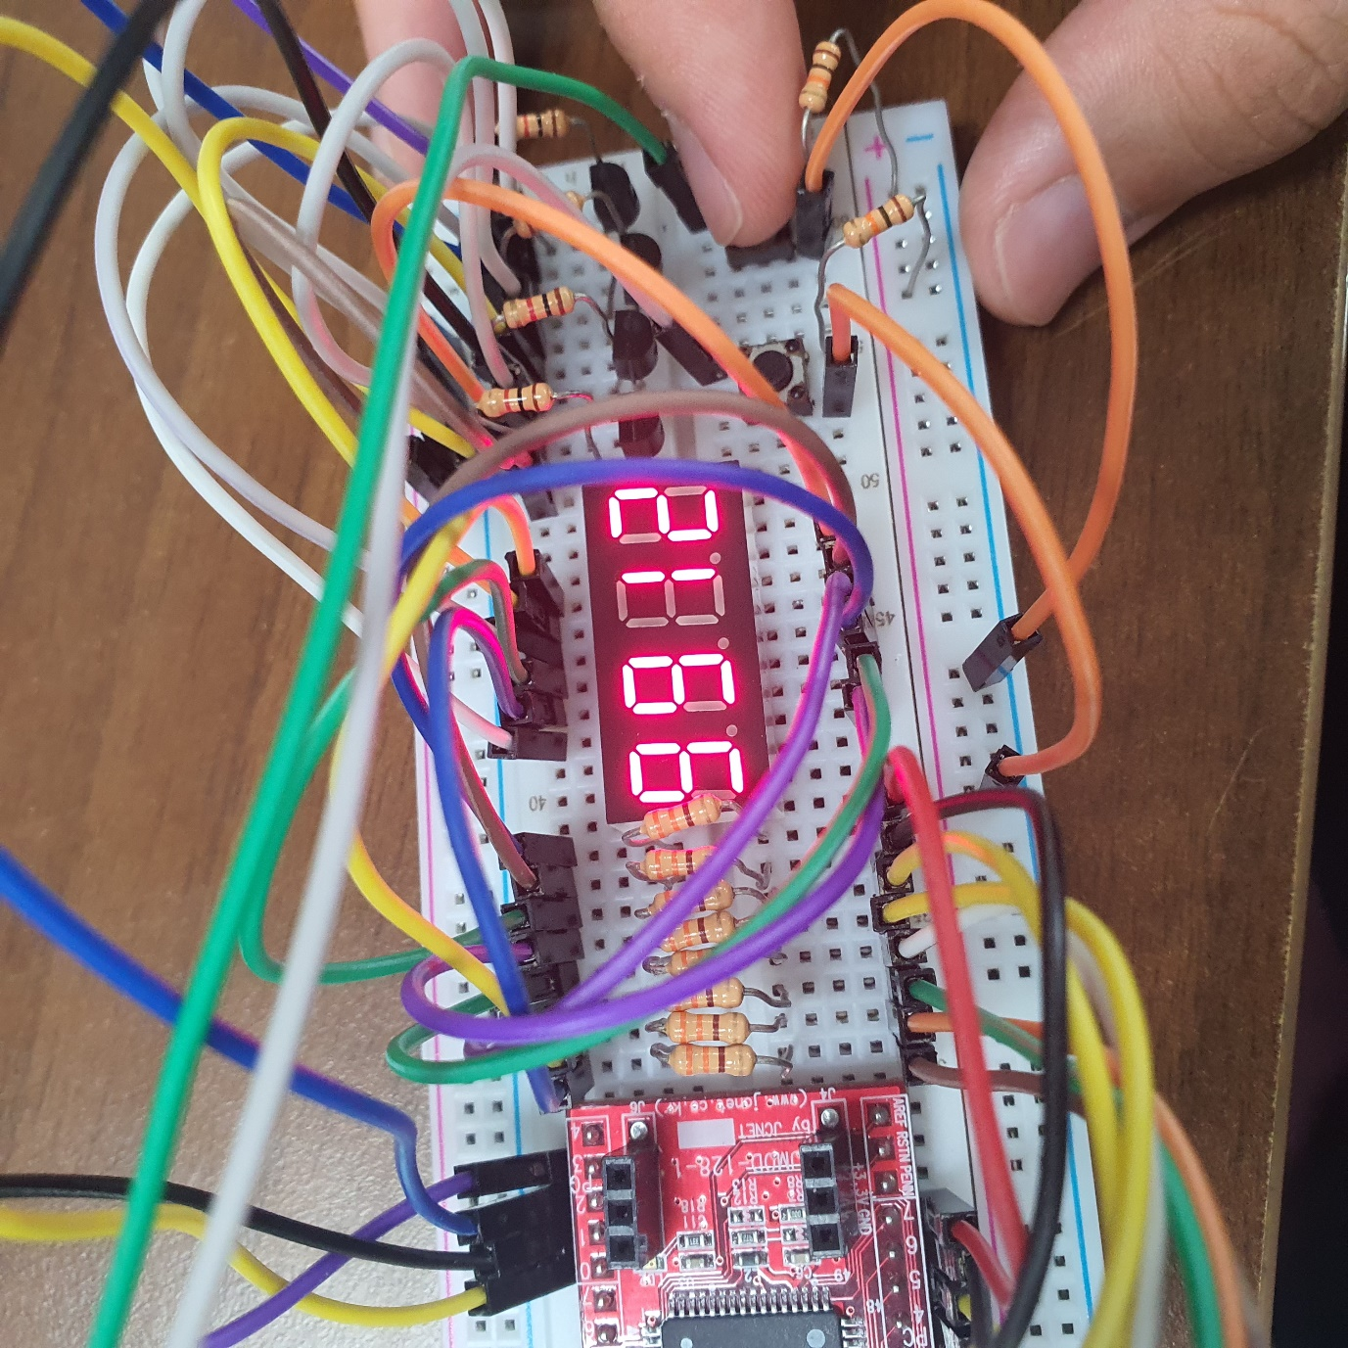

[PLUS 1000]