마이크로 컨트롤러 5주차 과제

MOTOR Project No. 1

201921280 김남훈

순서

SourceCode 2

Implementation 3

# SourceCode

#include <avr/io.h>

#include <avr/interrupt.h>

#define *F_CPU* 16000000UL

#include <util/delay.h>

#define MOTOR_CW 0xb0

#define MOTOR_CCW 0x70

#define MOTOR_BRAKE 0xd0

#define MOTOR_STOP 0x30

int state = MOTOR_STOP;

ISR(INT4_vect) //FORWARD

{

*_delay_ms*(50);

if((PINE & 0x10) == 0x10) return;

EIFR |= 1<<4;

state = MOTOR_CW;

}

ISR(INT5_vect) //REVERSE

{

*_delay_ms*(50);

if((PINE & 0x20) == 0x20) return;

EIFR |= 1<<5;

state = MOTOR_CCW;

}

int main(void)

{

DDRB = 0xf0; //motor 1

DDRE = 0x00; //Switch

DDRG = 0x03; //LED

EICRB = 0x0a;

EIMSK = 0x30;

sei();

while(1)

{

if(state == MOTOR_CW) PORTG = 0x01; //정방향 LED 점등

else if(state == MOTOR_CCW) PORTG = 0x02; //역방향 LED 점등

else PORTC = 0x00;

PORTB = state;

}

}

# Implementation

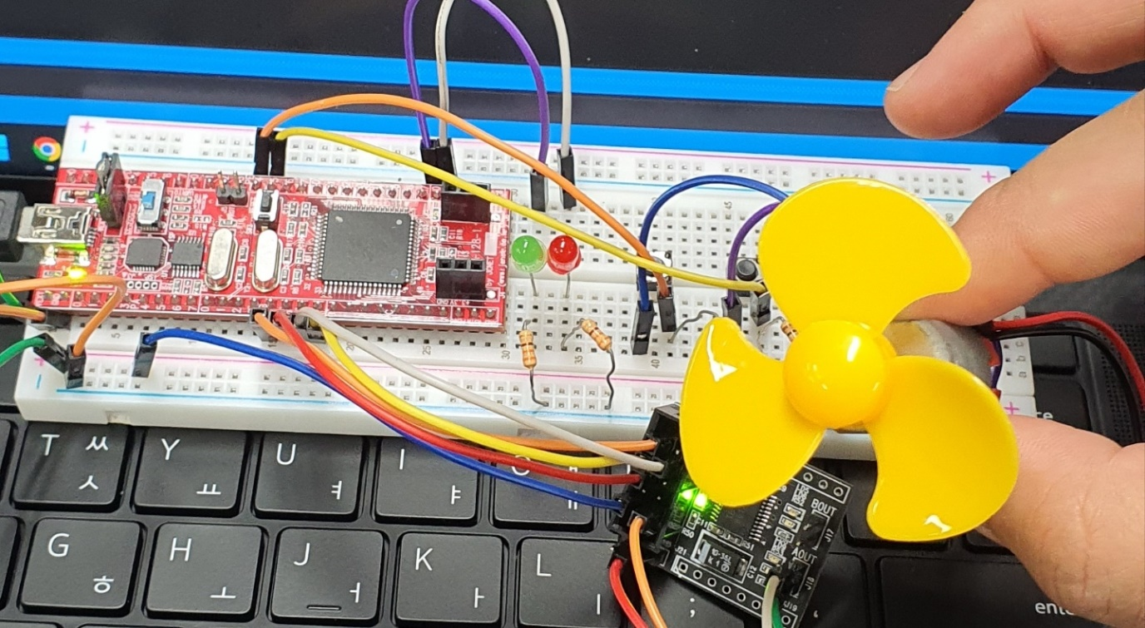

회로 완성, Idle state. LED: Forward/Reverse 표시기

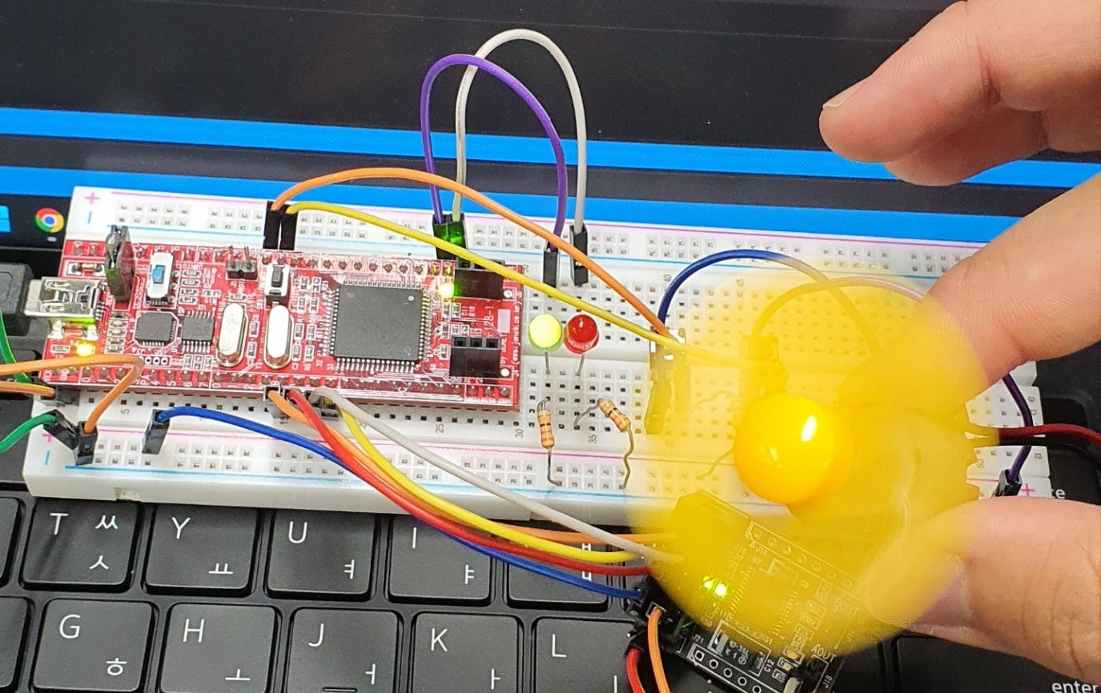

4번 스위치 Push, 정방향 회전

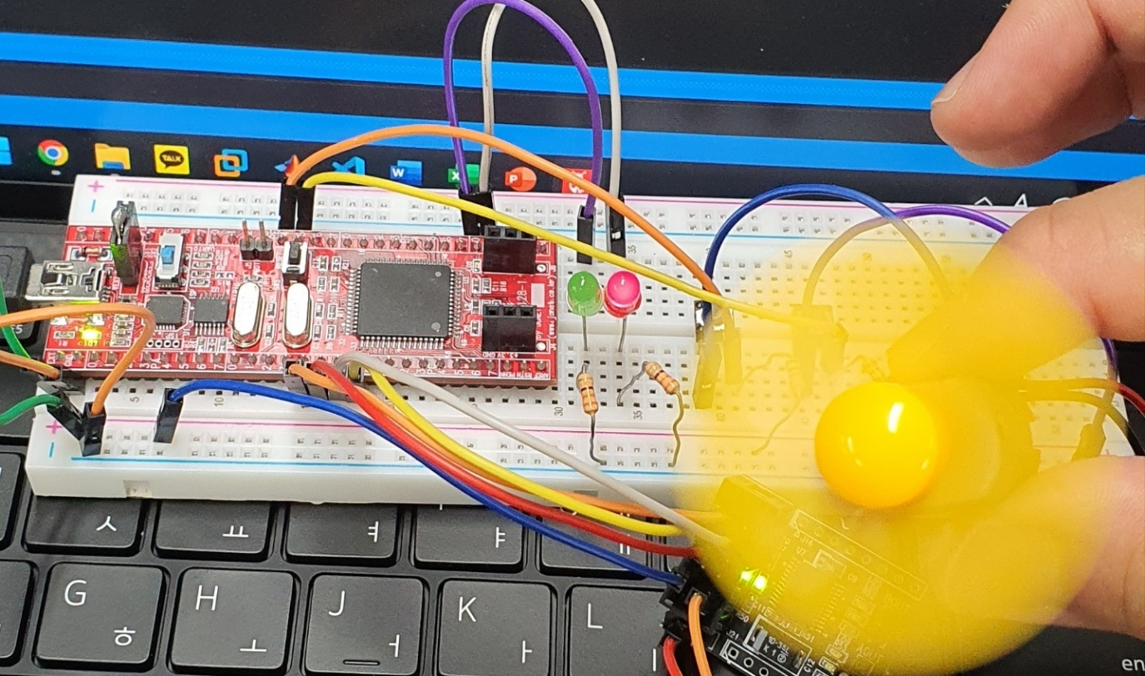

5번 스위치 Push, 역방향 회전