File Crawler
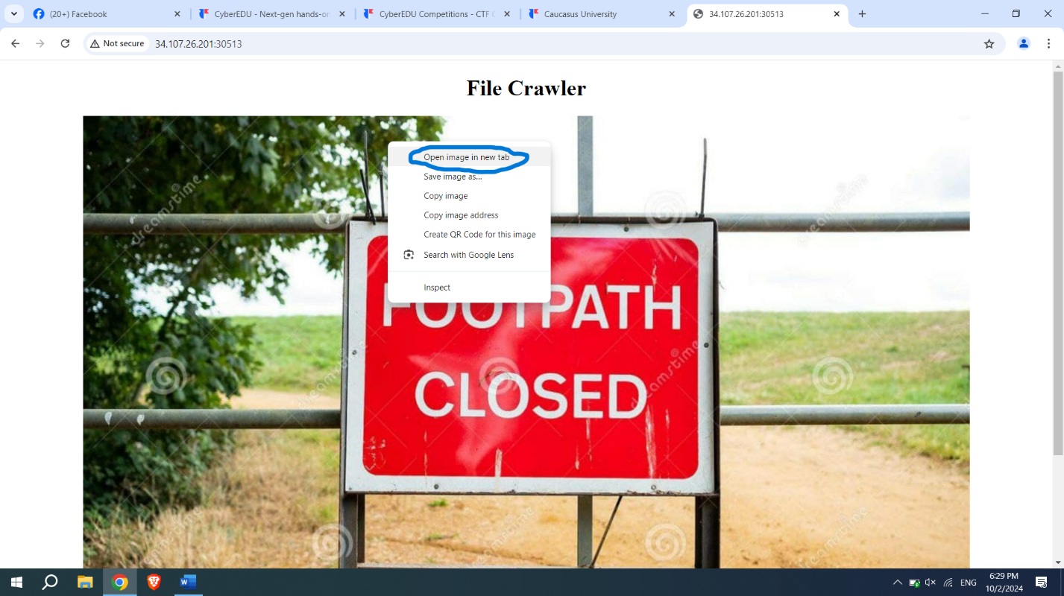
After checking inspect, it’s noticeable that the way image is brought to us might be vulnerable. So we open image on new Tab: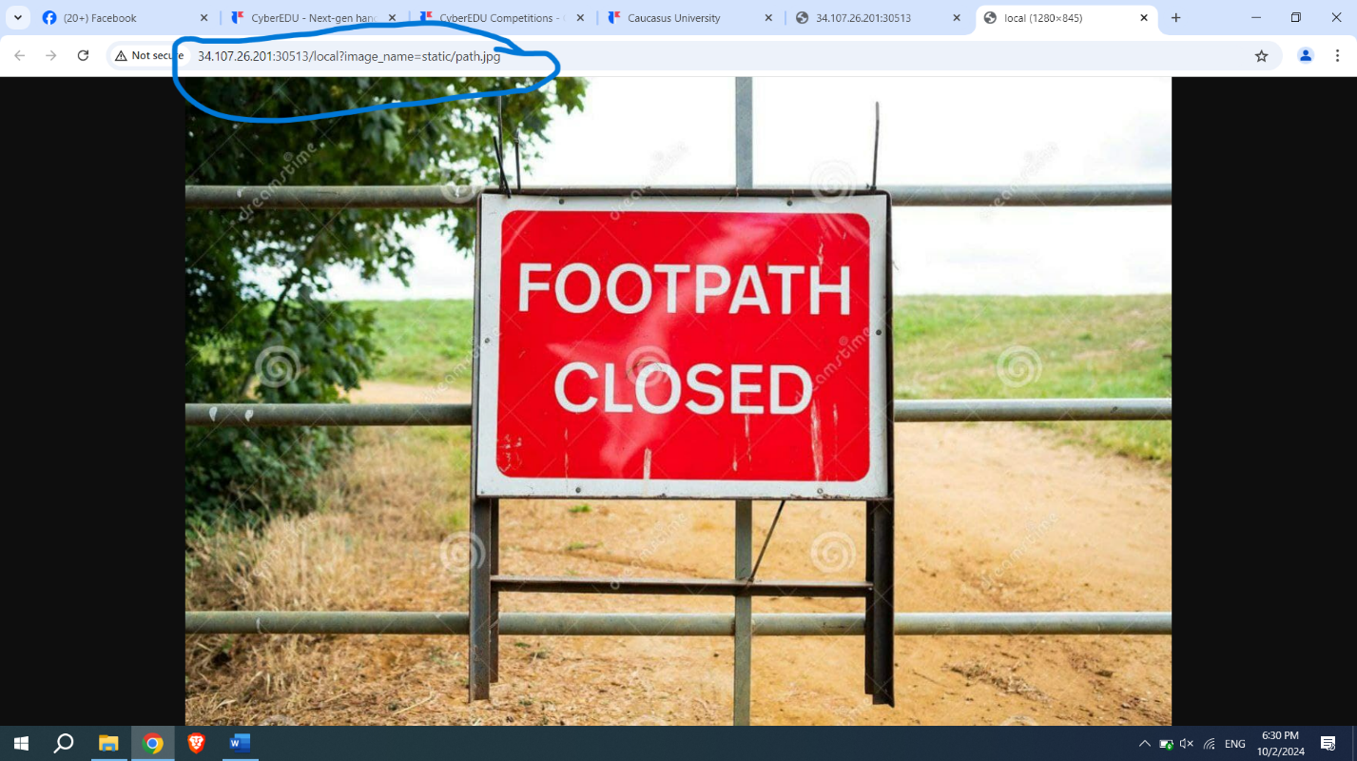
We’ve noticed that “local” property is used, so we can try to get access of other local files:
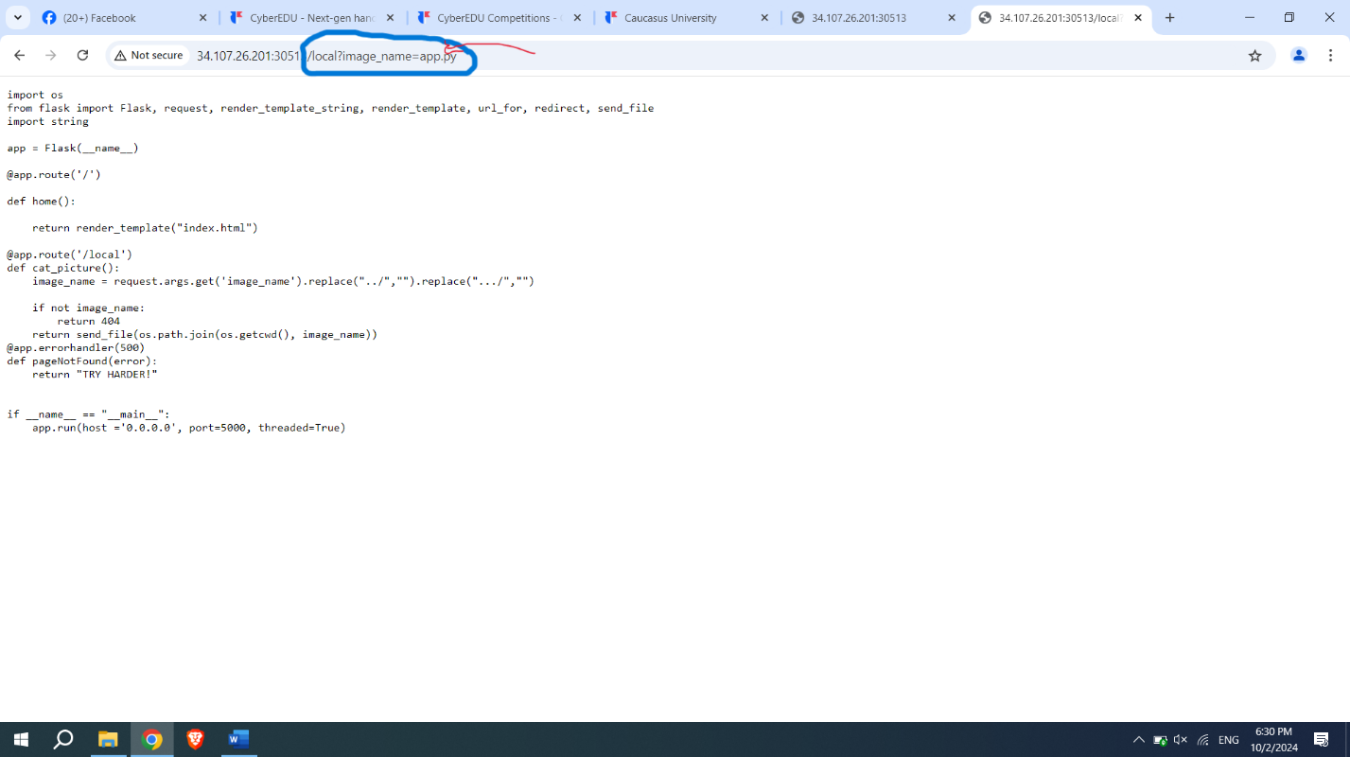
For example app.py after seeing these source codes it seems we were right: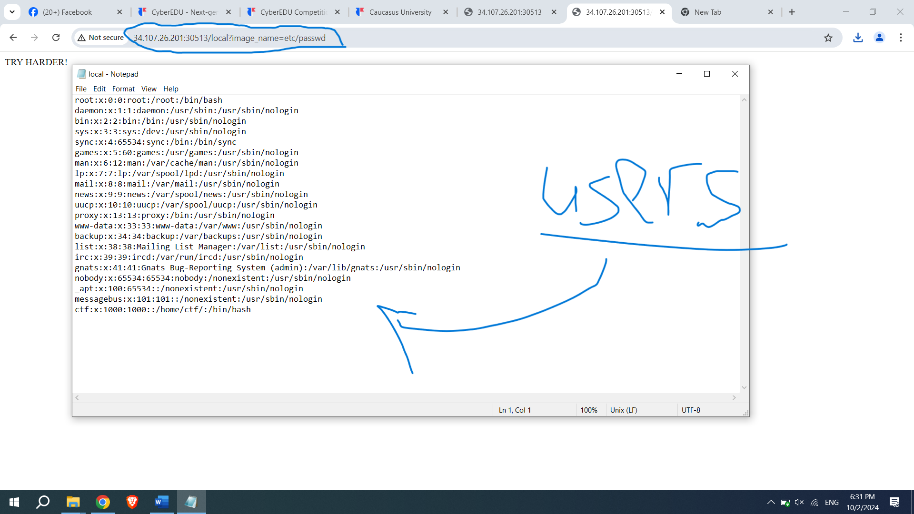
We used simple etc/passwd, this is common directory in linux that keeps information of users, now we can get the flag, because we knew flag is in temporary file, commonly in linux it’s called /tmp:
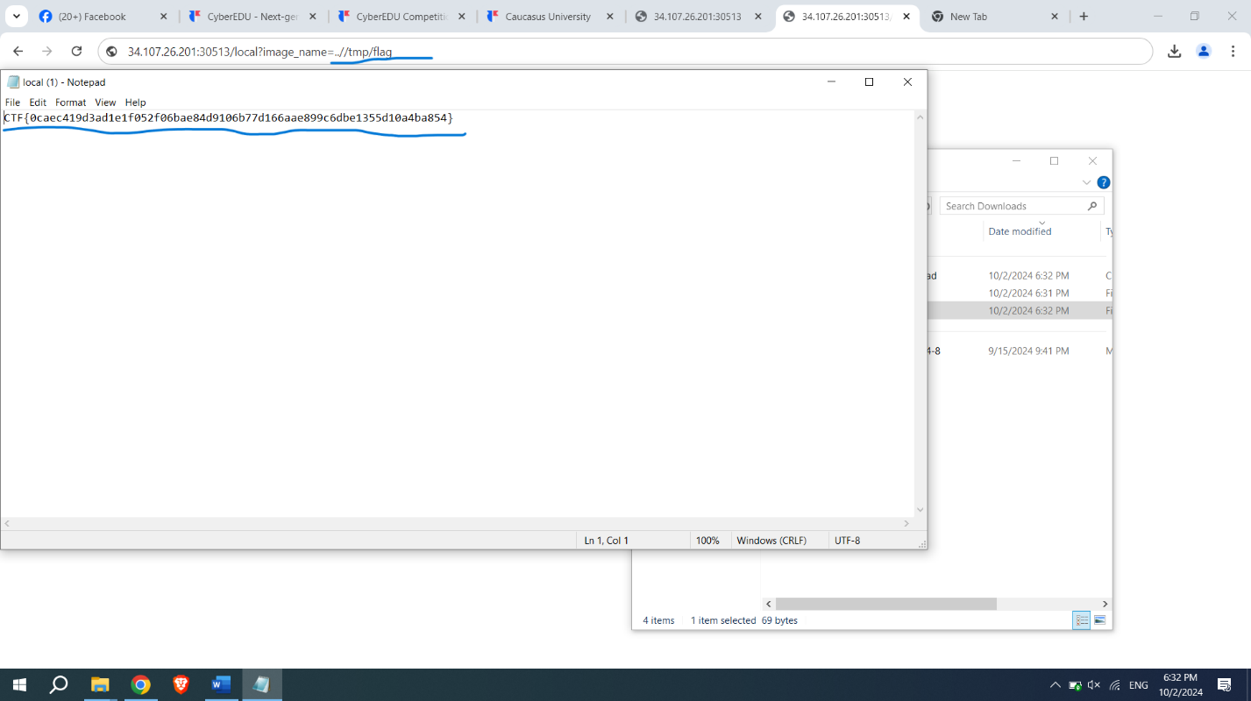
Since we tried ..//tmp/flag , we had a answers here is the flag:
CTF{0caec419d3ad1e1f052f06bae84d9106b77d166aae899c6dbe1355d10a4ba854}

Alien inclusion
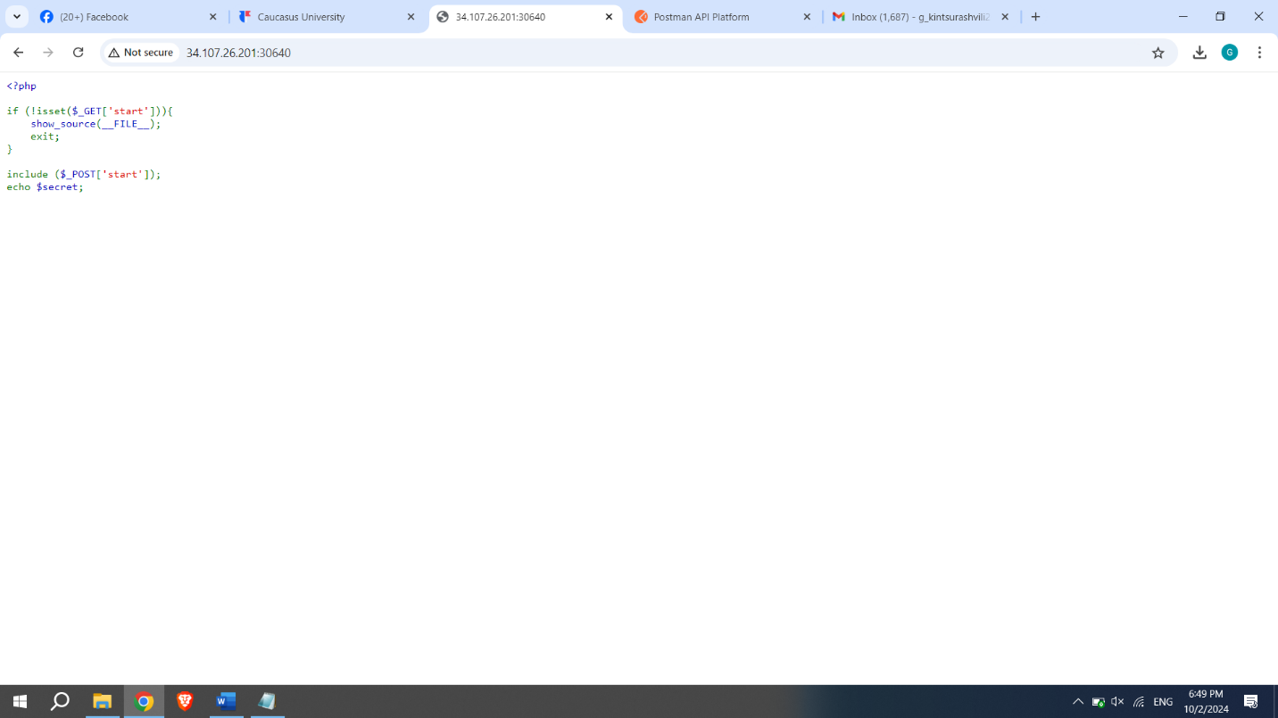
Landing page already gave us the information of where our answer is. This php code says that we need to give start parameter on header [GET] and the send the post request, We can use either curl command on linux, but This time, I’ll do it using Postman.
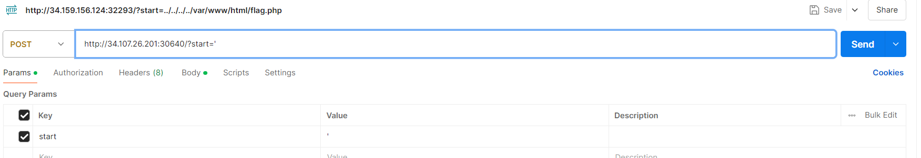
So as we see we put ‘start’ parameter (value doesn’t matter, because it wasn’t specified in the code (picture1)
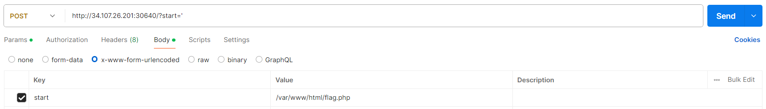
So on this picture we specify body, and we give it based on the knowledge of second part of the code ([POST] ‘start’) and the descfription that said the flag was on this directory: /var/www/html/flag.php

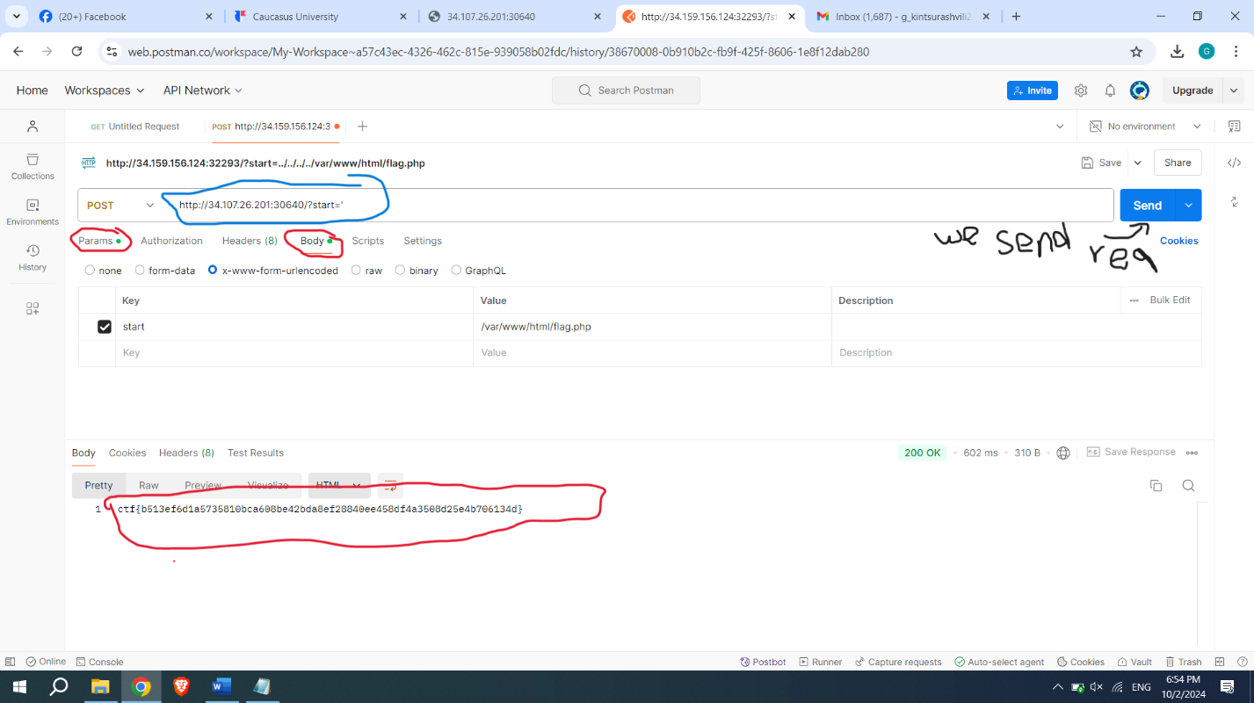
And here is the flag: ctf{b513ef6d1a5735810bca608be42bda8ef28840ee458df4a3508d25e4b706134d}

Task 3: Ultra-crawler
3.1) after opening the landing page, first we tried to access some directories, but it seemed unvulnurable until we tried: file:///etc/passwd : we tried because directory with this location is common and it worked this time as well:
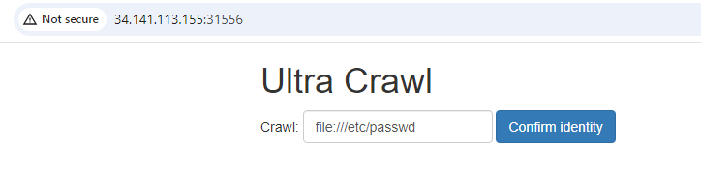
3.2)So as it was on previous task We’ll move to linux command prompt and try to access application file:
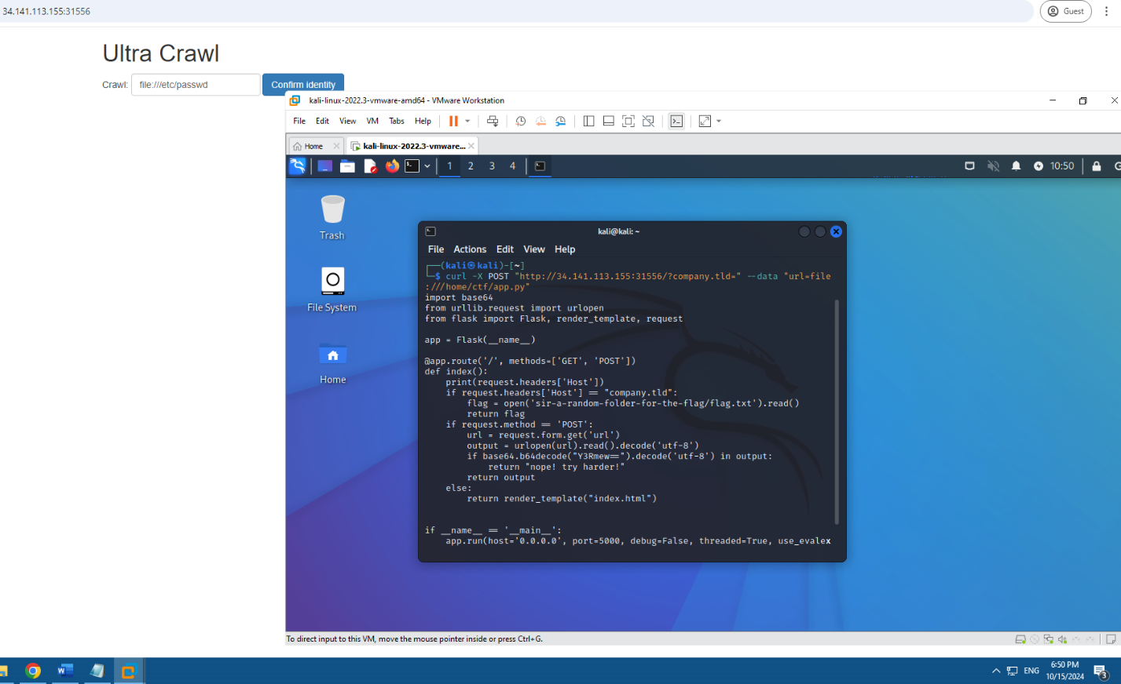
This gives us a lot of information including how to get flag. I switched POST to Host and tried the code but it was telling me I wasn’t allowed to make this request, I tried multiple and different commands but it was saying same, but I’m sure this command was right I wasn’t getting flag just because of firewall so please take it in consideration: (images on next pagae)
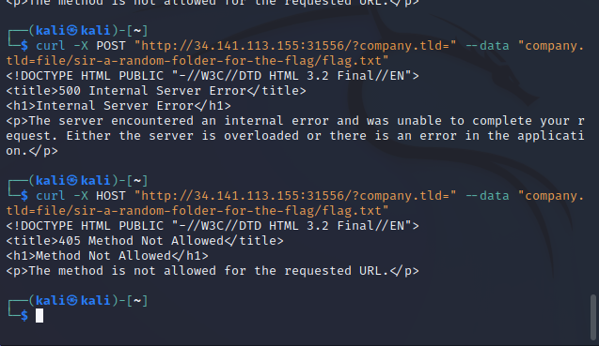

TASK 4: under-construction

- First thing first, we have to register on the website to get the token our information etc, so this authorization process usually gives us other features and permisions as an user:
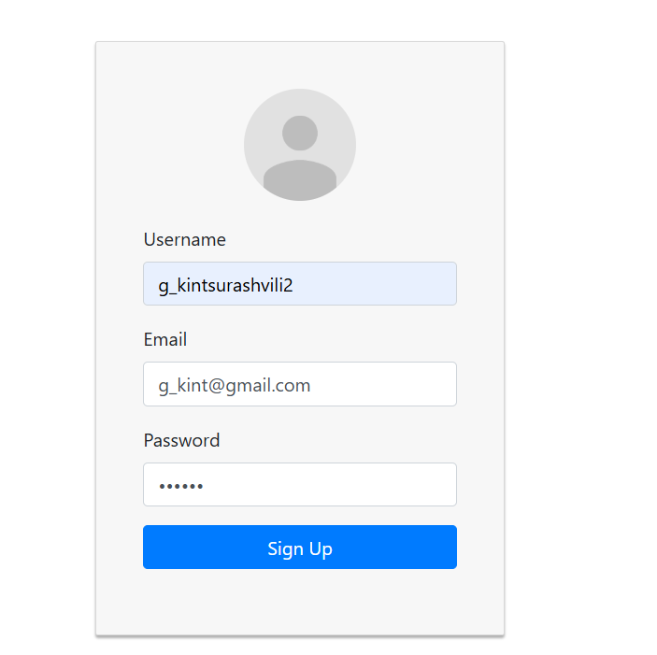
- After we log in and check local storage we see our information and data, important part is that we can see our role and token as well: 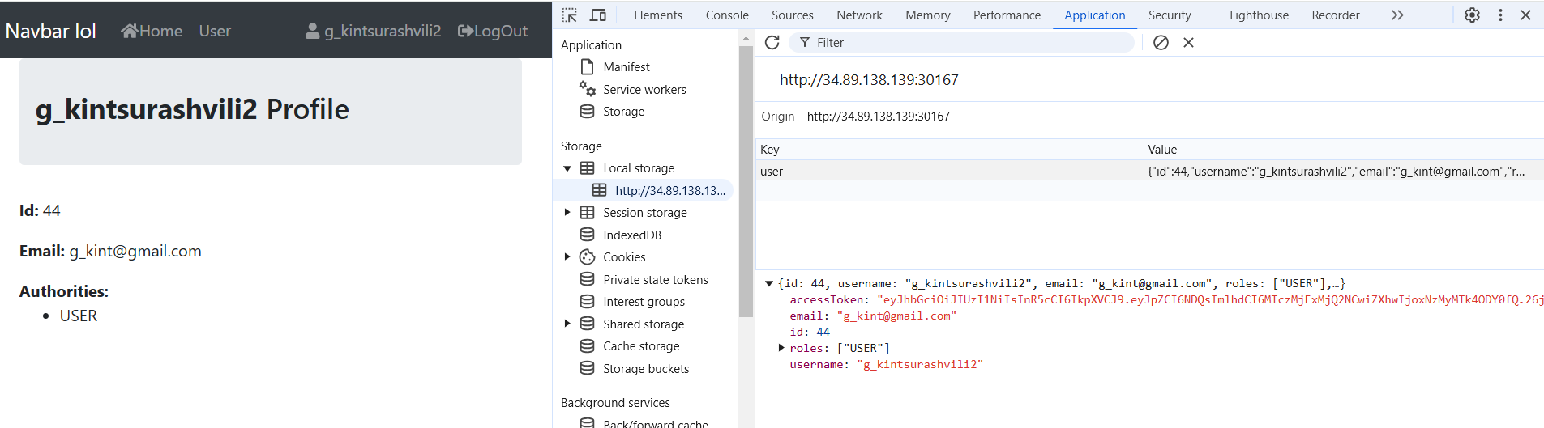
- The moment we change our role to admin locally, we can notice the admin section, but it won let us show anything on that section because our token is not authenticated admin token, but it’s still good for beggining: 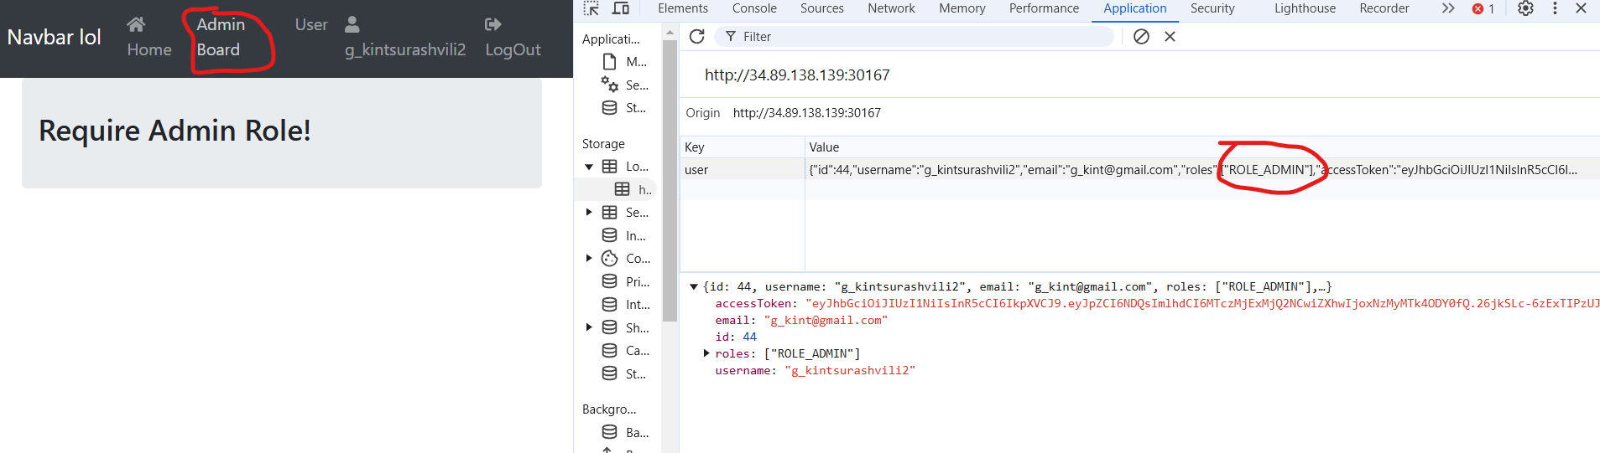
- What we can do is to modify our token as we wish using jwt.io platform, the most important changes that needs to be done is to change id to 1, because usually id 1 means that it was first account and it has to be admin, and we need to verify signatureas well.
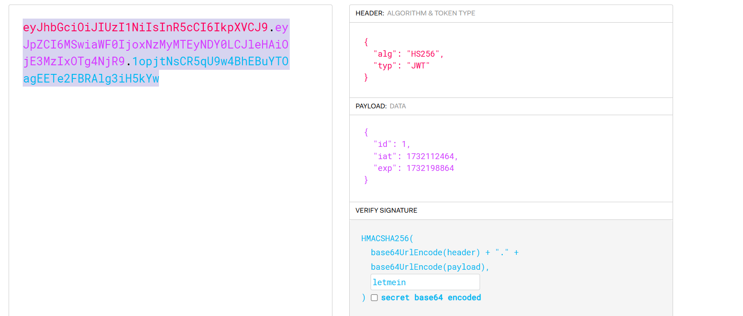
- Finaly when we replace the old token with the new one we can see flag which means we successfully passed authentication process: 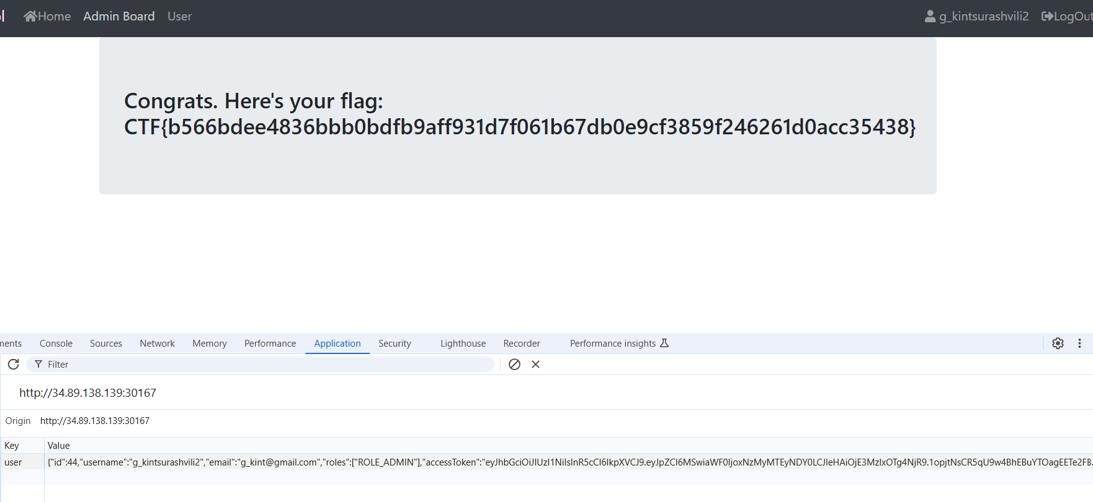

TASK 5: downloader v1

- Firstly we test the site and check the results: and as the result says it uses wget parameter so we can use –post-file 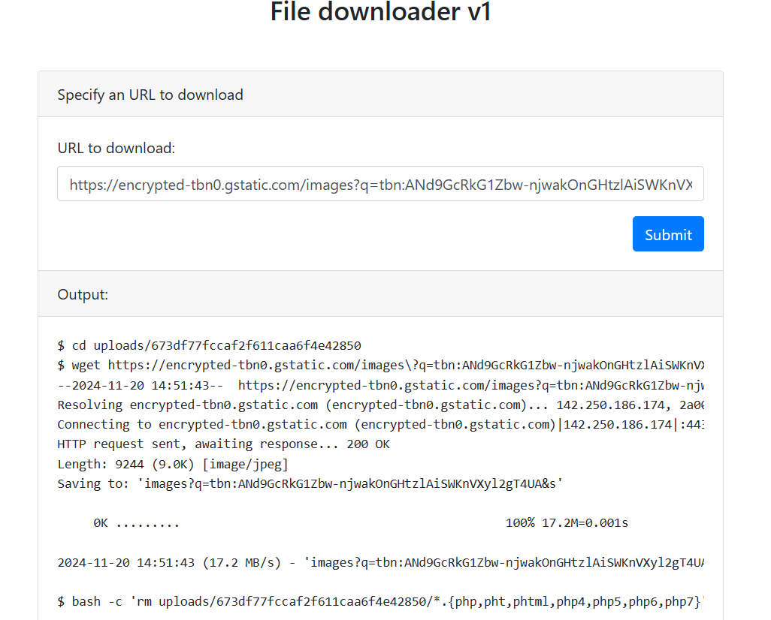
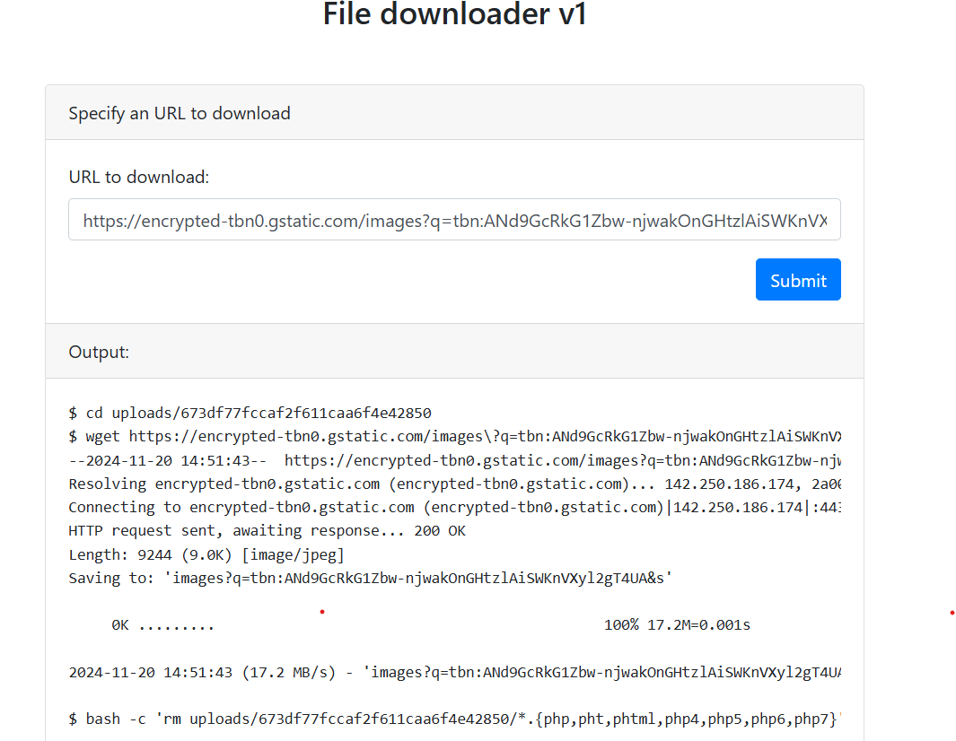
- We see in inspect that we have flag.php but unfortunatley we cant open it:
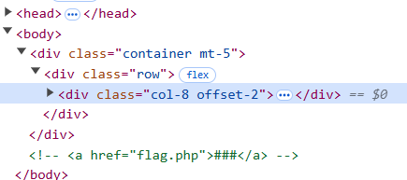

- The thing we can do it to open requestbin because it actually cab download files so what if we try to give it flag.php parameter? 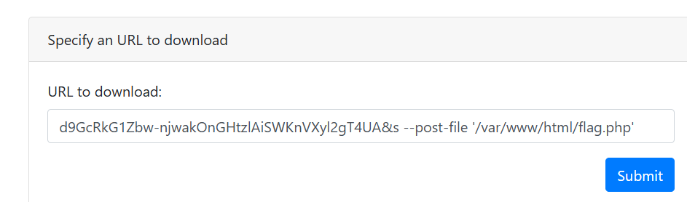

And on requestbin, after we use post request we can see flag:

