Lab 1: under-construction
http://34.89.138.139:30167/
first we see this:
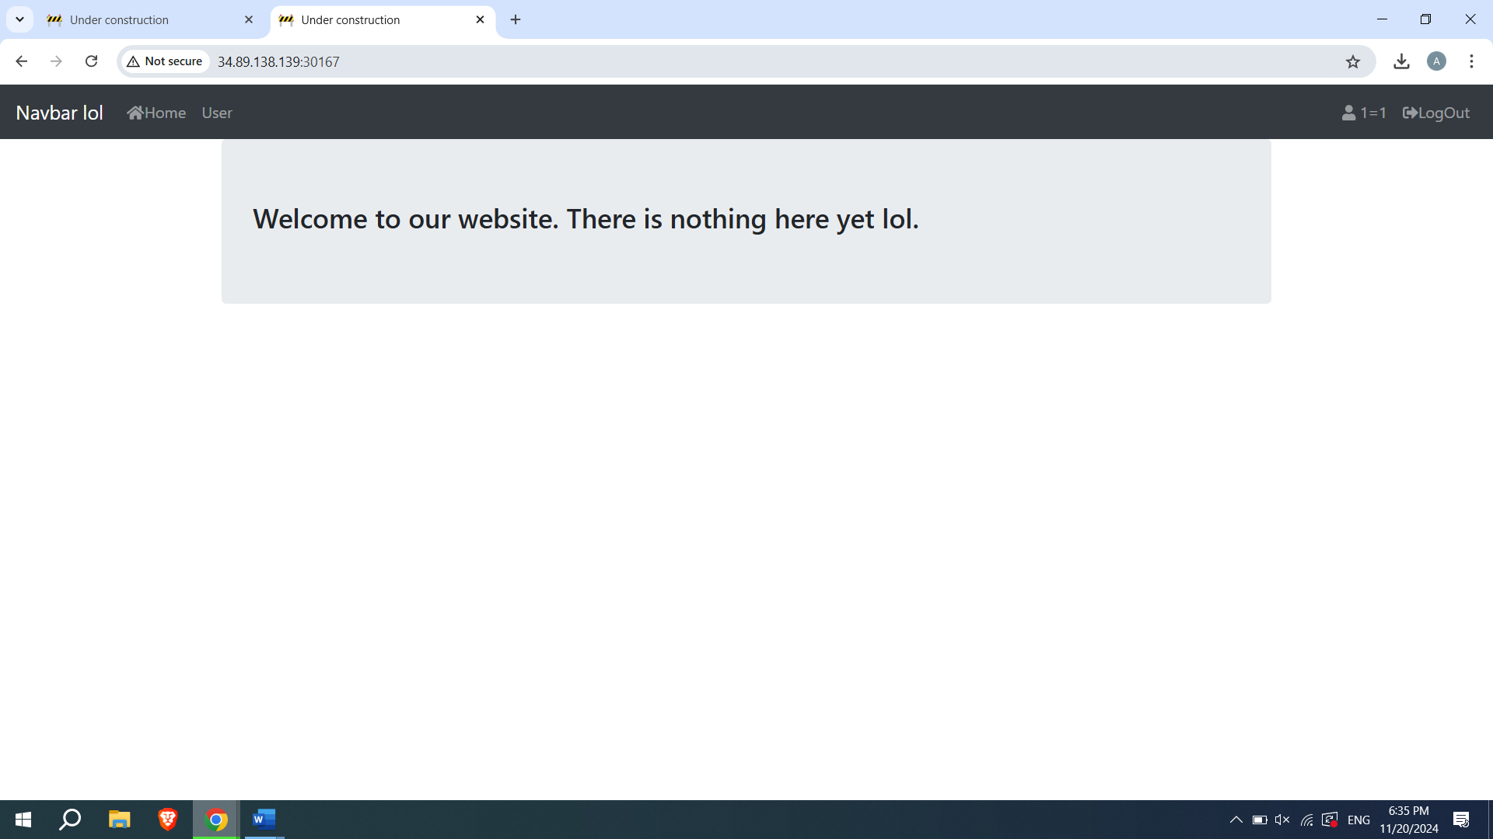

I used login and it shows us the credentials and account info
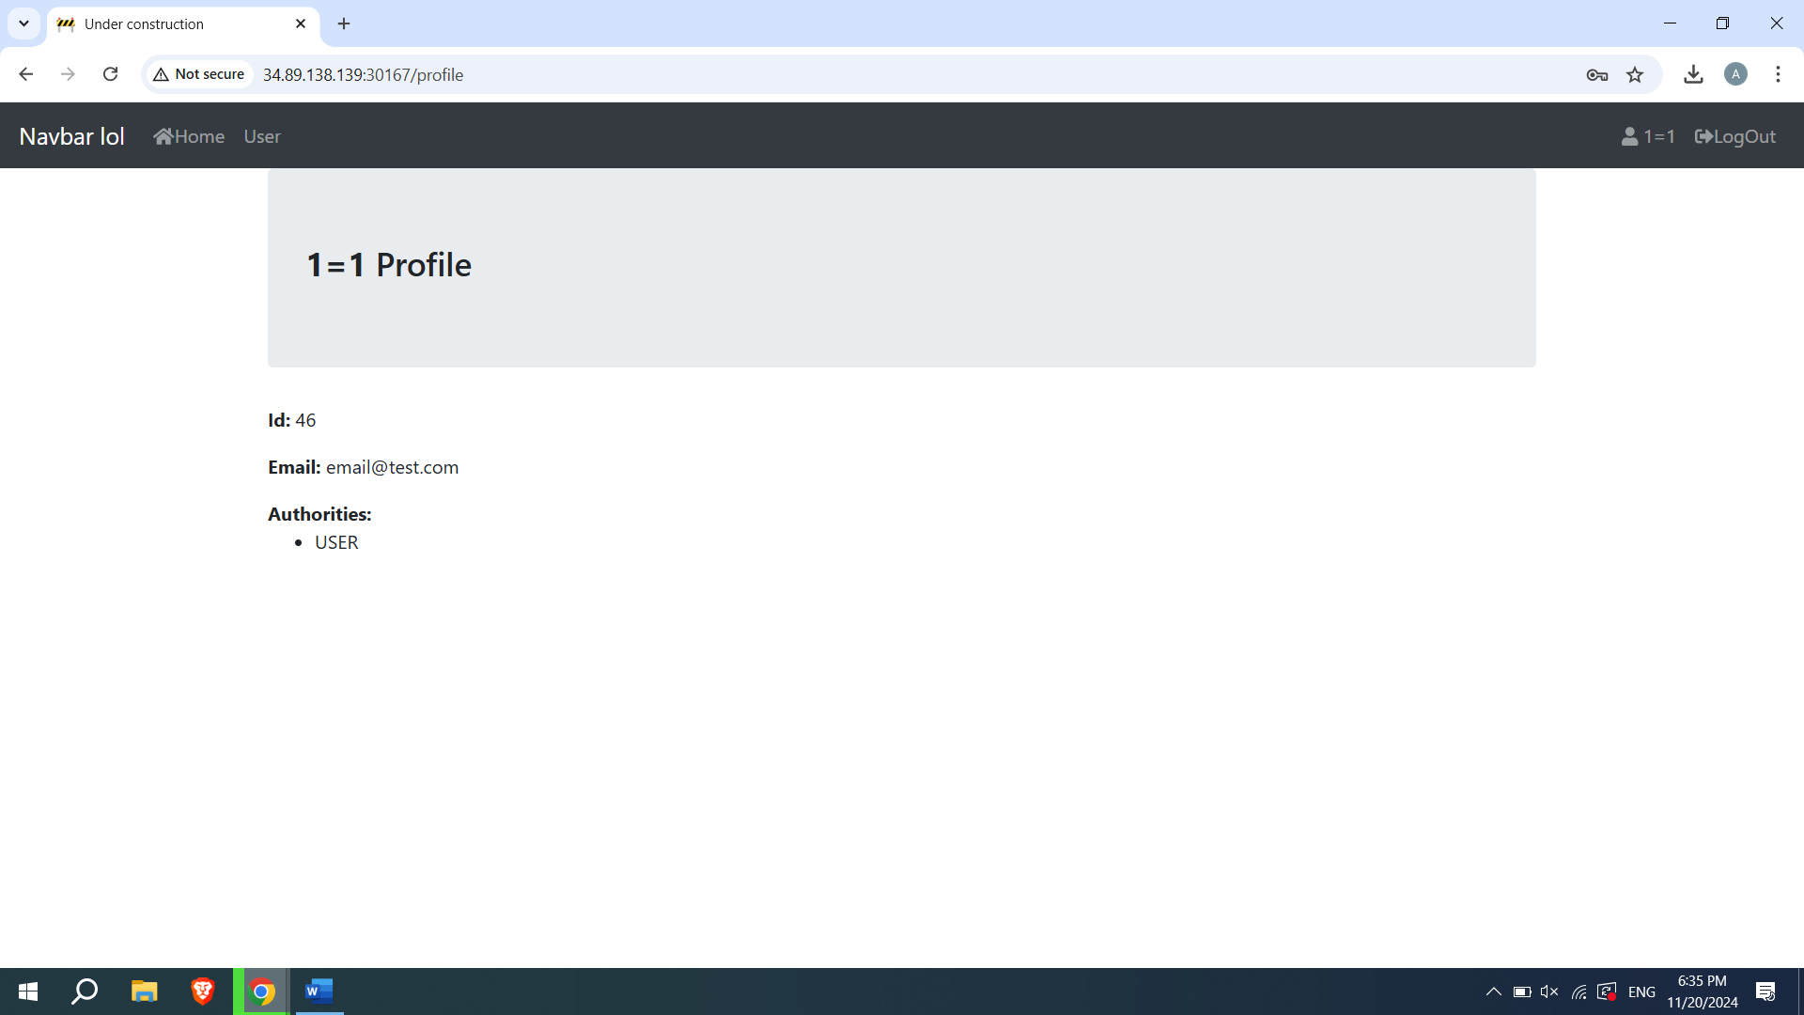
Since I am just a user for more information im going to change my role to role admin from storage
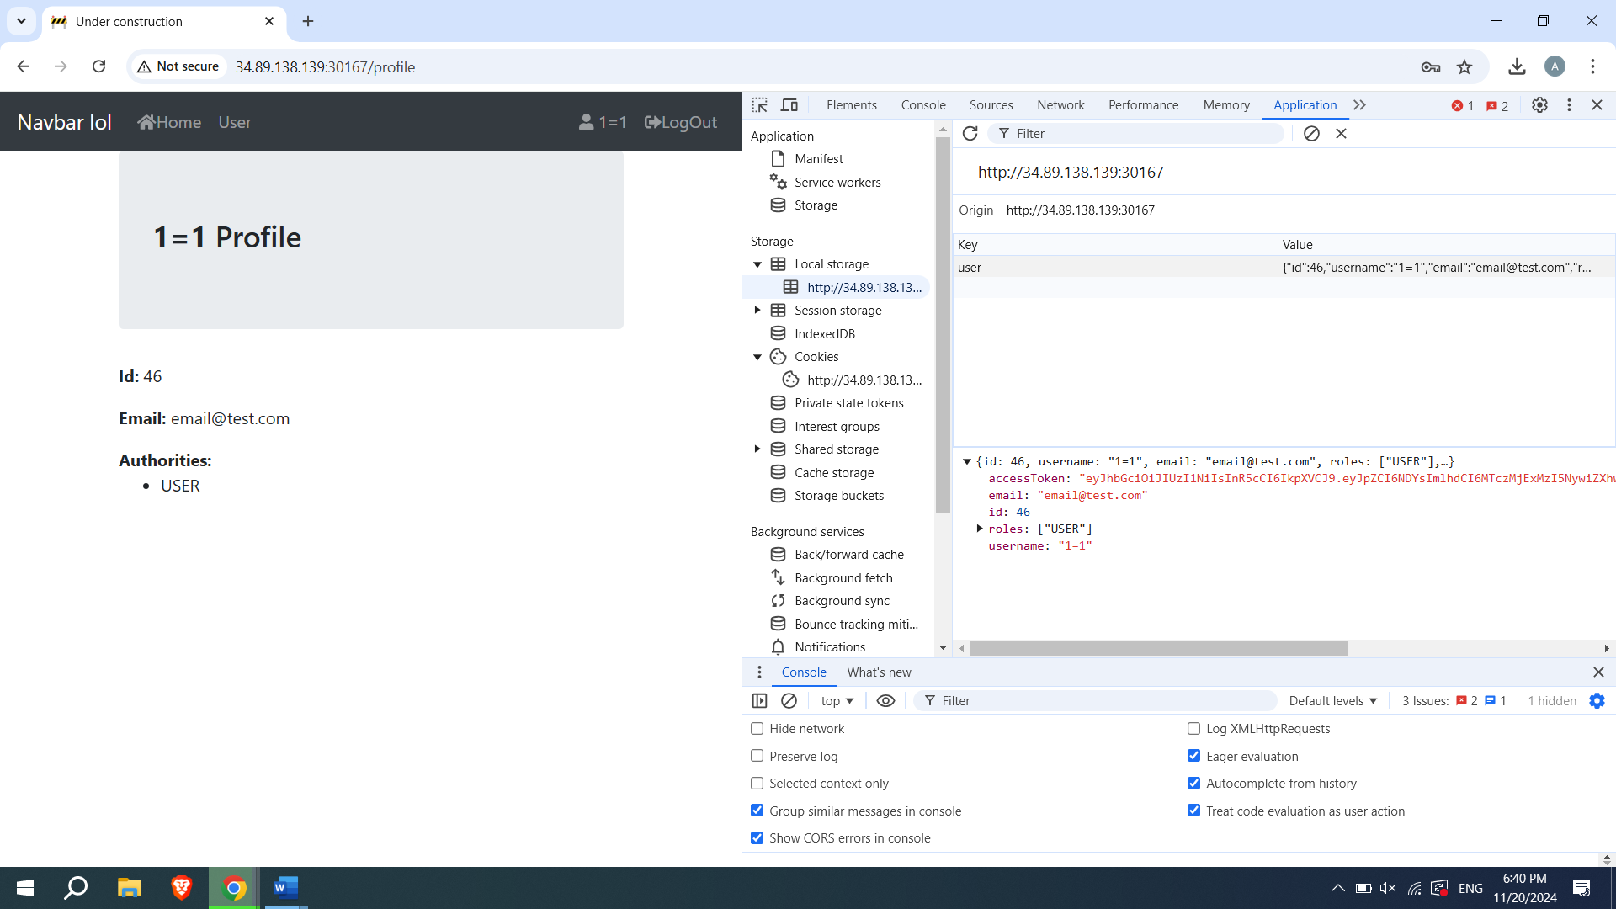

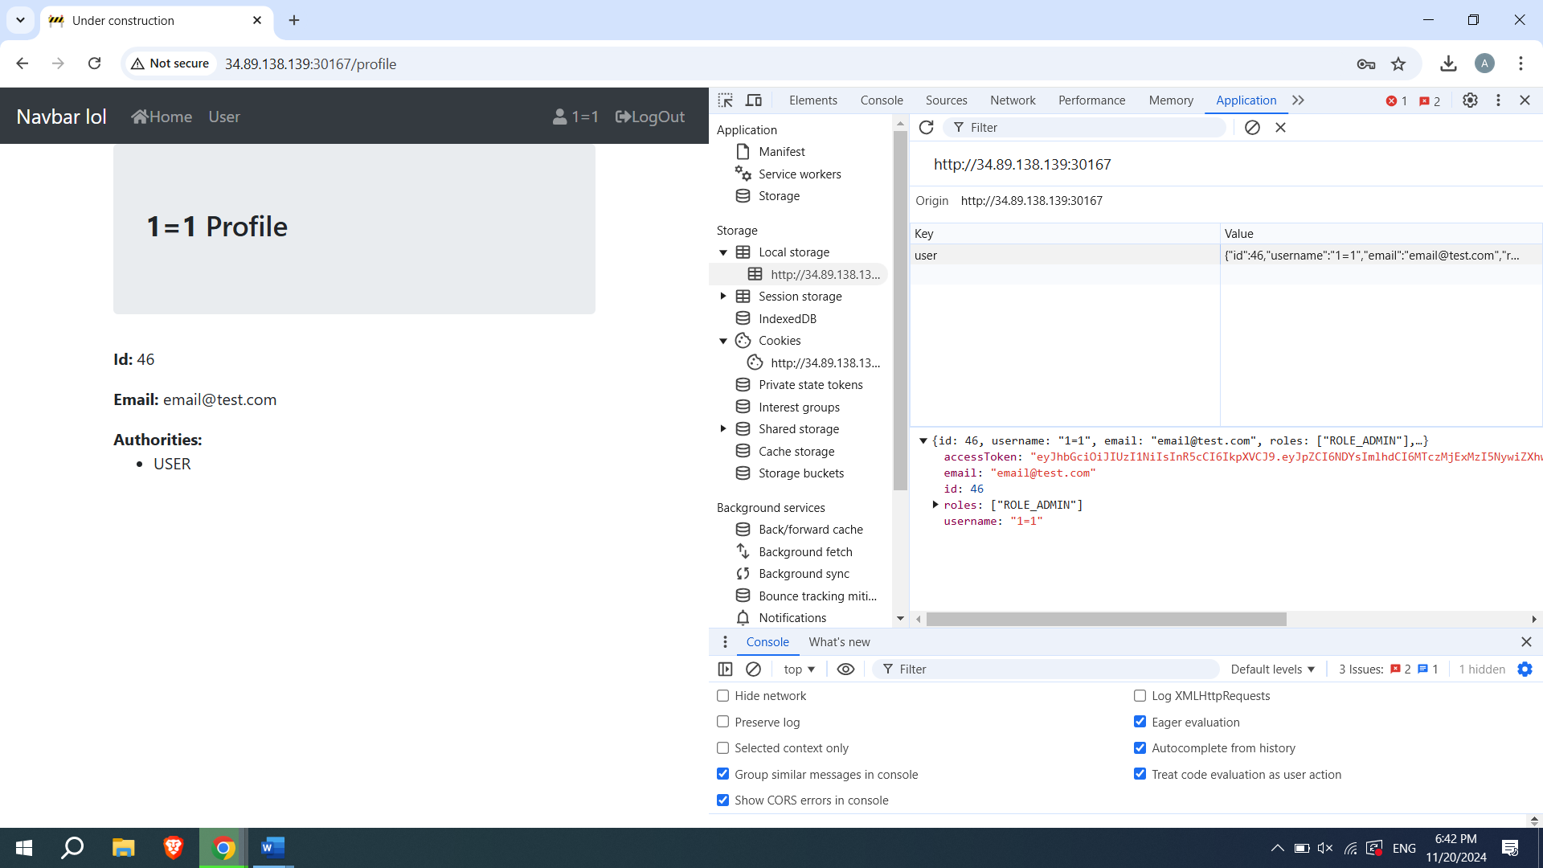
After this admin board appears in navbar
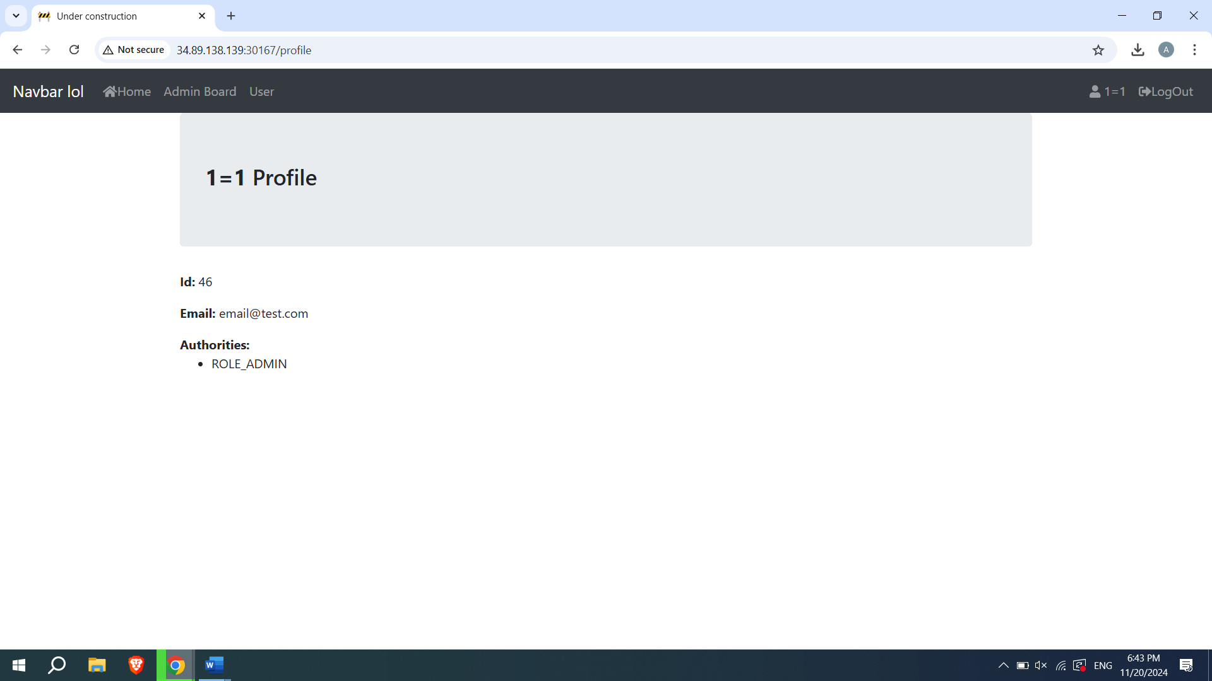

But it still wont let us fully access it
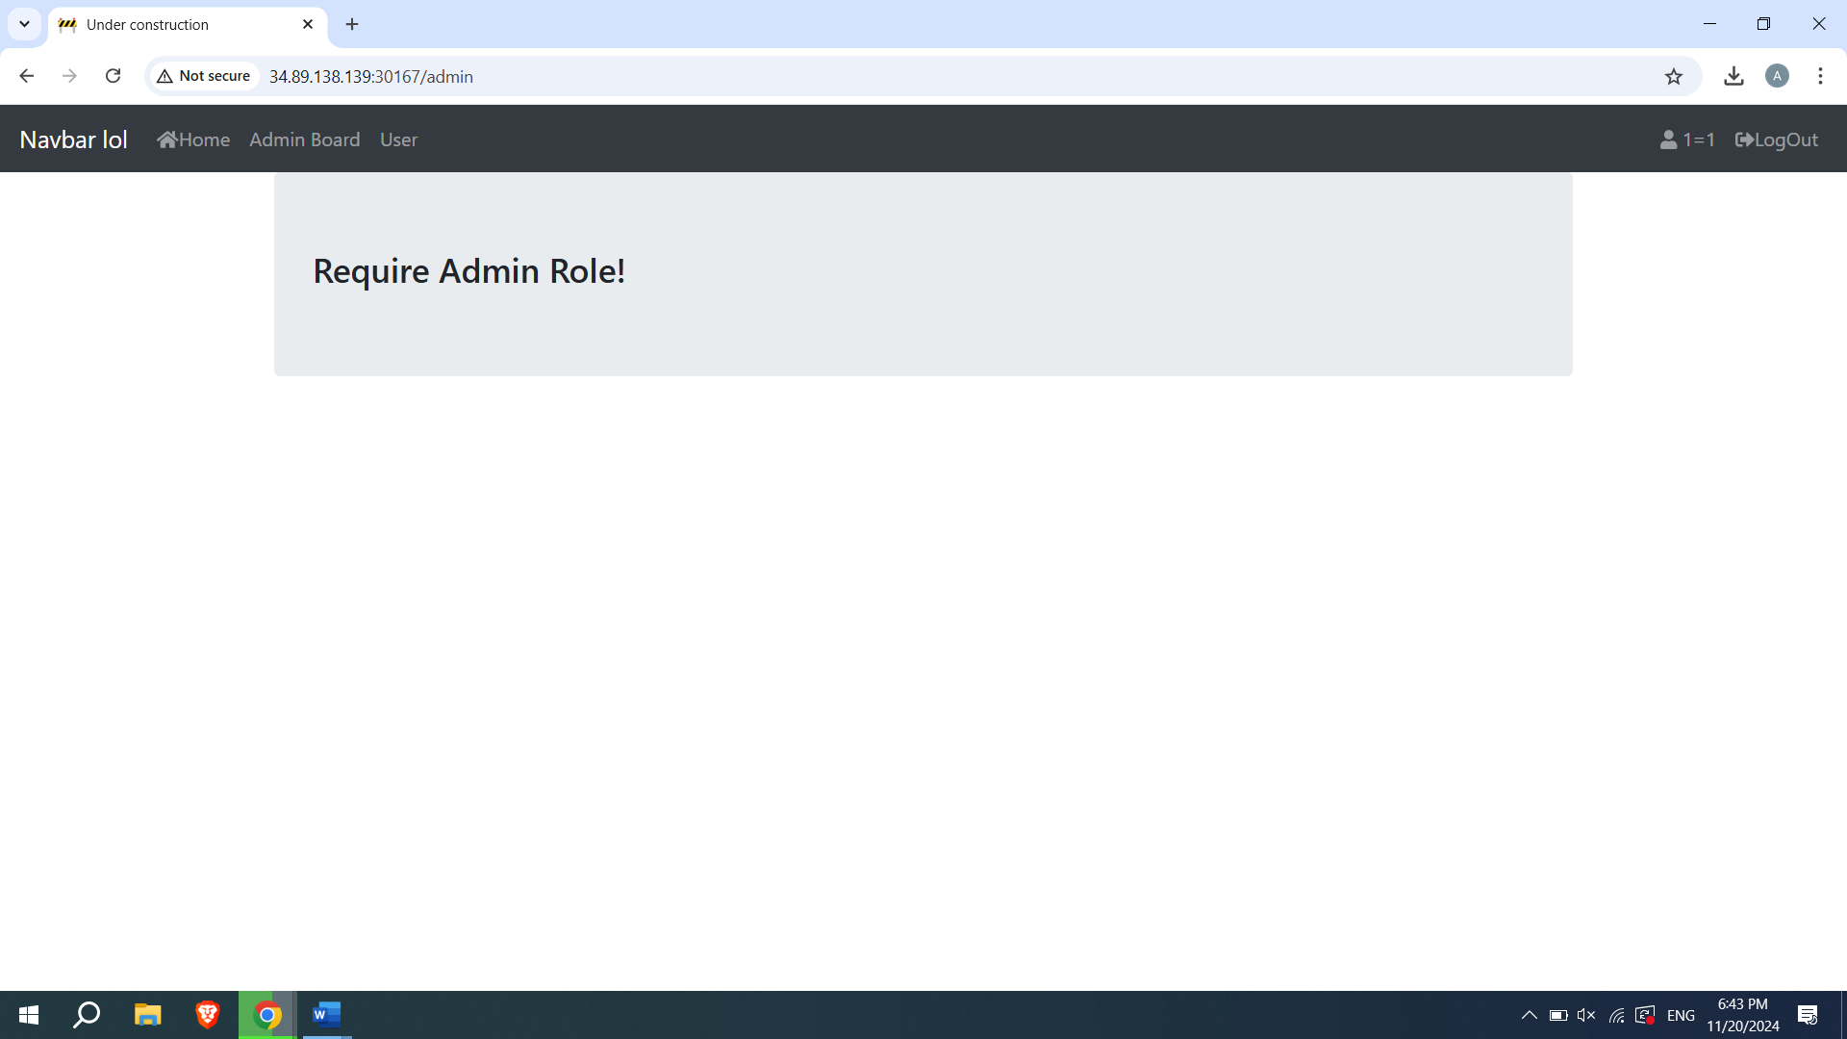
Now im going to take accesstoken
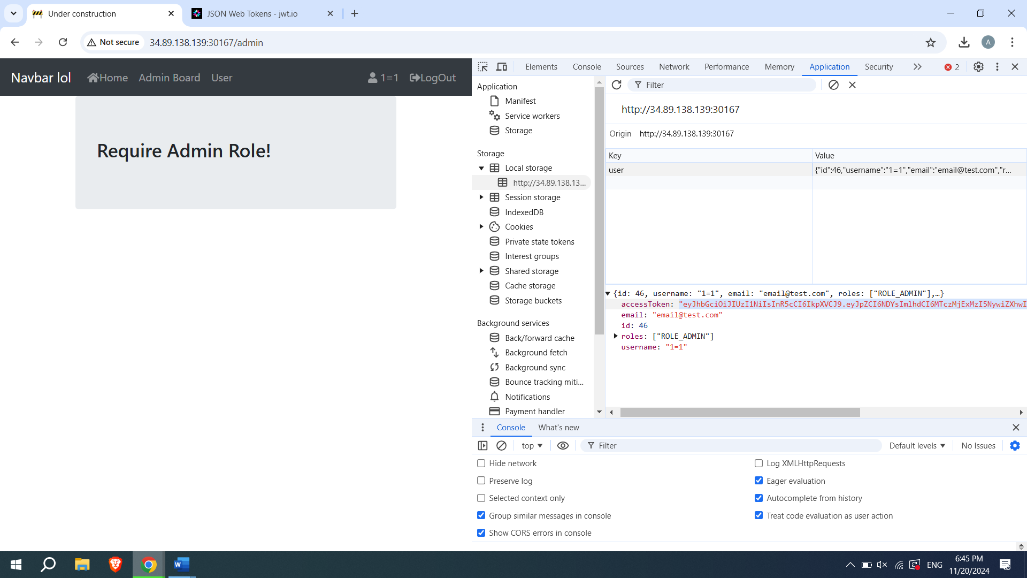
Go to jwt.io and insert it in the main input, change id to 1 since it takes more priority and in the secret code we put letmein
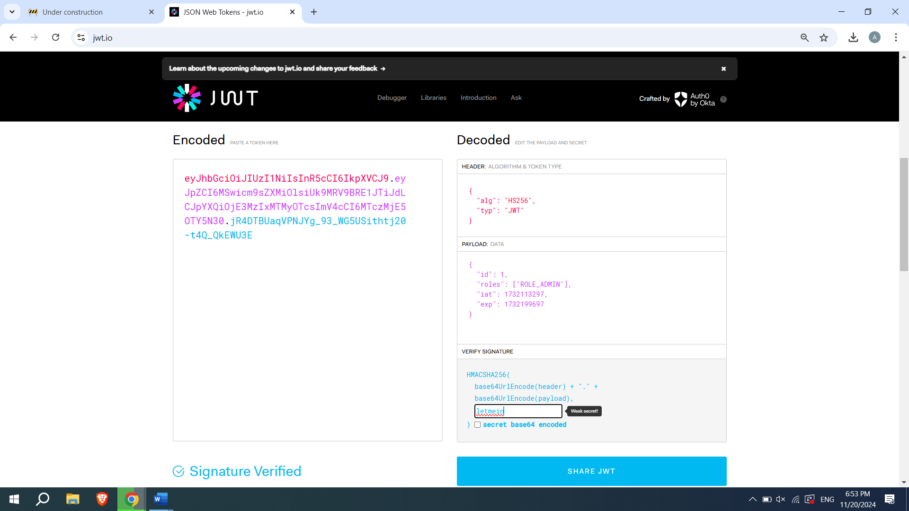
Now we take the generated token and insert it instead of the old one. Now in the admin board we see this:
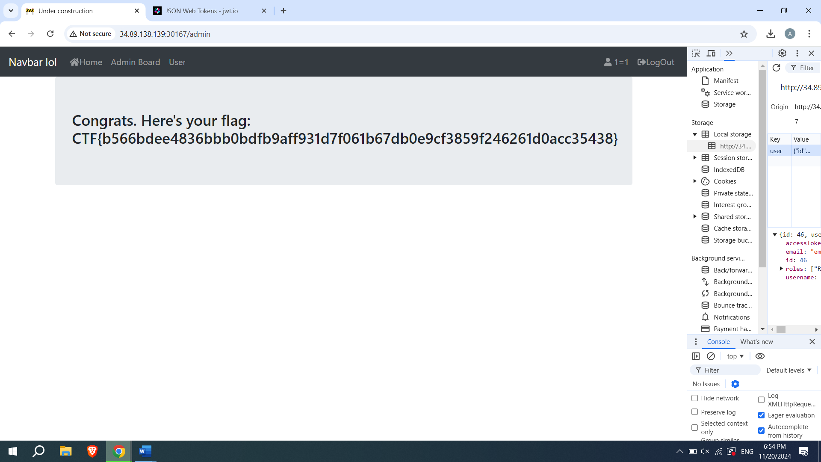

Our flag is: CTF{b566bdee4836bbb0bdfb9aff931d7f061b67db0e9cf3859f246261d0acc35438}

Next:
Lab2: downloader-v1
http://34.89.138.139:30715/
we have the following page

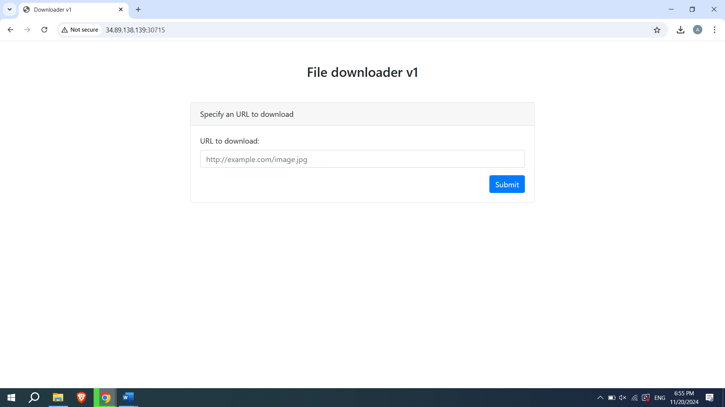
We see flag.php in the inspect
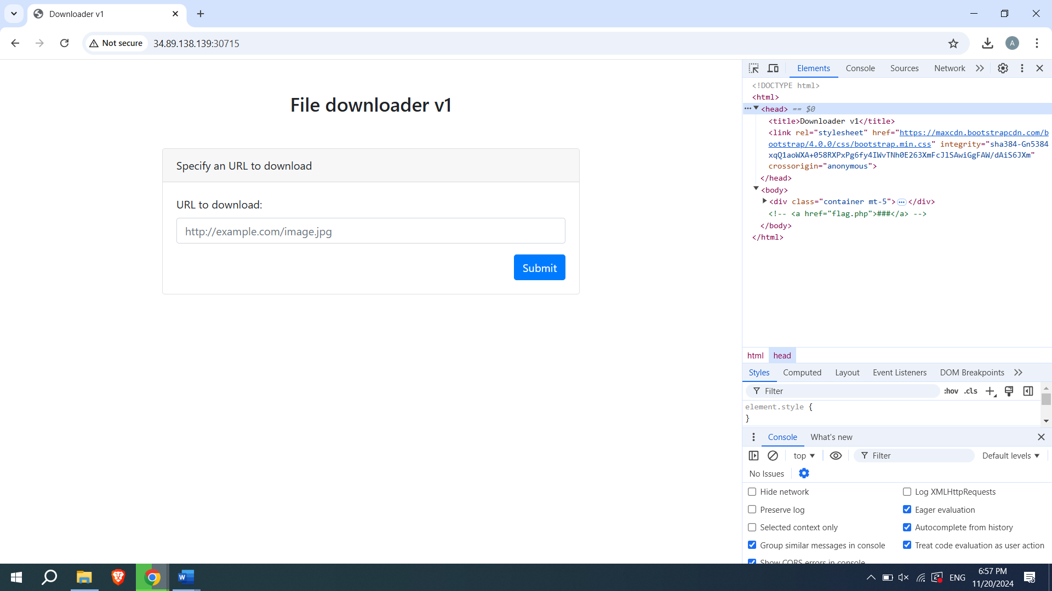
However we cant simply download
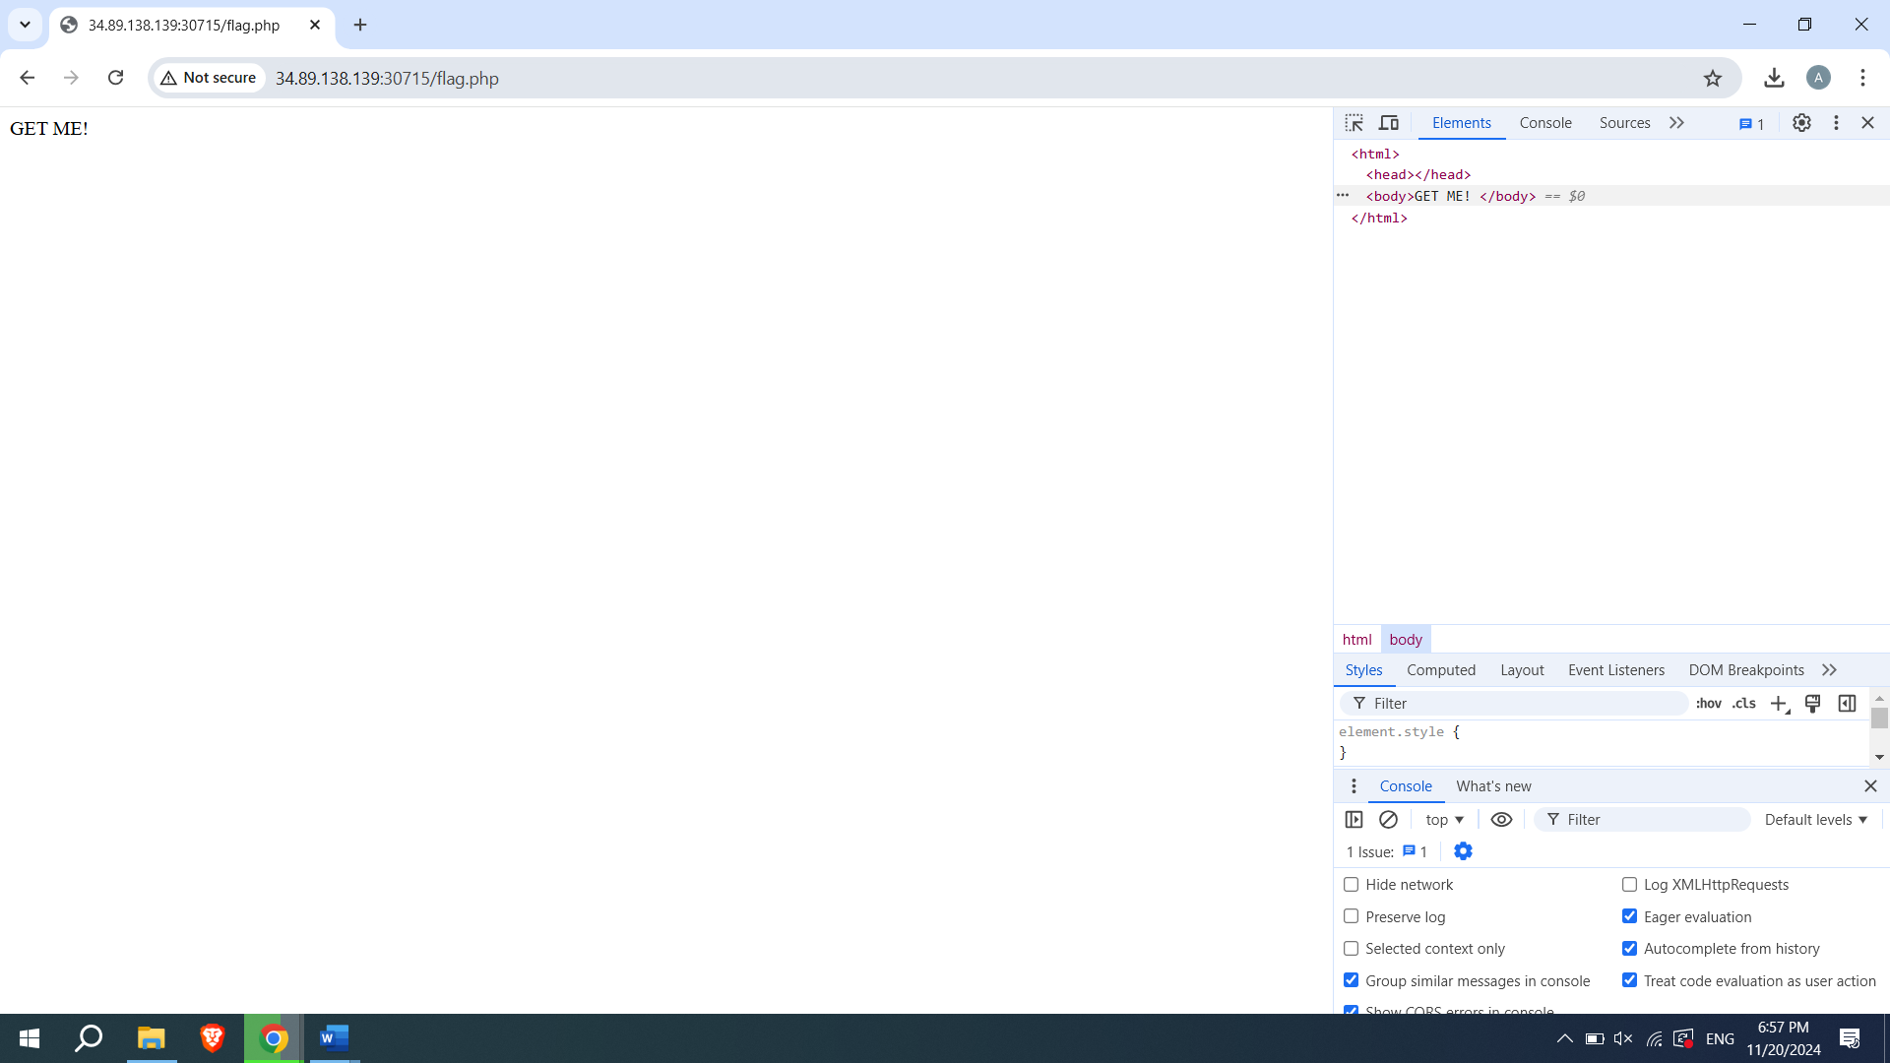
Im going to use request.bin platform such as pipedream then we get the unique url
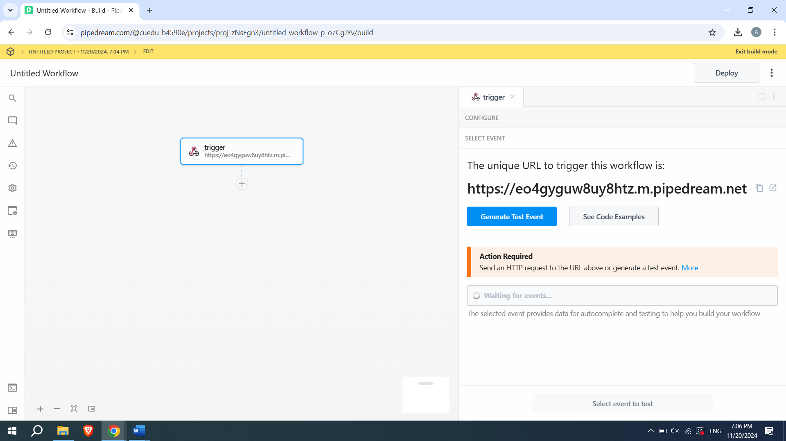
I put the url in our input and it was successful on both our page and pipedream
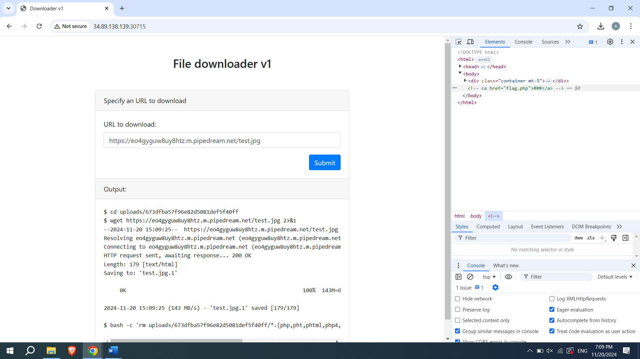

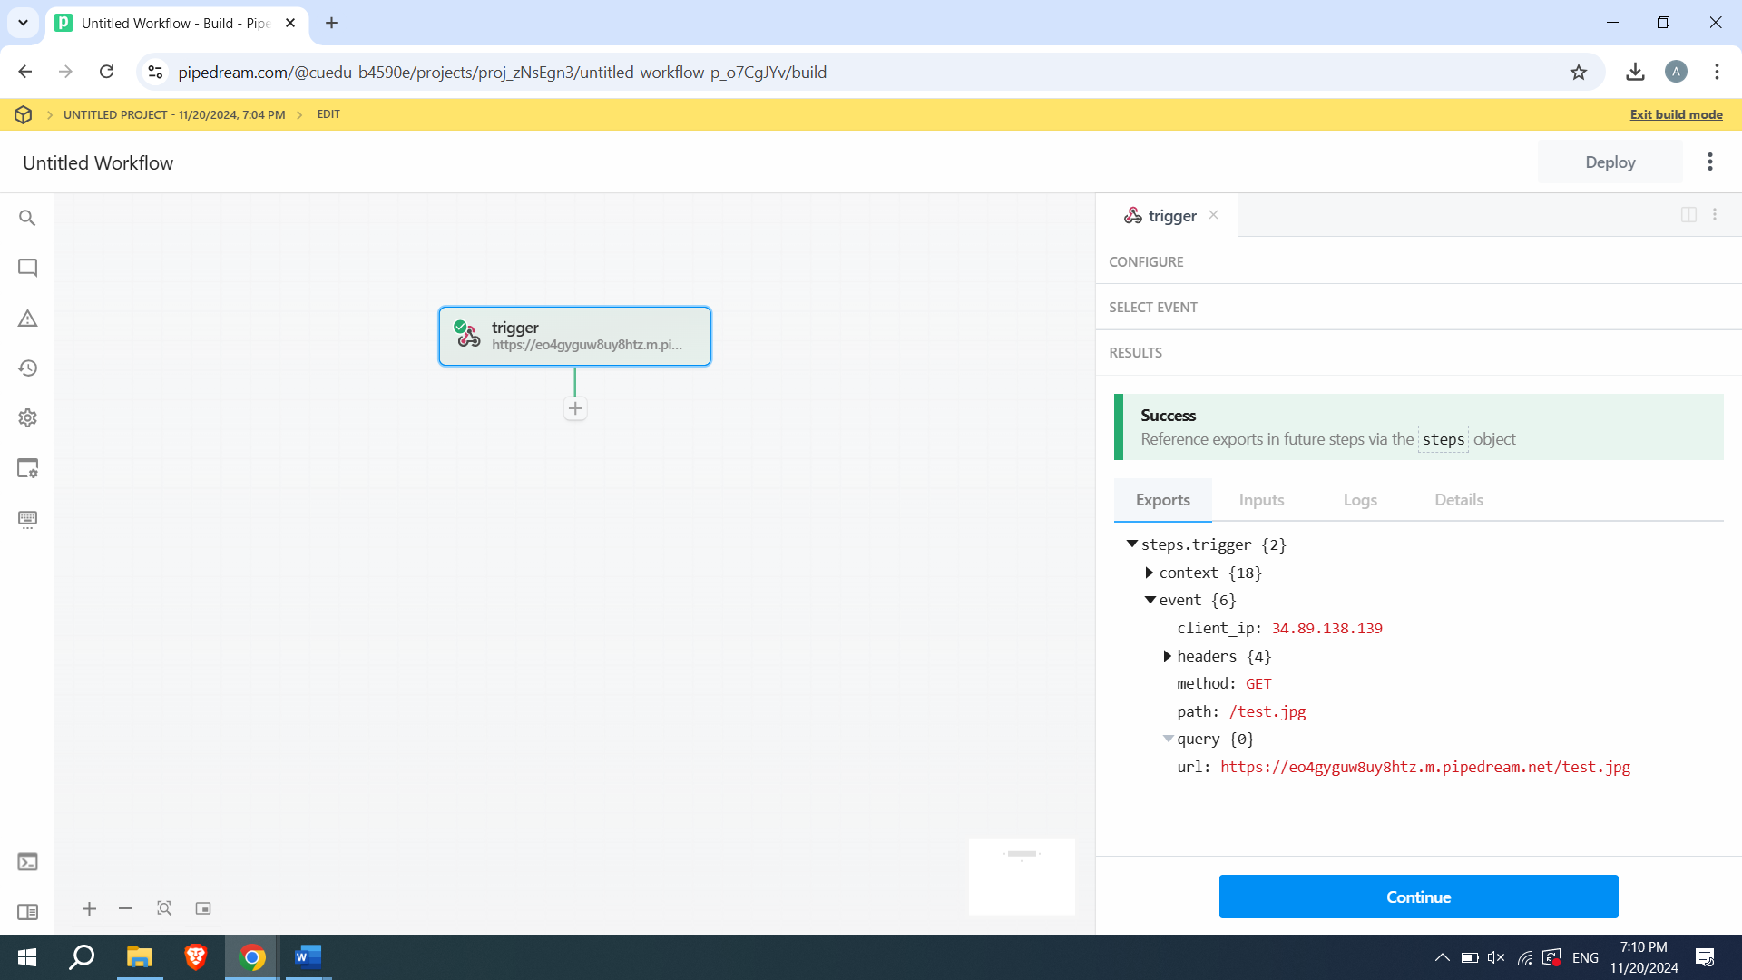
Then I use post method to get flag
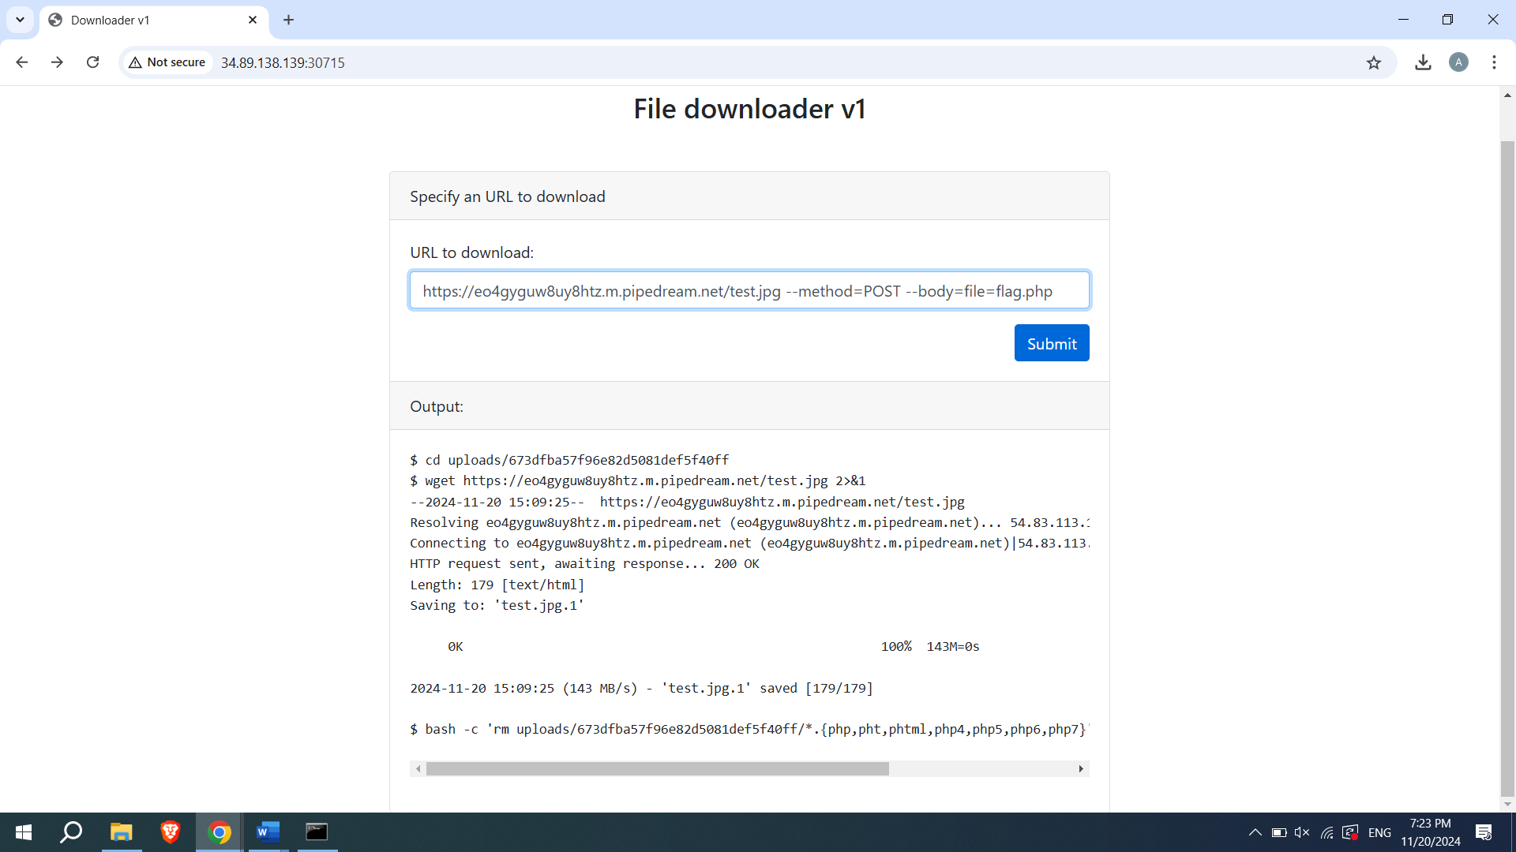
Flag.php wasn’t succesful so I used flag.png instead
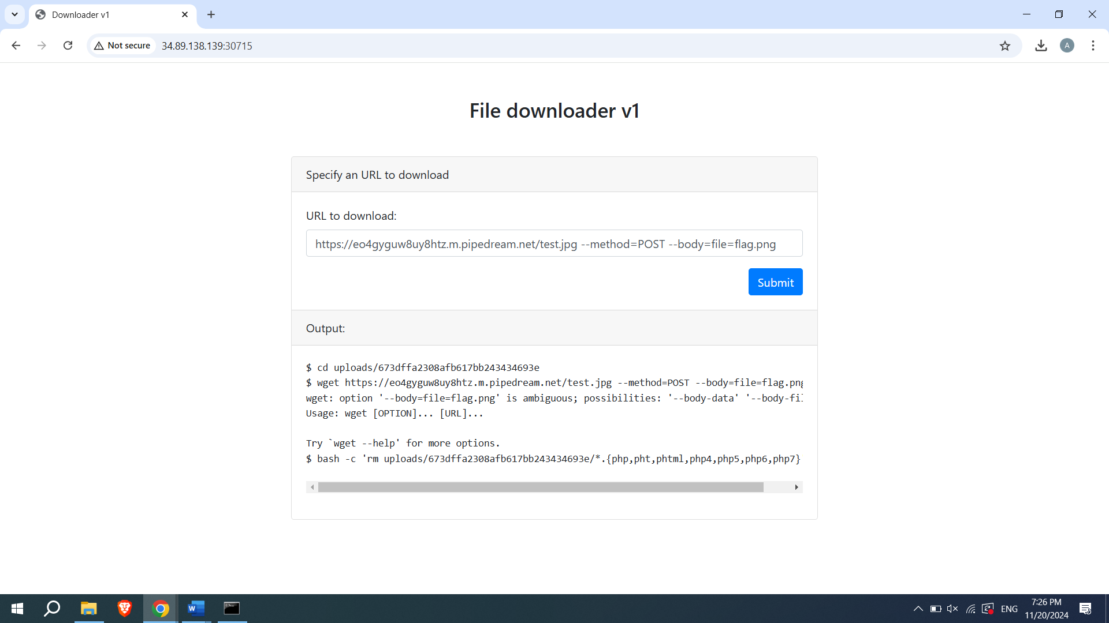
And now I got this in our request.bin
Our flag is: DCTF{6789af26f90396678909a99bf46ba3a78b2f1b349fbc4385e6c50

