Task 1 : File Crawler
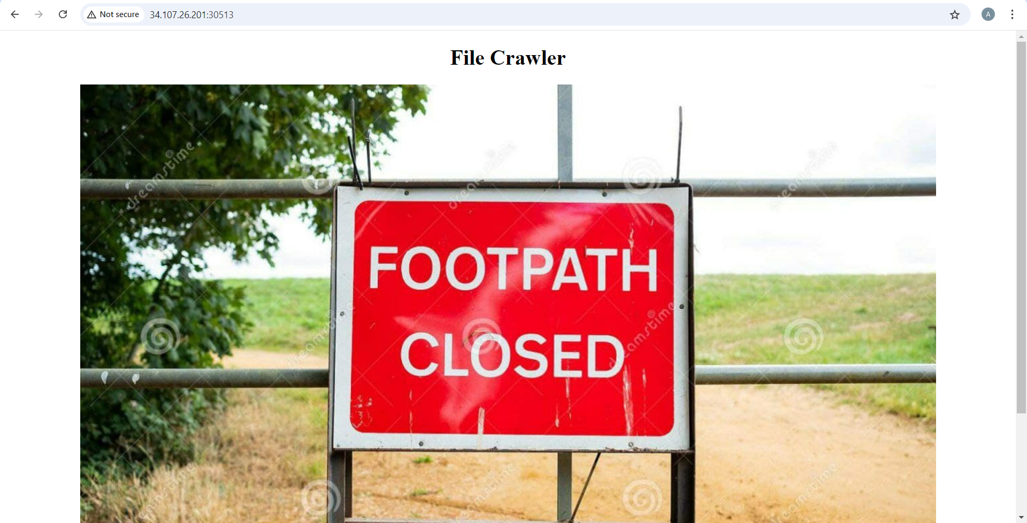
I was given this image which I viewed in new tab
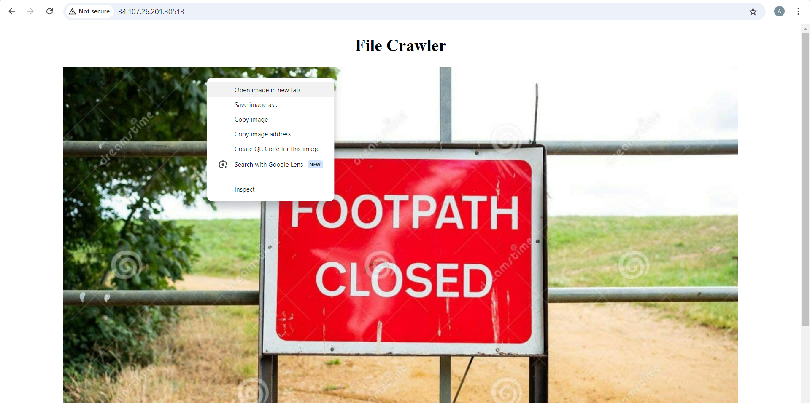
Then I changed the url http://34.107.26.201:30513/local?image_name=static/path.jpg into http://34.107.26.201:30513/local?image_name=app.py to see the python code of the file
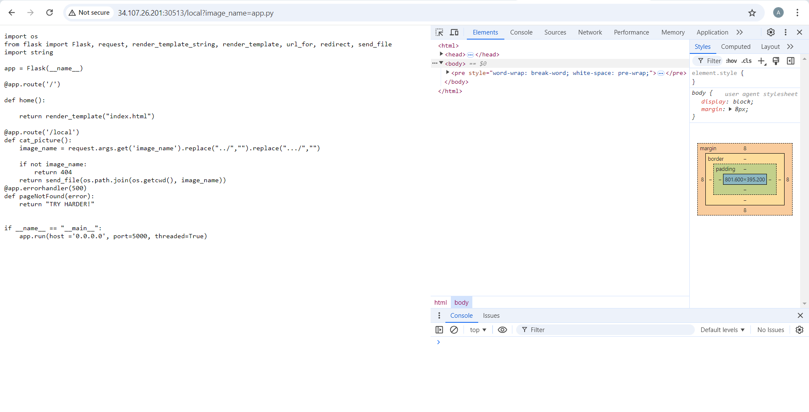
With the etc/password I downloaded a file which showed information stored about the users on the system
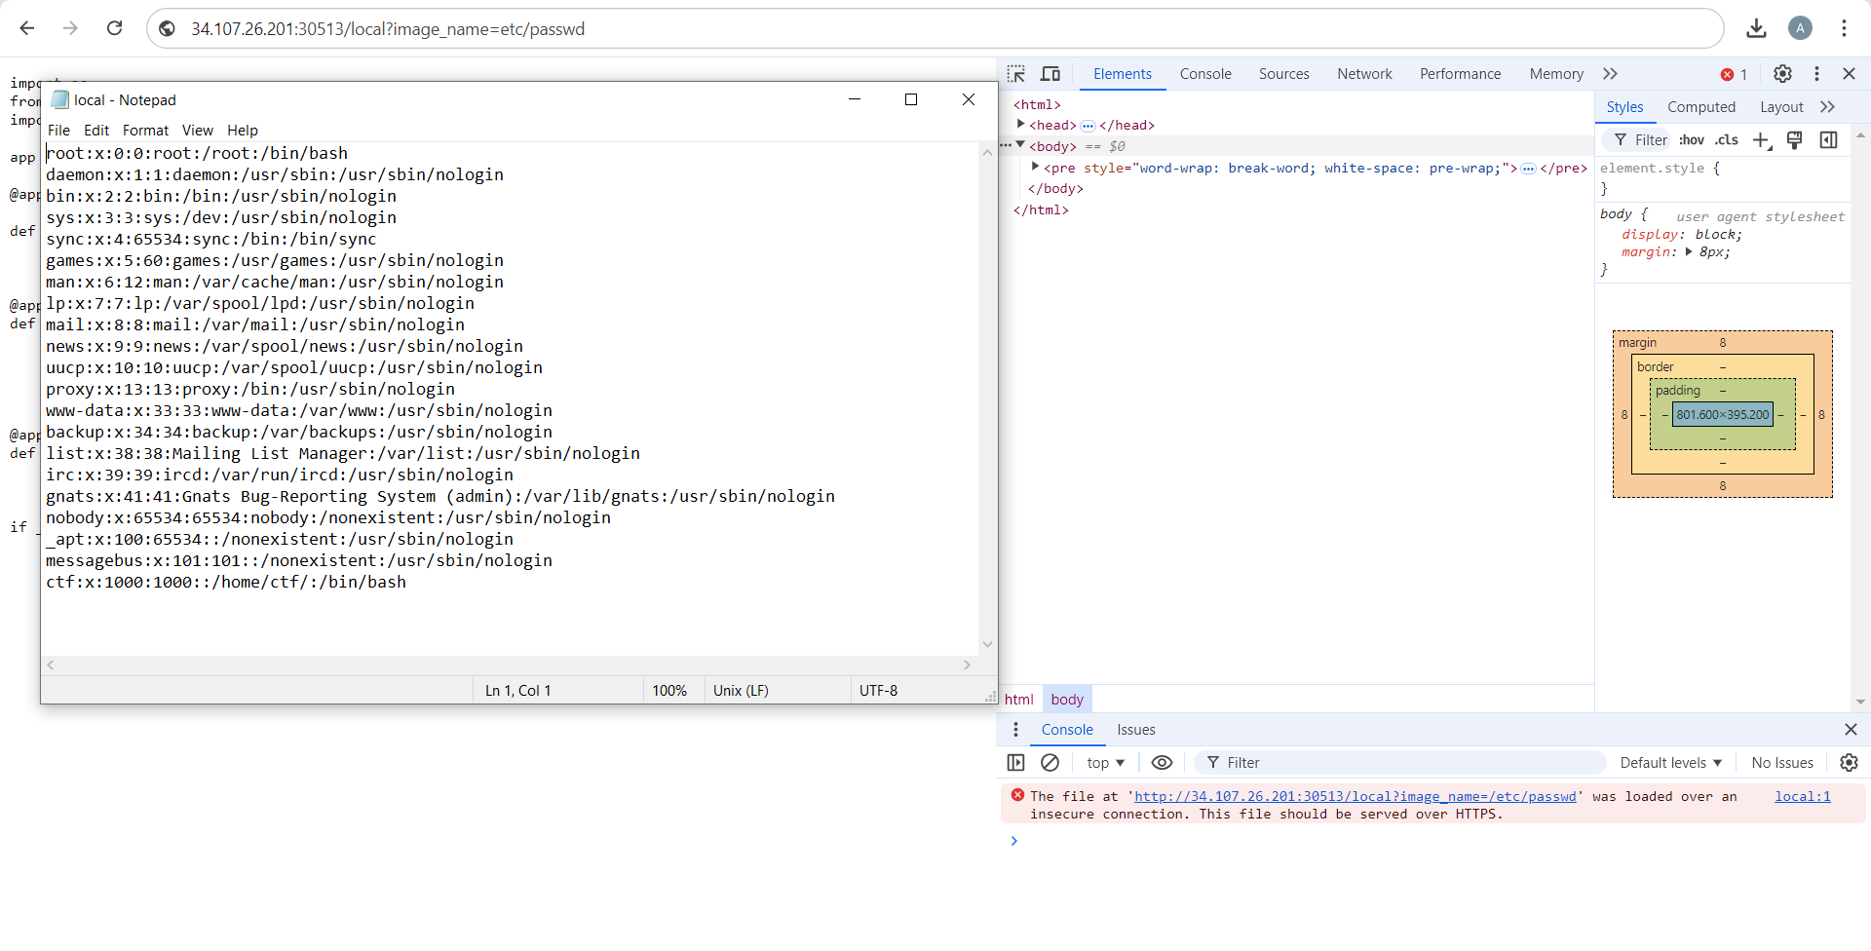
Finally I used ..tmp/flag to find the flag which was:
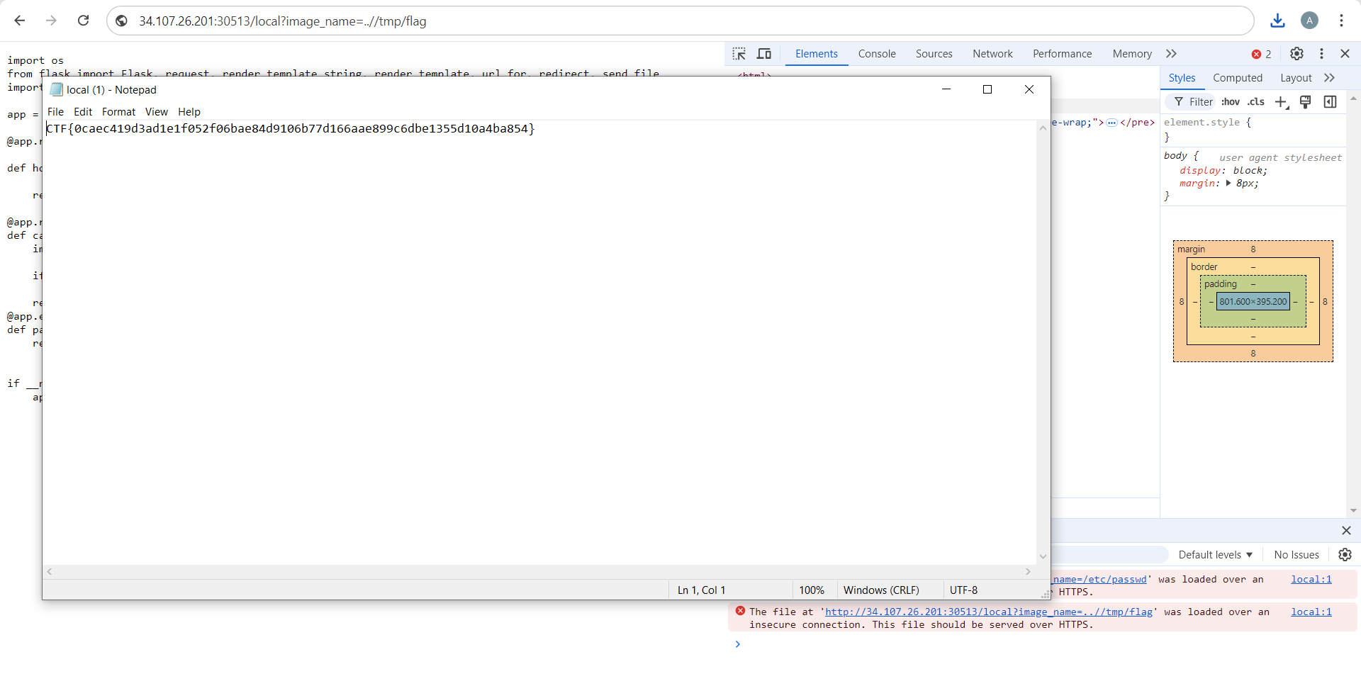
CTF{0caec419d3ad1e1f052f06bae84d9106b77d166aae899c6dbe1355d10a4ba854}

Task 2: Alien inclusion
To start off we have this page:

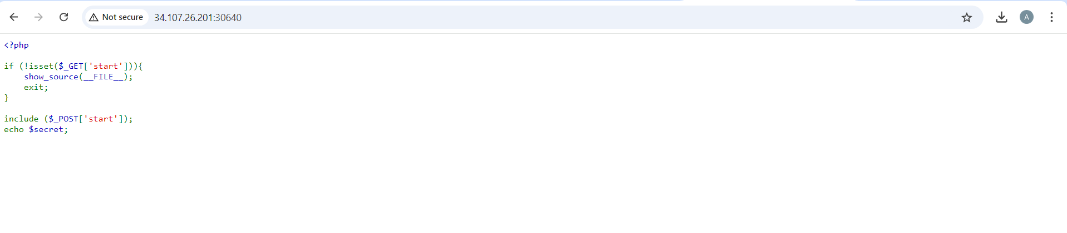
I opened Linux on VMWare and first checked if I had curl function installed and then went with the command curl -X POST "http://34.107.26.201:30640/?start=" --data "start=/var/www/html/flag.php", to find my flag.
The command curl -X POST "http://34.107.26.201:30640/?start=" --data "start=/var/www/html/flag.php" sends a POST request to a web server. It aims to include and execute the flag.php file on the server by setting the start parameter to its path. This is used to retrieve the hidden flag for the CTF challenge.
And as expected the command gave us the flag:
ctf{b513ef6d1a5735810bca608be42bda8ef28840ee458df4a3508d25e4b706134d}

