(3 Point) Design and code a class named Motor that holds information about a Motor and class named VNMotor which is derived from Motor.

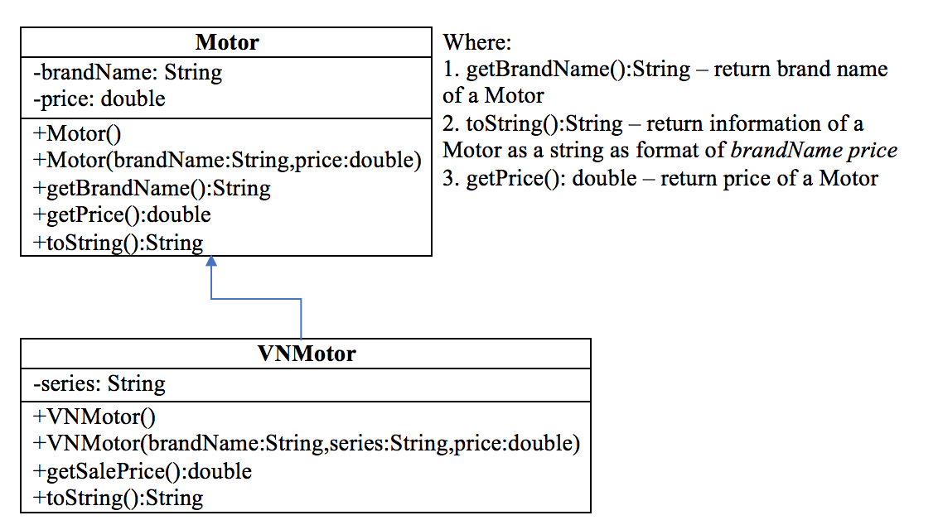

- toString():String - return information of a VNMotor as a string as format of brandName series price
- getSalePrice():double – use to determine sale fare of a Motor, sale price = original price – discount, where:
    - discount = 5 percent out of original price if original price < 3000.
    - otherwise discount = 10 percent out of original price.
Do not format the format the result.
The program output might look something like:

Correct output | Correct output
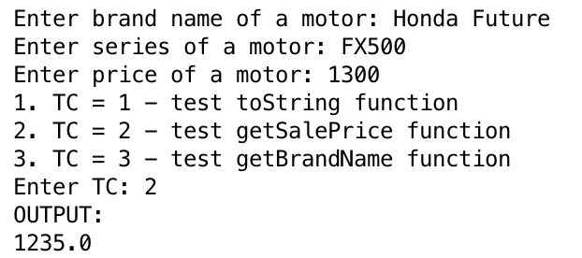 | 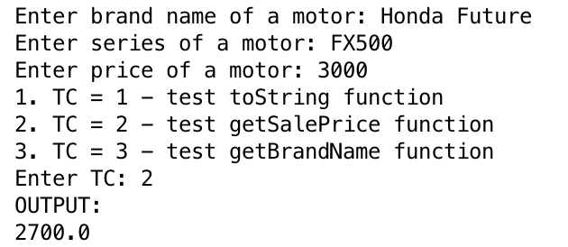
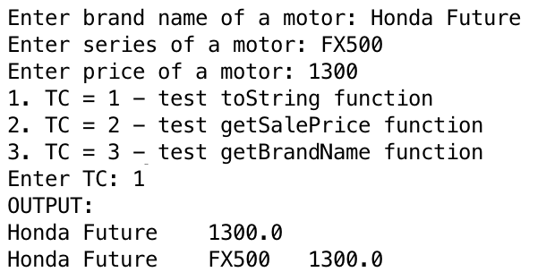 | 