(2 Point)
Design and code a class named Book that holds information about a Bicyle.
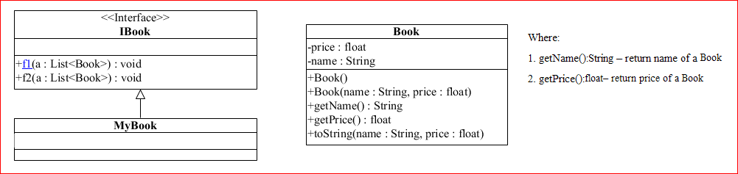
The interface IBook is given (DO NOT CREATE THIS ONE). Design and code a class named MyBycle which will implement interface IBook and complete 2 methods which were declared in IBook

- void f1(List<Book > a) – remove from the list of Book "a" the first Book has chepeast price
- void f2(List<Book > a) - sort Accending the list of Book "a" by name

Given some data which is added to list “a” in the Main already:

Bicyle name | Bicyle price
Toan 1997A | 110
LY 1997B | 250
Hoa 1997C | 120

By using given data, the program output might look something like:
