(3 Point) You are given an interface named Moto (DO NOT CREATE THIS ONE). Design a class MyMoto which will implement the interface Moto.
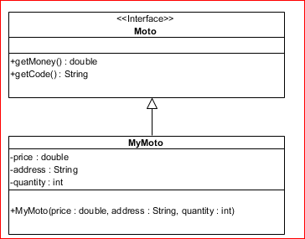

1. double getMoney()– use to determine its money, money=price*quantity, the Money shoude be arounded to the closest double value with tie rounding up if address start with letter ‘C’ or ‘c’, ortherwisre the money shoude be a rounded to the closest double value with ties rounding down
3. String getCode() – assuming that length of address is greater than 3 ; this function return code of address as the rule:
- Code of address = first 3 characters of address if address constains digit only.
- Otherwise Code of address = last 3 characters of address.
No of test case | Correct output
1 | 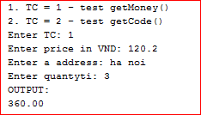
2 | 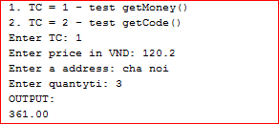
3 | 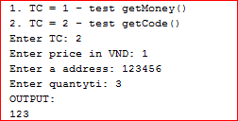
4 | 